  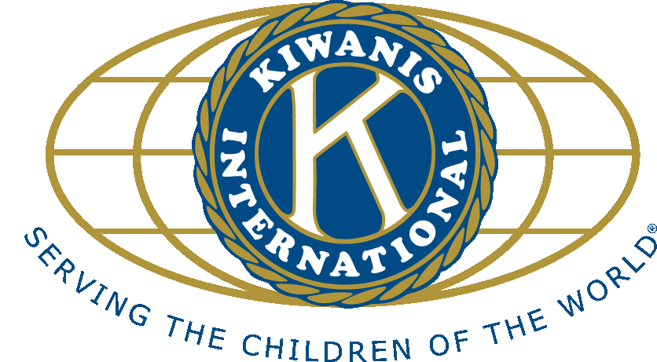

GREEN BAY – DOWNTOWN, Founded 1917

**KIWANIS KEY**

Weekly Newsletter of the Kiwanis Club of Green Bay – Downtown  
 KIWANIS MEETING OF December 18, 2023

We had total of nine at our Monday lunch meeting. Members attending were Rick, Maria, Ben W, Bob, Ann, Pat, Anne and Ben G. Also, attending was our speaker Pat Cichocki from Laundry Love with helping hands. Maria led

us in both the Pledge and Prayer. We sang Deck the Halls. Happy dollars were supplied by Anne, Maria, and Ann.

Our speaker, Pat Cichocki, thanked us for our recent donation to Laundry Love with Helping Hands. Their aim is to provide free laundry service weekly for those who cannot afford to pay for their own laundry. This includes kids, mothers, homeless, and even job seekers going on interviews. People using their service is often made of the working poor.

Three times a month they do the wash at Green Bay Express Laundry, on the east side. Once a month laundry is done at Fort Howard Apartments, which is a low-income senior housing unit. Laundry Love pays for all washing and drying. They serve about 60 families a week doing the laundry for about 180 people. The cost of doing all this laundry is between $4,000 and $5,000 a month. They are a local worthy cause do a great service.

Our next regular noon meeting is set for Monday, February 5th at the Hyatt Regency. The district Kiwanis Governor meeting and dinner will be held on Thursday January 25th at the Stadium View at 6:00 PM.  
  
By: Bob Rowan