REGULAR MEETING
DECEMBER 16, 2021

The Regular Meeting of the Town Board of the Town of Hampton, County of Washington and the State of New York was held at the Town Hall, 2629 State Route 22A, Hampton, New York, also via Zoom and live streaming on the You Tube Channel for “Town of Hampton New York” on the 16th day of December 2021.

Due to the Corona Virus, occupancy inside the Town Hall is limited at this time. Supervisor O’Brien did provide a link to join the meeting via Zoom.

PRESENT: David K. O’Brien------------Supervisor
Donald Sady-----------------Councilman – via zoom
Tamme Taran----------------Councilwoman
Andrea Sweeney------------Councilwoman – via zoom
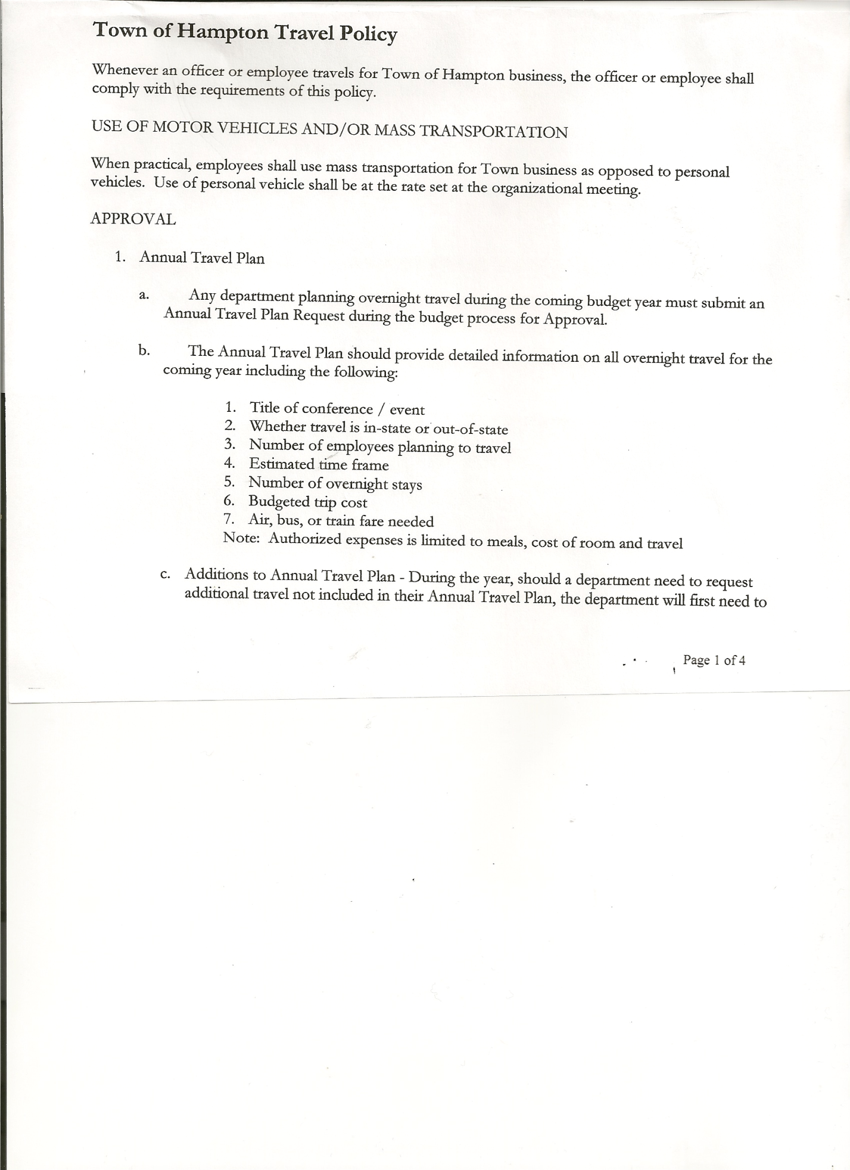
Michael Pietryka------------Councilman
Rebecca Jones---------------Town Clerk
Camilla Shaw----------------Tax Collector/Deputy Town Clerk
Herbert Sady, Jr.-------------Highway Superintendent

Planning Board Member(s):… Bonnie Hawley, Chair and Matthew Pratt
Others present at the Town Hall: See attached sheet
Lieutenant Kristen Hardy via zoom

The Regular Meeting was called to order by Supervisor O’Brien at 7:32pm, followed by the Pledge of Allegiance. Location of Fire Exits were given. Quorum of board members present.

Supervisor O’Brien asked for a moment of silence in memory of Holly Ross

RESOLUTION NO. 114-2021
APPROVAL OF THE MINUTES
On a motion of Councilwoman Taran, seconded by Councilman Pietryka, the following resolution was ADOPTED: AYES 5 O’Brien, Sady, Taran, Sweeney, Pietryka
NAYS 0
RESOLVED, that the Regular Town Board Meeting Minutes for November 18th , 2021 are approved.

Supervisor O’Brien introduced Lieutenant Kristen Hardy, via zoom. She will be Hampton’s local liaison with the Sheriff’s Office.

Larry Carman, Dog Control Officer submitted his report, which was read by Supervisor O’Brien, copy of report is attached.

Camilla Shaw, Tax Collector….no activity. Submitted Bank Statement to the Board for review and signatures.

Bonnie Hawley, Chair gave Planning Board Report……copy of the minutes of their meeting held December 8th, 2021 are attached. She has placed list of officials and Special Meetings notice on the Bulletin Board at the Firehouse in Low Hampton.

TOWN BOARD MEETING
DECEMBER 16, 2021 PAGE 2

Herbert Sady, Jr., Highway Superintendent submitted his last report as Highway Superintendent, copy of which, is attached.
Herb “thanked” the Town Board past and present for his years as a Town Board Member and Highway Superintendent.

Supervisor O’Brien will have plaques made for Herb and Andrea.

Supervisor O’Brien is looking into updating the Internet Service and Phone plans, maybe combining the two. Highway phone is having issues, considering a cell phone for the garage.

SUPERVISOR’S REPORT/ COUNTY UPDATES/ COMMUNICATIONS

RESOLUTION NO. 115-2021
APPROVAL OF SUPERVISOR’S MONTHLY REPORT
On a motion of Councilwoman Taran, seconded by Councilman Pietryka, the following resolution was ADOPTED: AYES 5 O’Brien, Sady, Taran, Sweeney, Pietryka
NAYS 0
RESOLVED that, the Supervisor’s Monthly report be accepted as submitted for NOVEMBER
10/30/21 11/30/21
ACCOUNT BALANCE RECEIPTS DISBURSEMENTS BALANCE
General Fund $ 67,145.83 $ 1217.20 $ 13,051.92 $ 55,311.11
Highway Fund $ 64,318.20 $ 1.60 $ 18,656.14 $ 45,663.66
Equipment Reserve $ 79,919.45 $ 1.97 $ 0.00 $ 79,921.42
Fire #1 $ 21,648.50 $ 0.00 $ 0.00 $ 21,648.50
Fire #2 $ 5,100.00 $ 0.00 $ 0.00 $ 5,100.00
Cemetery $ 1,753.94 $ 0.70 $ 0.00 $ 1,754.64
Totals $239,885.92 $ 1,221.47 $ 31,708.06 $ 209,399.33
All Board Members present signed Supervisor’s Report.

Annual Audits: Councilman Pietryka & Councilman Sady---Budget Officer
Councilwoman Taran & Councilman Dean----Town Clerk & Tax Collector
Supervisor O’Brien----Judge

RESOLUTION NO. 116 -2021
AUDIT OF CLAIMS
On a motion of Councilwoman Taran, seconded by Councilman Pietryka the following resolution was ADOPTED: AYES 5 O’Brien, Sady, Taran, Sweeney, Pietryka
NAYS 0
RESOLVED that the bills have been reviewed by the Town Board and are authorized for payment in the following amounts.
General Fund No. 141 through No. 153 $ 29,801.57
Highway Fund No. 146 through No. 154 $ 3,035.44
Total both funds $ 32,837.01

TOWN BOARD MEETING
DECEMBER 16, 2021 PAGE 3

The Town Clerk’s report for November 2021 was submitted to the Board. The Town Clerk had Board Members review and sign bank reconciliation statements for the Town Clerk Account and Special Clerk Account dated November 30, 2021.

RESOLUTION NO. 117-2021
MEETING ADJOURNED
On a motion of Councilman Pietryka , seconded by Councilwoman Taran, the following resolution was ADOPTED: AYES 5 O’Brien, Sady, Taran, Sweeney, Pietryka
NAYS 0
RESOLVED that the meeting adjourned at 8:12pm.

Respectfully submitted,

Rebecca S. Jones, RMC
Town Clerk

