What to Expect  Expect to have fun! Horizon summers are filled with exciting activities, projects, trips, and events. Campers take advantage of the plentiful nature oriented opportunities located right here in Martin Luther King Jr. Park such as fishing, hiking, and biking through numerous scenic trails. We also engage in trips that encourage campers to explore the community and interact with the world around them.  Staffing  All of our staff are CPR/First Aid Certified. There are also staff members present at all times who are properly trained to administer any medications required for your child’s health and safety.  What to Bring  Daily:  - Comfortable clothing  - Outdoor/Closed-toe shoes  - Sunscreen and/or hat  - A water bottle with your child’s name on it  - Lunch that does not have to be refrigerated or heated  - Optional: Bike, rollerblades, helmet  Fieldtrips:  - Horizon T-Shirt (provided with camp registration)  - Swimsuit and Towel  - Optional: Spending money |  |  | Horizon Child Care, Inc. encourages and accepts children of any race, religion, and ethnic background. |  |  | Horizon  Child Care, Inc.  Serving the Community since 1987  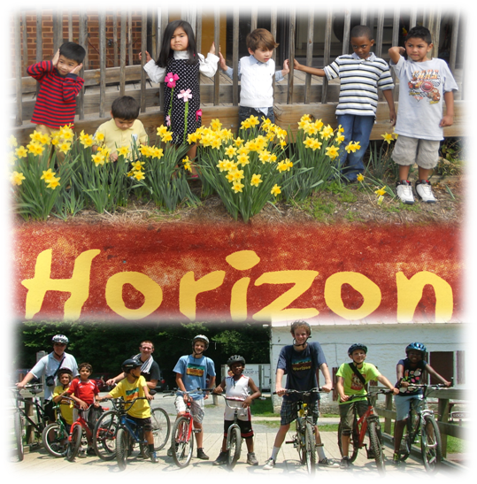  M-F 6:30am-6:00pm  1102 Jackson Road  Silver Spring, MD 20904  (301)680-0665  www.HorizonChildCare.org  horizonchildcare@hotmail.com

ABOUT HORIZON  Horizon Child Care continues to serve the children of our community by providing high quality licensed, child care. All of our staff are dedicated to continued professional development and have your child’s needs at heart. Horizon has an excellent staff to camper ratio ensuring maximum supervision and enabling each camper and staff member to form trusting and long lasting relationships.  Lifelong friendships are made here at Horizon, so come join us for an unforgettable summer experience!  We hope to offer a little bit of everything for children to experience.  There will be one trip to a local amusement  Park. |  |  | CAMP ITENIRARY  Week 1: Family Heritage Week – Follow the Underground Railroad trail in Sandy Spring.  Week 2: Down by the Bay, Go to Sandy Point Beach.  Week 3: Adventure Week, Trip to Sandy Spring Adventure Park. Wheaton Regional  Week 4: Back on the Farm Week – visit active farm and pick berries  Week 5: Bike Week, Learn about bikes. Take a long Bike trip on the C&O canal.  Week 6: Go Local; 6 Flags or Adventure Park USA  Week 7: Memory Week Pottery Making  Week 8: Animal Week. Blandair Regional Park.  Week 9: County Fair Week. Visit the fair and see how we did with our fair entries.  *Adjustments to schedules are possible* |  |  | SUMMER REGISTRATION  Child’s Name:______________________  D.O.B:____________________________  Home Address:_____________________  ________________________________  ________________________________  Parent #1:________________________  Relationship to Child:________________  Phone (h):________________________  Phone (c):_________________________  E-Mail:___________________________  Parent #2:________________________  Relationship to Child:________________  Phone (h):________________________  Phone (c) :________________________  E-Mail:___________________________ Shirt  Child: S M L Adult: S M L  (Circle 1 size)  $20.00 for additional shirt  Tuition -Registration:$100.00 (non refundable Full Day week rate:$300.00 Select weeks  __ Wk 1: June 19 -23  __ Wk 2: June 26 - 30 __ Wk 3: July 3-7 __ Wk 4: July 10 - 14 __ Wk 5: July 17 - 21 __ Wk 6: July 24 - 28 __ Wk 7: July 31 – Aug. 4 __ Wk 8: Aug. 7 - 11 __ Wk 9: Aug. 14 - 18 __ Wk 10: Aug. 21 – 25 Horizon is Closed  ___ School Starts August 28, 2023

