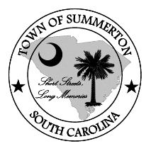
Town of Summerton
Council Meeting Agenda
Summerton Town Hall
Tuesday, May 14, 2019 at 6:00 p.m.

- Call to Order
- Invocation and Pledge of Allegiance
- Approval of Agenda
- Approval of Minutes of Previous Meeting
  - Council Meeting, April 9, 2019
- New Business
  - Presentation of the 2018 Audit Report – Hobbs Group
  - Adoption of the 2018 MASC Business License Ordnance-Wm. Brailsford
  - Removal of cap on Business License-Wm. Brailsford
  - Approval of 2019/2020 Fiscal Year Budget by Title Only-Mayor Bagnal

- Status Report
  - Mayor Bagnal
- Updates from Staff

- Public Participation as it Relates to the Agenda

- Adjourn

