From: CAIT_LTAP [mailto:cait_ltap-bounces@email.rutgers.edu] On Behalf Of cait_ltap@email.rutgers.edu
Sent: Wednesday, September 7, 2016 10:57 AM
To: cait_ltap@email.rutgers.edu
Subject: NJ LTAP- check the new offerings for fall courses- CPWM and NJ PE PDH credit where applicable

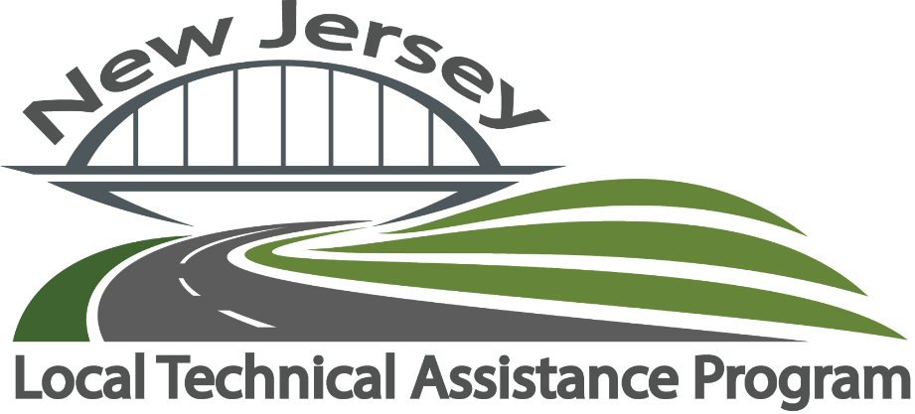

New Jersey municipal and county officials- this is our final schedule for 2016- reserve your seat before courses reach their maximum capacity of registrants! Do not wait until spring to make sure you have all of your hours for license renewal!

Construction / Project Cost Estimating for Public Works Projects

September 14, 2016
October 19, 2016
8:30 a.m.–3:30 p.m.
The escalation of costs and challenges with financing, developing and implementing highway related projects is a critical concern to all public agencies. This course provides municipal and county roadway agency and public works employees an understanding of practical applications for performing estimates on typical maintenance and construction projects within their local jurisdictions. Various mathematical rules necessary to perform basic computations and formulas to perform cost and quantity calculations are reviewed. The participants perform material estimating, problem solving, and dealing with cost and quantity estimates.
DETAILS >>

Permeable Pavements
September 15, 2016
8:00 a.m.–4:00 p.m.
This seminar provides design, construction and maintenance guidelines for porous asphalt, pervious concrete and permeable interlocking pavements. Presenters include co-editors of the 2015 ASCE book, Permeable Pavements, as well as speakers from industry, engineering consultants, researchers and municipal users. Project examples will emphasize maintenance methods, costs, and strategies for long-term performance.
DETAILS >>

Work Zone Safety for Municipal and County Public Utilities and Public Works Personnel (Work Zone Traffic Control)
October 6, 2016
November 7, 2016
8:00 a.m.–12:00 p.m.
This course, similar to our Work Zone Safety Awareness Program, is specifically being offered to New Jersey municipal and county public works and public utilities participants who require an overview of working safely in the roadway. The roles of workers and enforcement personnel at work sites, differences between NJDOT and local projects, and legal responsibilities in work zones will be addressed during this program.
DETAILS >>

Asphalt Roads: Common Maintenance Problems
September 20, 2016
8:00 a.m.–12:00 p.m.
This course provides relevant information to individuals who have to maintain asphalt pavements. The course material reviews the importance of preventive maintenance to the life of an asphalt pavement. The material will help the student identify common asphalt distress, the cause of the distress, and the appropriate treatments.
DETAILS >>

Roadside Safety Features
September 23, 2016
December 13, 2016
8:30 a.m.–3:30 p.m.
This course is designed to help local road agencies, engineers and public works personnel reduce the incident of traffic crashes through the application of low cost "best safety practices," many of which feature the efficient use of traffic control devices, into their routine day-to-day activities. The course focuses on the implementation of safety strategies described in FHWA's Toolbox of Countermeasures and Their Potential Effectiveness for Roadway Departure Crashes, Intersection Crashes, and Pedestrian Crashes.
DETAILS >>

Stormwater Management
September 27, 2016
September 28, 2016
8:00 a.m.–12:00 p.m.
This course focuses on understanding the issues related to stormwater and provides steps to manage and reduce problems resulting from stormwater. It will provide guidance for managing stormwater in relation to roadway infrastructure and practices of local roadway departments, from planning to maintenance.
DETAILS >>

Highway Inspection Procedures for Federal Aid Projects
September 28, 2016
November 21, 2016
8:30 a.m.–12:30 p.m.
This course is designed specifically for project engineers, project inspectors, supervisors and those in responsible charge of federal aid construction projects. It presents essential requirements and procedures for insuring conformance with contract plans and specifications including records and documentation necessary to facilitate reimbursement to recipients of federal funds. This is a ‘must have’ course for County, Municipal, and Consultant personnel at every level who may be responsible for ensuring on-time project completion, conformance with plans and meeting eligibility criteria for federal reimbursement.
DETAILS >>

Equipment and Worker Safety
September 30, 2016
November 4, 2016
8:00 a.m.–12:00 p.m.
This course is intended to provide instruction to entry level participants and a refresher for experienced participants on a variety of construction industry safety and health standards. This training effort is aimed at promoting workplace safety and health.
DETAILS >>

Roadside Vegetation Control
October 3, 2016
October 28, 2016
8:30 a.m.–3:30 p.m.
This course covers safety standards relating to all types of mowing equipment, brush-clearing tools, and other tools used in ground maintenance. Primary goals are to provide awareness of the hazards associated with equipment and to identify safe work practices.
DETAILS >>

Winter Maintenance: Snow and Ice Control for Local Roads
October 5, 2016
October 6, 2016
8:00 a.m.–3:30 p.m.
This six module, one day workshop will cover the full range of snow and ice removal and control, including program development, planning, pre-season activities, in-season operations, post storm activities, and post season activities. It is designed so that all involved personnel can have a sound understanding of the fundamentals and a better appreciation for why others in the network are doing what they are doing. Plow operators, other equipment operators, road superintendents, supervisors, town managers, town clerks, and elected officials can all benefit from this one day of training.
DETAILS >>

Roadway and Traffic Safety Improvement Program
October 5, 2016
8:30 a.m.–3:30 p.m.
This course covers how to establish and maintain a roadway and traffic safety improvement programs. Participants learn how to implement safety improvements targeted at areas that have a history of crashes or exhibit conditions associated with high-crash areas and they will learn how to develop a Traffic Safety Development Plan (TSDP) for their community.
DETAILS >>

Pavement Management for Local Agencies (Road Surface Management)
October 11, 2016
8:30 a.m.–3:30 p.m.
This course provides the basics for developing a road surface management program to help local governments manage their pavements by providing an understanding of the concept and importance of road surface inventories and condition surveys.
DETAILS >>

Traffic Incident Management Training for Emergency Responders
October 12, 2016
December 14, 2016
8:00 a.m.–12:00 p.m.
Using a multi-discipline approach, first responders in New Jersey will learn how to operate more efficiently and act collectively. The training covers topics including TIM guidelines, fundamentals, and terminology; notifications and scene size up; scene safety and risk management; traffic management; special circumstances; clearance; and termination. This course is open to all traffic-incident first responders including personnel in law enforcement, fire fighting, emergency medical services (EMS), public safety, public works, towing and recovery, and hazardous materials (HAZMAT).
DETAILS >>

Traffic Signs - NEW!!!
October 14, 2016
December 5, 2016
8:00 a.m.–12:00 p.m.
This course reviews the basic regulations and guidelines for properly establishing and posting regulatory, warning, and guide signs. It presents examples of improper signing so participants can better understand the basic concepts and principles associated with signs and supports, along with sign management techniques. (Note: The course does not cover work zone or temporary traffic control signing.)
DETAILS >>

An Introduction to NJ Traffic Regulations: Engineering and Traffic Studies - NEW!!!
October 18, 2016
December 14, 2016
8:30 a.m.–3:30 p.m.
This course for individuals that conduct engineering and traffic studies will review how to legally establish speed limits on municipal roads, how to properly place Stop signs, the problems associated with improper use of multi-way Stop signs and other common topics every municipality has to address.
DETAILS >>

Traffic Calming - NEW!!!
October 20, 2016
December 2, 2016
8:30 a.m.–3:30 p.m.
This course defines traffic calming, describes various traffic calming devices, outlines potential positive and negative impacts on a neighborhood, and reviews a sample traffic calming program. It also investigates related issues, such as impacts of traffic calming devices on liability, roadway maintenance, and emergency service.
DETAILS >>

Grant Management for Federal Aid Projects
October 25, 2016
November 28, 2016
8:30 a.m.–12:30 p.m.
This course is designed for recipients of Federal Highway’s Federal Aid Grants. Effective and efficient “management” of the funds received from such a grant is critical to insuring future eligibility and reimbursement. This course highlights for the administrator and grant coordinator key requirements and responsibilities that must be met as a condition to the grant.
DETAILS >>

Principles of Paving
November 2, 2016
8:30 a.m.–3:30 p.m.
This course is for municipal or county employees and those that work with them who are involved in the planning, inspecting and placing of asphalt pavements. The course will provide the information needed to properly plan and monitor a hot mix asphalt paving project.
DETAILS >>

Common Sense Solutions for Intersection Problems - NEW!!!
November 30, 2016
December 16, 2016
8:30 a.m.–3:30 p.m.
This course provides participants with (1) a basic understanding of intersection safety issues, (2) “How to” information for common safety tasks and low cost safety improvements that do not require an engineered design, and (3) background information on safety tasks that do not require an engineer. This workshop also outlines areas where non-engineers can assist traffic engineers in the safety process, and help them to understand when an engineer needs to be consulted to make a safety related change to an intersection.
DETAILS >>

Risk Management Strategies for Public Works Departments –NEW!!!
December 8, 2016
December 9, 2016
8:30 a.m.–3:30 p.m.
This workshop provides an overview of the legal duties and responsibilities of road agencies and their employees. Key legal concepts relating to the liability of roadway agencies are reviewed from a risk management standpoint. Common types of claims/lawsuits brought against street departments and roadway agencies are identified through examples and case studies.
DETAILS >>

Withdrawal Policy: In the event that you are unable to attend a program for any reason, please note you must submit your withdrawal at least 72 hours in advance of the start of a program to receive a refund. If a withdrawal is not received by our department, the full program fee will be charged and is nonrefundable.

Privacy Policy: The personal information we collect when you register for a program will not be disclosed to any outside parties. We use personal information for purposes of administering our business activities and providing customer service. We may also use the information we collect to notify you about important services and offerings we think you will find valuable. We are not responsible for the practices employed by websites linked to or from our website or the information or content contained therein.

