Pierceton Chamber of Commerce

Citizen of the Year
Business of the Year
Spirit of the Community

The Pierceton Chamber of Commerce is interested in demonstrating awareness and appreciation for the several residents who work to better our community. Many residents work behind the scenes to better our neighborhoods, create opportunities for our youth and elderly, protecting our environment or just making our community a great place to live and shop.
If you know of someone who you would like to nominate for this recognition, please complete the attached form and forward to the Pierceton Chamber of Commerce.

Thank you,

Alicia Elder
2017 Chamber President

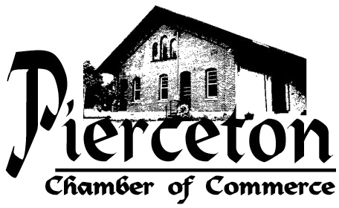
Help the Pierceton Chamber to nominate: Citizen, Business, & Spirit of the Community
NOMINATION FORM
Citizen ____Business ____Spirit____
Name of Nomination:
Address of Nomination:
Phone Number of Nomination: (cell, home, work circle one)
Community Position Held by Nominee:
Brief Narrative why Nominee should be considered: (Please attach a page if necessary)
Name of person making Nomination:
Phone number of person making Nomination:
Date Nomination form submitted:
Please send completed Nomination forms to:
PIERCETON CHAMBER OF COMMERCE, P.O. BOX 49, PIERCETON, Indiana 46562
Email: info@piercetonchamber.com
In by Thursday July 13, 2017
Open House July 18, 2017, at Community Center, Pierceton, Indiana
Questions call Alicia Elder 260-609-6982

