Registration and Information for Dog Parade Participation

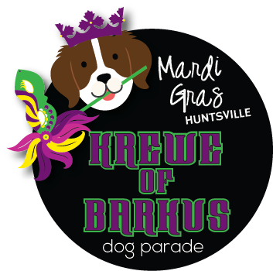

Grand Parade Begins at 4:30 pm – Lumberyard Parking Lot
February 18, 2023 - Huntsville, AL
NOTICE!! The dogs will be at the “TAIL END” of the grand parade, your dog needs to be ok with loud noises & large crowds.

1:
ALL Participating Dogs MUST:
- Be on leash
- Only ONE dog per person – each dog must have its own handler
- Be child and adult friendly
- Play well with other dogs
- Be in costume

Please return the registration form along with a $20 entrance fee (per dog) NO LATER THAN
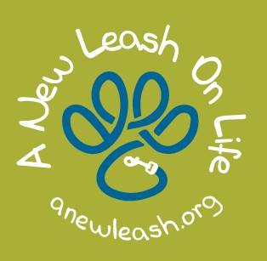
Friday, February 11, 2023, to:
Marydae Blank
1303 Monterrey Drive
Huntsville, AL 35801
- Cash or Checks may be made out to BHH.

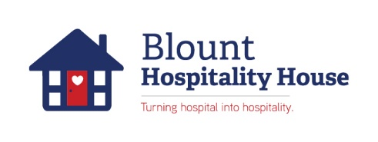
Questions? Sara Alavi at Sara@fmnanimalrescue.org
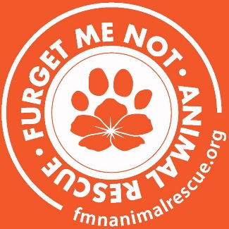

Grand Parade & Blount House Director:
Marydae Sneed
256-337-0141
Marydae@aol.com

Notes: You will be contacted by Mardi Gras Huntsville to confirm your entry via E-mail.

Registration for Dog Parade

First Name:___________________________Last Name:_______________________________
Dogs Name:___________________________Breed:___________________________________
Address:_____________________________ City:________________________State:___ ___
Mobile:___________________________ Email:___________________________________

RELEASE and HOLD HARMLESS/PHOTO AGREEMENT
I, the undersigned, have read and understand the Parade Rules and hereby request permission to participate in the Mardi Gras Huntsville Dog Parade, hosted by Blount Hospitality House. I agree that I am responsible for my Organization, its members and participants, and for their safety. I also agree that the Mardi Gras Huntsville Dog Parade, Blount Hospitality House, their staff, & directors, will not be held liable for any injuries, damages or claims resulting from or participation in the Mardi Gras Huntsville Grand Parade, held on February 18, 2023 at 4:30 in the afternoon. I understand that my dog(s) and I are participating in this event at our own risk.
In addition, I understand that any photographs taken in this parade will be used for marketing purposes by all participating organizations in the future. Pictures can be found on websites, promotional materials, & TV commercials.
PRINTED NAME:_______________________________________________________________
E-MAIL ADDRESS:______________________________________________________________
SIGNATURE:____________________________________________Date___________________
Please return this form along with a $20 entrance fee (per dog) NO LATER THAN Friday, Feb. 11th, 2023, to:
Blount Hospitality House (BHH)
610 Madison Street Dog Parade Contact:
Huntsville, AL 35801 Sara Alavi
256-337-0141 Sara@fmnanimalrescue.org

