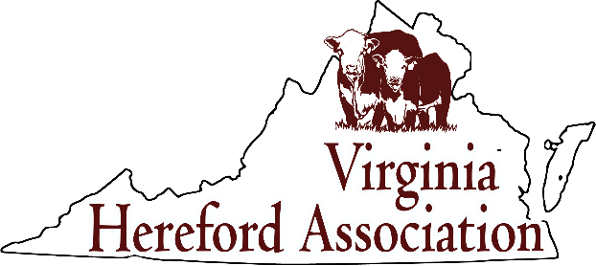

Virginia Hereford Association
118 Via Farm Lane, Patrick Springs, VA 24133
276-340-8181
camsherefords@gmail.com
The Virginia Hereford Association is a 501( c) (3) organization
January 16, 2024

Dear Hereford Breeders,
I hope this letter finds you and your families well and staying warm and safe with the cold temperatures we have been “enjoying”! As we look towards a new year, it is time to begin making plans for the 2024 Virginia Beef Expo Sale. Your Virginia Hereford Association has already begun to plan for the 2023 Mid-Atlantic Spring Bonanza, scheduled for Friday, April 19, 2024 at the Rockingham County Fairgrounds in Harrisonburg, VA; and would like to invite you to consign to this year’s sale.
The rules for the sale and information required for consignment are enclosed with this letter. Please take a moment to read over the information and consider consigning. This sale is an excellent opportunity for you to showcase some of your top cattle and promote your breeding program and farm.
Since the sale is in conjunction with the Beef Expo we are limited to 70 lots. Therefore, consignments will be accepted on a first come, first serve basis, with first preference given to current Virginia Hereford Association and American Hereford Association members. If space is available, consignments will be accepted from non-members up to the 70 lot limit. Please note, membership payment for VHA is expected before consignments will be accepted, and you must be a current member of the American Hereford Association. Also, registered cattle that do not have EPDs will be listed at the end of the catalog, just before the commercial black baldy females. For animals to have EPDs, the breeder/current owner must be a performance breeder and must have submitted calving ease and weaning weight data on all animals, and must complete their herd inventory for each season on all animals that they own. If you have any questions regarding this, or need assistance, please feel free to reach out and we are happy to help!
If you would like to consign animals to this sale, please fill out the information and mail it to Rebecca Webert at 7309 Starling Drive, Warrenton, VA 20186 or send the information via email to rebecca@blacklocustlivestock and CCed to rfunkhou@vt.edu (email is strongly preferred). With an electronic submission the information can be cut and pasted into the spreadsheet that AHA will use to produce the catalog which decreases the chance for typographical errors. Footnotes MUST be emailed in a format that allows for copying and pasting – either typed in a word document or typed in the body of an email. To help your consignments draw interest and sell well, it is important to be sure to have as much information as possible in the catalog. Please be sure to completely fill out the information sheet for each animal, and include all relevant breeding information, calving information and additional information about your consignment to supplement the pedigrees in your footnotes. Also, good pictures of your animals are always beneficial.
The final deadline to have all information for consignments (including footnotes, pictures, breeding information and any ads for the catalog) is February 11. Consignment fees are also due by February 11 and should be mailed to Rebecca at the above address.
As in the past, Tommy Coley, AHA Field Representative has offered to visit as many consignors as possible to take pictures and videos. If you would like him to come to your farm to picture your cattle, please let Rodney Phillips know no later than February 1 so that we can schedule those visits. Rodney can be reached by phone at 804-556-3810. You will need to make sure that heads of cattle are clipped before Tommy arrives and will need to have a place on the farm to take pictures.
If you have any questions about consignments or if there is any way I can be of assistance, please feel free to contact me at 540-333-1019 or send me an email at rfunkhou@vt.edu. I look forward to working with you to make this an excellent sale!

Best Regards,
Rebecca
Rebecca Webert
Sale Coordinator

Dates to Remember:
-February 1: Contact Rodney Phillips on or before this day if you would like Tommy to picture your animals
-February 11: ALL consignment information is due to Rebecca on or before this date. Information received after this date may not be included in the catalog.

