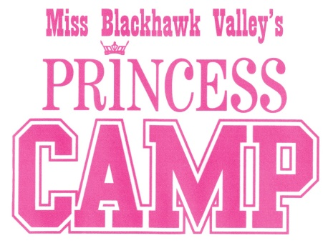
Princess Camp Opportunities for 2022

Participants in the 2022 Princess Program will have opportunities to build relationships with the Miss and Outstanding Teen BHV titleholders while developing speaking and performance skills through service-based appearances. Listed below are just some of the activities that are already being planned:

Performance and Mentor Opportunities
Miss BHV Competition November 14, 2021
Festival of Trees Center Stage November 2021
Festival of Trees Parade November 2021
Colona Memorial Day Parade May 2022
Miss BHV Send-off to Miss Illinois May/June 2022
Miss Illinois Competition June 2022
East Moline 4th of July Parade July 2022
Rock Island Labor Day Parade September 2022
Halloween Parade Float October 2022
Miss BHV Competition 2022 TBA 2022
Photoshoots TBA

Miss Illinois Princess Program
Opportunity to represent Miss Blackhawk Valley at the Miss Illinois Competition, June 2022.

Miss Blackhawk Valley Princesses will be admitted to all Miss Blackhawk Valley functions during the pageant year 2022

Each participant in the Princess Camp will receive:
- Tiara
- Sash
- Miss Blackhawk Valley Princess T-shirt

Revised 8/25/2021

