The 39th Annual Paul Bunyan Plainsmen Rendezvous by Mike Moran

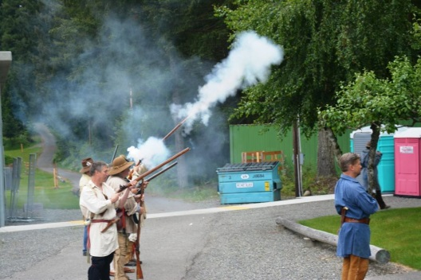
The canvas is finally dry, the guns have been cleaned, and gear is packed away. It’s the end of another great rendezvous at Paul Bunyan. For 39 years now muzzleloaders have been meeting for competition and camaraderie, friendship and fun. This year’s event was spectacular, and culminated a full year of planning and preparation. It was held over the 2014 Memorial Day weekend.
Firing Detail from Opening Ceremony
The main competitive event was comprised of an aggregate score of 3 events. The rifle trail consisted of 15 metal 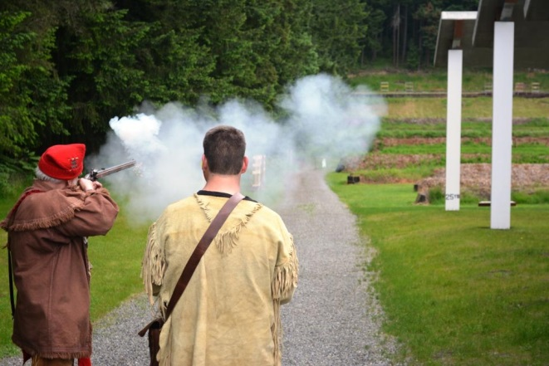
Shooting the Bear at 100 yds
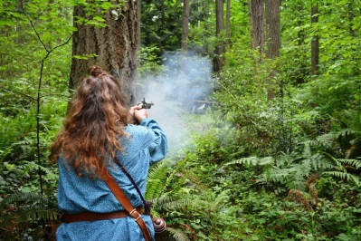
silhouette targets at ranges from 25 yards to 200 yards, with 5 optional targets that could be shot for a bonus score. The pistol trail was similar, with 15 silhouettes and 5 bonus targets. The knife and hawk trail had 16 targets, with one target engaged with a spear. Each trail gave a maximum of 20 points, plus one point for period attire.
Cindy Riggs on the Pistol Trail
The Paul Bunyan club members and a few others ran through their trail walks on Friday morning in order to serve as trail guides and scorekeepers. Friday also found the traders setting up their tents along Trader’s Row. It was a perfect day to do some black powder shooting – it rained all day. As the day progressed, participants began to arrive and erect their camps in either the primitive camp area on the shotgun range or for those with RVs beyond the IPSC range.
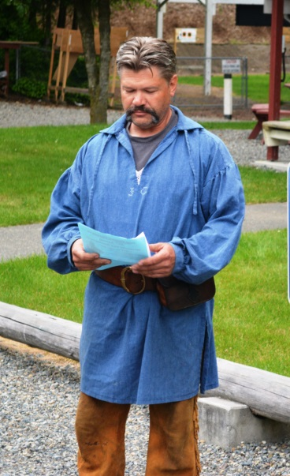
The opening ceremony began at 8:00 am Saturday with remarks and safety reminders by the Booshway, Jack Knight. Mark Curtis and Mikey Godat raised the colors, and Bill Sick led the detail in firing off a five gun salute. Rep. Hans Zeiger provided a welcome letter for the event. The first shooting groups started at 9:00, with one group heading to the rifle trail, and the other group to the Pistol, Knife and Hawk trails. New groups started every half hour, and the sun came out for a beautiful day of shooting.
Throughout the day there were activities such as the Bugler’s candy cannon and Lil’ Buckskinner crafts and games. The adults could shoot the primitive archery trail. Folks gravitated to trader’s row to check the wares or wandered back to their camps to relax. Lucie’s Stew Pot was cooking away all day, under the watchful eye of 93 year old Lucie herself. The stew was served to the whole camp at 5:30.
Booshway Jack Knight
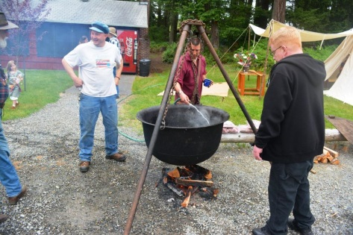
The Club Stake Shoot was a new event this year. Held right after dinner, it pitted teams of 6 shooters against each other in trying to cut through a 4”x4” wooden post. The teams started with unloaded guns, and at the starting bell each team had to load and fire their first shot as a volley, then continue individually until the stake was broken. Later that night another shoot was held to see who could extinguish the flame of a candle.
Sunday morning started with a Buckskin Church service at Ram’s Lodge, followed by more shooting groups for the rifle, pistol, and hawk and knife trails. In the afternoon there was a pistol duel and later the Chicken Shoot, where pairs of shooters had to shoot 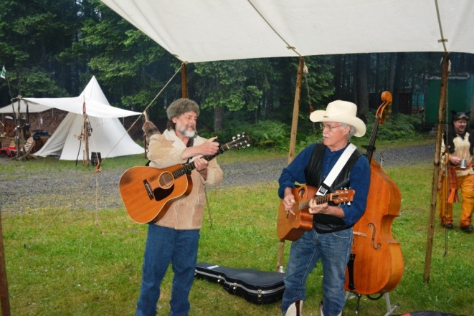
Preparing the stew
The Chance Brothers Band from Ellensburg
two steel plates and a small steel chicken target against another team. Young Mason served as “Chicken Boy”, racing down range in a chicken hat to reset the targets.
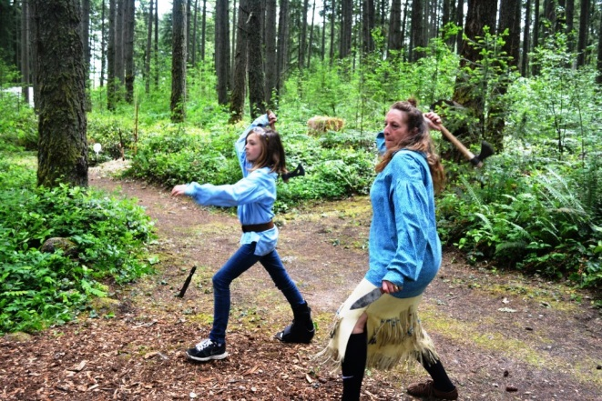
Even though the weather turned back to rain in the evening, it didn’t dampen the spirits of the participants for the weekend’s entertainment. Judges were recruited for the apple pie contest, and samples were liberally distributed. The council fire was built high, and the Chance Brother’s Band from Ellensburg performed a variety of songs on the acoustic guitar and upright bass (albeit from under a canvas fly). By the end of the evening, people in wool coats and hats were dancing in the rain, just like a scene from Paint Your Wagon.
Monday finished up with a Trade Gun Challenge, Pee-wee pistol shoot, and Junior archery. At noon the awards ceremony began, starting with all the kid’s prizes, then moving to the adults. Special recognition was given to Jack Knight for hosting the event, as well as for some seasoned shooters who forgot the motto, “Powder, patch and ball or it won’t shoot at all”. An amazing array of prizes was available for the winners to pick from, and everyone left with memories of another wonderful black powder rendezvous.
Lynden and Cindy with a tandem throw

Top Male Shooters:
1 Squatting Hawk 55
2 Glenn Borg 45.1
3 Allen Tresch 45
4 Boyd Phillips 44.1
5 Mike Nesbitt 44
6 Don Kerr 42.1
7 John Florio 42

Top Female Shooters:
1 Karla Hillberg 34
2 Chickadee 28
3 Fallen Woman 28

Top Junior Shooters
1 Fire Bug 22
2 Matthew Solelo 15
3 Connor Guiberson 11
4 Michelle Parsons 9
5 Jarod Barth 8
6 Melody Graham 5

