Sun | Mon | Tue | Wed | Thu | Fri | Sat
 |  | 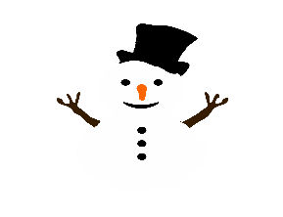 | 1  Sloppy Joe  French Fries  Vegetarian Beans  Fruit | 2  Hot Dog  Corn  Salad  Fruit | 3  Pizza  Green Beans  Salad  Fruit | 4
5 | 6  Chicken Nuggets  Dinner Roll  Corn  Fruit | 7  Taco  Lettuce/Tomato  Cheese  Refried Beans  Fruit | 8  Hamburger  Baked Beans  Salad  Fruit | 9  Teriyaki Chicken  Rice  Carrots/Broccoli  Fruit | 10  Cheese Fries  Sauce  Green Beans  Salad  Fruit | 11
12 | 13  Bag Lunch | 14 Lasagna  Green Beans  Dinner Roll  Salad  Fruit | 15 Hot Dog & Bun  French Fries  Baked Beans  Fruit | 16 Chicken Fajita  Cheese  Carrots  Salad  Fruit | 17 Pizza  Broccoli  Salad  Fruit | 18
19 | 20 Pancakes  Egg Patty  Potato  Fruit  Juice | 21 Start of Winter (Winter Solstice) Taco  Lettuce/Tomato  Cheese  Refried Beans  Fruit | 22 Hamburger Gravy  Mashed Potatoes  Dinner Roll  Carrots  Fruit | 23  No School  Christmas Vacation | 24 Christmas Eve  No School  Christmas Vacation | 25 Christmas  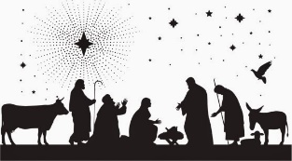
26 | 27 No School  Christmas Vacation | 28 No School  Christmas Vacation | 29 No School  Christmas Vacation | 30 No School  Christmas Vacation | 31 New Year’s Eve  No School  Christmas Vacation

