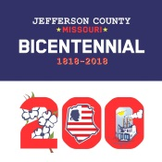
The Jefferson County
Bicentennial Exposition
October 6, 2018
9:00am to 5:00pm
At The Hillsboro Community Civic Club

The Jefferson County Bicentennial Committee is planning an Exposition to celebrate the 200th Birthday of Jefferson County! The Exposition will be held on the grounds of the beautiful Hillsboro Community Civic Club right in the heart of Jefferson County! The Hillsboro Community Civic Club is located at 10345 Business Hwy 21, Hillsboro, MO 63050. The Exposition will include Encampments, Re-Enactors and Period Era Displays, Artisans, Various Jefferson County Organizations & Businesses, 4-H Displays & Animals, Food Vendors, Live Music & Jam Session, Speakers about different topics on The History of Jefferson County, Antique Equipment & Tractor Displays, Beard and Mustache competition and much more! It is expected to be one of the biggest period era celebrations in Jefferson County history!
We want you to be a part of the celebration! If you are interested in participating please fill out the attached vendor reservation form or contact us at the numbers provided below for more information.

Please join us in celebrating our Beautiful County!

Sincerely,

Mandy Alley & Kelly Fortel
The Jefferson County Bicentennial Vendor Committee
chamberoffice@sbcglobal.net
PO Box 1228
Festus, MO 63028
636-208-2125, 636-789-4920 or 314-809-5244

Visit us online at https://jeffcomo.org200.org or Jefferson County Missouri Bicentennial

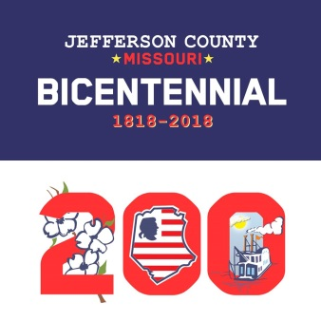
Jefferson County Bicentennial Exposition

Saturday October 6, 2018

Hillsboro Community Civic Club
9:00 a.m. to 5:00 p.m.

Vendor Reservation Form
Sponsored by
The Jefferson County Bicentennial Committee
*Set Up 7:15am-8:15 am Saturday unless other arrangements are agreed upon*
Craft/Artisan Booth Informational Display
10 x 10 Space No Charge
w/o electric $25.00 Electric $10.00
w/electric $35.00

Crafter means you hand make your own Informational Display or time period items
product. This price also includes Not For Profit that are not for sale.
Booths. Limited Space Available
NO EARLY BREAKDOWNS
Return bottom portion of Reservation Form by September 21, 2018 with fee.
Make Checks Payable to:
The Jefferson County Heritage & Historical Society

P.O. Box 1228
Festus, MO 63028
Attn: Expo Craft Space Reservation

If you have any questions, please call:
636-208-2125 (Mandy Alley)
Or 314-809-5244 (Kelly Fortel)
Visit us online at https://jeffcomo200.org or on Facebook @ Jefferson County Missouri Bicentennial

Your Name & Business: __________________________________________________________________

Home Phone: ________________________Email_____________________________________________

Address: _______________________________________________________________________________

Type of Craft items or Business: ___________________________________________________________

Number of Spaces desired: ______________ Electricity Required? Yes ( ) No ( )

Amount Enclosed $_______________
Please include a phone number or e-mail for confirmation!
Just because you mail this form in with payment it does not mean you are guaranteed a space.
There is limited space available. Spaces are available on a first come first serve basis.
Like items or businesses will be limited for the good of the vendor and the consumer.
No generator’s allowed. No moving vehicles allowed behind fence after set up time.

Must bring your own table and chairs…there will not be any provided! Tents are not provided for outside vendors.
Event held inside/outside rain or shine. There will be no refunds due to inclement weather, other acts of God, or events beyond the control of The Jefferson County Bicentennial Committee.
The Jefferson County Bicentennial Committee is not responsible for lost or stolen items.

