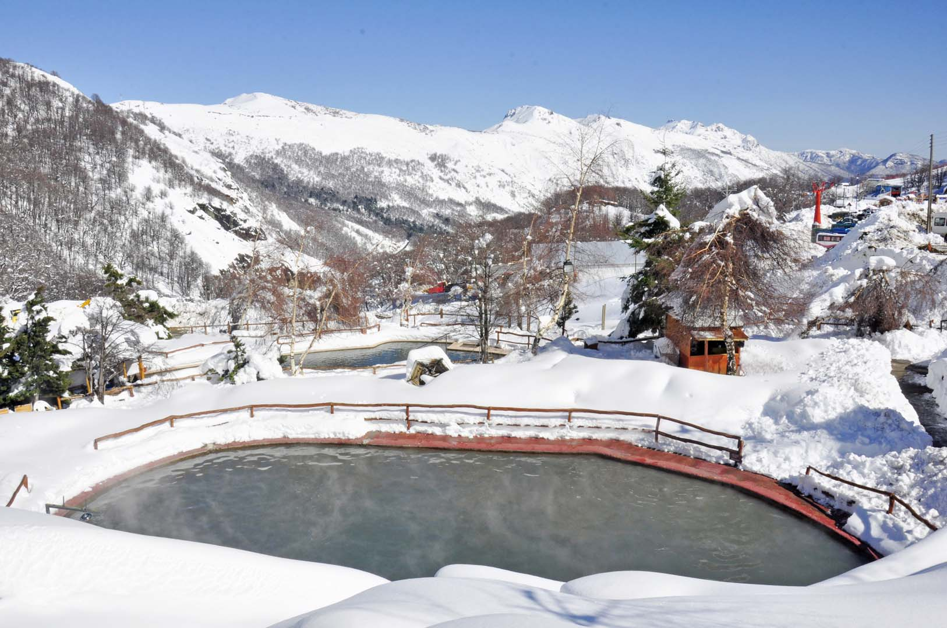
The Erie Ski Club presents Ski the Andes
Ski Nevados de Chillan Aug 10 thru 20, 2019 Cost $3250 (excluding air) $500 initial deposit
Contact: Tim Yaple (814) 323-1542 or at tlyaple1969@gmail.com

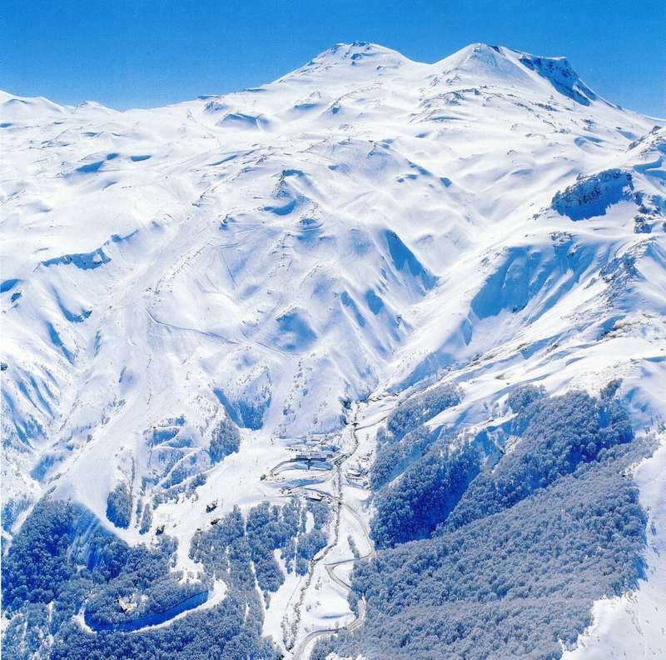
The Nevados de Chillan Ski Resort gets the most snow of Chile’s resorts has great skiing for beginners & intermediates and stands out for its interesting variety of expert off-piste and fantastic backcountry terrain that’s come about from a history of ancient rivers of lava flow.

Nevados is approximately 400 km south of Santiago and 194 km east from Concepcion (our point of arrival). The ski area has an average snowfall of 10m (the most in Chile) and has the longest run in South America (13km Las Tres Marias). There are 12 lifts, with 5 chairlifts and 7 drag lifts. The village sits at 1,403m (4,600ft) with the summit at 2,500m (8,200ft), so the vertical drop is 1,097m or 3,600ft.

Inclusions:
11 day fully hosted/guided trip from The Adventure Project, includes daily guiding and/or instruction. - Private transfer to and from Las Trancas to Concepcion airport. - 9 night’s twin-share accommodation at the Cabanas los Hualles in Las Trancas, includes breakfast. - Comprehensive avalanche safety training (where appropriate).
- 5 nights of dinners at Cabanas Los Hualles cooked by a private chef. Includes 2 x drinks per person per dinner (wine, beer or soft drink).
7 days of skiing (potential to ski an 8th day on the day of departure). - Transportation to and from the ski area each day. –
Transfer to Las Trancas
An Adventure Project representative will be at the Concepcion Airport to meet you on arrival. Please note that there can only be one scheduled pickup for the group, so please make sure to co-ordinate your arrival time around lunchtime on day 1. It is approximately a 2.5-hour drive from Concepcion to Las Trancas.
Accommodation in Las Trancas
We’ll be staying at the Cabanas los Hualles in Las Trancas. We will be staying in their new lodge rooms (10 twin/double rooms, all with ensuite bathrooms, satellite TV and ample storage). Breakfast is included and will be served in the main cafeteria building each morning. There is a drying room in the lodge and two outdoor hot-tubs (free use for our guests).
We will have 5 meals at the Cabanas los Hualles cooked by our own private chef (included). The other 4 nights we will eat out at one of the many excellent local restaurants that are within walking distance of our accommodation (not included).
Las Trancas is approximately a 20-minute drive (depending on road conditions and traffic) to the ski resort each day. We will generally eat lunch (not included) at one of the on-mountain restaurants. We will arrange for our shuttle to meet us at a pre-arranged spot at the end of the day for transfer back down to Las Trancas.
Cultural Day
During a down day (to be determined, it could be either a bad weather day on the mountain or a needed rest day), we will enjoy a cultural day in the Chillan/San Carlos area. It’s about a 1.5 hour drive down to Chillan. Our first stop of the day will be at the Santa Berta winery, a former Trappist Monastery that is now converted into a modern winery. Here you can sample several different wines and then buy wine at very low prices.
Then we travel to the town of San Carlos and head to Violeta’s Restaurant, owned and operated by famous Chilean chef David Vivero. Here we will try many courses of fine food, finishing with a tasty asado (Chilean BBQ) cooked in a 100-year-old oven. If there is time left over, we can head back into Chillan and visit the local markets.
Exclusions:
Airfare, 7 x Lift tickets (budget $55 USD per day low season)., Hotel in Concepcion for 1 night (budget $55 USD for the Ibis Hotel Concepcion, including breakfast). - Dinner in Concepcion., Equipment hire (it is advised to bring all of your own equipment). - Travel insurance. - Additional tours such as heli-skiing or snow-mobile tours etc. - Gratuities for The Adventure Project staff.

Logistics:
Visas
Most guests should be able to receive a 90-day tourist visa on arrival, for free (Australian passport holders may need to pay a reciprocity fee). It is your responsibility to check the current regulations for your passport.

Flights
You will need to fly to Santiago International Airport (Comodoro Arturo Merino Benítez International Airport (SCL) and then take a short 1 hour 15-minute domestic flight to Concepcion Airport (Carriel Sur International Airport (CCP). Airfare is not included in the $3250 trip price.

Suggested Itinerary
Depart home for Santiago via overnight international flight to Santiago. Day 1 – Arrive Santiago and take domestic flight to Concepcion. Arrive Concepcion for pick-up by The Adventure Project Staff – Depart for Las Trancas/Cabanas Los Hualles. 173 km – 2 hours 30 minutes by private van. Welcome dinner and avalanche safety talk. Day 2 – AM avalanche safety training and then in the afternoon Nevados de Chillan mountain orientation, time permitting. Day 3 – Ski Nevados de Chillan. Day 4 – Ski Nevados de Chillan. Day 5 – Potential non-ski/cultural day – guided trip to Chillan. Explore Chillan with an English-speaking guide, visit wineries and enjoy Chilean BBQ. Private transport included. The exact date of the trip will be confirmed during the trip as we normally take the non-ski/cultural day when everyone is feeling tired or there is inclement weather on the mountain. Day 6 – Ski Nevados de Chillan. Day 7 – Ski Nevados de Chillan. Day 8 – Ski Nevados de Chillan. Day 9 – Ski Nevados de Chillan. Day 10 – Depart Las Trancas for Concepcion (group can ski most of the day if they want). Overnight in Concepcion and farewell dinner (not included in price). Day 11 – Depart Concepcion for homeward journey.

Contact: Tim Yaple (814) 323-1542 or at tlyaple1969@gmail.com

