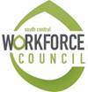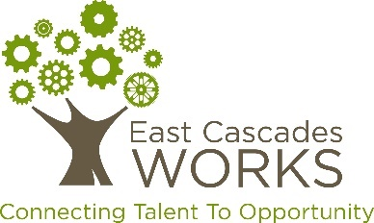

**Request for Proposals**

**Cross-Gorge**

**Incumbent Worker Training Grant**

**Question & Answer**

**Question 1 (Sep 4):** Can a non-profit organization work with multiple employers to cultivate an ask that is made up of several smaller asks?

**Answer 1 (Sep 4):** Yes, applicants can be led by non-profit, private or public employers; and can be a group of employers participating together in an ask. As long as one employee from each employer is participating in the training(s) proposed, they do qualify to participate as an applicant.