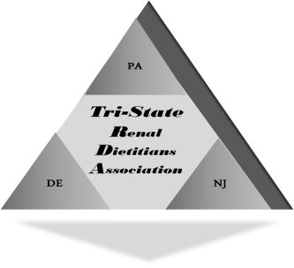
Tri-State Renal Dietitians Association

Membership Application and Renewal Form
2020 - 2021

Please print.
Name: _____________________________ Credentials: ________

Please provide your preferred email address for receiving TSRDA updates, meeting notices, etc.

Email: _____________________________________________________

Preferred telephone number: ___________________

Do you give TSRDA permission to include the information above (your name, email and phone number) in a digital Membership Directory which will be distributed via email to our members? _____Yes _____No

Annual dues are $25.

Method of payment (please check one): _____ Check to be sent (make out to TSRDA) _____ Paypal (via website www.TSRDA.org)

Please email (if enclosing a check) to the TSRDA Membership Secretary-elect at jeanstover6@gmail and I will provide my address to which you should send it….

