Timber Cruise Assessment

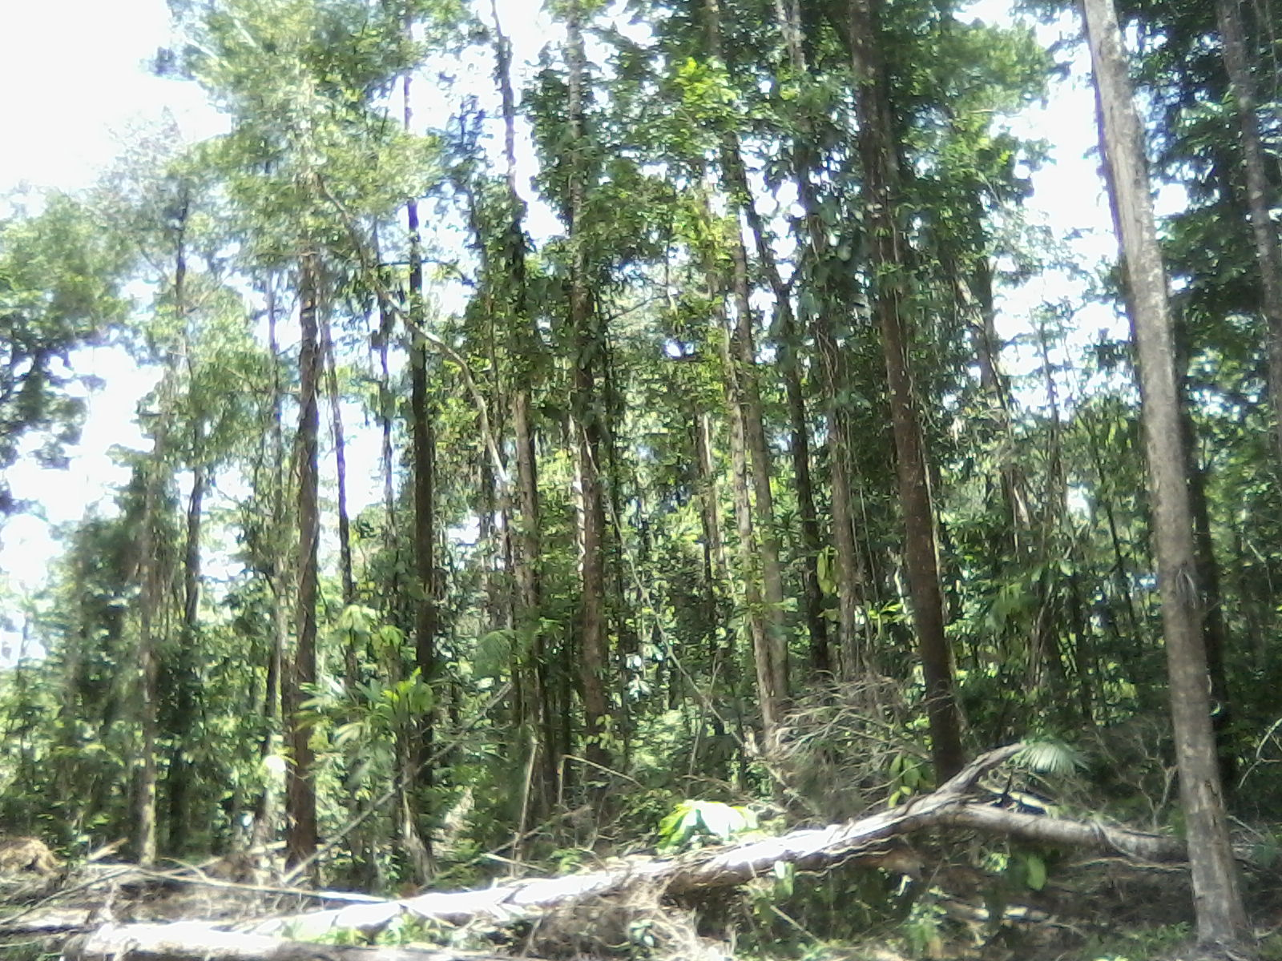

DOMINGO RUIZ

CONSULTANT

LEWIS USHER

TECHNICAL FORESTER

**TABLE OF CONTENT**

|  |  |  |  |  |
| --- | --- | --- | --- | --- |
| TABLES | |  |  |  |
|  | Table 1: Common and technical name of species present in the commercial census | | …………………………… | 6 |
|  | Table 2: The number of trees, basal area and volume of trees to be extracted and the future trees left for the next rotation cycle | | …………………………… | 9 |
| CHARTS | |  |  |  |
|  | Chart 1: Percentage of Future Trees | | …………………………… | 7 |
|  | Chart 2: Percentage of Harvestable Trees | | …………………………… | 8 |
|  | Chart 3: Basal Area and Volume of both Future and Harvestable Trees | | …………………………… | 9 |
|  | |  |  |  |

|  |  |  |  |
| --- | --- | --- | --- |
| INTRODUCTION | | …………………………… | 1 |
|  | Specific Objectives | …………………………… | 2 |
| INVENTORY OF FOREST RESOURCES | | …………………………… | 2 |
|  | Timber Resources – management level inventory | …………………………… | 2 |
|  | Type of inventory and sampling design | …………………………… | 2 |
| SAMPLE PLOT LOCATION AND LAYOUT | | …………………………… | 3 |
| RESULTS OF THE CRUISE LINE ASSESSMENT | | …………………………… | 5 |
|  | Classification of the volume to extract and reserve for all the species | …………………………… | 8 |
| CONCLUSION | | …………………………… | 10 |
| APPENDIX | | …………………………… | 11 |
|  |  |  |  |

**INTRODUCTION**

In the past little interest was expressed from indigenous groups and rural communities in becoming involved in large-scale commercial logging; h**.** owever, many local and indigenous people are now submitting applications for forest licenses. The problem now has become complex. There is no strategy for the forest industry in Toledo. Timber resources are being depleted at the national level. There is an assumed viable source of timber remaining in the Toledo District. The response to this challenge has been the Toledo Healthy Forests Initiative (THFI) which was appointed in November 2004 by the Minister of Natural Resources.

The major aims and objectives of the Toledo Healthy Forests Initiative shall be to: 1) Promote sustainable forest resource management in the Toledo District, 2) create sustainable financing mechanisms for sustainable forest resource management, 3) facilitate and coordinate local consultation processes related to the Toledo Healthy Forests Initiative, and 4) serve as an advisory body to the Forest Department and the Ministry of Natural Resources and the Environment.

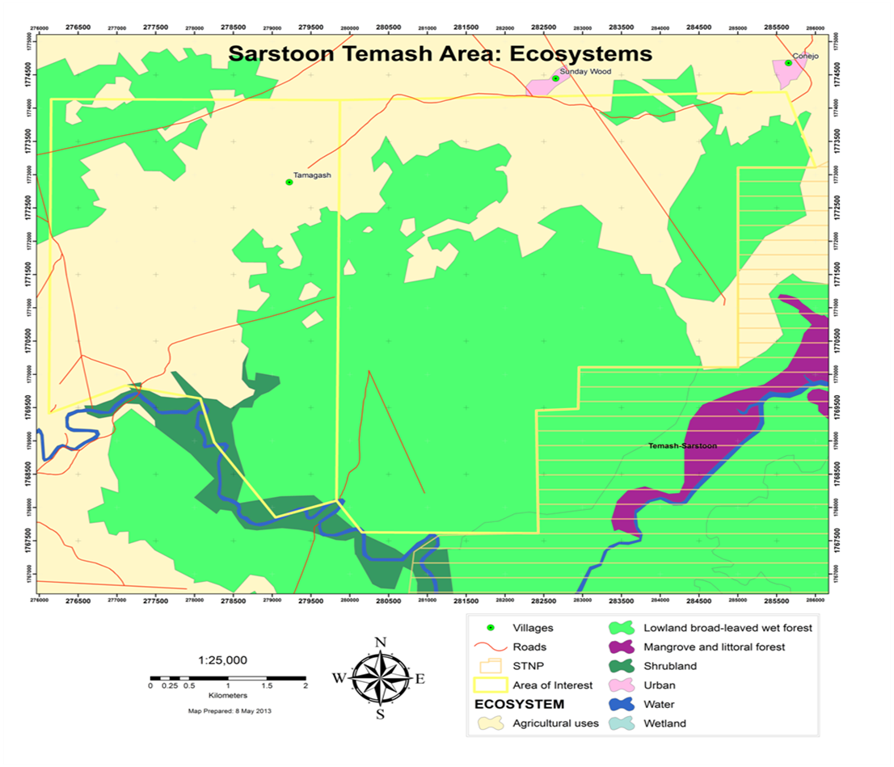

The development of a Sustainable Forest Management Plan SFMP would be looking to directly benefit economically and socially while allowing sustainable management of this forest resources. In order to determine if the area is suitable to apply this type of forest management, a Rapid Timber Cruise Lines was placed to assess the floristic composition and abundance of the forest species commercial groups, the qualitative characteristics, volume and Basal area starting with individuals with diameter at breast height (DBH) of 25cm and 20cm for rosewood. The area sampled is 9.6 ha or 0.56% of the total productive area (1,699.67ha) and 0.26 % of the total areas 3,642 ha which includes (production, subsistence agriculture and other developments areas)

The forest composition and structure are relatively homogeneous, having identified one stratum in relation to the intervention level of the area. The stratum has an extension of 9,000ac or 3,642 ha, which considers all the species of individuals with DBH>25 cm, and is represented by the 5 most abundant species (Nargusta, Yemeri, Rosewood, Santa Maria, Waika chew-stick).

SPECIFIC OBJECTIVES

Identify the floristic composition and relative abundance of forest commercial species.

Determine the sustainable productive potential (area and volume of the area)

INVENTORY OF FOREST RESOURCES

Timber Resources – management level inventory

The forest rapid inventory was carried out during the month of May 2013 . The team in charge of the work consisted of a Forest Management Specialist, 1 Technical Forester (tree spotter) and 2 workers from the buffer community. An initial training was carried out with the squad to understand the methodology and process of the forest inventory. Data analysis and writing of the final report was also carried out during May of 2013.

Type of inventory and sampling design

After the Forest Management Unit was identified, utilizing the latest satellite imagery of the forest cover, ecosystem maps and maps that shows infrastructure developments, village boundaries creeks etc. A set of 5 sampling cruise lines was distributed along the 1,700 ha (4,200 Acres) of broad leaved forests, giving a sampling intensity of 0.56%, which is considerable adequate for this forest type and size.

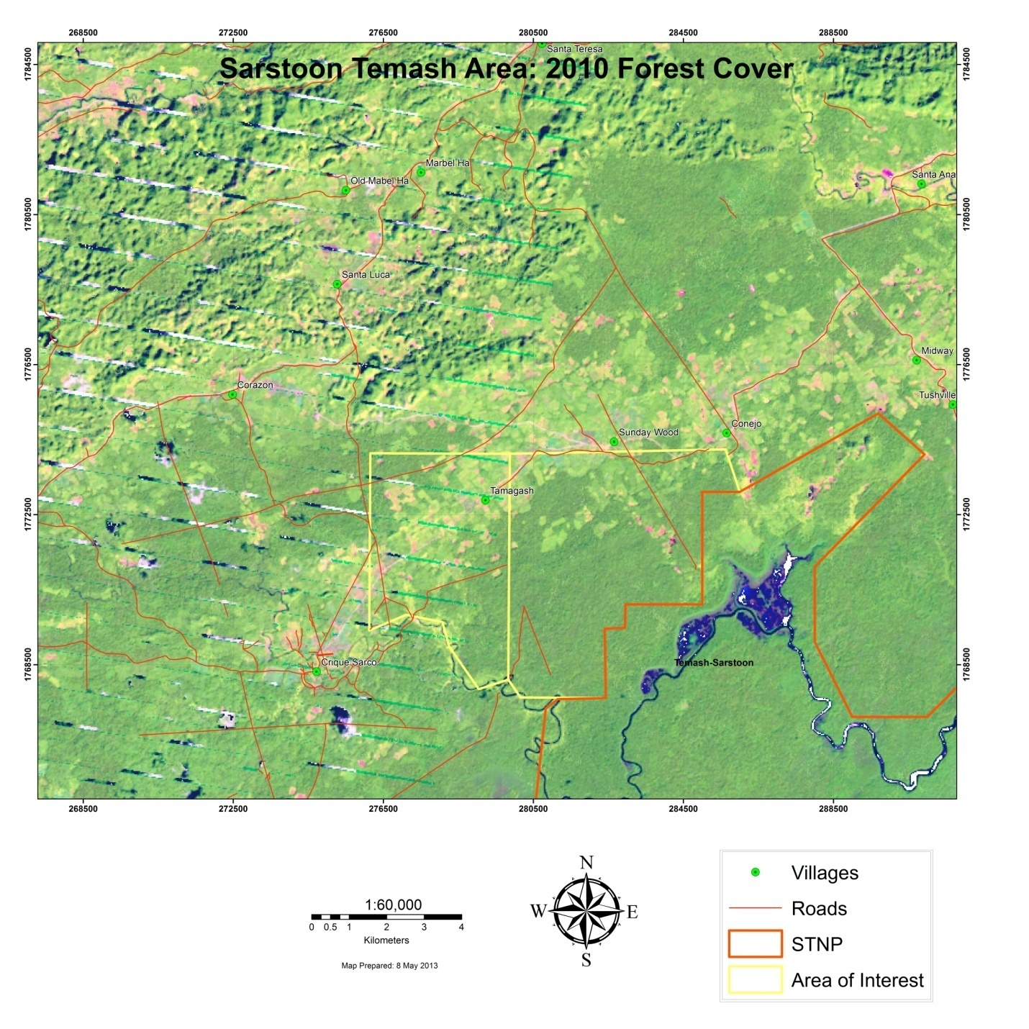

**SAMPLE PLOT LOCATION AND LAYOUT**

The plots were systematically distributed, along the productive forests. The plots were located in the field by means of a GPS unit. The plot center trail was placed heading north, south, east or west, depending on the geographic outline. The decision of using a GPS unit for the location of the plots is justified due to the distance between the plots, which made difficult the opening of trails between plots for their location.

The Sampling unit had a rectangular form with 20 m of width (10 m each side of the trail), and a length of 1000m to 1500m, in which all the > 25 cm dbh trees of commercial species were measured. The following variables were measured: Specie, diameter breast height (dbh), commercial height, log quality.

Coordinates are as follows

Starting point Ending point

Line No1 16Q0281723 1770481 16Q0282768 1770471

Line No2 16Q0282195 1767938 16q0280887 1767911

Line No3 16Q0281647 1769755 16Q0280146 1769773

Line No 4 16Q0280205 1771485 16Q0280706 1771460

Line No 5 16Q0284368 1772767 16Q0284368 1772260

Line No 1 was done in an easterly advance azimuth where the forest is dominated by yemeri and nargusta and ended in a nargusta /sapodilla forest located in the north central portion of block no 1 containing 500 acres

Line no 2 runs westerly from the road improved by US capital it falls within the transition zone of the lowland moist broadleaf forest and the Wet Broadleaf Forest as classified by Meermans ecosystems classifications dominated by santa maria/ banak trees. This line is located in the southern portion of block no 1 almost bordering the Satim National Park.

Line No 3 runs also westerly from the above mentioned road towards block no 2 into the Crique Sarco boundary, dominated by the banak/yemeri trees.

Line No 4 was placed in the upper northern portion of block 1 where it is located in the proximity of the wamils. The purpose of placing these two lines nearer to developed areas is to highlight the negative impacts. Four yemeri trees were felled, converted and extracted

Line No 5 is located in the upper northern portion of block 1 running in a southerly direction since this area was fragmented from the mass productive forest by development and too narrow to run in an east to west line, this area of forest is dominated by Banak/Gumbolimbo.

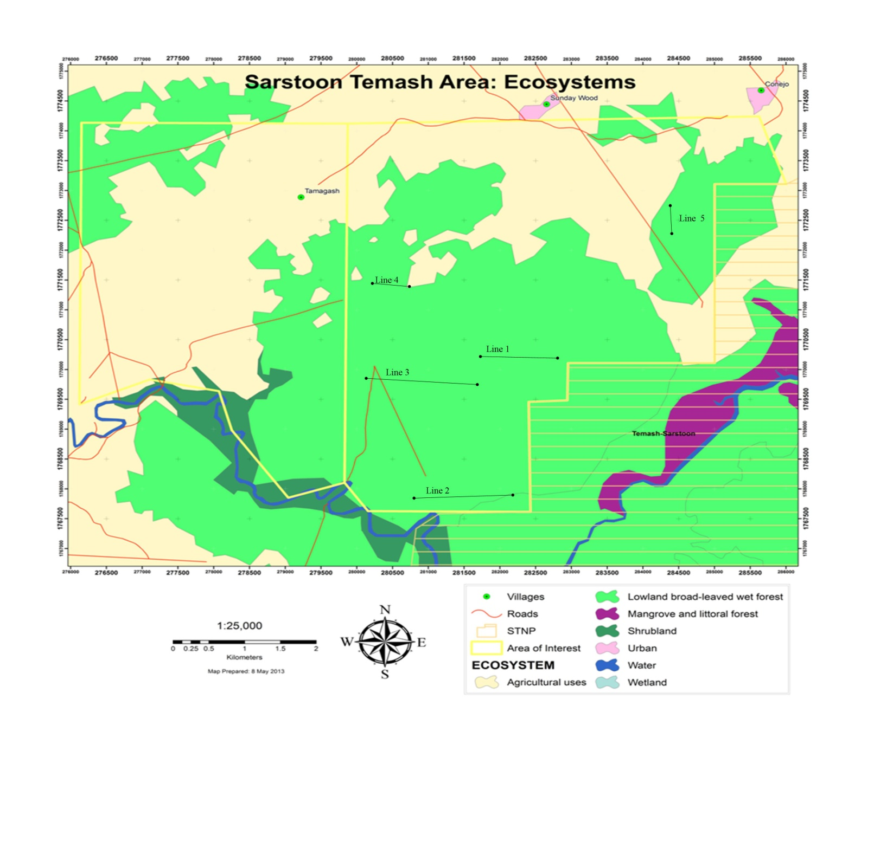

RESULTS OF THE CRUISE LINE ASSESSMENT

Total area sampled :4,200 of the 9000ac

No. of species assessed: 14

No. of trees sampled: 426 (All Harvestable Trees and future trees)

* 160 Harvestable trees
* 264 Future Harvest trees

The commercial census registered 14 different species that are considered to have a market at national level. However, only 5 of these will be considered for harvestable purposes. The other species, following management criteria, are future harvest when the rotation cycle completes. Table 2 present a detailed description of the results obtained in the commercial census for the trees above the minimum cutting diameter (MCD) and for future harvest.

Table: Common and technical name of species present in the commercial census

|  |  |  |  |  |  |  |
| --- | --- | --- | --- | --- | --- | --- |
| No. | Common Name | Technical Name |  | No. | Common Name | Technical Name |
| 1 | Waika Chew-Stick | *Symphonia globulifera* |  | 8 | White Mylady | *Aspidosperma megalocarpon* |
| 2 | Nargusta | *Terminalia amazonia* |  | 9 | Hingi hingi | *ssp* |
| 3 | Barba Jolote | *Pithecelobium arboreum* |  | 10 | Black Cabbage Bark | *Lonchocarpus castilloi* |
| 4 | sapodilla | *Acras sapote* |  | 11 | Santa Maria | *Calophyllum brasiliense* |
| 5 | Billy Web | *Sweetia panamensis* |  | 12 | hobillo |  |
| 6 | John crow bead |  |  | 13 | Rosewood | *Dalbergia stevensonii* |
| 7 | Mahogany | *Swetenia macrophylla* |  | 14 | Yemeri | *Vochysia guatemalensis* |
|  |  |  |  |  |  |  |

Chart 1: Percentage of Future Trees

Chart 2: Percentage of Harvestable Trees

CLASSIFICATION OF THE VOLUME TO EXTRACT AND RESERVE FOR ALL THE SPECIES.

The volume calculations for all the species, was done with the formula provided by FAO, which is VC= (0.0567 + (0.5074 * D2) * HC)

For estimating the volume in board feet, the relation of 185 bd ft for a cubic meter (as log)

The following table presents the number of trees, basal area and volume of trees to be extracted and the future trees left for the next rotation cycle.

Table 2: The number of trees, basal area and volume of trees to be extracted and the future trees left for the next rotation cycle

|  |  |  |  |  |  |  |  |  |
| --- | --- | --- | --- | --- | --- | --- | --- | --- |
| Future Trees | | | |  | Harvestable Trees | | | |
| Species | No of trees | Basal area M | Volume  Cu meters |  | Species | No of trees | Basal area | volume |
| Nargusta | 62 | 7.73 | 48.63 |  | Nargusta | 33 | 9.02 | 63.30 |
| Yemeri | 33 | 3.88 | 29.12 |  | Yemeri | 62 | 20.46 | 195.60 |
| Santa Maria | 73 | 9.21 | 75.12 |  | Santa Maria | 28 | 8.01 | 69.80 |
| Sapodilla | 6 | 0.63 | 2.70 |  | Sapodilla | 27 | 14.81 | 119.46 |
| Cabbage bark | 8 | 0.81 | 5.88 |  | Cabbage bark | 3 | 0.71 | 5.08 |
| My lady | 18 | 1.75 | 16.22 |  |  |  |  |  |
| Waika Chewstick | 31 | 3.34 | 22.88 |  | Waika Chewstick | 4 | 1.08 | 9.97 |
| rosewood | 22 | 1.47 | 7.85 |  |  |  |  |  |
| Hingi hingi | 4 | 0.59 | 4.51 |  | Hingi hingi | 1 | 0.32 | 3.23 |
| John crow bead | 1 | 0.12 | 0.44 |  | John crow bead | 1 | 0.33 | 2.73 |
| Mahogany | 3 | 0.36 | 2.01 |  |  |  |  |  |
| Barba jolote | 1 | 0.06 | 0.37 |  |  |  |  |  |
| Hobillo | 1 | 0.06 | 0.33 |  |  |  |  |  |
| Billy webb |  |  |  |  | Billy webb | 1 | 0.19 | 1.83 |
|  | 263 | 30.01 | 216.06 |  |  | 160 | 54.93 | 471 |

Chart 3: Basal Area and Volume of both Future and Harvestable Trees

The 9.6 ha of sampled area yields 160 commercial harvestable trees with a basal area of 54.93 meters squared with an estimated volume of 471 cubic meters which gives an average of 17 harvestable trees per ha with an average basal area of 3.23 meters squared per ha and an average volume of 27.70 cubic meters per ha.

If the areas are to remain constant with the sampling then the 1,700 ha should yield a total of 28,900 trees with a basal area of 5,491meters squared with an estimated volume of 47,090 cubic meters of timber. Therefore this area has the capacity to apply a 20 year rotation cycle of harvestable blocks of 85 ha per year. A portion of the area not suitable for timber harvesting ( that have been impacted by sustainable agriculture) can be used as buffer while the rest of the areas can be improved through a restoration project, thereby increasing the harvesting areas for the next harvesting cycle.

**CONCLUSION**

Since the economic value for timber production is limited to five species; the forest potential could significantly be incremented if eventually other benefits are incorporated to its productive capacity. It is also important to mention the referred forestry variables are mostly concentrated in the classes below the MCD (50 cm). This means that the applications of sylvicultural treatments are required in order to favor the development of individuals, mainly of species with commercial interest. In addition, a long-term alternative would be to explore and quantify other forest services and benefits, such as non timber products production in the short term, and the later incorporation of other environmental services, that would potentially add value to the importance of conserving these forest ecosystems for the benefit of the licensee

The sustainable productive potential in area and volume is determined therefore it is recommended that a comprehensive management plan be made to include technical guidelines and environmental measures to guarantee sustainability of the process.

**APPENDIX**

Appendix 1: Raw Data

|  |  |  |  |  |
| --- | --- | --- | --- | --- |
| species | DBH | Height | cat | line |
| nargusta | 58 | 13 | 1 | 1 |
| sapodilla | 70 | 12 | 1 | 1 |
| sapodilla | 90 | 14 | 1 | 1 |
| yemeri | 41 | 14.6 | 1 | 1 |
| yemeri | 51 | 13.8 | 1 | 1 |
| john crow bead | 65 | 12.5 | 2 | 1 |
| yemeri | 69 | 14.9 | 1 | 1 |
| nargusta | 29 | 10.4 | 1 | 1 |
| yemeri | 67 | 15.4 | 2 | 1 |
| nargusta | 49 | 13 | 1 | 1 |
| yemeri | 33 | 9 | 1 | 1 |
| yemeri | 67 | 16.5 | 1 | 1 |
| yemeri | 34 | 10.6 | 1 | 1 |
| nargusta | 43 | 13 | 1 | 1 |
| yemeri | 62 | 15.4 | 1 | 1 |
| cabbage bark | 31 | 10.6 | 1 | 1 |
| my lady | 27 | 13.6 | 1 | 1 |
| yemeri | 53 | 14.1 | 1 | 1 |
| nargusta | 26 | 9.8 | 1 | 1 |
| yemeri | 64 | 14.1 | 1 | 1 |
| nargusta | 30 | 8 | 1 | 1 |
| waika chew stick | 27 | 10 | 1 | 1 |
| my lady | 25 | 8 | 1 | 1 |
| yemeri | 69 | 14 | 1 | 1 |
| santa maria | 42 | 15.6 | 1 | 1 |
| nargusta | 40 | 10 | 1 | 1 |
| cabbage bark | 35 | 7 | 2 | 1 |
| nargusta | 63 | 9 | 1 | 1 |
| nargusta | 42 | 4.6 | 3 | 1 |
| nargusta | 48 | 6 | 2 | 1 |
| my lady | 44 | 16.6 | 1 | 1 |
| nargusta | 45 | 12 | 1 | 1 |
| nargusta | 43 | 8 | 1 | 1 |
| yemeri | 78 | 16.6 | 1 | 1 |
| yemeri | 58 | 15.8 | 1 | 1 |
| yemeri | 57 | 16.1 | 1 | 1 |
| yemeri | 46 | 15.6 | 1 | 1 |
| nargusta | 51 | 7.2 | 1 | 1 |
| yemeri | 61 | 14.6 | 1 | 1 |
| yemeri | 63 | 16.1 | 1 | 1 |
| nargusta | 51 | 3.3 | 3 | 1 |
| yemeri | 58 | 16.8 | 1 | 1 |
| cabbage bark | 34 | 15 | 1 | 1 |
| nargusta | 31 | 5 | 2 | 1 |
| my lady | 37 | 16 | 1 | 1 |
| rose wood | 27 | 9 | 1 | 1 |
| rose wood | 20 | 6 | 1 | 1 |
| hobillo | 28 | 7 | 2 | 1 |
| rose wood | 32 | 6.1 | 1 | 1 |
| my lady | 33 | 14 | 1 | 1 |
| yemeri | 66 | 15.3 | 1 | 1 |
| cabbage bark | 28 | 8 | 1 | 1 |
| nargusta | 44 | 15.1 | 1 | 1 |
| hingi hingi | 48 | 15.1 | 1 | 1 |
| nargusta | 66 | 12 | 1 | 1 |
| yemeri | 64 | 16.4 | 1 | 1 |
| nargusta | 46 | 7.4 | 1 | 1 |
| nargusta | 43 | 11.1 | 1 | 1 |
| nargusta | 55 | 15.6 | 1 | 1 |
| nargusta | 54 | 14.6 | 1 | 1 |
| sapodilla | 90 | 10.6 | 1 | 1 |
| my lady | 41 | 11 | 1 | 1 |
| nargusta | 31 | 8 | 1 | 1 |
| rose wood | 26 | 9 | 1 | 1 |
| yemeri | 42 | 11 | 1 | 1 |
| yemeri | 60 | 13.1 | 1 | 1 |
| yemeri | 41 | 9.2 | 1 | 1 |
| cabbage bark | 29 | 6 | 1 | 1 |
| nargusta | 42 | 12 | 1 | 1 |
| yemeri | 59 | 16.2 | 1 | 1 |
| yemeri | 57 | 15.2 | 1 | 1 |
| sapodilla | 85 | 17.1 | 1 | 1 |
| sapodilla | 90 | 14.6 | 1 | 1 |
| yemeri | 63 | 15 | 1 | 1 |
| nargusta | 66 | 16 | 1 | 1 |
| santa maria | 78 | 16 | 1 | 1 |
| yemeri | 67 | 15.8 | 1 | 1 |
| rose wood | 30 | 10 | 1 | 1 |
| yemeri | 41 | 16.4 | 1 | 1 |
| my lady | 32 | 11 | 1 | 1 |
| yemeri | 66 | 14.7 | 1 | 1 |
| nargusta | 45 | 13.6 | 1 | 1 |
| my lady | 46 | 14 | 1 | 1 |
| sapodilla | 84 | 12 | 1 | 1 |
| sapodilla | 106 | 14 | 1 | 1 |
| sapodilla | 86 | 15 | 1 | 1 |
| nargusta | 54 | 12 | 1 | 1 |
| nargusta | 48 | 10 | 1 | 1 |
| nargusta | 54 | 16 | 1 | 1 |
| my lady | 46 | 14.4 | 1 | 1 |
| cabbage bark | 48 | 12 | 1 | 1 |
| yemeri | 48 | 14 | 1 | 1 |
| nargusta | 31 | 11 | 1 | 1 |
| nargusta | 46 | 13 | 1 | 1 |
| my lady | 30 | 7 | 1 | 1 |
| rose wood | 25 | 4 | 2 | 1 |
| yemeri | 35 | 11 | 1 | 1 |
| santa maria | 43 | 15 | 1 | 1 |
| yemeri | 38 | 8.6 | 1 | 1 |
| yemeri | 78 | 14 | 2 | 1 |
| yemeri | 35 | 10 | 1 | 1 |
| yemeri | 46 | 10.2 | 1 | 1 |
| sapodilla | 72 | 13 | 1 | 1 |
| sapodilla | 67 | 14.5 | 1 | 1 |
| nargusta | 40 | 9 | 1 | 1 |
| sapodilla | 38 | 6.4 | 1 | 1 |
| sapodilla | 79 | 14 | 1 | 1 |
| yemeri | 65 | 13 | 1 | 1 |
| sapodilla | 52 | 14 | 1 | 1 |
| hingi hingi | 64 | 15.3 | 1 | 1 |
| santa maria | 46 | 12 | 1 | 1 |
| sapodilla | 95 | 11 | 1 | 1 |
| yemeri | 51 | 16.5 | 1 | 1 |
| my lady | 29 | 14 | 1 | 1 |
| yemeri | 78 | 17 | 1 | 1 |
| sapodilla | 70 | 14.2 | 1 | 1 |
| sapodilla | 68 | 12 | 1 | 1 |
| sapodilla | 95 | 14.6 | 1 | 1 |
| yemeri | 32 | 9 | 1 | 1 |
| sapodilla | 66 | 14 | 1 | 1 |
| sapodilla | 70 | 14 | 1 | 1 |
| sapodilla | 73 | 13.3 | 1 | 1 |
| sapodilla | 76 | 14 | 1 | 1 |
| john crow bead | 39 | 5.1 | 1 | 1 |
| santa maria | 45 | 14.1 | 1 | 2 |
| santa maria | 32 | 7 | 1 | 2 |
| santa maria | 49 | 15 | 1 | 2 |
| yemeri | 50 | 9 | 1 | 2 |
| sapodilla | 51 | 7 | 1 | 2 |
| yemeri | 59 | 13 | 1 | 2 |
| hingi hingi | 48 | 6.2 | 1 | 2 |
| nargusta | 50 | 6 | 1 | 2 |
| nargusta | 43 | 7.1 | 1 | 2 |
| nargusta | 47 | 8 | 1 | 2 |
| sapodilla | 36 | 7.6 | 1 | 2 |
| mahogany | 35 | 6.7 | 1 | 2 |
| cabbage bark | 34 | 5 | 1 | 2 |
| sapodilla | 48 | 6.5 | 1 | 2 |
| sapodilla | 56 | 10 | 1 | 2 |
| hingi hingi | 31 | 7 | 1 | 2 |
| rose wood | 30 | 6 | 1 | 2 |
| nargusta | 32 | 6 | 1 | 2 |
| rose wood | 38 | 7 | 1 | 2 |
| nargusta | 45 | 6 | 2 | 2 |
| waika chew stick | 25 | 7 | 1 | 2 |
| waika chew stick | 42 | 9 | 1 | 2 |
| waika chew stick | 30 | 7 | 1 | 2 |
| nargusta | 40 | 7 | 1 | 2 |
| waika chew stick | 47 | 10 | 1 | 2 |
| waika chew stick | 28 | 7.4 | 1 | 2 |
| waika chew stick | 49 | 7 | 2 | 2 |
| waika chew stick | 40 | 9.6 | 1 | 2 |
| mahogany | 44 | 8 | 1 | 2 |
| waika chew stick | 50 | 13.1 | 1 | 2 |
| santa maria | 78 | 14 | 1 | 2 |
| santa maria | 65 | 14 | 1 | 2 |
| waika chew stick | 38 | 12 | 1 | 2 |
| waika chew stick | 36 | 10 | 1 | 2 |
| nargusta | 31 | 6.3 | 1 | 2 |
| yemeri | 52 | 7.2 | 1 | 2 |
| yemeri | 55 | 14 | 1 | 2 |
| yemeri | 70 | 15.2 | 1 | 2 |
| yemeri | 65 | 12 | 1 | 2 |
| sapodilla | 60 | 7.1 | 1 | 2 |
| nargusta | 36 | 8 | 1 | 2 |
| nargusta | 44 | 7.4 | 1 | 2 |
| sapodilla | 98 | 10.2 | 1 | 2 |
| sapodilla | 100 | 12 | 1 | 2 |
| santa maria | 40 | 8.1 | 1 | 2 |
| santa maria | 50 | 14 | 1 | 2 |
| santa maria | 47 | 10.6 | 1 | 2 |
| waika chew stick | 36 | 4 | 2 | 2 |
| santa maria | 24 | 6.1 | 1 | 2 |
| santa maria | 24 | 8.2 | 1 | 2 |
| santa maria | 30 | 7.2 | 1 | 2 |
| waika chew stick | 36 | 10 | 1 | 2 |
| nargusta | 36 | 6 | 1 | 2 |
| waika chew stick | 34 | 6.1 | 1 | 2 |
| santa maria | 30 | 7 | 1 | 2 |
| waika chew stick | 40 | 8.4 | 1 | 2 |
| santa maria | 49 | 13 | 1 | 2 |
| santa maria | 35 | 6 | 1 | 2 |
| santa maria | 30 | 6.2 | 1 | 2 |
| waika chew stick | 31 | 5.1 | 2 | 2 |
| santa maria | 42 | 6 | 1 | 2 |
| santa maria | 53 | 11 | 1 | 2 |
| santa maria | 45 | 7 | 1 | 2 |
| waika chew stick | 40 | 7 | 1 | 2 |
| santa maria | 50 | 11.4 | 1 | 2 |
| santa maria | 45 | 10.4 | 1 | 2 |
| waika chew stick | 36 | 11 | 1 | 2 |
| nargusta | 42 | 9 | 1 | 2 |
| waika chew stick | 28 | 7.2 | 1 | 2 |
| waika chew stick | 28 | 6 | 1 | 2 |
| santa maria | 42 | 10 | 1 | 2 |
| waika chew stick | 56 | 8 | 1 | 2 |
| nargusta | 46 | 7.1 | 2 | 2 |
| nargusta | 56 | 13 | 1 | 2 |
| santa maria | 66 | 14 | 1 | 2 |
| santa maria | 48 | 12.1 | 1 | 2 |
| nargusta | 46 | 6.4 | 2 | 2 |
| santa maria | 65 | 14 | 1 | 2 |
| waika chew stick | 38 | 13 | 1 | 2 |
| santa maria | 52 | 15 | 1 | 2 |
| santa maria | 44 | 12.6 | 1 | 2 |
| santa maria | 51 | 13 | 1 | 2 |
| santa maria | 42 | 14.1 | 1 | 2 |
| santa maria | 36 | 15.2 | 1 | 2 |
| santa maria | 46 | 14 | 1 | 2 |
| waika chew stick | 32 | 15.1 | 1 | 2 |
| santa maria | 41 | 13.6 | 1 | 2 |
| santa maria | 45 | 14 | 1 | 2 |
| santa maria | 48 | 13 | 1 | 2 |
| santa maria | 42 | 6.4 | 1 | 2 |
| santa maria | 58 | 12.5 | 1 | 2 |
| santa maria | 40 | 15 | 1 | 2 |
| santa maria | 42 | 12.4 | 1 | 2 |
| santa maria | 31 | 10.6 | 1 | 2 |
| santa maria | 56 | 16 | 1 | 2 |
| waika chew stick | 48 | 16.7 | 1 | 2 |
| santa maria | 36 | 10 | 1 | 2 |
| santa maria | 32 | 12.1 | 1 | 2 |
| waika chew stick | 32 | 6 | 1 | 2 |
| nargusta | 34 | 7.6 | 1 | 2 |
| waika chew stick | 45 | 16 | 1 | 2 |
| santa maria | 48 | 13 | 1 | 2 |
| waika chew stick | 46 | 6 | 1 | 2 |
| waika chew stick | 36 | 6.1 | 2 | 2 |
| waika chew stick | 40 | 5.2 | 2 | 2 |
| santa maria | 50 | 14 | 2 | 2 |
| santa maria | 56 | 7.6 | 2 | 2 |
| santa maria | 37 | 14 | 1 | 2 |
| santa maria | 39 | 12.1 | 1 | 2 |
| santa maria | 49 | 10 | 1 | 2 |
| santa maria | 44 | 12.2 | 1 | 2 |
| santa maria | 43 | 10 | 2 | 2 |
| santa maria | 60 | 16.1 | 1 | 2 |
| santa maria | 27 | 6.8 | 1 | 2 |
| santa maria | 40 | 14 | 1 | 2 |
| santa maria | 46 | 12.4 | 1 | 2 |
| santa maria | 54 | 13 | 1 | 2 |
| santa maria | 40 | 14 | 1 | 2 |
| santa maria | 45 | 13.4 | 1 | 2 |
| santa maria | 32 | 14 | 1 | 2 |
| santa maria | 62 | 10.6 | 1 | 2 |
| waika chew stick | 45 | 12.1 | 1 | 2 |
| santa maria | 53 | 16 | 1 | 2 |
| santa maria | 50 | 10 | 1 | 2 |
| santa maria | 61 | 15.1 | 1 | 2 |
| santa maria | 54 | 10 | 2 | 2 |
| santa maria | 35 | 13 | 1 | 2 |
| santa maria | 43 | 12.4 | 1 | 2 |
| santa maria | 42 | 12 | 1 | 2 |
| santa maria | 39 | 8.6 | 1 | 2 |
| santa maria | 32 | 10 | 1 | 2 |
| santa maria | 48 | 14 | 1 | 2 |
| santa maria | 46 | 14.2 | 1 | 2 |
| santa maria | 47 | 13 | 1 | 2 |
| santa maria | 51 | 16 | 1 | 2 |
| santa maria | 51 | 14.1 | 1 | 2 |
| santa maria | 53 | 14 | 1 | 2 |
| santa maria | 54 | 15.4 | 1 | 2 |
| santa maria | 48 | 16 | 1 | 2 |
| santa maria | 44 | 14.1 | 1 | 2 |
| waika chew stick | 40 | 12 | 1 | 2 |
| santa maria | 30 | 10 | 1 | 2 |
| santa maria | 51 | 14.2 | 1 | 2 |
| santa maria | 45 | 12 | 1 | 2 |
| santa maria | 31 | 8.6 | 1 | 2 |
| santa maria | 39 | 15 | 1 | 2 |
| santa maria | 32 | 12.1 | 1 | 2 |
| santa maria | 34 | 12 | 1 | 2 |
| santa maria | 41 | 13 | 1 | 2 |
| waika chew stick | 39 | 14.4 | 1 | 2 |
| santa maria | 40 | 12.3 | 1 | 2 |
| santa maria | 53 | 14 | 1 | 2 |
| sapodilla | 33 | 10 | 1 | 2 |
| santa maria | 30 | 10.4 | 1 | 2 |
| santa maria | 38 | 12 | 1 | 2 |
| santa maria | 37 | 10 | 1 | 2 |
| santa maria | 49 | 16.1 | 1 | 2 |
| santa maria | 46 | 14 | 1 | 2 |
| yemeri | 49 | 16 | 1 | 3 |
| yemeri | 40 | 10 | 1 | 3 |
| nargusta | 38 | 11.1 | 1 | 3 |
| yemeri | 70 | 16 | 1 | 3 |
| nargusta | 44 | 7.6 | 1 | 3 |
| nargusta | 36 | 9.7 | 1 | 3 |
| my lady | 34 | 14 | 1 | 3 |
| rose wood | 32 | 2 | 3 | 3 |
| yemeri | 40 | 8.9 | 1 | 3 |
| nargusta | 44 | 6 | 2 | 3 |
| yemeri | 58 | 14.6 | 1 | 3 |
| nargusta | 48 | 10 | 1 | 3 |
| nargusta | 46 | 12 | 1 | 3 |
| nargusta | 56 | 9 | 1 | 3 |
| yemeri | 89 | 16 | 1 | 3 |
| yemeri | 45 | 7.4 | 1 | 3 |
| nargusta | 25 | 5 | 1 | 3 |
| cabbage bark | 50 | 7 | 1 | 3 |
| nargusta | 60 | 7.8 | 1 | 3 |
| sapodilla | 110 | 6 | 1 | 3 |
| santa maria | 32 | 10.1 | 1 | 3 |
| sapodilla | 118 | 10 | 2 | 3 |
| rose wood | 28 | 7.2 | 1 | 3 |
| nargusta | 65 | 7.6 | 1 | 3 |
| my lady | 26 | 15 | 1 | 3 |
| hingi hingi | 44 | 15 | 1 | 3 |
| nargusta | 46 | 8.4 | 1 | 3 |
| nargusta | 28 | 4.6 | 2 | 3 |
| my lady | 36 | 11.6 | 1 | 3 |
| rose wood | 30 | 8 | 1 | 3 |
| nargusta | 42 | 9.6 | 1 | 3 |
| nargusta | 46 | 10 | 1 | 3 |
| rose wood | 30 | 7 | 1 | 3 |
| rose wood | 25 | 6.1 | 1 | 3 |
| santa maria | 96 | 9 | 1 | 3 |
| nargusta | 56 | 14 | 1 | 3 |
| nargusta | 30 | 9.1 | 1 | 3 |
| yemeri | 63 | 17 | 1 | 3 |
| waika chew stick | 58 | 16 | 1 | 3 |
| nargusta | 56 | 14.2 | 1 | 3 |
| yemeri | 91 | 15 | 1 | 3 |
| yemeri | 80 | 16 | 1 | 3 |
| yemeri | 36 | 8.9 | 1 | 3 |
| yemeri | 52 | 9 | 1 | 3 |
| yemeri | 54 | 16.7 | 1 | 3 |
| yemeri | 60 | 15 | 1 | 3 |
| yemeri | 65 | 16 | 1 | 3 |
| yemeri | 70 | 16 | 1 | 3 |
| nargusta | 29 | 9 | 1 | 3 |
| yemeri | 44 | 6.4 | 1 | 3 |
| nargusta | 56 | 8.3 | 1 | 3 |
| nargusta | 50 | 9 | 1 | 3 |
| yemeri | 46 | 12 | 1 | 3 |
| yemeri | 45 | 15 | 1 | 3 |
| nargusta | 60 | 6.6 | 2 | 3 |
| nargusta | 40 | 8.4 | 2 | 3 |
| rose wood | 40 | 8.1 | 1 | 3 |
| yemeri | 38 | 9.2 | 1 | 3 |
| nargusta | 30 | 9.4 | 1 | 3 |
| nargusta | 50 | 6 | 2 | 3 |
| yemeri | 56 | 12.4 | 1 | 3 |
| yemeri | 30 | 6.1 | 1 | 3 |
| santa maria | 34 | 14 | 1 | 3 |
| yemeri | 86 | 10.4 | 1 | 3 |
| nargusta | 48 | 10 | 1 | 3 |
| yemeri | 27 | 6.5 | 1 | 3 |
| yemeri | 56 | 12.1 | 1 | 3 |
| my lady | 30 | 16 | 1 | 3 |
| yemeri | 90 | 15 | 1 | 3 |
| yemeri | 28 | 10 | 1 | 3 |
| nargusta | 54 | 12.1 | 1 | 3 |
| yemeri | 70 | 16 | 1 | 3 |
| yemeri | 76 | 15 | 1 | 3 |
| rose wood | 20 | 6.1 | 1 | 3 |
| yemeri | 26 | 9.7 | 1 | 3 |
| yemeri | 65 | 12 | 1 | 3 |
| nargusta | 58 | 11.2 | 1 | 3 |
| rose wood | 22 | 5.6 | 1 | 3 |
| nargusta | 46 | 11 | 1 | 3 |
| cabbage bark | 56 | 10.4 | 1 | 3 |
| nargusta | 48 | 10 | 1 | 3 |
| nargusta | 56 | 8.8 | 3 | 3 |
| yemeri | 50 | 10 | 3 | 3 |
| nargusta | 28 | 6.9 | 2 | 3 |
| nargusta | 40 | 10 | 1 | 3 |
| nargusta | 56 | 11.1 | 1 | 3 |
| yemeri | 25 | 10 | 1 | 3 |
| yemeri | 56 | 14 | 1 | 3 |
| yemeri | 46 | 9.4 | 2 | 3 |
| rose wood | 22 | 6.8 | 1 | 3 |
| rose wood | 30 | 5.8 | 1 | 3 |
| cabbage bark | 58 | 14 | 1 | 3 |
| yemeri | 56 | 16.4 | 1 | 3 |
| sapodilla | 70 | 15 | 1 | 3 |
| rose wood | 26 | 7.9 | 1 | 3 |
| nargusta | 40 | 7.6 | 1 | 3 |
| yemeri | 60 | 15 | 1 | 3 |
| nargusta | 34 | 7 | 2 | 3 |
| yemeri | 52 | 12 | 1 | 3 |
| yemeri | 65 | 16 | 1 | 3 |
| nargusta | 57 | 14 | 1 | 3 |
| yemeri | 52 | 14 | 1 | 3 |
| yemeri | 50 | 15 | 1 | 3 |
| nargusta | 25 | 9 | 1 | 3 |
| yemeri | 52 | 14 | 1 | 3 |
| mahogany | 38 | 9 | 1 | 3 |
| cabbage bark | 44 | 14 | 1 | 3 |
| rose wood | 41 | 9 | 1 | 3 |
| waika chew stick | 69 | 17 | 1 | 3 |
| sapodilla | 25 | 5.2 | 1 | 4 |
| yemeri | 40 | 15 | 1 | 4 |
| my lady | 48 | 14.1 | 1 | 4 |
| yemeri | 50 | 15 | 1 | 4 |
| yemeri | 30 | 7.4 | 1 | 4 |
| yemeri | 90 | 13 | 1 | 4 |
| rose wood | 27 | 7.4 | 1 | 4 |
| nargusta | 42 | 7.3 | 1 | 4 |
| santa maria | 70 | 10.4 | 11 | 5 |
| nargusta | 52 | 12 | 1 | 5 |
| billy webb | 50 | 14 | 1 | 5 |
| nargusta | 60 | 10.6 | 1 | 5 |
| nargusta | 64 | 8.9 | 1 | 5 |
| nargusta | 60 | 7.6 | 3 | 5 |
| nargusta | 70 | 9 | 1 | 5 |
| nargusta | 66 | 11.1 | 1 | 5 |
| yemeri | 48 | 10 | 1 | 5 |
| my lady | 40 | 14 | 1 | 5 |
| nargusta | 34 | 7.7 | 2 | 5 |
| barba jolote | 29 | 7.4 | 1 | 5 |
| yemeri | 42 | 10 | 1 | 5 |
| nargusta | 50 | 9.6 | 1 | 5 |
| yemeri | 58 | 14 | 1 | 5 |
| santa maria | 38 | 10.1 | 1 | 5 |
| rose wood | 29 | 8.2 | 1 | 5 |
| santa maria | 44 | 10 | 1 | 5 |
| nargusta | 44 | 9.6 | 1 | 5 |
| yemeri | 50 | 10.1 | 1 | 5 |
| rose wood | 27 | 7.9 | 1 | 5 |
| rose wood | 32 | 6 | 1 | 5 |
| rose wood | 20 | 6.6 | 1 | 5 |
| rose wood | 20 | 9.3 | 1 | 5 |
| nargusta | 75 | 11 | 1 | 5 |
| nargusta | 48 | 12.1 | 1 | 5 |