REGULAR MEETING
MARCH 18, 2015

A Regular Meeting of the Town Board of the Town of Hampton, County of Washington and the State of New York was held at the Town Hall, 2629 State Route 22A, Hampton, New York on the18th day of March, 2015.

PRESENT: David K. O’Brien------------Supervisor
Tamme Taran---------------Councilwoman
David Jensen-----------------Councilman
Donald Sady-----------------Councilman
Andrea Sweeney------------Councilwoman
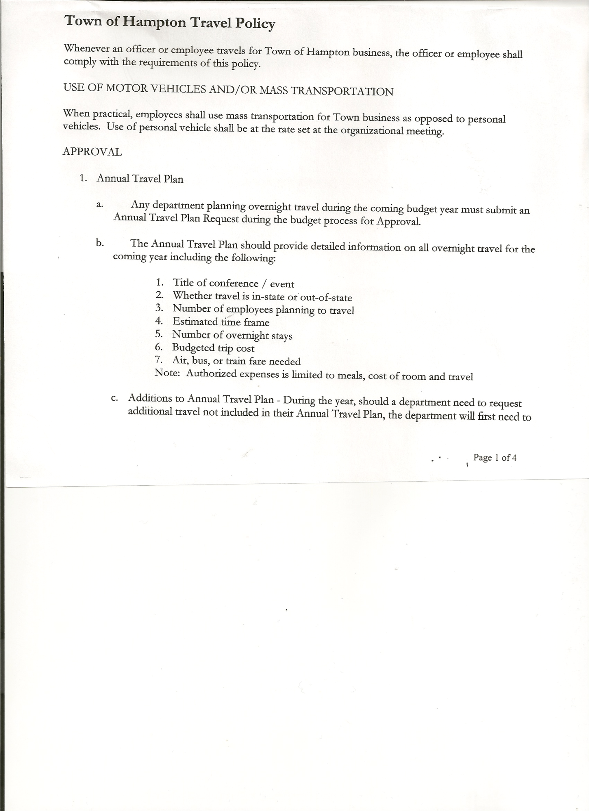
Rebecca Jones---------------Town Clerk
Camilla Shaw----------------Tax Collector/Deputy Town Clerk
Herbert Sady, Jr.-------------Highway Superintendent

Planning Board Member(s): Bonnie Hawley, Chair and Francis Baker

Also present: Kevin Hayes, Washington County Administrator; Albert Nolette, Washington County Treasurer; Artie Pratt and Matthew Pratt

The meeting was called to order by Supervisor O’Brien at 7:00pm followed by the Pledge of Allegiance. Locations of Fire Exits were given.

Kevin Hayes and Al Nolette discussed the Government Efficiency Plan (Towns and County to file together) and Workers’ Compensation fee changes for the future (Information sheets are attached)

RESOLUTION NO. 25-2015
MOTION BY: Councilwoman Tamme Taran
SECONDED BY: Councilman Donald Sady

TITLE: TO AUTHORIZE THE TOWN OF HAMPTON TO PARTICIPATE IN THE LOCAL
GOVERNMENT EFFICIENCY PLAN

WHEREAS, the State of New York has required each local government unit to file a Government Efficiency Plan with the New York State Division of Budget (DOB); and

WHEREAS, the County is looking to be the lead governmental unit for filing the Plan; now, therefore, be it

RESOLVED, that the Town of Hampton hereby agrees to work with the County and submit ideas for the plan which will save at least 1% of the 2014 combined tax levy amount of all participants; and be it further

RESOLVED, that the Town of Hampton agrees to make its best effort to implement the Plan beginning in 2017 to 2019; and be it further

RESOLVED, that the Town Board authorizes their Chief Financial Officer to certify the Government Efficiency Plan.

TOWN BOARD MEETING
MARCH 18, 2015 PAGE 2

DATED: March 18, 2015 Supervisor David O’Brien AYE
Councilwoman Tamme Taran AYE
Councilman David Jensen AYE
Councilman Donald Sady AYE
Councilwoman Andrea Sweeney AYE

RESOLUTION NO. 26-2015
APPROVAL OF THE MINUTES
On a motion of Councilman Sady, seconded by Councilwoman Sweeney, the following resolution was ADOPTED: Ayes 5 O’Brien, Taran, Jensen, Sady, Sweeney
Nays 0
RESOLVED that the Regular Town Board Minutes for February 18th, 2015 are approved.

Camilla Shaw, Tax Collector submitted her report for February 2015 to the Town Board and also had board members sign and date bank reconciliation statement dated February 28th, 2015. There are 140 parcels left to be paid.

Larry Carman, Dog Control Officer submitted his report, which was read by Supervisor O’Brien, copy of report is attached for 2/10/15 – 3/15/15. Another dog was picked up on County Route 21 and taken to Kennel in Greenwich, no luck reaching the owner yet and owner is responsible for fees that are accumulating.

Planning Board Report….Bonnie Hawley, Chair gave the report:
- Working on final draft of the mobile home park/campground law
- Robert Johnson has taken another position where he currently lives, not becoming a resident of Hampton at this time
- Shawn Camara looking to move locations for car lot…needs to come to Planning Board Meeting
- Next Planning Board meeting will be at 7:00pm at the Town Hall on March 24th, 2015

Herbert Sady, Jr., Highway Superintendent gave his report: (a copy is attached)
- Doing maintenance on trucks and building
- Graded down the Hills Pond Road, Hickey Road & Roberts Road
- New tire on loader and replaced glass door
- Received more sand from Charlie Holcomb
- Putting road base material on Hills Pond Road, if it works well, may also use on Hickey
Road and Roberts Road
- Replaced mailbox on the South Road (Wanamaker’s)

Board of Assessment Member needed…..Cynthia Hollister has taken a job out of town and is unable to be on the Board of Assessment.

COUNTY UPDATES/COMMUNICATIONS
- Working with Granville to get more Sales Tax monies for the towns
- Sparklers may be legalized
- County Rabies Clinic will be May 16th in Hampton

TOWN BOARD MEETING
MARCH 18, 2015 PAGE 3

Hampton Fire Department….discussing with Justin Perry, President the idea of the Fire Department having ownership of the building

RESOLUTION NO. 27-2015
APPROVAL OF SUPERVISOR’S MONTHLY REPORT
On a motion of Councilwoman Taran, seconded by Councilman Jensen, the following resolution was ADOPTED Ayes 5 O’Brien, Taran, Jensen, Sady, Sweeney
Nays 0
RESOLVED that the Supervisor’s Monthly report be accepted as submitted for FEBRUARY 2015
1/31/15 2/28/15
ACCOUNT BALANCE RECEIPTS DISBURSEMENTS BALANCE
General Fund $ 214661.91 $ 94256.52 $ 220719.33 $ 88199.10
Highway Fund $ 16740.90 $ 169506.58 $ 27202.17 $159045.31
Equipment Reserve $ 85159.78 $ 15006.66 $ 0.00 $100166.44
Fire #1 $ 6.29 $ 34001.27 $ 0.00 $ 34007.56
Fire #2 $ 0.00 $ 4754.00 $ 0.00 $ 4754.00
Totals $ 316568.88 $ 317525.03 $ 247921.50 $386172.41

All Board Members present signed Supervisor’s Report.

Town of Hampton’s 2014 Annual Financial Report has been filed with the Comptroller’s Office.

The Town Clerk’s report for February 2015 was submitted to the Board. The Town Clerk had Board Members review and sign bank reconciliation statements for the Town Clerk Account and Special Town Clerk Account dated February 28th, 2015.

RESOLUTION NO. 28 -2015

AUDIT OF CLAIMS
On a motion of Councilman Sady, seconded by Councilwoman Taran the following resolution was ADOPTED Ayes 5 O’Brien, Taran, Jensen, Sady, Sweeney
Nays 0
RESOLVED that the bills have been reviewed by the Town Board and are authorized for payment in the following amounts.
General Fund No. 34 through No. 44 $ 2682.57
Highway Fund No. 24 through No. 32 $ 7630.91
Total both funds $ 10313.48

On a motion of Councilwoman Taran, seconded by Councilman Sady , the meeting adjourned at 8:20pm. All in favor Aye.

Respectfully submitted,

Rebecca S. Jones, RMC
Town Clerk

