2/13/2014
GROUP COPY
Number Effect ( RedZone, Forscasting, Commissions, Spread Report)
Team Building Exercise- Demonstration- Working together- No I in WE
Sales ---Verbal Manipulation and Misdirection- Psychological
Magic-Methods, Techniques and Principles -
“To Understand your Present…You must Appreciate the Past” - BKN
MedSys Group/Client Services
Reference Guide
Sales Concepts/Strategies
Brandon Kirk Newsom
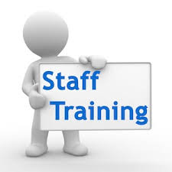

Introduction::::: If we encounter a man of rare intellect, we should ask him what books he reads.
–Ralph Waldo Emerson
Been in sales for over 20 years. Bought almost every book on SALES Techniques. Library of Congress on Sales, and Motivation Books. Persuasion- Communication … -
Know your client, Company -product service, competition, positive attitude-be prepared-follow up
INDEX Cards: Motivation, Sales, Persuasion, Communication, Inspirational
Tom Hopkins, (Puppy Dog close) ,Zig Ziglar Brian Tracy, - Tony Robbins., James K Van Fleet, Jeffrey Gitomer, Stephen Covey , Og Mandino, Napolean Hill, Dale Carnegie, Norman Vincent Peale, Ken Blanchard, Harvey Mackay, Denis Waitley, Mark Victor Hansen, Maxwell Maltz. Jose Silva , Eckhart Tolle, Wallace D Wattles, Robert Cialdini, William Clement Stone, Samuel A Cypert.
YELLOW FOLDER- Top Sales Books
My Father- His Approach- advice
For every sale you miss because you're too enthusiastic, you will miss a hundred because you're not enthusiastic enough. – Zig Ziglar
- Being Tenacious, Assertive, Persistent. Always described me since the very beginning
Green Folder WHAT IS YOUR BRAND? Cheetah- (Momma Lisa) –Brian Tracy -Life is a Mystery to be lived not a problem to be solved

Questions:::::
RED Folder Spin Selling- come up with a way to ask your client questions in order to expose their “pain” and then “save them with your product or services.
- Yellow Folder Scoping a Meeting Document – Consulting
Go over a few of the Highlights-
Questions::::::
BRANDON- KEY POINTS- My APPROACH
Outside Sales Mentality- attire, time, professionalism
Relationships are the key. Develop them
It’s not what you say it’s how you say it. (nonverbal)
Be Enthusiastic, Energetic, Creative, Positive, Determined -Aggressive
Learn Matching and Mirroring techniques
Don’t behave like a salesperson-
Be visible- people buy from people that they like
Listening is different that hearing.
- From the Blog- 10 sales training Tips
- My top3-4 …. What are yours?
Conclusion:::::::::::
Why we are here----- ???$$$ in Box- Relationships to build and $
“Whatever you are, be a good one.”
-Abraham Lincoln
ORDER THIS BOOK
Non
Verbal Communication

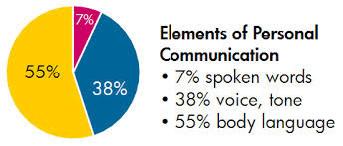

According to Kramer, "94% of our communication is nonverbal, Jerry" (Seinfeld, January 29, 1998).

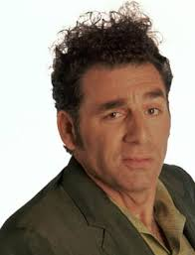

NOTES :

Brandon K Newsom 2/13/2014

“Your attitude, not your aptitude, determines your altitude.” – Zig Ziglar

