SPECIAL MEETING

APRIL 12, 2024

A Special Meeting of the Town Board of the Town of Hampton, County of Washington and the State of New York was held at the Town Hall, 2629 State Route 22A, Hampton, New York, on the 12th day of April, 2024.

PRESENT: David K. O’Brien------------Supervisor

Donald Sady----------------- Councilman

Tamme Taran----------------Councilwoman

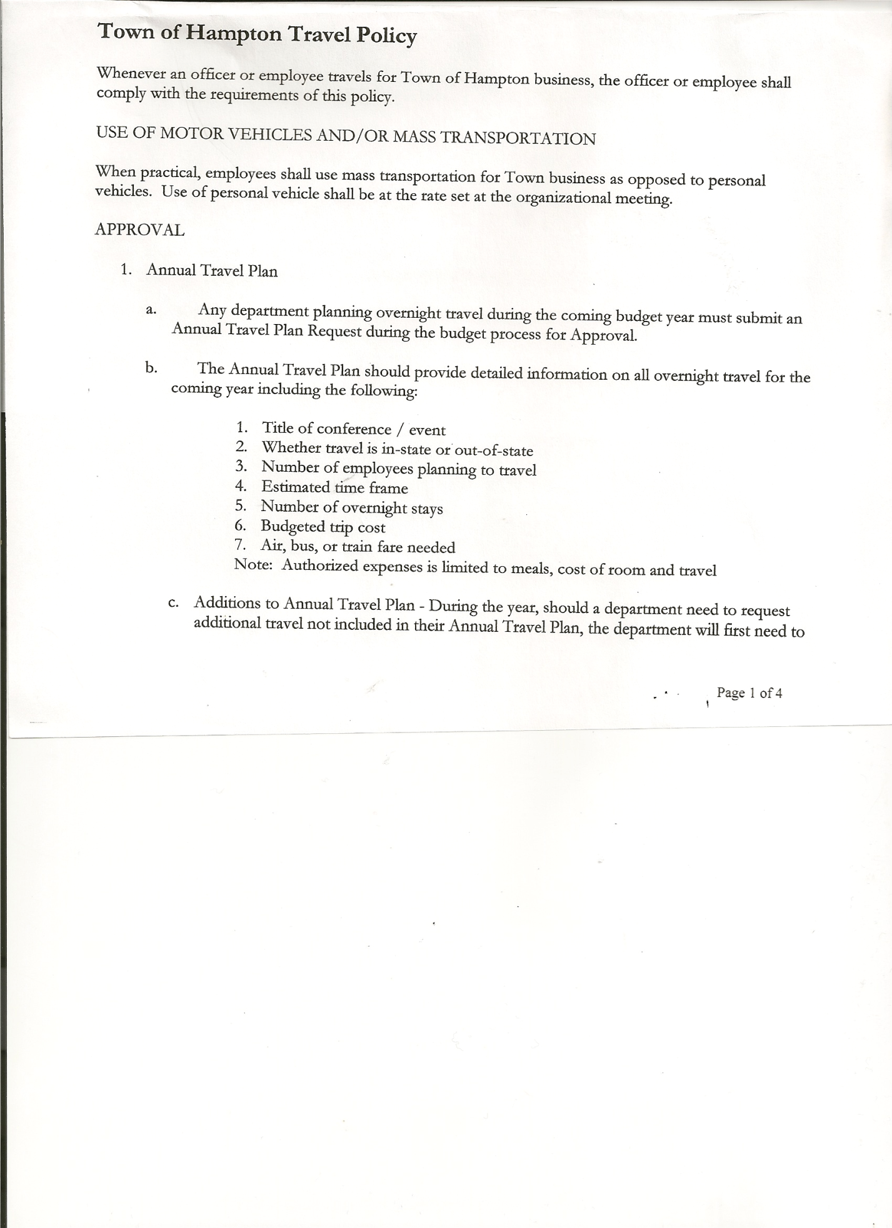 Michael Pietryka------------Councilman

Andrea Kugler---------------Councilwoman - absent

Rebecca Jones---------------Town Clerk

Tyler McClure---------------Highway Superintendent

Planning Board Member (s):…Rene Rountree

Others present at the Town Hall: none

The Special Meeting was called to order by Supervisor O’Brien at 6:00pm, followed by the Pledge of Allegiance. Location of Fire Exits were given. Quorum of board members present.

The purpose of the meeting was for a contract discussion and Highway Equipment purchase.

Following a discussion regarding hiring a new accounting service, the following resolution was introduced:

**RESOLUTION NO. 43-2024**

**ACCOUNTING CHANGE**

On a motion of Councilwoman Taran, seconded by Councilman Pietryka the following resolution was ADOPTED: AYES 4 O’Brien, Sady, Taran, Pietryka

NAYS 0

ABSENT 1 Kugler

RESOLVED, to enter into a Contract with Mary P. Hollister, CPA,PC for accounting services during the year ending December 31, 2024.

Highway Equipment……

Tyler McClure, Highway Superintendent and Councilman Donald Sady located a used John Deere Backhoe in Killington, VT. The piece of equipment is a 2013 John Deere with five thousand (5000) hours. The asking price is $43,500.00. Both Tyler and Don agreed it was very clean. Councilman Sady will try and negotiate a lower price. Maintenance records are up to date. Would need to purchase a ditching bucket to go on it. The price for a ditching bucket would run between $900 and $1100.

Tyler has looked at several others, mostly at dealerships that, in his opinion not worthy of the price. Following a discussion about the above piece of equipment, the following resolution was introduced:

TOWN BOARD MEETING

APRIL 12, 2024 PAGE 2

**RESOLUTION NO. 44-2024**

**HIGHWAY EQUIPMENT PURCHASE**

On a motion of Councilman Pietryka, seconded by Councilwoman Taran the following resolution was ADOPTED:

By Roll Call Vote: Supervisor O’Brien AYE

Councilman Sady AYE

Councilwoman Taran AYE

Councilman Pietryka AYE

Councilwoman Kugler ABSENT

RESOLVED, to spend up to $43,500.00 for the 2013 John Deere backhoe.

**RESOLUTION NO. 45-2024**

**MEETING ADJOURNED**

On a motion of Councilman Pietryka, seconded by Councilwoman Taran the following resolution was ADOPTED: AYES 4 O’Brien, Sady, Taran, Pietryka

NAYS 0

ABSENT 1 Kugler

RESOLVED that the meeting adjourned at 6:15pm.

Respectfully submitted,

Rebecca S. Jones, RMC

Town Clerk