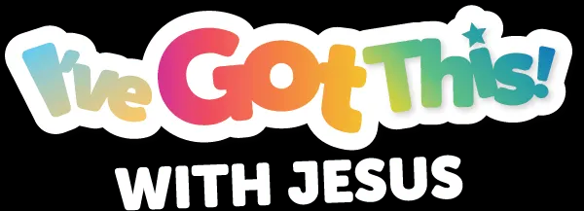

YOUTH/TEEN VIRTUAL VBS LESSON PLAN
Middle District Baptist Association
North Carolina
July 13 - 15, 2021

WEDNESDAY, JULY 14, 2021

Title of Lesson: WE ARE CONQUERORS

Purpose: Based upon the topics the students selected as their top 3 during the prior night polling, the Conquerors will learn what it means to have Jesus as Best Friend! We will use a Mystery Mash Up: Drama Night as a tool and technique to not only get students actively involved, but also to engage students with learning Bible content.

Learning Outcome: Students will build their trust, faith, and belief on the truth – Jesus Christ!

TIME | ACTIVITY | OUTCOME
6:15pm -6:30pm | GREETINGS | As each student enters the room, the instructors will greet them enthusiastically! We are excited for them to come to Virtual VBS!
6:30pm – 6:35pm | OPENING PRAYER  WELCOME & ICE-BREAKER | Prayer, Welcome and Introduction of each student. Our daily ice-breaker will engage students to know Jesus more.
6:35pm-- 6:40pm | PACE-SETTER:  - Ground Rules Reminder  - Expectations  - Day 1 Memory Recap | We are partners in this together, so each student has input to the success and outcomes of the class. Students will understand and say, “I’ve Got This! with Jesus.”
6:40pm – 6:45pm | OPEN THE MAIL  - Lesson Introduction  - Word of the Day | The opening exercise is what is needed for teens to open their Bibles daily, just as they would mail that comes as a text from a friend! Everyday they can open the Good News from Jesus!
6:45pm – 6:50pm | SNACK BREAK  - Bible Memory Verse of the Day | Students will read the memory verse of the day and find an item at their location in which they can relate to the verse. This is not an actual snack break, but a “Bible Verse Break” to taste and see that the Lord Jesus is Good!
6:50pm – 7:10pm | BIBLE LESSON via MYSTERY MASH UP! DRAMA NIGHT! | Use of the Word of the Day, Bible Memory Verse of the Day, and the Lesson Introduction to foster learning through various dramas. Students will use multi-sensory to retain learning.
7:10pm –  7:20pm | LESSON FOR LIFE | Each student will relate the Bible Lesson to their individual life. Conversation encouraged. Questions to determine direct application of materials.
7:20pm –  7:25pm | CONQUEROR RECAP | Closing Activity for retention of learning. Questions to determine understanding of materials.
7:25pm –  7:30pm | CLOSING PRAYER & BENEDICTION

