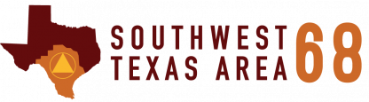

Delegate Report
for the 72nd Annual General Service Conference
Saturday, August 6th | 11:30 am – 1:00 pm
1142 Eikel Street, New Braunfels, Texas 78130
Barbara R., the current Panel 72 Delegate for Area 68, will be providing an overview of the committee discussions that took place that the AA General Service Conference hosted in New York this past April. This is a great opportunity to learn more about what goes on at an annual conference, specific items that were discussed and/or tabled, and Barbara’s committee participation.
Some of the Topics for Review Include:
- Recommended changes to the Twelve Steps and Twelve Traditions
- Timeline on the 5th edition of the book Alcoholics Anonymous
- Update on the recent change to the Preamble.

refreshments Will Be Provided

