- This is a Sample Project to help you understand the concept of the work. Few lines of the Sample have been typed for demonstration.
- You are required to type the exact text from the left box to the blank box at the right.
- The size of the text should be 8-10 and theme should be ‘Arial’ or ‘Times New Roman’.
- 15 errors per page is permissible. Pages containing more than 15 errors are not eligible for payment.
- Only spelling and punctuation errors are counted.
- Paragraph spacing, alignment, word position etc. are not considered errors.
- The text which are underlined or italic should be underlined and italic.
- Payment per page depends on the plan chosen.
- The main project would contain further information regarding submission of assignment.

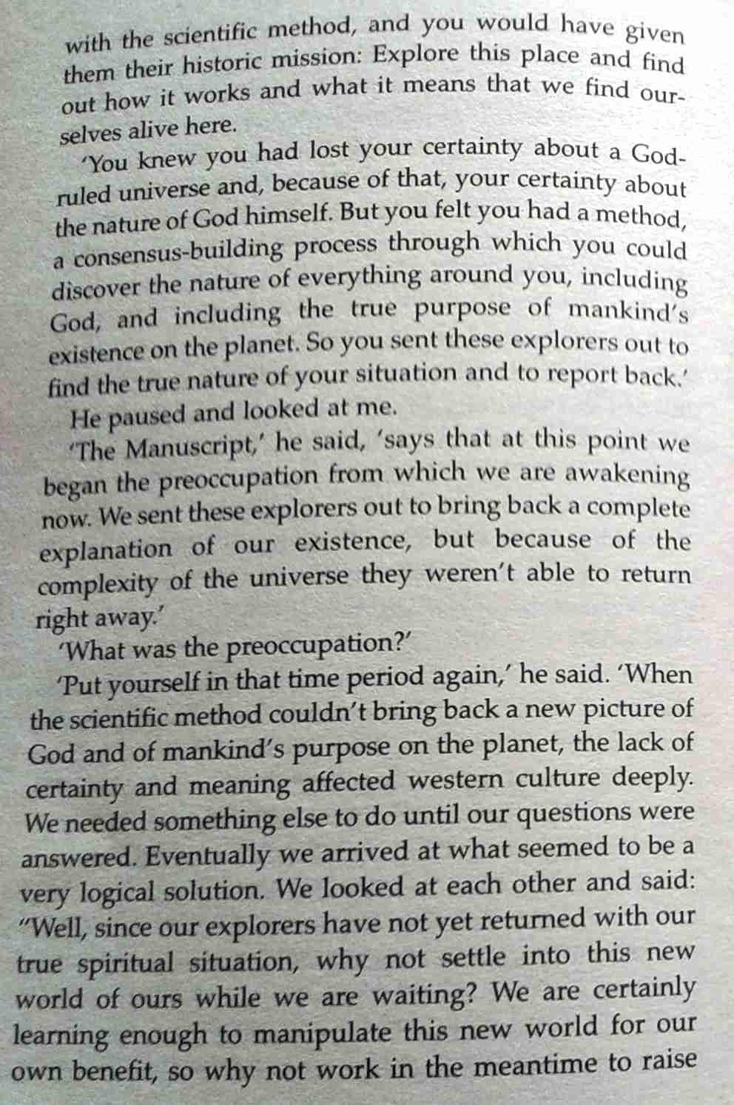
with the scientific method, and you would have given them their historic mission: Explore this place and find out how it works and what it means that we find our-selves alive here.
‘You knew you had lost your certainty about a God-ruled universe and,
