Fall/Winter Newsletter 2018
Ilarion Residence
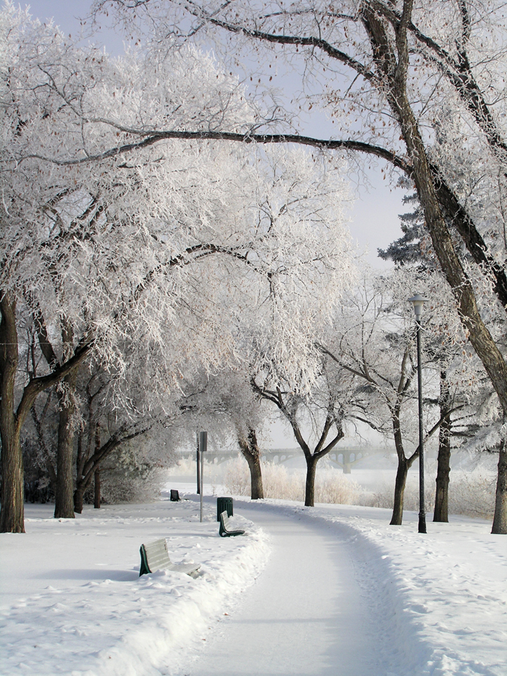

Table of Contents

Page 2 Amateur Hour News

Page 3 Giving Thanks and Birthdays

Page 4 Other Ilarion News

Page 5 Keeping Your Health

Page 6 Christmas Traditions from Around the World

2509 Louise Street Saskatoon SK. S7J 3L7
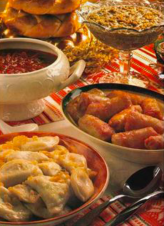
T: (306) 373-7011 www.ilarion.ca

Ukrainian Christmas Traditions
-Taken from www.ukrainianpeople.us
For those who do not know, Ukrainian Christmas festivities begin on Christmas Eve (January 6th) and end on the Feast of Epiphany. The Christmas Eve Supper (Holy Supper) brings the family together to partake in a large meal with special foods, along with other rituals. The Christmas Eve rituals are dedicated to God, the welfare of the family, and to the remembrance of ancestors.
There are 12 courses in the supper, because according to the Christian tradition each course is dedicated to one of Christ’s Apostles. The courses are meatless because there is a period of fasting required by the Church until Christmas Day. This also pays respect to the animals, as many Ukrainians typically were/are farmers. Some of the foods include Kutia (boiled wheat mixed with poppy seeds and honey), borscht (a beet soup), uzvar (stewed fruits, which should contain twelve different fruits, also known as God’s drink), and varenyky (boiled dumplings filled with cabbage, potatoes, prunes, or if you live in Saskatchewan, sometimes Saskatoon berries).
To learn more about Christmas around the world, go to Page 6 of this Newsletter! The holiday season is also a time for sharing, so we are asking for Ilarion residents to submit their families Christmas/holiday traditions to be shared on a bulletin board in Ilarion! Submit your traditions to the Program Coordinators office (mail slot) by December 23rd.

Amateur Hour News
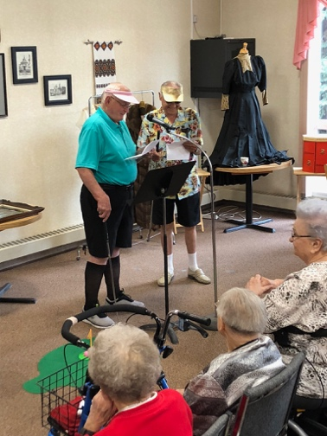
The holiday season is best spent with loved ones, and with Christmas only a few short days away and the New Year right around the corner, this is a great time to reflect on what an amazing year it has been! All of our unique and fantastic residents of Ilarion are what make this place we call home so special! This September we were fortunate enough to celebrate Ilarion’s second Amateur Hour! Now, this is never an easy event to put together as it seems everyone loves to keep their talents to themselves, but through some encouraging and coaxing we had a ton of amazing people show some bravery and take part in the show. I want to say a big thank you to all the people that made our Amateur Hour so special! They all did an amazing job whether it was sharing special trinkets or antique heirlooms, role playing a hilarious skit, sharing their musical talents, or getting us to laugh through joke telling. Everyone who participated made it all look so easy! I can assure you it’s never an easy thing to get up in front of a crowd full of people and share something, but everyone who stepped into the spotlight did a fabulous job! As we are all unique and possess our own special talents, what better thing to do than share them with everyone? In May of 2019 we will be putting on another Amateur Hour! I encourage everyone to share and participate! It is something we’ve started at Ilarion with the goal of just having a little fun! We are never short of funky costumes or funny skit ideas, so if you are interested don’t hesitate to ask! Merry Christmas to everyone! -Sophie Program Coordinator
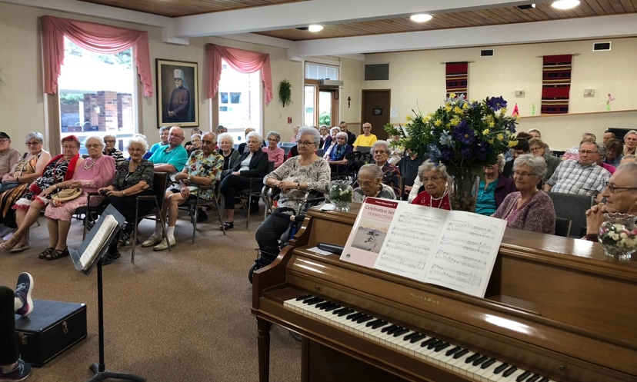
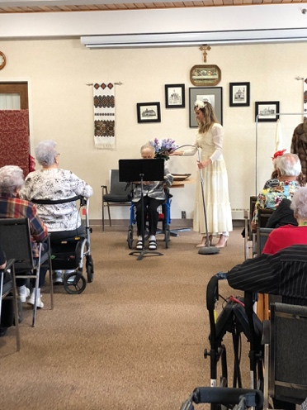

Happy Birthday to all Ilarion Residents and Staff who celebrate in the Fall or Winter

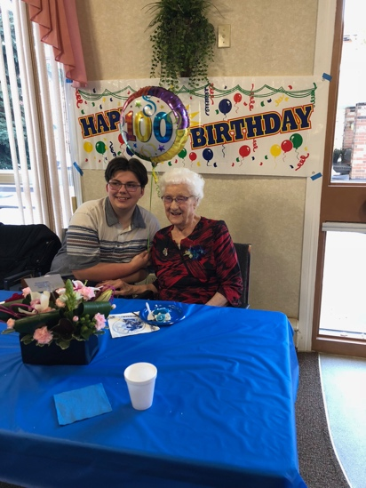
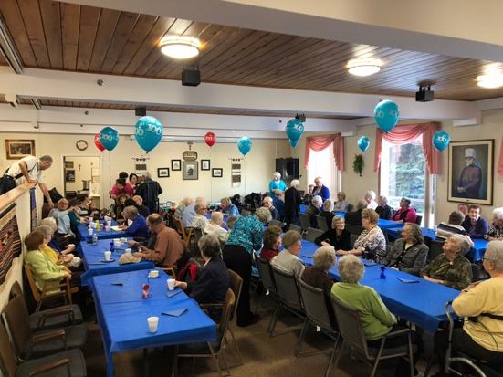

A special happy birthday to Louise Phillips who turned 100 on November 22nd, 2018!

Give Thanks
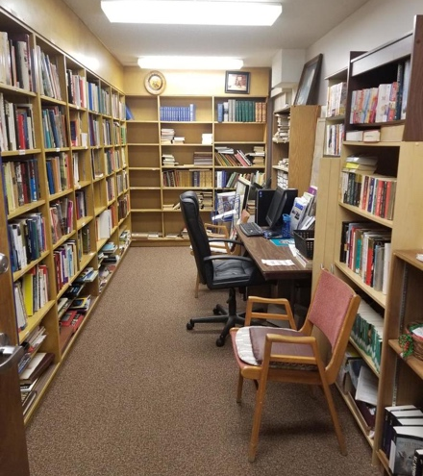
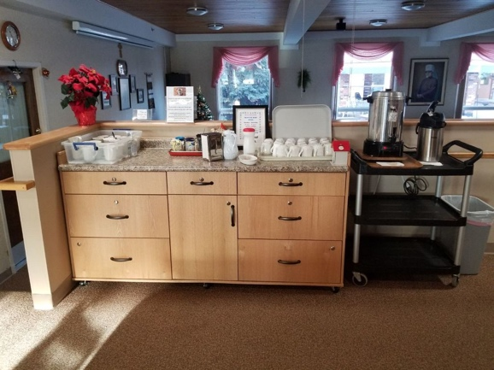
With the constant chill in the air and the need to dress up in multiple layers before leaving the house, this is the perfect time to curl up with a fuzzy blanket and a good book! The Ilarion library is full of all sorts of good books to keep you entertained during our long Saskatchewan winter. Our library even possesses the unique feature of having not only English books but also Ukrainian books to read as well. We have a wonderful group of volunteers, who happen to also be residents of Ilarion, who spend a large portion of their time making sure the library is presentable for everyone. Through long hours organizing the books by genre to make them easier to find or sorting new books coming in, the fantastic committee deserves a very big “thank you!”. Rachel is our library committee President, and with the help of many dedicated individuals she has done a terrific job at making the library a welcoming place for everyone! Feel free to say “thank you” to Rachel or other committee members when you see them!
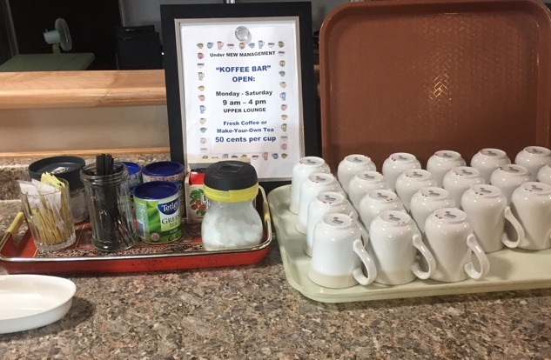

Give Thanks- continued
What goes well with a good book? A hot cup of coffee or tea! After finding a good book in the library you can make your way to the Upper Front Lounge for a pit stop at the Koffee Bar! Another incredible group of individuals who devote long hours to supplying hot coffee and tea to Ilarion residents! We owe our ladies and men of the Koffee Bar Committee a great big hug for always waking up before the sun to make sure a hot pot of coffee is brewing. Vera is a familiar face that can be found at the Koffee Bar refilling the cream container and sugar jar, so never hesitate to let her know you appreciate all her hard work! Fun fact, if you weren’t aware the Koffee Bar also hosts a monthly entertainment social and supplies other goodies and treats that accompany a hot drink! We are lucky to have them!
Thank you also to all of the other residents of Ilarion who volunteer their time in some way or another to make sure our building is a great place to live! Let us all be appreciative of each other during this winter season, and spread the warmth with our hearts!

Diabetes-Canada A Very Successful Canvas
The committee in charge of canvassing for Diabetes- Canada raised a total of $864.00 for diabetes research. In a 3-day canvas from October 17-19. The committee would like to express their sincere thanks to all the Ilarion Residents who contributed to this very successful campaign. Committee convenor was Orest Mysak assisted by Mary Mysak, Lloyd and Elizabeth Ullrich, Gloria Hrabowy, and Eleanor Franson.

Learn about UPCOMING EVENTS at Ilarion!

“Staying on Your Feet”- Thursdays starting January 10th @10am in the Lower Lounge -Pre-registration is required. Sign-up sheet is near the mailboxes

“Live Well with Chronic Conditions”- Mondays starting January 21st @1:30 pm in the Board Room. -Pre-registration is required. Register in the Office.

*To keep up to date with programs, make sure to check the monitors daily!

Keeping Your Health
This area of the newsletter offers information for you to consider when reflecting on your day-to-day health and habits. This page could be taken out and put up in your home as a reminder!

The 7 Dimensions of Wellness -Information taken from article “Life Enrichment and Wellness” by Touchmark

Emotional
Having a strong sense of self-worth, being aware of and accepting feelings, and coping with challenges in a positive way.

Environmental
Respecting resources, choosing green options, and finding ways to appreciate nature.

Intellectual
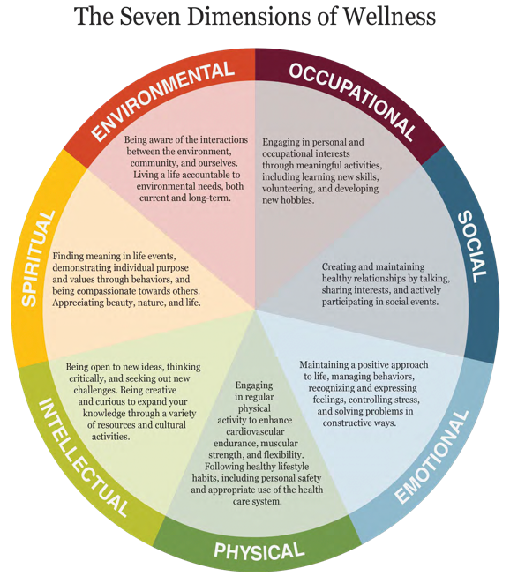
Engaging in new and challenging activities, participating in lifelong learning pursuits, and sharing ideas with others.

Occupational

Living a life of purpose, utilizing unique skills and passions, and cultivating personal satisfaction.

Physical
Making healthy lifestyle choices to maintain or improve health and function through physical activity, good nutrition, adequate sleep, and stress management.

Social
Creating and maintaining healthy relationships, engaging in positive interactions, and feeling connected to your community.

Spiritual
Living with a sense of purpose, being guided by personal values, and finding a connection to the world and others

Christmas and other Holidays Around the World- www.whychristmas.com
Christmas and other Holidays are celebrated differently around the world. Below are some traditions that you could see if you were travelling at this time!

Australia- Many towns, cities, and schools hold “Carols by Candlelight” services with local bands and choirs where they perform Christmas Carols. As it is the middle of Summer in Australia at this time, the words to the Carols about snow and cold winter are sometimes changed to special Australian words!
Bangladesh- December 25th is a public holiday for Christmas even though only about 0.3% of the population are Christians (about 170 million people). Following church services, it is a tradition that everyone has Christmas dinner together at the church. This is called the ‘Preeti-bhoj’ or ‘Prem-bhoj’ which means ‘love feast’.
Egypt- Most Egyptian Christians belong to the Coptic Orthodox Church and celebrate Christmas on January 7th. The Coptic month leading to Christmas is called Kiahk, and people sing special praise songs on Saturday nights before the Sunday service. In Egypt, Santa is called Baba Noël (meaning Father Christmas), and children are hopeful that he will climb through a window and leave presents!
Ghana- People in Ghana celebrate Christmas from the 20th of December to the first week of January with many different activities. Over 66 languages are spoken in Ghana, and all these language groups have their own traditions and customs! Traditional food includes stew or okra soup, porridge and meats, rice and a yam paste called ‘fufu’.
India- Instead of having traditional Christmas Trees, a banana or mango tree is decorated. On Christmas Eve, Christians in Goa hang out giant paper lanterns in the shape of stars between houses so that the stars float above you as you walk down the road.
Jamaica- Christmas Eve is also called ‘Grand Market’ and is a really exciting time. There is a cross between a festival and a market. During the day, people go shopping for Christmas foods, sweets, and toys, and in the evening, a celebration begins and lasts until the morning. Everyone comes out in their new/best clothes to celebrate and party all night!
Thanks for reading!

If you have anything to contribute to the next Newsletter, please submit it to the office!

