

**AAT NEWS**

**February 2019**

**PRE-TRIP INSPECTIONS**

Recently there have been conversation(s) with our customers regarding drivers performing complete pre-trip inspections when picking up trucks.

*With this in mind….*

1. We will be focusing on different portions of the

pre-trip inspection in the upcoming newsletters.

1. We have also asked the shuttle drivers to help support each driver in performing a comprehensive inspection. They will need to initial the upper corner of each driver’s bill of lading indicating they have participated.
2. DJ is available for any questions about the pre- trip inspections.

**AFTER HOURS PHONE**

The after-hours cell phone is for **urgent** matters and is available for drivers at the following times:

Monday-Friday 6:00 AM to 8:00AM

4:30 PM to 10:00PM

Saturday-Sunday 6:00 AM to 10:00PM

Holidays 6:00 AM to 10:00PM

After hour’s calls are reserved for *urgent* questions regarding vehicle breakdowns and repairs, weather conditions, transportation issues, accidents, pick up or delivery complications or FMCSR questions.

Please ***do not*** call the after hour’s support line with non-urgent items such as: settlement issues, availability, when you can’t reach the dispatcher on their desk phone, future shipments, etc. We are here to assist you, please call during business hours when applicable. Thanks for your cooperation.



Pat A., Ray, Brian D., Luis, John H.,

Paul J., Ricky and Bob.



The suggested time frame for a thorough pre-trip is 30-45 minutes.

Before the engine is turned on—**LIFT THE HOOD**!

Check for puddles on the ground, dripping fluids,

paying close attention to hoses, clamps & belts.

Oil—did you know some manufacturers are placing

putty on the dipstick. If it delivers with the putty

intact—no oil has been checked!

Check all fluids—Oil, coolant levels, power steering

fluid, DEF, transmission and window washer fluids.

While a majority of the vehicles AAT moves are new; a pre-trip inspection is still required.

**Inspection Info  
nfo**

This n That

**When bringing trucks to the AAT lot please bring keys and Bill of Lading to dispatch or turn in with your paperwork. We are no longer leaving keys on dipsticks, battery boxes, etc. unless specifically requested.**

**instructed to do so.**

Prescription glasses (2 pairs now) still in Lost & Found.

Pick up a dirty truck……deliver it cleaned out.

W-9’S need to be filled out for the new year.

**SAFTEY VESTS** are available for all AAT drivers. If

You have not received your safety vest, please see DJ.

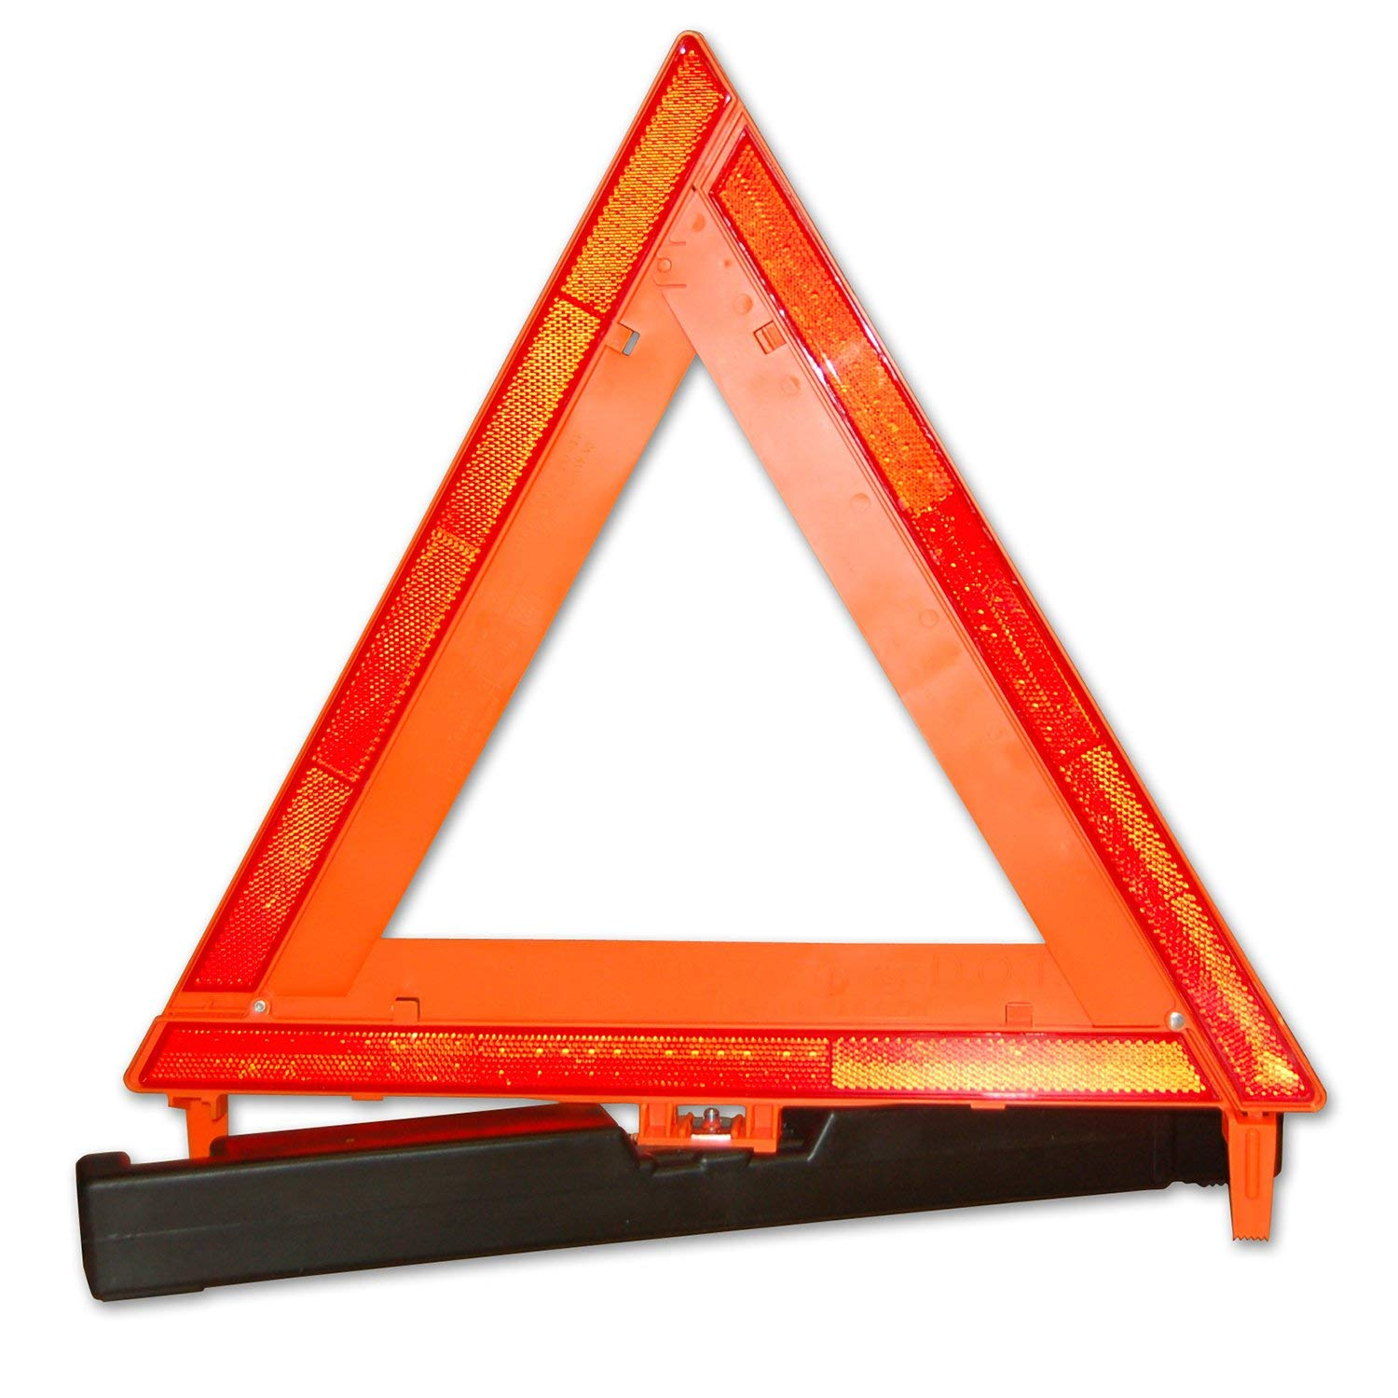

**TRIANGLES-- Don’t leave home without them.**



**POLICY CHANGE**

Due to the recommendation from Cummins we are changing our policy for anti-gel products. Please use **Power Service Diesel Fuel Supplement+Cetane Boost.**

Pat A., Ray, Brian, Luis,

John, Paul J. and Ricky.

**Feb 17th Random Act of Kindness Day**

Let’s be honest-- life can be tough, we all go through our struggles. By giving just a little time or effort it can really make a big difference in someone’s life and our own. Something as simple as a compliment or holding the door open for someone. See a person unloading a cart of groceries, stop and help. Buy a bag of chocolate kisses and give them away thru the day. Kindness Matters!

**Scott, Debra, DJ, Donna, Jackie, Penney, Kara & Patti**