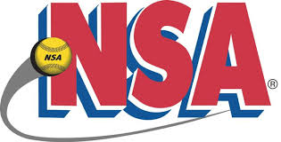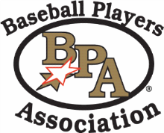
2019 NSA/BPA Umpire Super Clinic
We will be hosting the Umpire Super Clinic at the CCAC in Warsaw, Indiana this year for anyone interested in becoming a new umpire, as well as the required annual training for veteran umpires. This is a great opportunity to get your 2019 NSA/BPA Umpire Membership, rulebook, gear and training required for the season. All attendees will be able to attend all three programs, if interested.
The Clinic will be March 3, 2019 at 9 AM Eastern Time and will conclude at 3 PM.
The cost for the clinic is $10, which will include lunch. Umpires may also sanction at the clinic, but MUST be paid for by credit card, as all sanctions are paid online to the National Office. The sanction fee to umpire all three programs is $60 for returning umpires, and $40 for all new umpires.
We will have umpire apparel, and working on gear, for those interested in updating their uniforms or equipment. Those may be purchased with cash, check or credit card.
We ask that you RSVP so we know numbers for lunch, rulebooks and any handouts. You can RSVP through your State UIC below, or by contacting the CCAC.
Karl Swihart N.Zone UIC/State Dir 574-806-7727 kswihart@playnsa.com
Mike DellaRocco State FP UIC 219-718-8237 mdellarocco@playnsa.com
Tony Drzewiecki State BPA UIC 219-871-9215 inbpauic@playbpa.com
Kevin McCowan State SP UIC 765-744-0957 kmccowan@playnsa.com
CCAC-Warsaw Host Site 574-269-6663 jeff@ccacwarsaw.com

RSVP by February 28th.

