

# Summer 2018 Season

# Week 2 – 04.04.18

# Singles League Report

# 

**Remember if you cannot play on the scheduled fixture date; please try to play in advance.**

**If you have not played on the scheduled fixture date please take into account section 4 of the rules to avoid penalty point deductions.**

Well Jonny Hill’s unbeaten record went as he lost to Matt Buesnel but only just losing game one 13 – 12.

Geoffroy Buffetrille as official got a bogie player in David Ibitson who beats him two seasons running.

In the Winter season just past Ross Payne only win was against Matt Pinel, could he repeat that feat. Not this time, but should have drawn the match losing one game 13 – 12. Matt Pinel sitting top with 6 points from his first two matches.

Alice Ibitson played her first match, against Brian Harris and picked up three well earned points. Brian Harris doubles partner Paul Le Moine did win, against Toby whose form is going from bad to worse as he again struggles.

Keith Pinel and Neil Selby drew as did Callum Stewart and Ross in a catch up match to finish off the Premier fixtures this week.

**Matches not played**

Andrew Bellamy-Burt v Callum Stewart

Division 1 saw title favourite Joey only manages to draw again. He needed to win the second game to get a valuable point as the pressure of being title favourite takes its toll.

Well done to Mo De Gruchy who won her first game in the league, unfortunately not the match but a very positive step taking a league point against experience John McGaw.

Matt Hutchings late show saw him also just miss out on a win despite leading comfortably lost 13 – 12 in the first game but recovered to get a point against Brigitte Ibitson.

Alex Stewart is on 100% record with two wins in two, this time against newcomer Stephen Stoneman as Alex looks for back to back promotions to the Premier League.

Paul Bell got off the mark with a close win 13-10, 13-8 over Jean Stewart after losing to Alex Stewart last week gets him back on the promotion trail.

Cassie Stewart ensured Laurent Pellaton remained without a league win so far this season, in stark contrast to the winter season. A draw was the case as both players without a win.

**Matches not played**

David Le Gresley v Harrison Marie

**Super 6 Results**

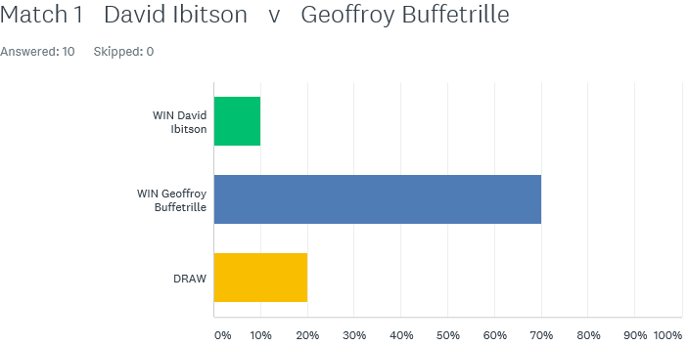

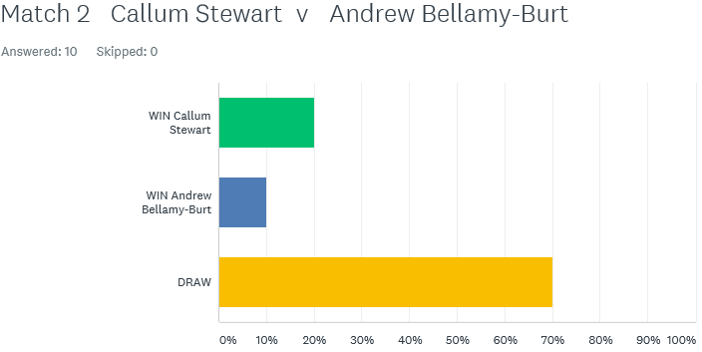

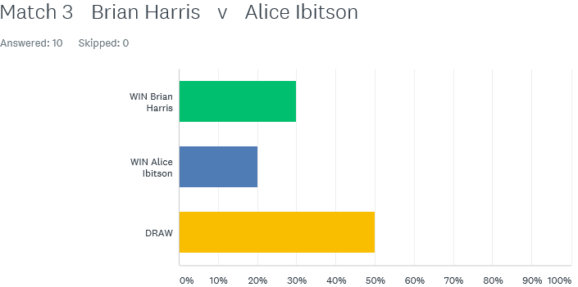

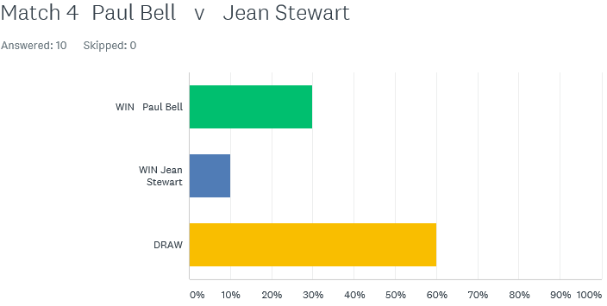

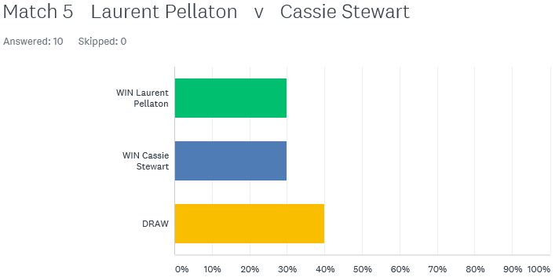

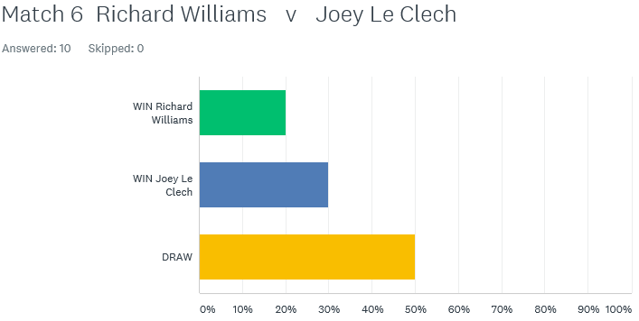

How would you have done on the **Super 6**? – next weeks out on Monday – have a go, see how good you are.

**First Open of the year is the Singles Open on Saturday 7th April 2018**

Best of Luck to everyone

***NEXT WEEK***

**11th April - Doubles League – Week 1**

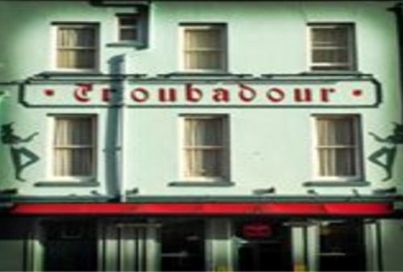

**WEBSITE** [**www.liberationpetanque.co.uk**](http://www.liberationpetanque.co.uk)

**EMAIL** [**liberationpc@gmail.com**](mailto:liberationpc@gmail.com)

**Kind Regards**

**Toby Northern**

**Chairman**

**Liberation Petanque Club**

# SPONSORED BY