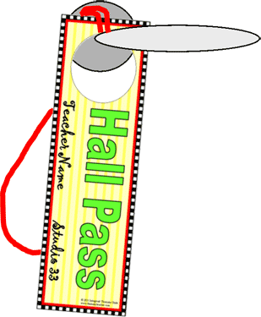
The Artful Classroom
Classroom Passes
Use these handy little passes to limit how many students leave your room at a time, and keep track of where they go. You can change the names on any of the passes by selecting them, and retyping your own words. An “Emergency Pass” is included in case you must send a runner to the office to get help in a hurry!
Preparation:
- Change “Teacher Name” to your name by selecting the words and retyping your name.
- Change “Studio 33” to your own room number by selecting the numbers and retyping your room number.
- If you want to remove the circle (removing the image) for the door hanger, click on the page, go to Format-Group-Ungroup. Then click on the image, delete it, and click on the edge of the circle, delete it. Then you can regroup (click on the image, then go to Format-Group-Regroup.)
- Print out as many passes as you need. (You may want to make a couple of sets in case some are lost or torn during the year.) Print them on heavy white drawing paper, cover stock, tag, or photo paper.
- Laminate.
- Trim and cut out the circle for the door hanger (if you wish to use it that way). If you aren’t hanging them on the doorknob, punch a hole in the pass near that end.
- Tie a piece of roving through the hole to make a “necklace”. They will not be so easily lost that way!
- Hang them on your classroom doorknob, or from a pushpin next to the door.
Now, whenever someone is gone, you’ll know where they went (the pass that is missing), and you’ll limit the number of people going to the bathroom at one time (use either the generic restroom pass, or the boy’s and girl’s passes—whichever suits your needs).
There is an extra page in case you want to make more kinds of passes. To do this, go to page 7 and follow the directions on the top of that page.
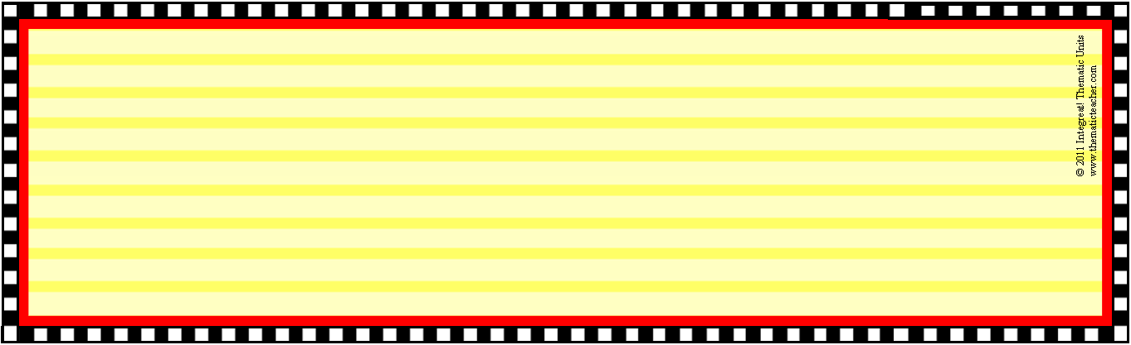
Teacher Name
Studio 33
Teacher Name
Studio 33
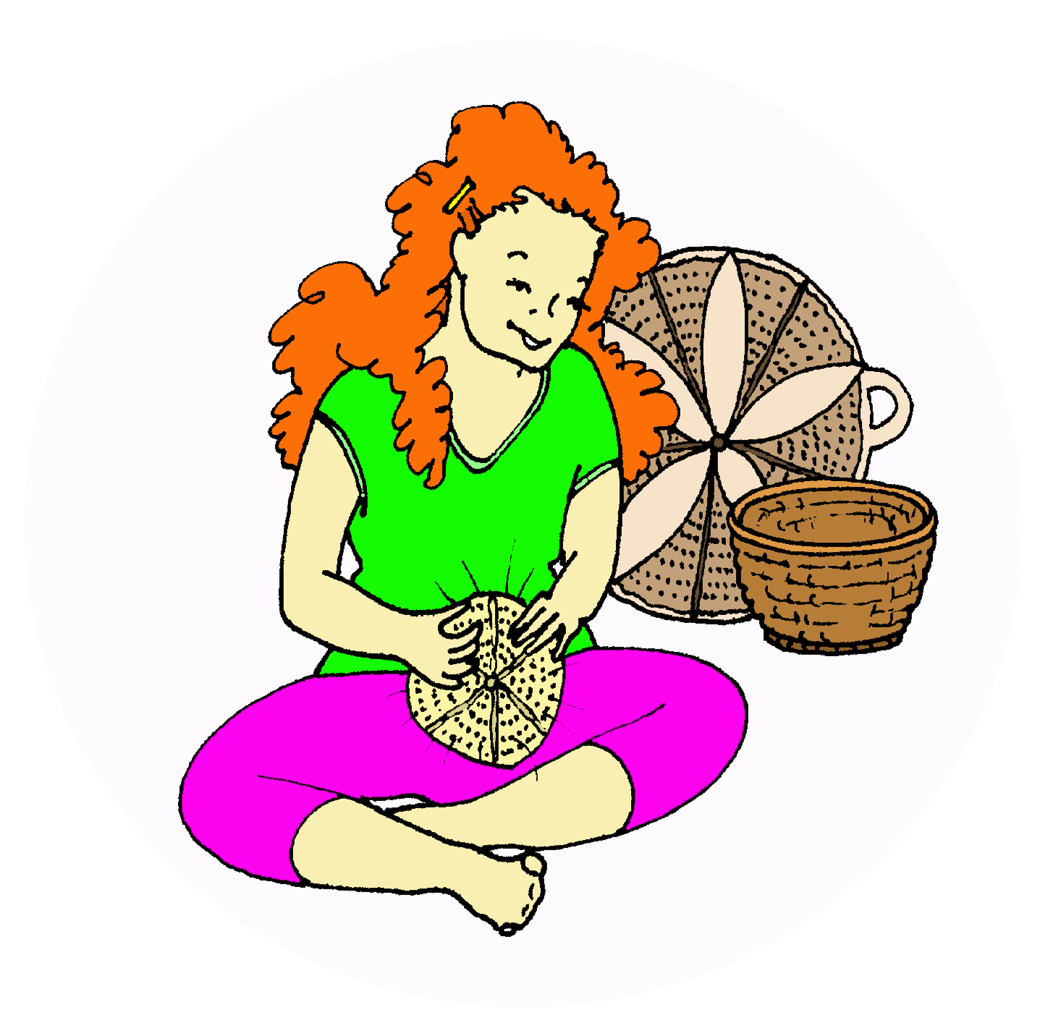
Teacher Name
Studio 33
Teacher Name
Studio 33


Teacher Name
Studio 33
Teacher Name
Studio 33

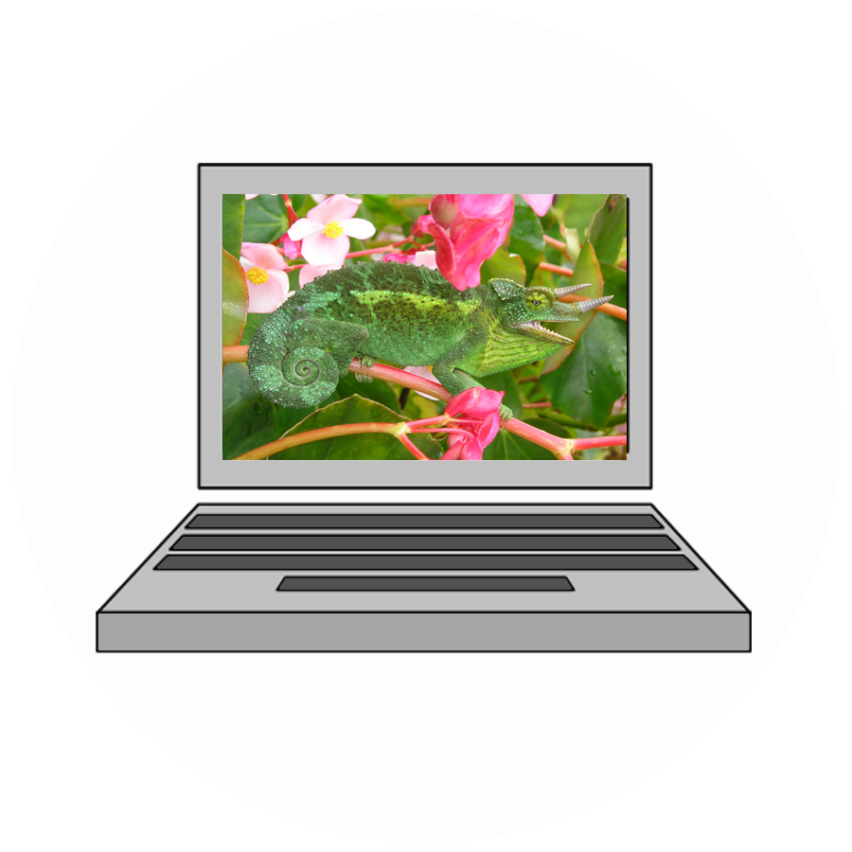
Teacher Name
Studio 33
Teacher Name
Studio 33

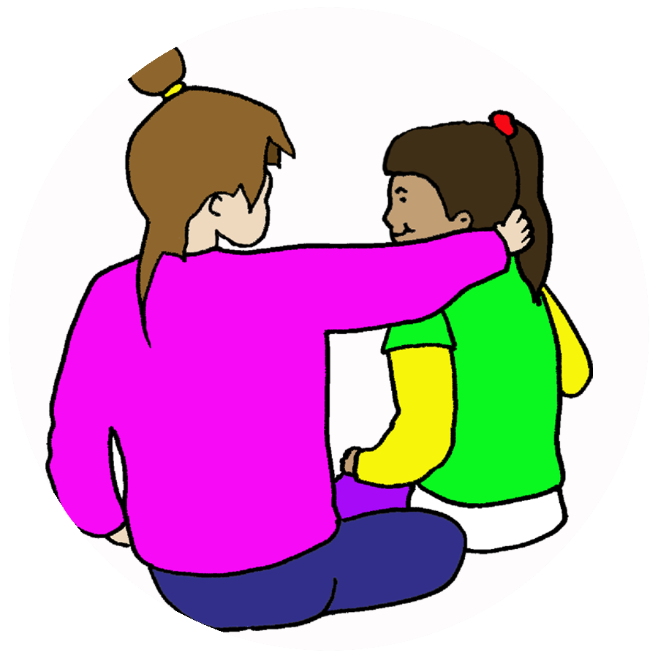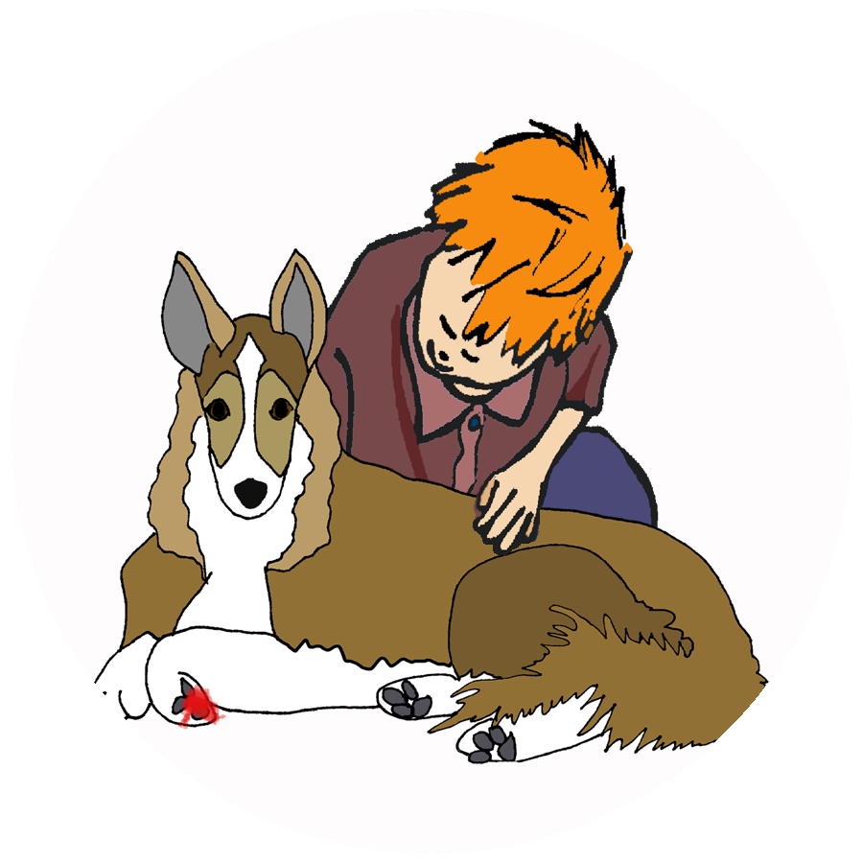
Teacher Name
Studio 33
© 2011 Integreat! Thematic Units
www.thematicteacher.com
Teacher Name
Studio 33
Make your own Passes:
Double click on “New Title”.
Change the name in the Format Menu (top of screen) under “Edit Text” (far left).

If you want to remove the cut-out circle for the door hanger, click on the image, and delete it, then click on the edge of the circle and delete it.

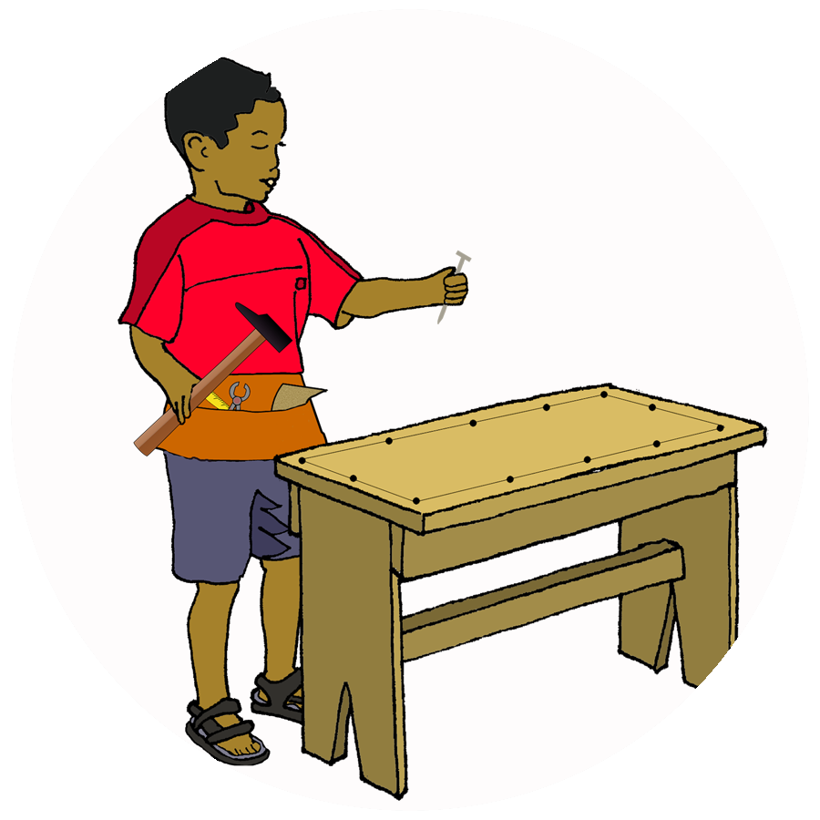
Studio 33
Teacher Name
Studio 33
Teacher Name

