

2020
Liberation Singles Open
The Liberation Singles Open 2020 was another well attended event this month, but with holder Mark Nicol unable to play a new name was going on the trophy this year.
Laurent, who was the top ranked player in the club singles with 5 wins from 5 struggled in his first match just managing to win 13-12 over Brigitte Ibitson. This was one of three 13-12 results in round 1 as Matt Buesnel the 2016 champion lost to Alan Lahiffe and Matt Hutchings beat Paul Bell.
Last years top Swiss player Neil Selby though won 13 – 0 to start his tournament off well.
The ever improving Andrew Limbrick put a big dent in 2013 champion Ross Payne’s hope of another success winning 13 – 6 as did Lorna Limbrick who beat 2014 champion Toby Northern 13 – 8.
A bigger shock though was Liberation Club Singles champion Brian Harris 13 – 3 defeat to Kevin Daly playing in his first Liberation competition.
Matthew Scholefield had a tough first round draw against Jake Romeril but won comfortably and Jean Stewart continues to improve with a win over Keith Pinel.
Round 2 saw another three 13-12 wins, with Branden De La Haye proving to be Geoffroy bogey player beating him for the second successive competition. Lorna beat Kevin for two wins from two and James Rondel beat doubles partner Gavin Scott.
Mo De Gruchy recovered from her 13-0 loss to Neil in round 1 beating James Villalard and Andrew Limbrick handed out a hammering 13 – 2 to one of the pre-tournament favourites Laurent Pellaton.
Matt Scholefield won another tough match, this time against Callum Stewart but Toby, Ross and Matt Buesnel picked up their first wins.
Round three saw the Matt Scholefield make it three from three win a win over doubles team mate Alan Lahiffe. Matt Pinel also made it three wins beating Alex Stewart.
Toby Northern won by the same margin as in the Club Singles Cup, 13 – 5 as he beat Geoffroy for the second successive competition.

Kevin’s round 1 win was fading away as he suffered a 13-0 loss to Matt Buesnel and Andrew Limbrick beat wife Lorna to make it three from three.
The surprises kept coming as Laurent lost again and James Rondel beat Neil to make it three from three.
Round 4 saw three players with four wins from four as Matt Pinel; beat Andrew Limbrick, Keith Boleat beat Keith Pinel and James Rondel beat Matt Scholefield 13 -4.
Callum Stewarts tournament was ended by Neil who moved onto three wins with a chance of the top 8. This was the same form Lorna who pull off another big result against Alan Lahiffe 13 – 11.
Tom Le Sueur just missed out against Brian Harris who along with Toby, Ross and Matt Buesnel won three straight matches.

There was also good wins for Paul Waters over Margaret Robinson and James Villalard over Matt Hutchings.
In 2019 9 players had 4 wins, with one player missing out was heart breaking. Again though this year the top 8 had 4 wins or more.
Matt Pinel won all 5 to top the rankings in a competition he had never won previously. Matt beat Keith Boleat 13 – 2, but Keith still went through in 4th place.
James Rondel already through started incredibly well against Toby who needed to win to have any chance of going through, but despite James leading much of the way it was Toby who won 13 – 10 to make the top eight finishing 7th with four straight wins, as was the case in a winner takes all match Brian Harris beat Neil Selby to take 8th place with four straight wins after a disappointing opening round defeat.
Matt Buesnel and Ross Payne also repeated this feat with wins against Matt Scholefield and Lorna Limbrick who both missed out as a result. An impressive performance from Lorna though finishing 9th place and highest finishing female player on the day. Jean Stewart 14th, Cassie Stewart 15th and Joy Hart 16th all with three wins as the ladies proved they could compete with the best.
Andrew Limbrick finished 2nd place with a win over Gavin Scott, showing great consistency following his runners up spot in the Doubles Open.
So quite a few different names made the top 8 with last years runner up Callum Stewart finishing 24th and Laurent Pellaton last year’s third place finishing 17th. Only Matt Buesnel made the top 8 for the second successive year.

So the Quarter Final Line up was as follows:
Ranked | Quarter Finals |  |  |  |  | Ranked
1st | Matt Pinel |  | v |  | Brian Harris | 8th
2nd | Andrew Limbrick |  | v |  | Toby Northern | 7th
3rd | James Rondel |  | v |  | Ross Payne | 6th
4th | Keith Boleat |  | v |  | Matt Buesnel | 5th

So the top ranked player, Matt Pinel was aiming to avoid the dreaded curse of being the number one but it was looking very likely that he would lose to Brian who was leading 11 – 3, but a great comeback saw Matt win 13 – 11.
The rankings didn’t matter in the second semi-final though as despite losing early on Toby came back to win 13 – 8 against Andrew to make the semi-finals.
James Rondel was pointing extremely well, combined with some good shooting won comfortably against Ross Payne 13 – 3. The last Semi-final though went to the wire with Matt Buesnel winning 13 – 12 over Keith Boleat.

Ranked | Semi Finals |  |  |  |  | Ranked
1st | Matt Pinel |  | v |  | Matt Buesnel | 5th
3rd | James Rondel |  | v |  | Toby Northern | 7th

Matt Pinel made light work of Matt Buesnel winning comfortably this time 13 – 4. It also looked to be that way in the second semi-final as despite it being closed early on Toby moved to a 12 – 6 lead but missed chances to seal the win giving James hope and it went to 12-12 before Toby took the final point to beat James for the second time in the competition, but two very close matches.
Third place went to Mat Buesnel with a 13 – 9 win over James Rondel with both players having very good tournaments.
In the final Toby took a 4 nil lead before Matt got back to 4-4, again though a good three pointer saw Toby move ahead 7 – 4. It wasn’t to be for Toby though as Matt’s firing and pointing was spot on as he lifted the title for the first time.
Huge thank you to all those who took part but this couldn’t happen without the Liberations committee making it all possible, well done everyone.

Pictured, Winner Matt Pinel
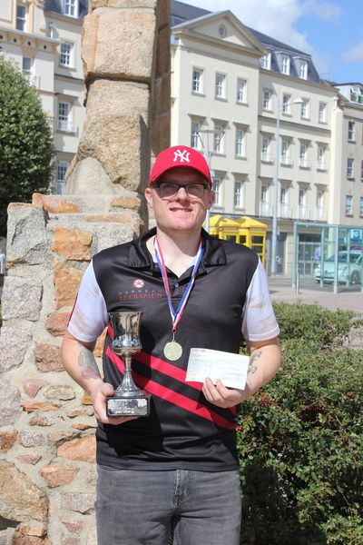

Swiss Results below.

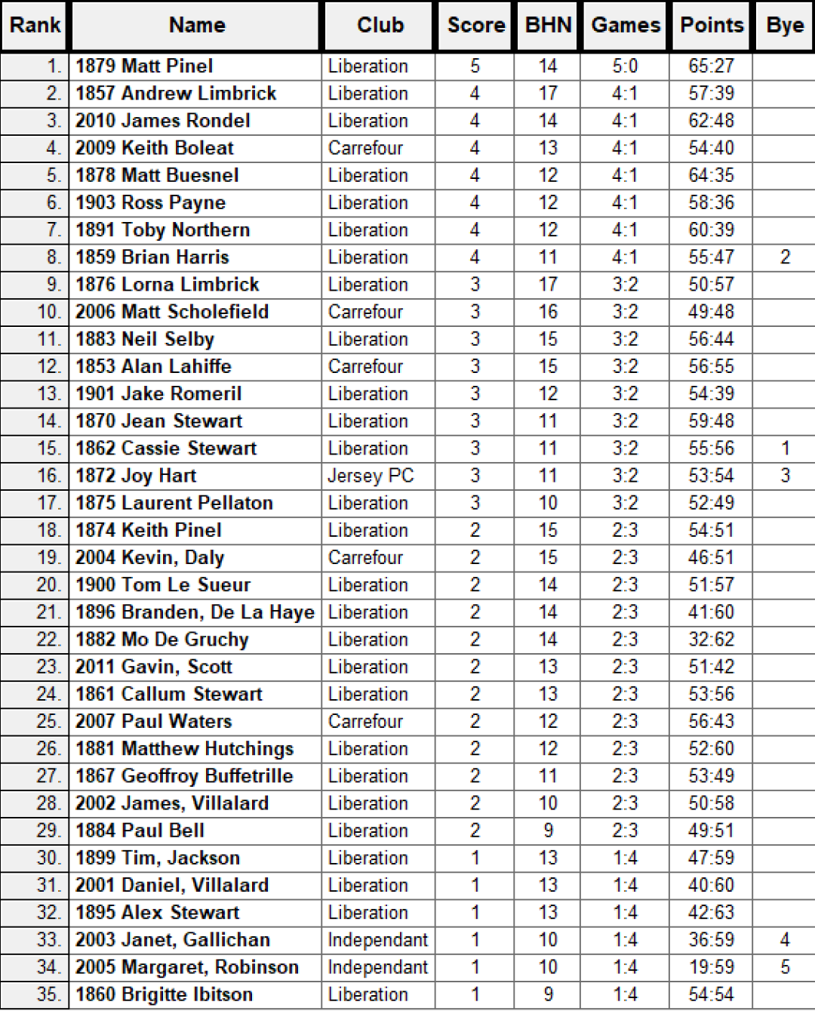
Ranked | Quarter Finals |  |  |  |  | Ranked
1st | Matt Pinel | 13 | v | 11 | Brian Harris | 8th
2nd | Andrew Limbrick | 8 | v | 13 | Toby Northern | 7th
3rd | James Rondel | 13 | v | 3 | Ross Payne | 6th
4th | Keith Boleat | 12 | v | 13 | Matt Buesnel | 5th
 | Semi Finals
1st | Matt Pinel | 13 | v | 4 | Matt Buesnel | 5th
3rd | James Rondel | 12 | v | 13 | Toby Northern | 7th
 | 3rd Place Play Off
3rd | James Rondel | 9 | v | 13 | Matt Buesnel | 5th
 | Finals
1st | Matt Pinel | 13 | v | 7 | Toby Northern | 7th

Club email address - liberationpc@gmail.com

Club Website - www.liberationpetanque.co.uk

Kind Regards

Toby Northern

Chairman

Liberation Petanque Club

SPONSORED BY

