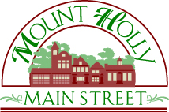
Robert V. Drapala
Mount Holly Car Show Committee Chairman
Ph: 609-346-2416
Email: msmhnj@gmail.com
www.MainStreetMountHolly.org
PO Box 747, Mount Holly, NJ 08060

16th Annual Mount Holly Car Show
Sponsorship Levels

Presenting Sponsor (one available) - $3,000

- Top contributing sponsor in the 16th Annual Mount Holly Car Show
- Your logo prominent on all event marketing such as social media, yard signs, t-shirts, event banners (not including airplane tow banner below)
- Live event publicity announcements at the DJ and stage during the car show
- 10x10 Space at the event
- 6’x2’ Banner (artwork to be provided by sponsor)
- Up to (5) complimentary cars entered into the show
- One “Presenting Sponsor” trophy selected by your representative
- Logo placard placed on each car entered into the show

Platinum Level Sponsor (one available) - $2,000

- Live event publicity announcement at the DJ and stage during the car show
- Logo on social media, t-shirts
- 10x10 Space at the event
- 6’x2’ Banner (artwork to be provided by sponsor)
- Up to (3) complimentary cars entered into the show
- One “Platinum Sponsor” trophy selected by your representative

Banner Tow (two available) - $2,000-range

- Price depends on size, type of banner (plain text, full-color, etc.)
- Airplane flying over high-traffic area Friday before event and then during peak event time
- Customizable image and logo available
- 10x10 Space at the event
- (1) Complimentary car entered into the show

Proceeds from the event benefit Main Street Mount Holly, a volunteer-driven nonprofit organization, whose mission is to protect, promote and enhance our historic downtown. Main Street Mount Holly is a NJ 501c3 registered organization so your donation is tax deductible (EIN 04-3668475).

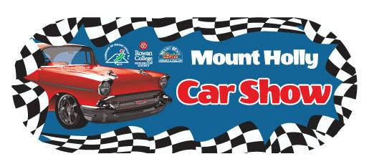

16th Annual Mount Holly Car Show
Sponsorship Levels (Continued)

Gold Level Sponsor (one available) - $1,000

- Live event publicity announcements at the DJ and stage during the car show
- 10x10 Space at the event
- 6’x2’ Banner (artwork to be provided by sponsor)
- One “Gold Sponsor” trophy selected by your representative

Stage Sponsor (two available) - $750

- Live event publicity announcements at the DJ and stage during the car show
- Large banner affixed to stage (your logo or message captured in many pics of bands!)

Silver Level Sponsor (two available) - $500

- Live event publicity announcements at the DJ and stage during the car show
- 6’x2’ Banner (artwork to be provided by sponsor)
- One “Silver Sponsor” trophy selected by your representative

NEW Bronze Level Sponsor (four available) - $350

- Live event publicity announcements at the DJ and stage during the car show
- 3’x2’ Banner (artwork to be provided by sponsor)

NEW Drawstring Bag Sponsor (limited quantities) - ONLY $250

- Your logo on the drawstring backpacks that will be handed out to every car show entrant and also available for purchase by event attendees
- Also entitles you to place your marketing materials inside for distribution!

Trophy Sponsor (limited quantities) - $150

- One trophy winner selected by your representative

Note - Local Merchant Discount - $100 off Presenting, Platinum, Gold or Silver sponsorship (for businesses within downtown Mount Holly’s business district)

Proceeds from the event benefit Main Street Mount Holly, a volunteer-driven nonprofit organization, whose mission is to protect, promote and enhance our historic downtown. Main Street Mount Holly is a NJ 501c3 registered organization so your donation is tax deductible (EIN 04-3668475).

