REGULAR MEETING
JULY 21, 2022

The Regular Meeting of the Town Board of the Town of Hampton, County of Washington and the State of New York was held at the Town Hall, 2629 State Route 22A, Hampton, New York, on the 21st day of July 2022.

PRESENT: David K. O’Brien------------Supervisor
Donald Sady-----------------Councilman
Tamme Taran----------------Councilwoman
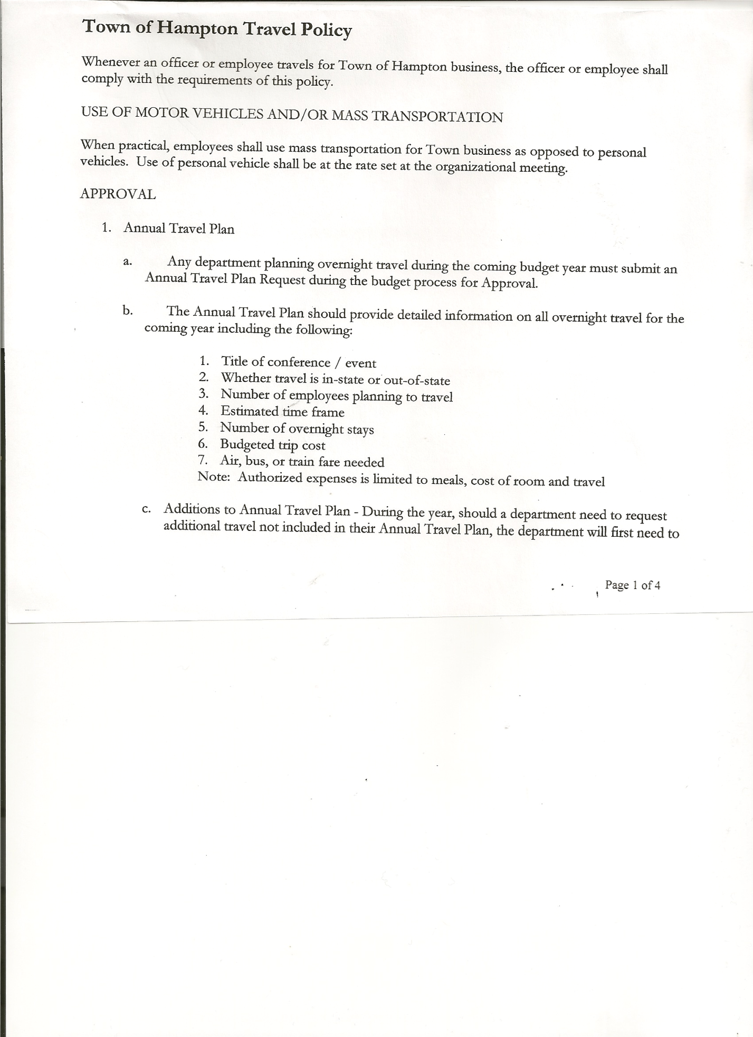
Michael Pietryka------------Councilman
Travis Dean------------------Councilman
Rebecca Jones---------------Town Clerk
Camilla Shaw----------------Tax Collector/Deputy Town Clerk
Tyler McClure---------------Highway Superintendent

Planning Board Member (s):…Matthew Pratt and Richard Cole
Others present at the Town Hall: Abigail Dean, Bruce Jones, Artie Pratt, Leonard Reed and Andrea Sweeney

The Regular Meeting was called to order by Supervisor O’Brien at 7:30pm, followed by the Pledge of Allegiance. Location of Fire Exits were given. Quorum of board members present.

RESOLUTION NO. 50-2022
APPROVAL OF THE MINUTES
On a motion of Councilman Sady, seconded by Councilwoman Taran, the following resolution was ADOPTED: AYES 5 O’Brien, Sady, Taran, Pietryka, Dean
NAYS 0
RESOLVED, that the Regular Town Board Meeting Minutes for June 16th, 2022 are approved.

PERMITS/SUBDIVISIONS
Bruce Jones, 2338 County Route 18 came before the board to amend his previous filed Subdivision. The amended Mylar Map shows .7 and 62 +/- acres be subdivided. Following a discussion, the following resolution was introduced:
RESOLUTION NO. 51-2022
JONES- APPROVAL OF AMENDED SUBDIVISION
On a motion of Councilman Sady, seconded by Councilwoman Taran, the following resolution was ADOPTED: AYES 5 O’Brien, Sady, Taran, Pietryka, Dean
NAYS 0
RESOLVED, to approve the Amended Subdivision and Mylar Map as presented.

Richard Cole, Dog Control Officer has a State Inspection on Monday, July 25th @11:00am. No calls. Dog crate that the Town has may need to be replaced.

Camilla Shaw, Tax Collector….. no activity. Submitted Bank Statement to the Board for review and signatures.

TOWN BOARD MEETING
JULY 21, 2022 PAGE 2

Bonnie Hawley, Chair Planning Board…submitted her report, which was read by Supervisor O’Brien, copy of the minutes of their meeting held July 13th, 2022 are attached. Next meeting is planned for August 10th, 2022.

Tyler McClure, Highway Superintendent submitted his report, copy of which, is attached.
Insurance will cover items (tools, equipment and signs) that were in the back of one of the trucks, that was stolen. Discussed security options for the Town Garage/Town Hall. Will check on prices and discuss further at a future meeting.
Thank you to resident Joe Taran for his watchful eye for the missing truck and alerting Tyler to its whereabouts.
Tyler also wanted to say Thanks to the Town of Whitehall, Town of Granville and Village of Granville for their help with various items on the work with the culverts.

SUPERVISOR’S REPORT/ COUNTY UPDATES/ COMMUNICATIONS

RESOLUTION NO. 52-2022
APPROVAL OF SUPERVISOR’S MONTHLY REPORT
On a motion of Councilwoman Taran, seconded by Councilman Sady, the following resolution was ADOPTED: AYES 5 O’Brien, Sady, Taran, Pietryka, Dean
NAYS 0
RESOLVED that, the Supervisor’s Monthly report be accepted as submitted for JUNE
05/31/22 06/30/22
ACCOUNT BALANCE RECEIPTS DISBURSEMENTS BALANCE
General Fund $ 53,381.45 $ 14371.39 $ 8,084.76 $ 59,668.08
Highway Fund $333,078.00 $ 8.15 $ 18,878.96 $ 314,207.19
Equipment Reserve $114,935.37 $ 2.83 $ 0.00 $ 114,938.20
Fire #1 $ 44,163.00 $ 0.00 $ 22,081.50 $ 22,081.50
Fire #2 $ 10,404.00 $ 0.00 $ 5,202.00 $ 5,202.00
Cemetery $ 1,760.46 $ 1.21 $ 0.00 $ 1,761.67
Totals $557,722.28 $ 14,383.58 $ 54,247.22 $ 517,858.64
All Board Members present signed Supervisor’s Report.

NEW BUSINESS
Dog Control Law. Following a discussion, the following resolution was introduced:
RESOLUTION NO. 53-2022
Introduced by Councilman Donald Sady
who moved its adoption.
Seconded by Councilman Michael Pietryka

TITLE: RESOLUTION INTRODUCING PROPOSED LOCAL LAW AMENDING THE DOG CONTROL LOCAL LAW OF THE TOWN OF HAMPTON

WHEREAS, pursuant to Section 64 of the Town Law of the State of New York and the Municipal Home Rule Law, the Town Board (the “Board”) of the Town of Hampton (the “Town”) has the authority to adopt a local law protecting the health, safety and welfare of the residents of the Town of Hampton; and

WHEREAS, the Board has been reviewing and discussing the possibility of adopting a local law modifying certain provision of the current Dog Control Local Law of the Town of Hampton and a local law has been drafted and prepared regarding the regulation of Dog Control in the Town of Hampton; and

TOWN BOARD MEETING
JULY 21, 2022 PAGE 3

WHEREAS, the Board believes that it is in the best interests of the residents of the Town of Hampton to proceed with the review and holding of a public hearing with regard to the proposed local law; and

WHEREAS, the Town Board wishes to hold a public hearing with regard to the proposed local law.

NOW, THEREFORE BE IT RESOLVED, that the Town Board hereby introduces and schedules a public hearing on the proposed local law modifying the Dog Control Local Law of the Town of Hampton, a copy of which is attached to this resolution and made a part hereof, which public hearing shall be held at the Town Board’s meeting on August 18th, 2022, at 7:00 p.m.; and be it further

RESOLVED, that the Town Clerk shall publish notice of the public hearing in the official newspaper of the Town and post notice thereof in accordance with law; and be it further

RESOLVED, that this resolution shall take effect immediately.

DATED: July 21, 2022, Supervisor O’Brien AYE
Councilman Donald Sady AYE
Councilwoman Tamme Taran AYE
Councilman Michael Pietryka AYE
Councilman Travis Dean AYE

NEW BUSINESS
Letter of resignation from Councilman Travis Dean was read by Town Clerk Jones.
RESOLUTION NO. 54-2022
ACCEPTANCE OF RESIGNATION
On a motion of Councilman Sady, seconded by Councilwoman Taran, the following resolution was ADOPTED: AYES 4 O’Brien, Sady, Taran, Pietryka,
NAYS 0
ABSTAIN 1 Dean
RESOLVED, to accept Councilman Dean’s resignation letter, effective August 7th, 2022

From the County Board of Elections…August 8th is the last day to resign and have the office on the November ballot. So Councilman Dean’s unexpired term will be up for a vote on the November 8th ballot in Hampton. The Hampton Republican and Democrat Town Committees will have the responsibility of appointing a candidate to run for the office. In the interim, the Town Board can appoint someone to fill the vacancy through 12/31 or just leave it vacant until 1/1/23. Former Councilwoman Andrea Sweeney agreed to fill the position for the remainder of the year. Following a discussion on the above, the following resolution was introduced.
RESOLUTION NO. 55-2022
APPOINTMENT OF TOWN COUNCIL MEMBER
On a motion of Councilman Pietryka, seconded by Councilman Sady, the following resolution was ADOPTED: AYES 5 O’Brien, Sady, Taran, Pietryka, Dean
NAYS 0
RESOLVED, to appoint Andrea Sweeney to fill the Council seat effective August 8th to December 31st, 2022.

TOWN BOARD MEETING
JULY 21, 2022 PAGE 4

PUBLIC COMMENTS/COUNCIL COMMENTS
Brent Perry, son of Kim and David Perry, grandson of Supervisor O’Brien is currently in North Dakota at the Greco Roman Junior Nationals. Brent is a Granville High School wrestler representing the Golden Horde.

Hampton Volunteer Fire Co., Inc. submitted their January – December 2021 Operating Budget.
The Fire Company will be holding a Chicken BBQ on August 13th at the Fire House.

RESOLUTION NO. 56 -2022
AUDIT OF CLAIMS
On a motion of Councilwoman Taran, seconded by Councilman Sady the following resolution was ADOPTED: AYES 5 O’Brien, Sady, Taran, Pietryka, Dean
NAYS 0
RESOLVED that the bills have been reviewed by the Town Board and are authorized for payment in the following amounts.
General Fund No. 91 through No. 106 $ 2,153.96
Highway Fund No. 64 through No. 75 $ 20,871.54
Total both funds $ 23,025.50

The Town Clerk’s report for June 2022 was submitted to the Board. The Town Clerk had Board Members review and sign bank reconciliation statements for the Town Clerk Account and Special Clerk Account dated June 30, 2022.

RESOLUTION NO. 57-2022
MEETING ADJOURNED
On a motion of Councilman Sady, seconded by Councilwoman Taran, the following resolution was ADOPTED: AYES 5 O’Brien, Sady, Taran, Pietryka, Dean
NAYS 0
RESOLVED that the meeting adjourned at 8:42pm.

Respectfully submitted,

Rebecca S. Jones, RMC
Town Clerk

