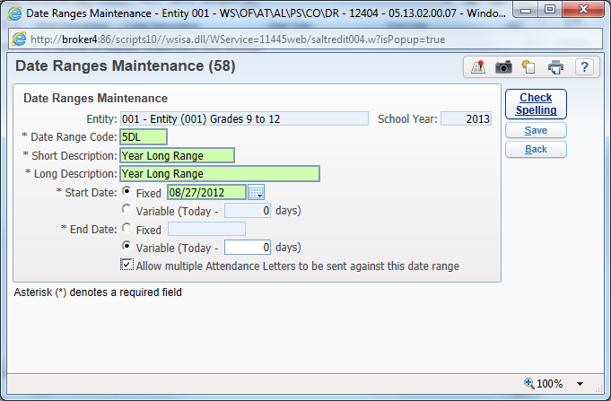
5 Day [Unexcused] Attendance Letters YR Long – once a student pulls the 5 days – this setup will start recounting
For YR long range to add a grace period for parent notes add it here at the *End Date – Variable (Today – 4 days) or add the number that your system uses
- Create a Date Range (WS\OF\AT\AL\PS\CO\DR). The start date should be fixed and set to the start date of the school year for the entity. The End Date should be set to Variable and equal to Today – 0 days. The option “Allow multiple Attendance Letters to be sent against this date range” needs to be checked. [Note: the Grace period does not work on YR long – you have to add the days at the *End Date – Variable (Today – 4 days) or the number of days needed
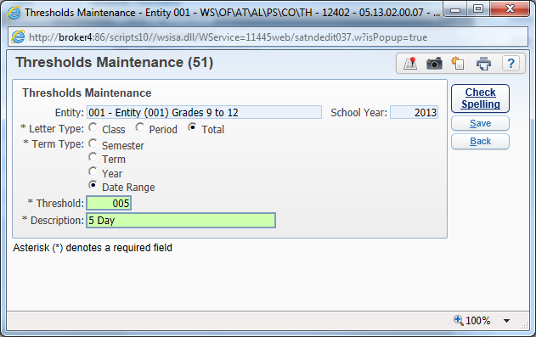
- Create a Threshold (WS\OF\AT\AL\PS\CO\DR). The Letter Type should be set to Total; the Term Type should be set to Date Range. Enter the Threshold of 005.

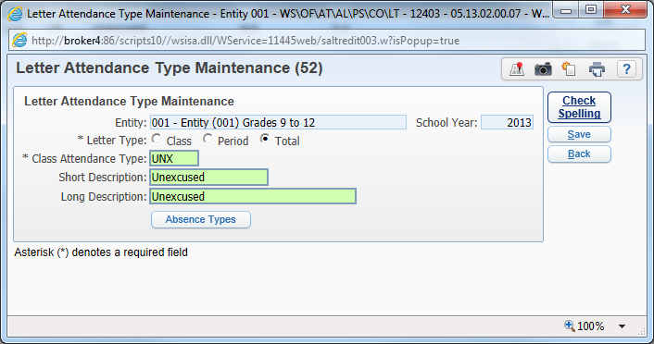
- Create a Letter Attendance Type (WS\OF\AT\AL\PS\CO\LT). The Letter Type should be set to Total. Click the Absence Types button to select which absence types will be counted for the Letter.
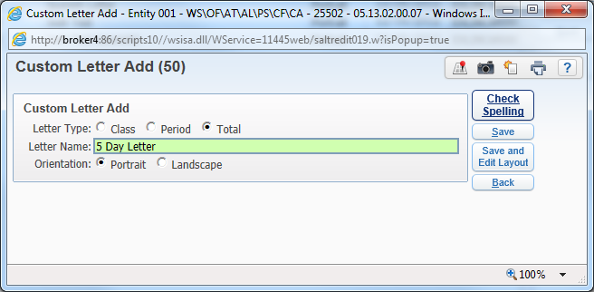
- Add a new Custom Attendance Letter (WS\OF\AT\AL\PS\CF\CA). The Letter Type needs to be set to Total.
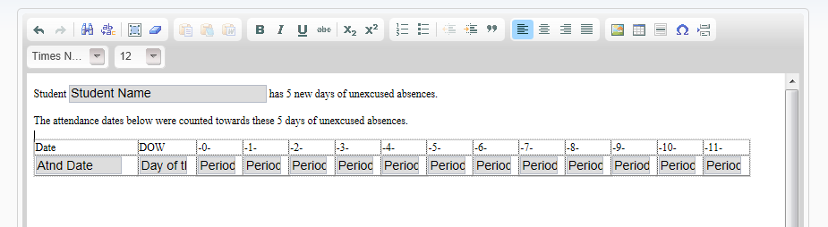
- The custom letter can be set up as the customer desires. To include the attendance details for the 5 days of absence be sure to include the Detail Area in the Letter.
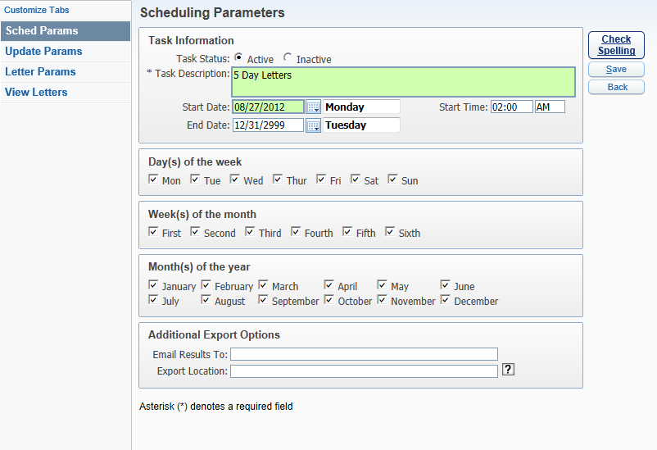
- Create a new Scheduled Letters task (WS\OF\AT\AL\SL). This should [can] be set up to run every day. **** [Our system only runs once a week]
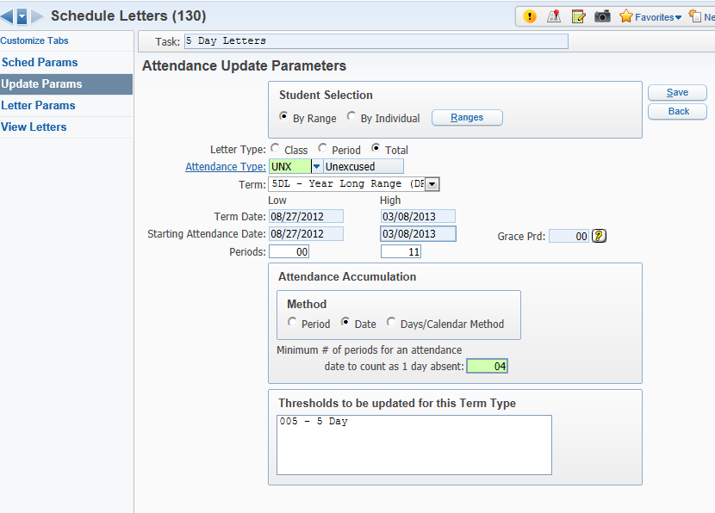
- Enter the Attendance Update Parameters as shown. The Letter Type set to Total; Attendance Type should be the one that was created earlier, UNX in this example. For the term select the Date Range that was created earlier, 5DL in this example. Select “Date” for the Attendance Accumulation Method. Enter the number of periods for the Day to count as absent.
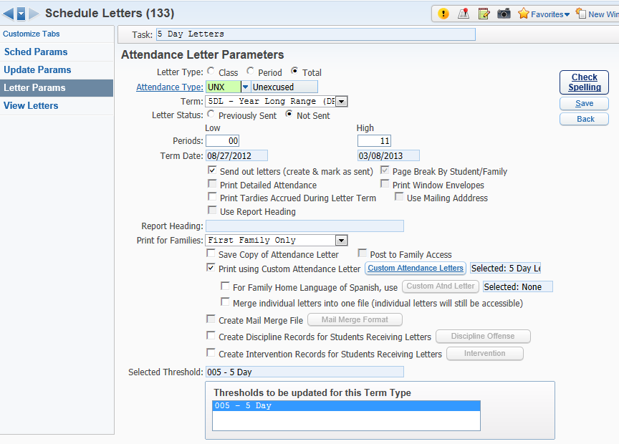
- Enter the Attendance Letter Parameters as shown above. Select Total Letter Type. The Attendance Type should be the one created earlier, UNX in this example. The Term should be set to the Date Range that was created earlier, 5DL in this example. Set the Letter Status to Not Sent. Select the option “Sent out letters (create & mark as sent). Check the option “Print using Custom Attendance Letter”, and then select the Custom Letter that was created earlier. Select the 005 threshold.

*You set up the attendance letters each year
** You also have to go to Office/Attendance/Product Setup/Configuration/Attendance Letters Setup–AL
Path – WS\OF\AT\PS\CF\AL
Entity Year Attendance Options – and check – Use Attendance letter by Totals
And you do this for each school – once this is set up it clones over and stays the same

