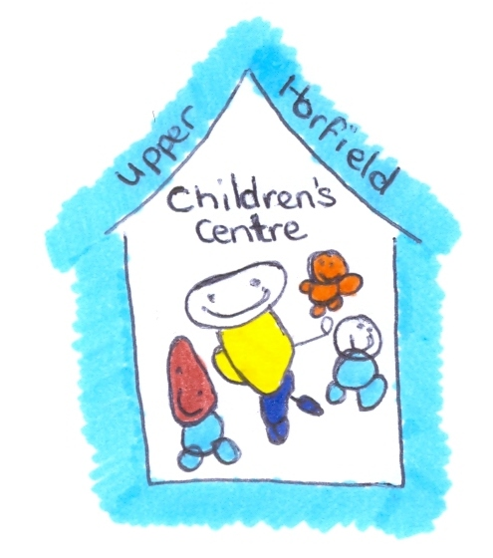
Upper Horfield Children’s Centre and Community School
Transition Policy
January 2015-17
The Children’s Centre bases its principles on believing that children should feel as comfortable, confident and emotionally safe and secure as possible when entering this early years setting and/or moving between rooms. It is recognised that the emotional bonds that children form with their parent/s and other caregivers are crucial for their personal, social and emotional development. Helping children to develop secure attachments with key persons will support them to feel safe and confident to explore and learn in their new environment and to enable the various transitions processes to be successful. It is important for key persons to work closely with the child and their parent/ or carer to get know them as individuals and discuss the child’s current experiences, routines, strengths, preferences and interests to plan a smooth transition to a new environment. Children enter the setting from a variety if different backgrounds and the aim is to respond to these in various different ways so that all children and their families are welcomed as individuals and have their needs met accordingly. It is important to work together with children and their families to support children’s developing independence, self confidence and resilience as they take the next step in their learning and development journey.

Aims and guidelines for children entering centre and/or transitioning between rooms
- To share the transition process with children and their families ahead of time to prepare children for their new experience. This will be through discussions with the Centre Manager if new to the setting or with a current key person if moving between rooms
- Parent/carers will receive a leaflet that explains the transition process, identifies key person/s and how the Centre aim’s to support children to learn and develop in their new room. Practitioners will ensure that the information is communicated in ways that enable all families to understand the process, new routines and key information.
- To provide new starters with an opportunity for a home visit from two practitioners from the centre, one person being their child’s new key person and the other being a family support worker or room leader. This will provide an opportunity to get to know the child in their home environment and begin to enable them to develop a bond with new caregivers. Parent’s will share knowledge of their child including their individual personalities, likes and dislikes, current routines and the languages the child is familiar with. Practitioners will be able to answer any questions parents or children may have about the transition process.
- To provide children moving between 0-3’s to the 2-4’s room with another home visit to introduce new key person/s and update children’s ‘All About Me’ forms, care plans, discuss their routines and needs at home and answer any questions the parent/carer may have.
- Where appropriate to provide visuals and/or other forms of communication so that children can be prepared for a transition e.g. a simple book that shows photographs of the new environment and key persons
- To offer a transition/settling in period that promotes short periods of separation which are gradually built up to a whole session and minimises anxiety and stress.
- To encourage children and their families to recognise the transition as an exciting time to gain new experience, grow in confidence and take the next step in their learning journey, whilst acknowledging that some children and families may experience a range of emotions.
- To create and maintain an ethos and learning environment that is responsive and flexible to value and meet individual children and families needs
- To follow the induction process for each room and transition. After paperwork is completed and home visits have occurred, the children will visit the new room with their parent/carer for up to an hour. This will support children to explore the environment with the support of their parent/carer and familiarise with new persons, routines and opportunities. New starters to the centre will have a further two visits to the room and parent/carers will be encouraged to stay on site but the time away from the parent will be gradually increased to provide opportunity to build a relationship with their new key person/s.
- Children moving between rooms will have at least one visit to the room with a current key person to enable them to explore the new environment with a familiar care-giver; they will also have a visit to the new room with their parent/carer. Children usually transition smoothly between rooms but the transition is based on the individual needs of the child and family and may extend or adjust the settling in period accordingly. Current key person/s will meet with new key person to discuss information regarding their care needs and learning and development.
- Children will have photographs of themselves and families within their new environment to help them develop a sense of belonging
- To arrange a parent consultation meeting with new key person/s within the first 6-8 weeks of settling to a new room to discuss and share progress, learning and development.

There is an aim to adapt transition timing to the needs of the child but there are some guidelines on which the Centre bases the principle of moving to different rooms, they are as follows:

Starfish babies = 0-24 months
Pufferfish 2’s = 24 months – 30/33 months (36 months if born Jul/Aug)
Coral 2’s = 30/33 months to pre-school age
Coral 3 and 4’s = pre-school to reception.

Guidelines – children moving to another setting
- Parents/carers are asked which setting their child in moving to.
- Where possible children are prepared for the move through discussions and group times around change and feelings
- Parents/carers are asked whether they wish to pass on the child’s learning diary to the setting themselves or would like centre to forward
- The child’s recent ‘Learning Journey’ and a current observation are forwarded to the receiving setting.
- If child is moving to reception class they will have a Bristol City Council EYFS transition form completed and forwarded to the receiving setting.
- Teachers and or key/staff from new setting are invited to meet the child during a session at the centre. Where possible they will have an opportunity to meet with a key person to update them on child’s progress and individual needs
- Children and their parents are invited to a ‘graduation ceremony’ near the end of the summer term as nursery children leave for reception. This is to celebrate their achievements, say goodbye and wish them luck on their learning journey
- Children with additional needs will have a carefully planned transition to their new setting which includes visuals, photograph books and additional meetings with parents and receiving setting

