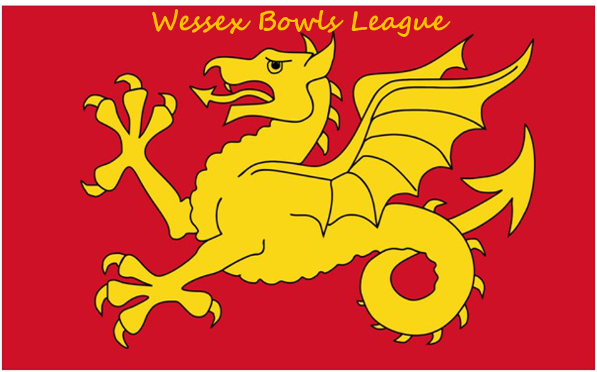

WESSEX BOWLS LEAGUE
Treasurer
Debroy Gregory

Secretary
Peter Stewart

Chairman
David Murley BEM
Wessex Bowls Play Off Rules

47. Sixteen Clubs shall qualify for the knockout stages after completion of the programme of Regional matches
48. These shall comprise the winners and runners up of each Region plus two wild card entries with the best record as determined by
(a) average points earned per each match. Followed by
(b) average shot difference per each match. Followed by
© highest number of shots scored.

49. The eight winners will be drawn randomly. The sixteen qualifiers shall play a first round on a knockout basis as follows:
Game A Winner 1 v Runner Up 7
Game B Winner 2 v Runner Up 5
Game C Winner 3 v Wild Card
Game D Winner 4 v Runner Up 6
Game E Winner 5 v Runner Up 3
Game F Winner 6 v Wild Card
Game G Winner 7 v Runner Up 4
Game H Runner Up 1 v Runner Up 2

Quarters Finals
Game J Winner A v Winner B
Game K Winner C v Winner D
Game L Winner E v Winner F
Game M Winner G v Winner H
The first round and quarter finals games shall be played on a two-rink home, two-rink away basis over 21 ends or 4 hours maximum (excluding the two trial ends)whichever is the shorter.
In the event of a tie after 21 ends ONE rink number only, to be nominated by the Challenger before the draw is made for rinks, shall play an extra end to determine the result of the tie. The extra end shall only be played if the game ends in a draw. The only exception to this is when the home and away rinks are unable to play at the same time then the extra end will be played by the nominated rink immediately after the 21st end is completed.

50. The semi-finals will be:-
Winner Game J v Winner Game K
Winner Game L v Winner Game M

These two games and the Final shall be played on neutral greens over 21 ends or 4 hours maximum (excluding the two trial ends). In the event of a tie after 21 ends ONE rink number only, to be nominated by the Challenger before the draw is made for rinks, shall play an extra end to determine the result of the tie. The extra end shall only be played if the game ends in a draw.
Issue date: May 2019

