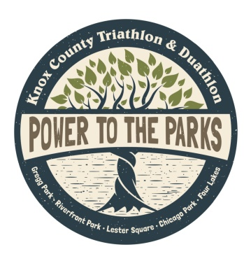
16th Annual
Knox County
Triathlon & Duathlon
Sunday, June 11, 2023
Gregg Park

2023 Sponsorship Opportunities
Sponsorships accepted until May 1, 2023
(Act NOW for optimal recognition!)

www.tryknoxcounty.com

Sponsorship Levels:

Platinum- Cash & In Kind Gifts * $3,000+
(Monetary donation must also be included to qualify at this level)
- Your logo on shirt, website and in race-day packets
- Your logo on race-day products (1st come, 1st choice)
- Your sponsorship announced in rotating radio ad
- Your product or coupon in race-day packets
- Opportunity to present medals at finish line
- Your banner and/ or tent on site
- Recognition on Facebook and at post-race event

Gold- Cash & In Kind Gifts * $1,000- $2,999
- Your logo on shirt, website and in race-day packets
- Your sponsorship announced in rotating radio ad
- Your product or coupon in race-day packets
- Opportunity to present medals at finish line
- Your banner and/ or tent on site
- Recognition on Facebook and at post-race event

Silver- Cash & In Kind Gifts * $500- $999
- Your logo on shirt, website and in race-day packets
- Your sponsorship announced in rotating radio ad
- Your product or coupon in race-day packets
- Your banner and/ or tent on site
- Recognition on Facebook and at post-race event

Bronze- Cash & In Kind Gifts * $150- $499
- Your name on shirt, website and in race-day packets
- Your product or coupon in race-day packets
- Recognition on Facebook and at post-race event

Ribbon- Cash & In Kind Gifts * Up To $149
- Your name on website and in race-day packets
- Your product or coupon in race-day packets

* In Kind Gifts: Subject to committee chair approval, defined as “products or services donated which provide a direct race benefit.”

Sponsorship Level: Platinum*_____ Gold*_____ Silver*_____ Bronze_____ Ribbon_____
*Please provide business logo. Logos can be sent to richardville7@live.com

Cash Gift $_______________ In Kind Donations___________________________________ Value $____________
List goods and/or services (includes fair market value, to be approved by committee chair)

Name____________________________________________________________________________________________
Exactly as you wish it to appear on promotional material- may be modified for space

Mailing Address___________________________________________________________________________________

Contact Person___________________________________________________________________________________
Signature Printed name/title

Contact Info _________________________________________________________________________________________________________
Phone Email

*If applicable, we have a banner for display on race day ___________ (Platinum, Gold, Silver)
Check here
Banners can be dropped off at the main entrance of Rainbow Beach June 5-9. Thank you!

------------------Detach and mail with check payable to: Vincennes Parks Department, 201 Vigo Street, Vincennes, IN 47591---------------------------

Please completely fill out and mail the above form to help. Thank you for your support of our event!

For questions/additional information contact:
Renee Richardville, Chair: 812-890-0544

Hosted By:
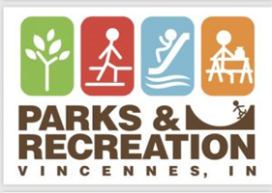

In Partnership With:

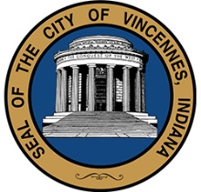
City of Vincennes
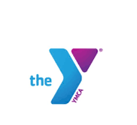
YMCA of Vincennes

