Hot Rods Fresno
City of
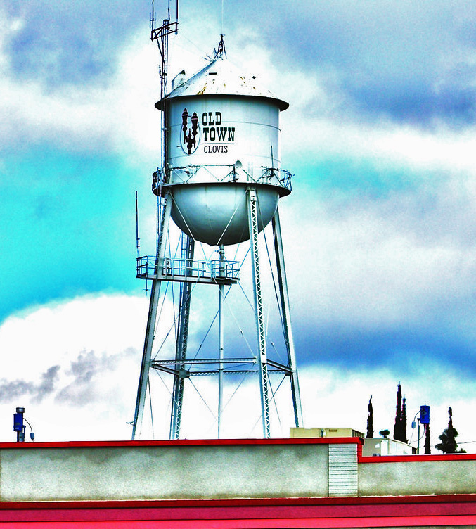
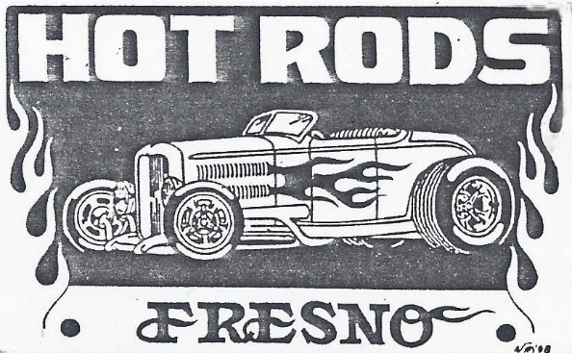
Water Tower Car Show
NEW LOCATION
Clovis
Old Town Clovis on Pollasky

Saturday, April 13, 2024
10:00 am ~ 3:00 pm
Registration between 7:00 am ~ 9:00 am
Awards Presentation is at 2:00 pm
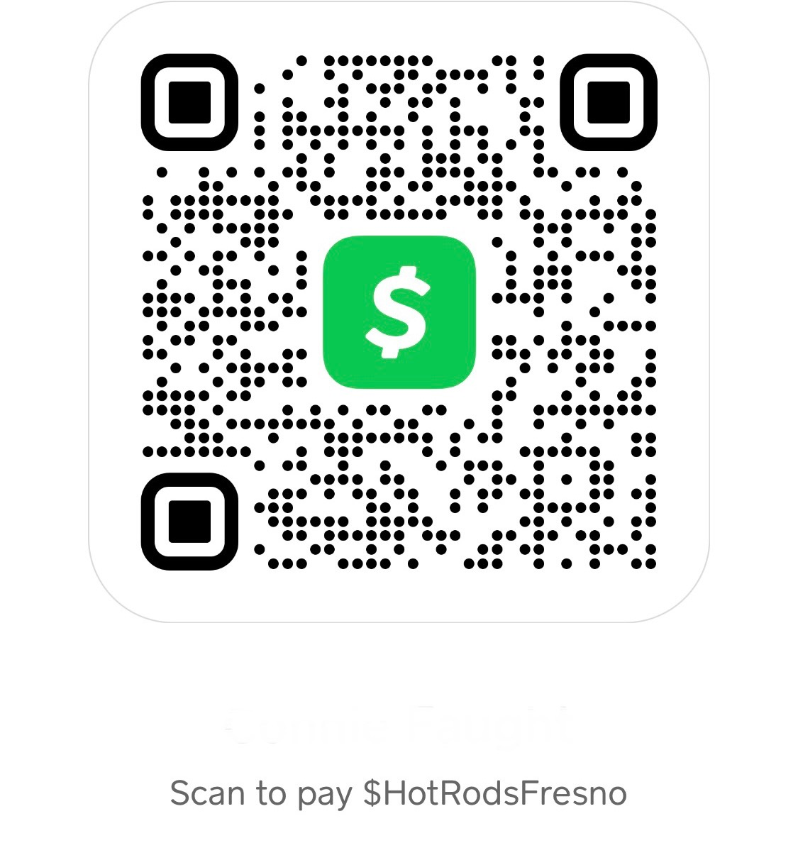
Check us out on Facebook
& Instagram
AWARDS
Top 50
Best of Show
Hot Rod Legend

No starting cars or stereo playing during show

Pre 1980 Cars Only

Make Checks Payable to HOT RODS FRESNO
Or CashAp (on notes add registration name)
Mail entry form to 1555 Pico Ave, Clovis, CA 93611

For questions, please contact Bill Faught 559-392-1281 or Connie Faught 559-392-1282
Email hotrodsfresno@hotrodsfresno.com website hotrodsfresno.com

NAME: ____________________________________________ Phone: __________________________

Address ______________________________________ City _____________________

Pre-regeration $30 (post marked on or before 4/1/24) Day of Registration $35 (after 4/1/24)

Registration $ _______________

# T-Shirts ______________ @ $20 = $ _______________ S M L XL XXL XXXL

Total Enclosed $ _______________

****NO RAIN CHECKS, THIS SHOW WILL GO ON RAIN OR SHINE (NO REFUNDS) *****
For vendor information, please contact Bill Faught @ 559-392-1281 (payment check or CashAp)
Registration form available at hotrodsfresno.com

Liability: In consideration of the acceptance of the right to participate, entrants’ participants and spectators, by this entry, release and discharge the producers and all associated with, of any/and all known damages, injuries and/or losses that may occur

