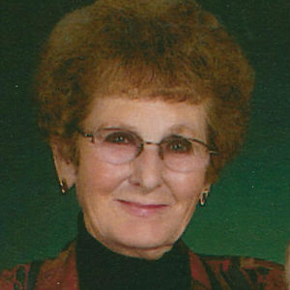
Jessie June Farnum, 88 of Owendale and Pigeon, passed away peacefully on Wednesday, December 30, 2015 at the Huron County Medical Care Facility, Bad Axe.
June was born June 20, 1927 at Gagetown, the daughter of Carl and Jessie (Andrews) Winchester. She and Willis Farnum were married at Gagetown on June 17, 1950. He preceded her in death on May 21, 2014. June and Willis resided in Owendale for 61 years, until 2011, when due to Willis' failing health, they moved to the Rose Garden Assisted Living facility in Pigeon. June resided there until May, 2015, when due to her declining health, she became a resident of HCMCF.
June loved children and was a babysitter for many children of the Owendale area. She was also a foster mother to several foster children that she and Willis took into their home, and she was a Sunday School teacher. She also worked at the Owendale school cafeteria for a few years, and was an Avon representative for many years. She loved taking care of her yard and beautiful flowers, especially roses, and was known in Owendale as the "Flower Lady." She attended the Elkton Missionary Church in Elkton for many years.
Surviving are her children, Gloria (Jerry) Laughlin of Caseville, Darwin (Kimberly) Farnum of Gilbert, Arizona, and "foster daughter," Bonnie Perry of Bad Axe; grandchildren, Jessica and Nicholas Farnum of Gilbert, Arizona; brother, Gerald Winchester of Caro; and many dear nieces and nephews. She was preceded in death by her beloved husband, Willis; sisters, Norma Fournier, Beulah Hobart, Althea Lorencz, Gwendolyn Sommers, Jane Hudson, and Margaret Winchester; and brothers, John, James, William, C.L., and Carlton Winchester.
The funeral service will be 11:00 a.m. on Monday, January 4, 2016 at the Elkton Missionary Church, with Pastor Reggie Courliss officiating. Burial will be in Grant Township Cemetery.
Memorials may be given to Elkton Missionary Church, Huron County Medical Care Facility, or Home and Hospice Advantage.
VISITATION AT MEYERSIECK-BUSSEMA FUNERAL HOME, PIGEON:
Sunday, January 3 2 – 8 p.m.
AND AT ELKTON MISSIONARY CHURCH, ELKTON:
Monday, January 4 10 a.m. until time of service at 11

