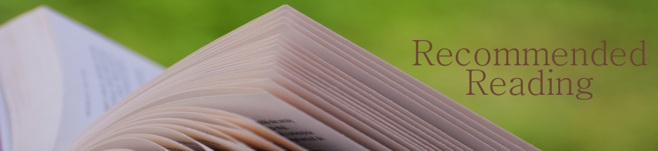
Suggested Reading: Babe Didrikson Zaharias
Compiled by Leslie Goddard, Ph.D.
For younger readers:

Babe Didrikson: Athlete of the Century by R. R. Knudson (1985). 8-12 years. Well-rounded, highly readable biography for children, part of the Women of Our Times series. My top pick for children.

Babe Didrikson: The Greatest All-Sport Athlete of All Time by Susan E. Cayleff (2000). Gr 7-12. Although intended for younger readers, this is an engaging, brief biography for anyone.

For adult readers:
Wonder Girl: The Magnificent Sporting Life of Babe Didrikson Zaharias by Don Van Natta Jr. (2011). The definitive biography of Babe to date. Thoroughly researched and highly readable. My top recommendation.
Babe Didrikson Zaharias: The Making of a Champion by Russell Freedman (1999). Engaging visual biography that uses hundreds of photographs to capture Babe’s irrepressible personality.
This Life I’ve Led: Babe Didrikson Zaharias Tells Her Own Story by Babe Didrikson Zaharias (1955). Babe sometimes elides the truth in the autobiography that appeared shortly before her death, but it’s fun to read and captures her larger-than-life personality.
Whatta Gal! The Babe Didrikson Story by William O. Johnson (1977). A fascinating, readable biography done after the success of the 1975 TV movie. Notable for the many interviews done with people who knew Babe, from her childhood friends to her teammates and golf competitors.
Movie:
Babe: The Babe Didrikson Zaharias Story, DVD (1975). Actress Susan Clark won an Emmy for her portrayal of Babe in this 1975 made-for-TV movie also starring former football star Alex Karras (they later married in real life). Wonderful film, rarely seen now and worth looking for.
Pat and Mike, DVD (1952). Babe makes a brief cameo in this black-and-white romantic comedy starring Katharine Hepburn and Spencer Tracy. The story is loosely based on Babe’s life with George.

