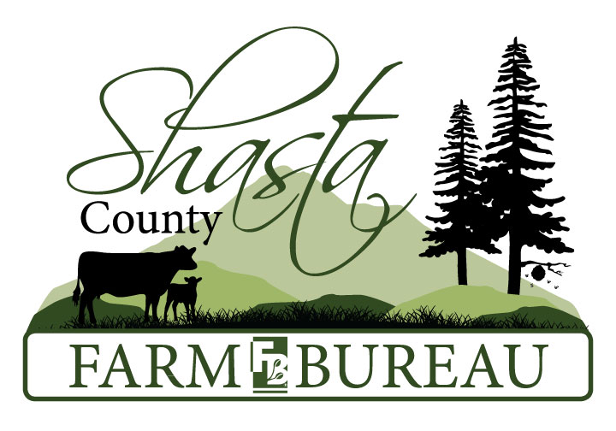
9444 Deschutes Rd Palo Cedro, CA 96073 (530) 547-7170 shastacountyfarm1@gmail.com
Membership Information
Protecting California
Family Farms and Ranches
Non-Profit 501 (C) (5)

Agricultural Membership ~ $175
An agricultural membership is an individual that receives income or is projected to receive income from agriculture. Agricultural members can be involved in setting policies at the county, state and national’s levels. Agricultural members receive the weekly Ag Alerts and the quarterly Shasta County Farm Bureau Farm News.
Business Supporting Membership ~ $215
A Business Supporting membership is for any business within Shasta County. You will receive weekly Ag Alerts (Agricultural Member) and the quarterly Shasta County Farm Bureau Farm News. Business Supporting members receive the following: 1 Free Business card size ad (per year), your business name and phone number in the directory, Farm Bureau Business Supporting stickers to display in your business and a Metal Farm Bureau Sign.
Deluxe Business Supporting Membership ~ $310
A Deluxe Business Supporting membership is for any business within Shasta County. You will receive weekly Ag Alerts (Agricultural Member) and the quarterly Shasta County Farm Bureau Farm News. Deluxe Business Supporting member receives the following: 1 Free ½ page ad in Shasta Farm News (per year), your business name, phone number and website in the Deluxe Business Supporting directory, Farm Bureau Business Supporting stickers to display in your business as a supporter of Shasta County Agriculture and Metal Farm Bureau Sign.
Support Agriculture with an Associate Membership ~ $72
An associate membership is for individuals who do not receive income from agriculture. Associate members receive the California Bountiful magazine and the quarterly Shasta County Farm Bureau Farm News.
Collegiate Supporting Membership ~ $25
A Collegiate membership is for students between 16-24 years old. Enrolled in post-high school education program such as a community college, four-year university or trade school. Gift memberships may be purchased. California residency is not required for membership. Collegiate supporting members have access to 46 weekly issues of Ag Alert online, scholarships, internship contacts, local and state events and the Young Farmers & Ranchers program.

Name: ____________________________________________________ Business Name: ________________________________________________
Address: ________________________________________________________________________________________________________________
Phone:( )___________-________________ E-mail: ________________________________________________________________________
County: _____________________ Date of Birth: __________________ Member Level (Dues): _____________________
Payment Options:
Online with a Credit Card at www.shastafarmbureau.com or www.cfbf.com
Mail form and payment to: CFBF-Membership 2600 River Plaza Dr. Sacramento, CA 95833
CREDIT CARD INFO: ____VISA____MASTERCARD____DISCOVER
CARD#_______________________________________EXPIRATION DATE________________3 DIGIT CODE

If you have any questions on how to join, call Stephanie Niles at 530-547-7170 or email shastacountyfarm1@gmail.com

