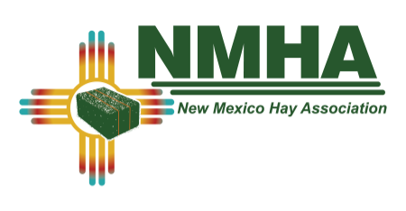
2022 VENDOR PRE-REGISTRATION
SOUTHWEST HAY CONFERENCE & TRADE SHOW
RUIDOSO CONVENTION CENTER, JANUARY 27TH & 28TH 2022.
PLEASE COMPLETE ALL INFORMATION BELOW

NAME OF PERSON(S) ATTENDING______________________________________________

____________________________________________________________________________

COMPANY:__________________________________________________________________

ADDRESS:__________________________________________________________________

CITY/STATE/ZIP:_____________________________________________________________

PHONE:______________________EMAIL_________________________________________

INDICATE BELOW:
STANDARD BOOTH EXHIBIT SPACE: $450.00
-TYPICAL TABLE DISPLAY
-PAYMENT ON/BEFORE DECEMBER 27TH
-INCLUDES REGISTRATION/HOSPITALITY HOUR & MEALS FOR TWO $________

**LATE REGISTRATION FEE $475.00, POSTMARKED AFTER DEC 31st ** $________

INDOOR TRADE SHOW AREA:
LARGE MACHINERY SPACE, $100 PER ITEM $________
(EX: SWATHER, BALER, TRACTOR, ETC.)
SMALL MACHINERY SPACE, $50 PER ITEM $________
(APPROX 6’X8’)
OUTDOOR MACHINERY SPACE $75 (approx. 20’X30’) $________
REGISTRATION (non-exhibitors) $100.00/person $________
NMHA Annual Membership $45.00 $________
DOOR PRIZE CONTRIBUTION ___________________________________________________
SILENT AUCTION CONTRIBUTION _______________________________________________

SPONSORSHIP DONATION LEVELS:
____”PREMIUM HAY”-$1000.00 OR MORE $________
(example): MAJOR SPEAKER, MEAL SPONSOR, ETC.)
INCLUDES BOOTH SPACE, REGISTRATION, DUES
____”DAIRY HAY”-$500 – 1000 $________
(example): COFFEE BREAK, HOSPITALITY HOUR, ETC.)
INCLUDES NON-EXHIBIT REGISTRATION AND DUES
____”GOOD HAY”-$250 $________
(example): PARTIAL COFFEE BREAK, ETC.)

TOTAL REMITTED: $______________
PLEASE RETURN THIS FORM ALONG WITH YOUR CHECK / OR ONLINE PAYMENT COMFRIMATION # TO THE ADDRESS ABOVE
CONVENTION CENTER DOOR WIDTH IS 16FT
NMHA IS NOT RESPONSIBLE FOR EXTRA ITEMS (electric cords, etc.) NEEDED FOR DISPLAYS

