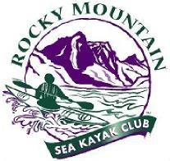
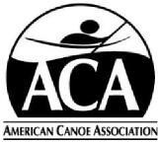
ROCKY MOUNTAIN
SEA KAYAK CLUB
MEMBERSHIP FORM
All Rocky Mountain Sea Kayak Club memberships are due to be renewed on or before March 31 regardless of the date you joined. All Rocky Mountain Sea Kayak (RMSKC) members must be current members of the American Canoe Association (ACA) and have a current and in-force insurance waiver on file with ACA.
Place an “X” in the appropriate boxes:
NEW RMSKC MEMBERSHIP RENEWING RMSKC MEMBERSHIP
RMSKC INDIVIDUAL MEMBERSHIP (18 + years old)
RMSKC FAMILY MEMBERSHIP (A family membership consists of all adults and children under the age of 18 residing in a household, regardless of relationship. In addition, all members of a household do not have to reside at the same address as in the case of children at college or children who live with another parent.) Each family member must have an individual ACA membership.
Full Name: __________________________________ Age ____ ACA# ________________ ACA Expiry: __/__/___
Full Name: __________________________________ Age ____ ACA# ________________ ACA Expiry: __/__/___
Full Name: __________________________________ Age ____ ACA# ________________ ACA Expiry: __/__/___
Address: _______________________________ City: ________________ State: ________ Zip Code: ________
Primary Phone(s): ________________________ Cell Phone(s): __________________________
________________________ __________________________
Email Address(es): _________________________________ ________________________________
Emergency contact for the persons listed above:
Contact Name: ___________________________________ Relationship: __________________

Telephone(s): _____________________________________ Email Address: ______________________________

- Mail this form and a $10 check (payable to RMSKC) to:
Rocky Mountain Sea Kayak Club
C/O Marsha Dougherty, Membership Coordinator
- S. Carr Street, Lakewood, CO 80226
- Join or renew membership with ACA and forward 2 emails to Marsha Dougherty marsha5847@gmail.com
One email is titled "ACA - Membership Card and Benefits" the second email is "PAC Annual Waiver (Adult) is signed and filed!"

Additional instructions are on the website and are very helpful www.rmskc.org
Or email Marsha with questions. Revised for the 2020 Season

