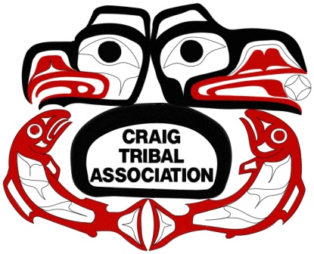

**Craig Tribal Association**

**P.O. Box 828**

**Craig, AK 99921**

**PH: (907)826-3996**

**Fax: (907)826-3997**

**Job Announcement**

**The Craig Tribal Association** is seeking to fill the following positions in Craig, Alaska: Heavy Equipment Operators, Truck Drivers (AK CDL required), Laborers, Flaggers, Mechanic, and Mechanic Assistant. These positions are full-time seasonal for the 2019 construction season. CTA has several funded, ready to start projects to complete for this year. Employment applications can be obtained at the following locations: CTA Main Office or Transportation Department and at the CTA Website.

**CLOSING DATE:** Open until filled

Posted: 03/04/19

By: Anna Guthrie, Administrator

ALASKA NATIVE, AMERICAN INDIAN PREFERENCE SHALL BE GIVEN TO THE APPLICANT WHO MEETS THE MINIMUM QUALIFICATIONS PURSUANT TO THE CRAIG TRIBAL ASSOCIATION’S PERSONNEL POLICIES AND PROCEDURES.

Applications may be emailed to: [tribal.admin@craigtribe.org](mailto:tribal.admin@craigtribe.org) or brought to:

CTA Office – 1330 Craig/Klawock Highway, Craig, Alaska. (907) 826-3996

The Craig Tribal Association will conduct background checks, pre-employment and random drug testing as a condition of Employment.