HOW TO USE THE WEB PORTAL
This service is FREE to our patients
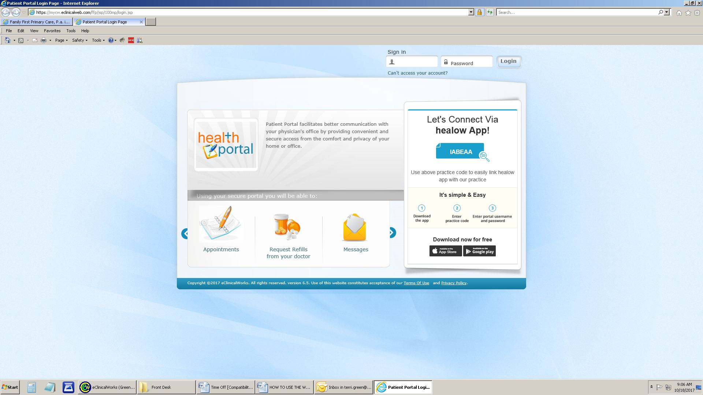
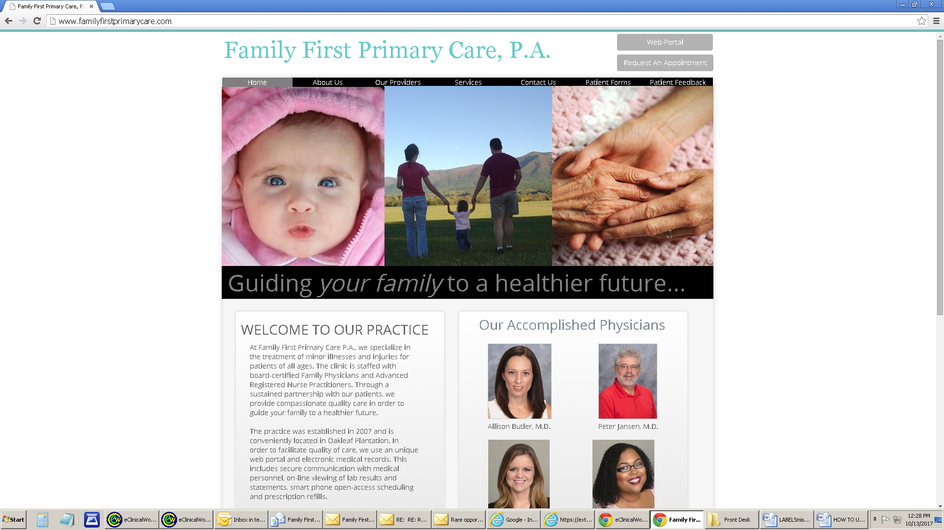

1. Open your INTERNET BROWSER

2. Log onto familyfirstprimarycare.com

3. Click onto “Web Portal”

- Type in your UNIQUE user name and
password

5. Read and sign the consent

Your web portal permits you to:
  - Email our office
  - Request prescription refills
  - Review your labs and other tests
  - Request an appointment

