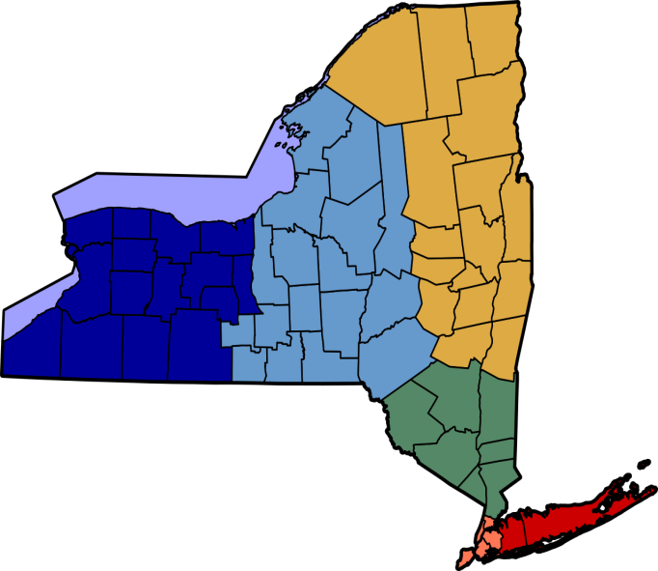
The New York State Association of Tax Receivers and Collectors
NYSATRC
By-Laws
6/14/2016

ARTICLE I
Section 1-Name
The name of this organization shall be the “NEW YORK STATE ASSOCIATION OF TAX RECEIVERS AND COLLECTORS (NYSATRC)”
Section 2-Objectives
The objectives of this organization shall be:
- To bring the Receivers and Collectors pertinent information from the State Legislature and others that may have an effect on their position.
- To provide, promote, and manage an annual training school for Tax Receivers and Collectors.
- To promote the attendance of Tax Receivers and Collectors at the Association of Towns’ annual meeting and training school in New York City.
- To assist in the formation of Local Associations of Tax Receivers and Collectors.
- To bring to the Receivers and Collectors an exchange of methods, ideas, information, etc. To fully realize this all-important position in local government.
Section 3 –Governing Rules
“Roberts Rules of Order” shall be the governing laws of Parliamentary Procedure for this Association, unless otherwise specified in these by-laws.
ARTICLE II
Section 1-Membership
- The membership of this Association shall be open to all Collectors and Receivers within New York State, Town, Village or School taxing authorities (and any individual holding a position in the office of Receiver or Collector of Taxes appointed or elected by the same taxing authority). The dues shall be twenty-five dollars ($25.00) per person, per year. One vote per taxing authority.
- Business Membership shall be available to individuals of business entities who perform business functions or dealing with tax collection. The dues shall be fifty dollars ($50.00) per individual business within the business per year.
- Social Membership of this Association shall be available to all retired Tax Receivers. Collectors and their Deputies. The dues shall be ten dollars ($10.00) per year
- All TSO’s that are paid members may attend the Executive Board meetings, with one voting member appointed by the Executive Board.

ARTICLE II (Continued)

Section 2-Membersip Dues
- The membership renewal application shall be mailed in January of each year with the intent that payment be received by April 30th or prior to the annual training seminar.
- Only those with membership in good standing are eligible to attend the NYSATRC annual conference.
- If membership has not been received by the annual conference registration, dues can be paid at the time of the conference with an additional fifteen dollars ($15.00) processing fee.
ARTICLE III

Section 1-Officers
The Association shall have the following Officers:
- President, First Vice President, Second Vice President, Secretary and Treasurer.
Section 2-Directors
The number of Directors shall be:
- Fourteen (14) representing the fourteen districts of this Association.
District 1 Erie, Genesse, Niagara, Orleans, Wyoming Counties
District 2 Allegany, Cattaraugus, Chautuaqua, Schuyler, Steuben Counties
District 3 Livingston, Monroe, Ontario, Wayne, Yates Counties
District4 Cayuga, Jefferson, Onondaga, Oswego, Seneca Counties
District 5 Herkimer, Lewis, Madison, Oneida, Otsego Counties
District 6 Broome, Chemung, Chenango, Cortland, Tioga, Tompkins Counties
District 7 Hamilton, Warren, Washington Counties
District 8 Essex, Clinton, Franklin, St. Lawrence Counties
District 9 Albany, Fulton, Montgomery, Rensselaer, Saratoga, Schenectady Counties
District 10 Columbia, Delaware, Greene, Schoharie Counties
District 11 Orange, Rockland, Sullivan, Ulster Counties
District 12 Westchester County
District 13 Nassau, Suffolk Counties
District 14 Putnam, Dutchess Counties

ARTICLE III (Continued)

- One Director from each Tax Service Organization (TSO) approved by the Executive Committee.
- Immediate Past President
Section 3 Executive Committee
- The Executive Committee is comprised of the Officers of the Association, District Directors, TSO Directors and the Immediate Past President
- Meetings may include any persons appointed as Committee Chairpersons whose presence at the Executive Session is deemed appropriate; as non-voting attendee (s)
Section 4 Terms of Office
- Offices of the President, First Vice President and Second Vice President shall be elected to one consecutive two (2) year term with the intent of ascending in rank.
- Offices of the Secretary and Treasurer shall be elected to a term of two (2) years, with maximum of (2) consecutive terms; by a majority vote of the membership.
Section 5 Vacancies
- In the event a vacancy exists in any office, the vacancy shall be filled by a majority vote of the Executive Committee for the remainder of the term.-
- An Officer, Chairperson, or Director who has been remiss in the performance of his/her duties shall be removed by a majority vote of the Executive Committee.
Section 6 Duties
The duties of each office shall be as follows:
- President shall preside at all business meetings of the Association and keep the Vice President(s) informed of all Association matters. The President shall annually approve the following standing Committees:
- Education
- Conference Planning
- Legal
- Membership
- Newsletter
- Fundraising
- Budget/Finance
- Nominating
- Scholarship
ARTICLE III (Continued)

- First Vice President shall be President-Elect with the intent to serve as President at the conclusion of the incumbent’s term. The First Vice President shall perform the duties of the President should he/she be absent or incapacitated in any way. The First Vice President will be a Member Ex-Officio of all committees with the right to vote; with the exception of the Nominating Committee. The First Vice President will also oversee the District Directors.
- Second Vice President shall be the First Vice President-Elect with the intent to serve as First Vice President at the conclusion of the incumbent’s term. He/she shall perform the duties of the First Vice President should he/she be absent or incapacitated in any way. He/she shall –perform whatever other duties necessary to help conduct the business of the Association.
- Treasurer shall receive and keep an account of all monies received and expended by the Association. Shall deposit all monies in the Association’s accounts. Shall prepare an itemized Treasurer’s report to be given at each executive meeting and also an itemized Treasurer’s report to be given to the membership at large at the Annual Meeting.
- Secretary shall take minutes and provide copies to members. Shall keep accurate records of general and executive meetings. Shall maintain and keep an up-to-date listing of all members and maintain all Association documentation as dictated by law. Shall keep an up-to date listing of all committees and committee members. Shall oversee the membership committee.
- Board of Directors shall assist in the formation of local associations. Shall provide information and support to all local receivers and collectors. Shall recruit new members. Shall maintain membership. Shall identify new collectors and provide them with a copy of the collector’s “First Aid Kit”. Shall be liaison between State and local associations.
- Committees shall elect a chairperson. Shall meet at least twice a year in person or via telephone. Shall provide committee goals and objectives to the Executive Committee. Shall provide a list of all committee members to the Secretary. Shall submit formal reports to the Executive Committee prior to each meeting. Shall submit one report to the general membership at the annual conference. Shall submit a report to the Newsletter Chairperson each time the newsletter is to be distributed.
Section 7 Meetings
- There shall be one (1) annual business meeting of all members and the Executive Committee that shall be held in conjunction with the annual Tax Receivers and Collectors meeting.
- Meetings of the Executive Committee shall be held on at least a biannual basis at a place central to all officers, unless there is sufficient business to prompt additional meetings. One of the meetings of the Executive Committee will be at the annual NYSATRC conference.

ARTICLE III (Continued)

- Fifty percent plus one of the Executive Committee shall be a quorum. All questions before the Committee shall be decided by a majority vote of those present.
Section 8 Elections
At the June meeting the President shall appoint a Nominating Committee of an odd number of members. Elections shall be held at the June meeting the subsequent year. Newly elected officers will assume their duties immediately.
ARTICLE IV
Section 1 Fiscal year
- The fiscal year of the Association shall be January 1st to December 31st.
- It shall be the responsibility of the Treasurer to prepare annually an itemized report in writing to be distributed to the members of the Association at the Annual Meeting.
- The Treasurer’s annual itemized report shall include the annual budget prepared by the Budget/Finance Committee and approved by the Executive Committee.
ARTICLE V
Section 1 By-Law Changes
The by-laws may be amended, revised or otherwise changed by a majority of the voting members of the Association present at the Annual Meeting.

Revision Dates:
Adopted August 23, 1974
Revised June 12, 1991
Revised June 14, 1998
Revised June, 2001
Revised June 15, 2004
Revised August 3, 2005
Revised June 10, 2014
Revised June 14, 2016

