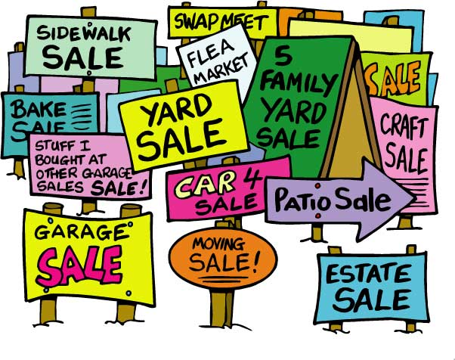

**The Bear Paw Ladies will be holding their Annual Yard Sale and we need you and your unwanted items. Mark your calendars for August 1st. You may donate your items by placing them in front of the store room at the clubhouse.**

**Mark your Calendar**

**BPLA Annual Yard Sale**

**August 1st**

**8:00 am - 12:00 noon**

**We Need Your**

**UNWANTED STUFF**

**We Need**

**Toys Linens**

**Sports Equipment**

**Christmas Items**

**Baby Items Games**

**Furniture Home Decor**

**Kitchen Supplies**

**Cookware Appliances**

**For information call Jean**

**Murtagh 706/735-3444 or**

**Margaret Jones 644-0006 to**

**donate items or sign up to help with the yard sale.**