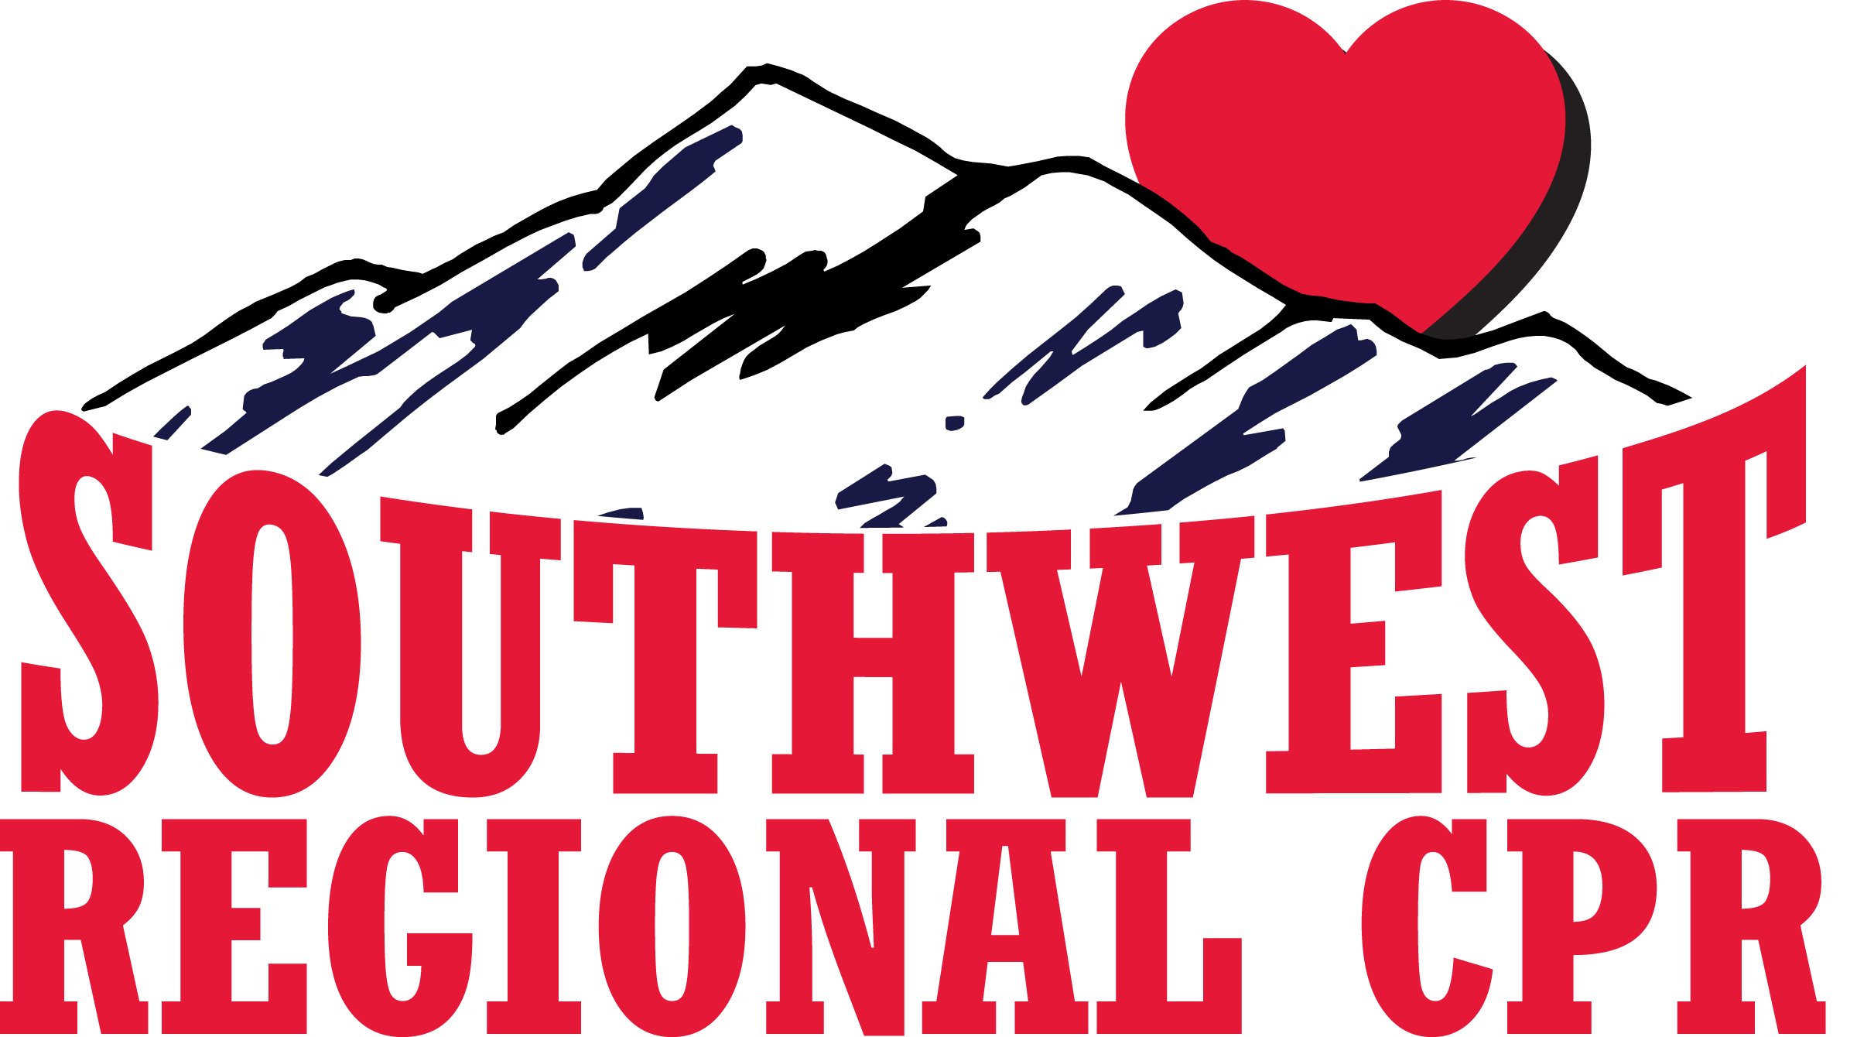
2117 Templeton Gap, C/S, Co, 80907 Phone: (719) 761-8979 Fax: (719) 457-5914

INSTRUCTOR/TRAINING SITE AGREEMENT FORM

This is an agreement between ________________________________, designated as a:

Check all that apply:
BLS Instructor : _________ Heartsaver CPR Instructor: _________
ACLS Instructor: _________ PALS Instructor: _________
Training Center Faculty: _________ Course Director: _________

member, and Southwest Regional CPR, Inc., a contracted training center with the American Heart Association (AHA).
The above instructor is affiliated with the following Training Site:______________________
This agreement is valid from issue date of the AHA Instructor/TCF card through the renewal date. The Instructor, TCF and/or Training Site will conduct all BLS, ACLS or PALS courses; Course Director, TCF, Instructor, ACLS Provider, PALS Provider, Healthcare Provider, Heartsaver, Heartsaver AED, Heartsaver First Aid, CPR for Family & Friends, and Heartsaver CPR in Schools, in accordance with standards and guidelines set forth by the AHA’s ECC Sub-committee for the Colorado and Wyoming region, using the following criteria:

CRITERIA

- Follow ALL of the most current AHA guidelines.
- Maintain a current Instructor card throughout this agreement.
- Maintain a copy of all rosters for classes taught for a period of three (3) years, making sure to send the original rosters and monitoring forms to Southwest Regional CPR, Inc. within 30 days of the course.
- Issue appropriate documentation of completion/participation to each student. If the cards are not given, Southwest Regional CPR, Inc. is NOT required to maintain records.
- Ensure all training will be done in an appropriate facility with all of the necessary equipment present.
- Maintain proper sanitary conditions on all supplies and equipment according to AHA standards.
- Instructor shall conduct himself/herself in a professional manner and not to jeopardize the integrity of Southwest Regional CPR, Inc. or the American Heart Association.
- Formally acknowledge that all fees for BLS, ACLS or PALS training do not represent revenue to the AHA.
PROBLEM SOLVING
Incomplete paperwork and/or classes taught improperly will result in the following:
- Verbal communication to discuss problems.
- Written communication with possible suspension and/or warning of termination.
- Possible termination of Instructor privileges with Southwest Regional CPR, Inc.

This agreement is a two-year agreement and will terminate on and no later than the date noted on the Instructor/TCF card. There is NO grace period for expiration. Southwest Regional CPR, Inc. reserves the right to terminate this agreement at anytime if the Training Center policies and/or AHA standards and guidelines are not met.

As an Instructor/TCF, I will adhere to the above criteria. I understand and agree to follow all of the above criteria and non-compliance may result in termination of this agreement.

______________________________ ______________________________
Instructor / TCF signature Date TC Coordinator signature Date

