
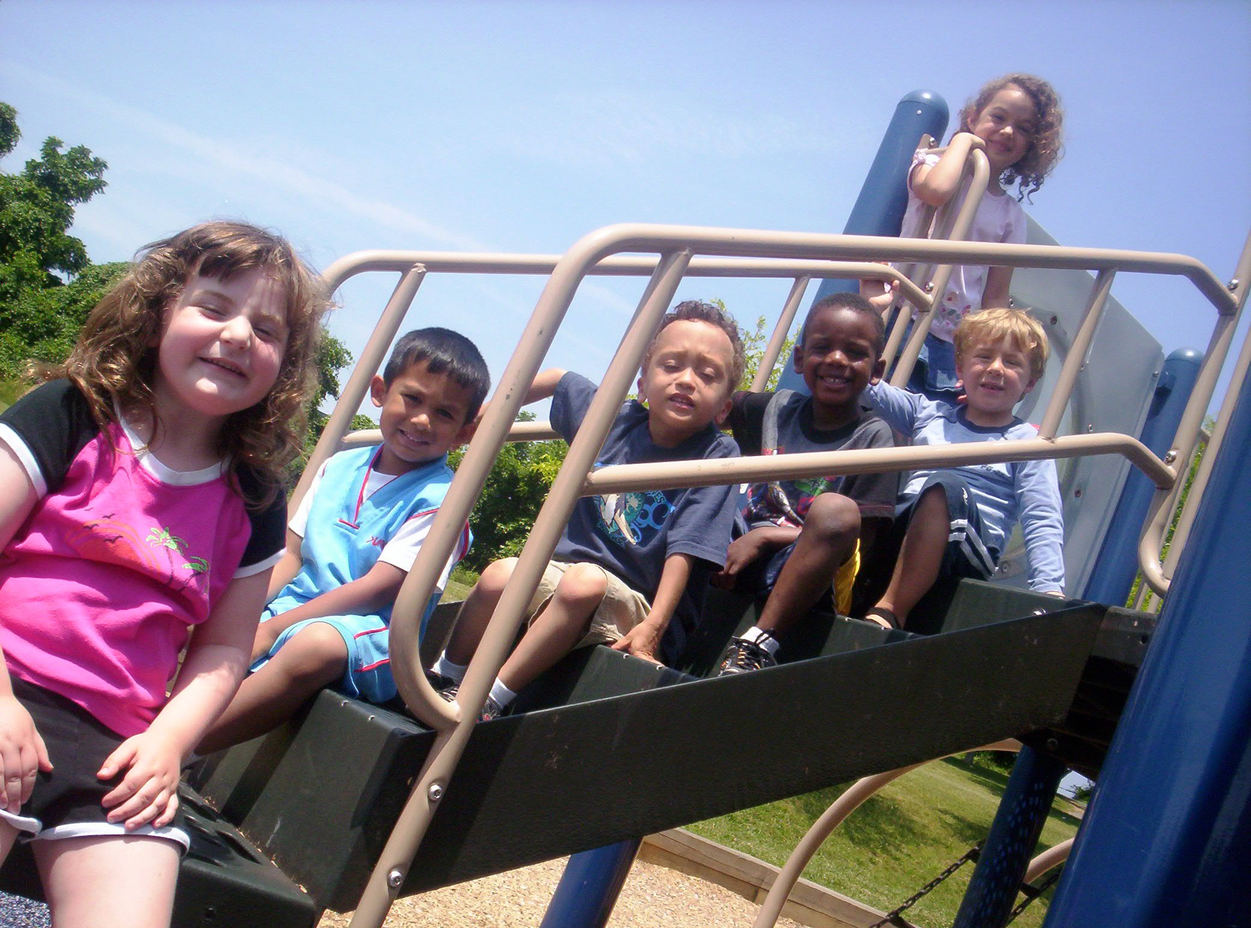
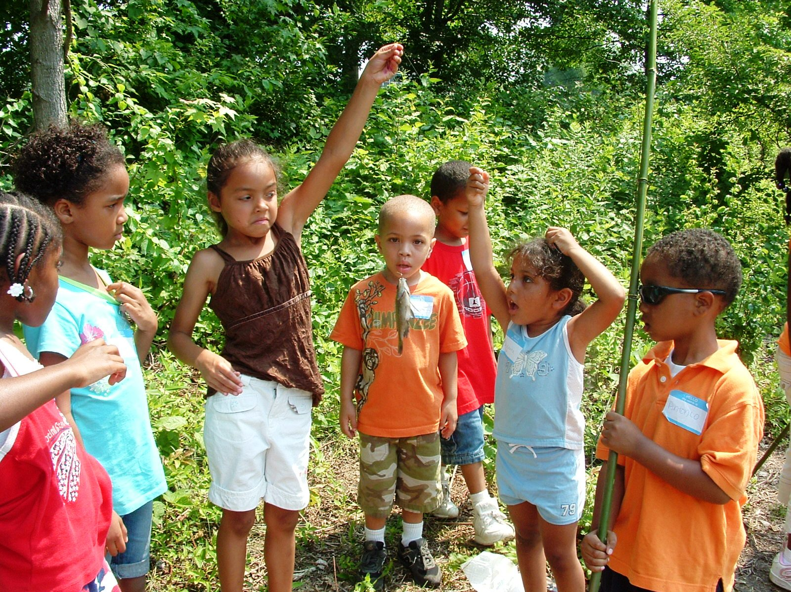
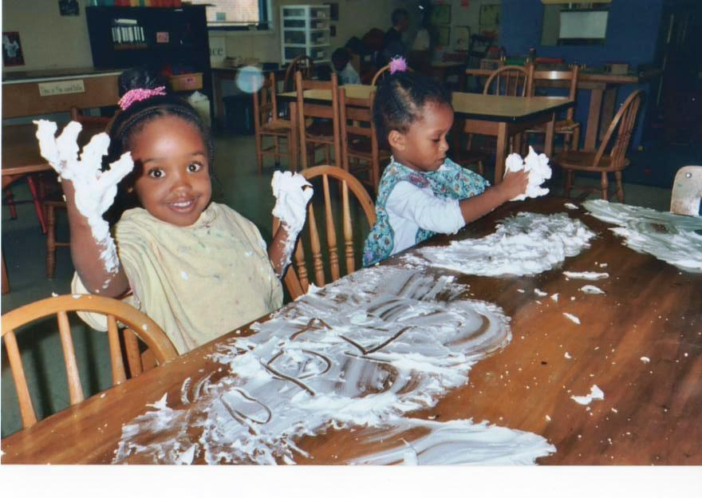
Serving the Community since 1987
Licensed by the State of Maryland Department of Education

Horizon
Child Care, Inc.
Martin Luther King Jr. Park
1102 Jackson Road
Silver Spring, Maryland 20904
301-680-0665
M-F 6:30 AM -6:00 PM

Rolling Terrace Elementary School
705 Bayfield St.
Takoma Park, Maryland 20912
301-422-3415
M-F 7:00 AM-8:45 AM,
3:00 PM-6:00 PM

Burnt Mills Elementary School
(Holding School)
13313 Old Columbia Pike
Silver Spring, Maryland 20904
301-593-6056
M-F 7:00 AM-8:15 AM, 2:45 - 6:30 PM

Email: horizonchildcare@hotmail.com
Website:
WWW.HorizonChildCare.org
04/2023

Our Locations
Our Philosophy and Mission
Horizon Child Care, Inc. is a community of talented, caring individuals committed to creating a nurturing, dynamic environment designed to foster a child's curiosity while fully addressing his or her needs.
We are professionals committed to respecting the dignity of each individual child. We encourage each child to discover new abilities and master new skills.
We are firm believers that parents and guardians are children’s first teachers and we are only here to help facilitate and grow what has begun from home.
We are dedicated to providing staff with advance opportunities for growth and provides/promote workshops and training that are not only beneficial to staff, but families and our community.
Horizon Child Care, Inc. accepts states subsidies, such as Working Parents Assistance (WPA) and Child Care Scholarship (CCS). See registration packet for detailed information regarding WPA and CCS Programs.

Horizon Child Care, Inc. respects, appreciates, encourages and accepts families/children of any race, religion, ethnic background and welcome all abilities.
___
The preschool child needs nurturing affirmation in a setting that is both secure and homelike. The program provides both group and individual activities designed to enable a child to explore the world around him or her while developing social skills. Our setting encourages a child to use his or her imagination and grow as an individual through activities such as:
- building blocks
- dress-up,
- dramatic presentations
- sand and water creations
- open ended arts and crafts
- music and dancing
- rigorous outdoor play
The program balances these individual activities with developmentally appropriate large group activities such as:
- circle time
- puppet presentations
- cooking activities
- organized games
- staff lead art projects
Language acquisition and communication skills are essential to early childhood development and are reinforced throughout all of these activities.
The school-age child care supplements a family setting between school hours and home hours. A school-age child has complicated needs ranging from affirmation to discipline, and from stimulating activities to quiet time. School-aged children have an increasing need to make choices, express preferences, and feel independent while still belonging to a group. Peer pressure and the stigma of “still” going to daycare are negative factors that many older school-age children face. Horizon addresses these needs by providing opportunities for both individual and large group activities. A typical week at Horizon will include:
- daily individual and group indoor and outdoor free play and organized games
- daily quiet study hall with staff assistance as needed
- staff organized arts and crafts
- cooking projects
- logic games such as checkers, chess, Monopoly and Connect Four
Half day and full day special and seasonal activities include:
- nature walks and fishing trips
- field trips to local pools and parks
- library visits
- sledding and bike riding

Registration

For information on open positions or to submit your resume, please visit our Web site at: www.lucernepublishing.com
Child’s Name __________________________
Child’s Date of Birth _____/_____/_________
Parent’s Name _________________________
School Child Attends____________________
Age ________ Grade________
Allergies ______________________________
Special Needs _________________________
Home Address _________________________
_________________________
_________________________
Email Address _________________________
Phone Numbers
Home ____________________________
Parent’s Cell ______________________
Parent’s Cell _______________________
Parent’s Work _____________________
Parent’s Work ______________________
Persons authorized to pick up child

How did you learn about Horizon Child Care?

___ Referral from a friend
___ Referral from school
___ Referral from internet
___ Other: ____________________________
Preschool Program
School-Age Program

