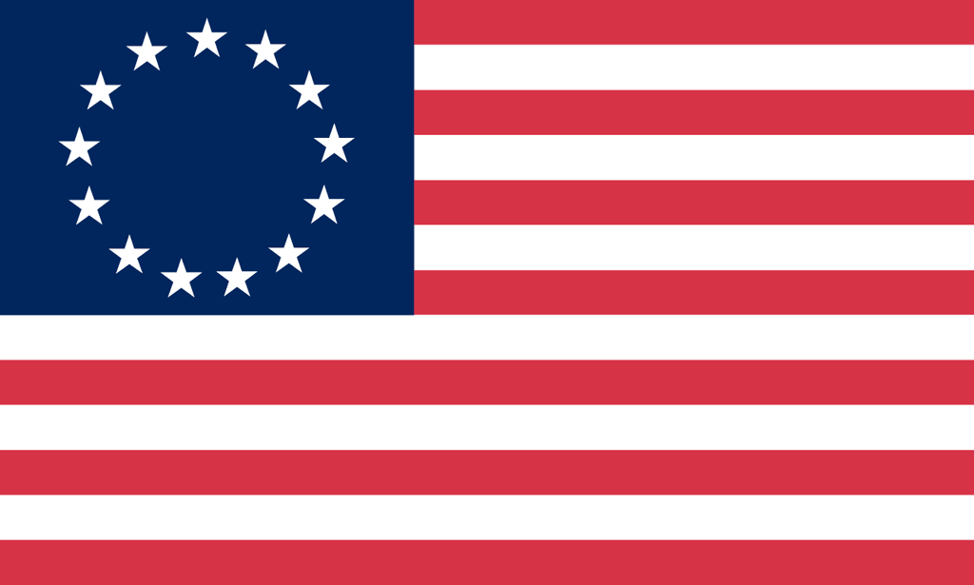U.S. History with Mr. Brown Name _______________________________ Period _____
European Exploration Vocab Warm UP

Directions: Match the definition on the right with the correct vocabulary term on the left.

1) _____ Slavery  2) _____ Civilization  3) _____ Iroquois League  4) _____ Christopher Columbus  5) _____ Domestication | A: An alliance amongst several native tribes  B: Breeding plants or animals to meet the needs of humans  C: A culture defined by it economics, government, religion, record keeping , and tools  D: an Italian Sailor who thought he knew a faster way to reach Asia  E: Holding a person in bondage for labor
6) _____ Middle Passage  7) _____ Plantations  8) _____ African Diaspora  9) _____ Columbian Exchange  10) _____ Conquistadors | A: A large farm worked by slaves that produces cash crops  B: Middle leg of the Triangular Trade that brought slaves over from Africa to the New World  C: Spanish explorer soldiers  D: The exchange of plants animals and diseases between the old and the new world  E: The forced removal of Africans from their home lands to serve as slave labor

