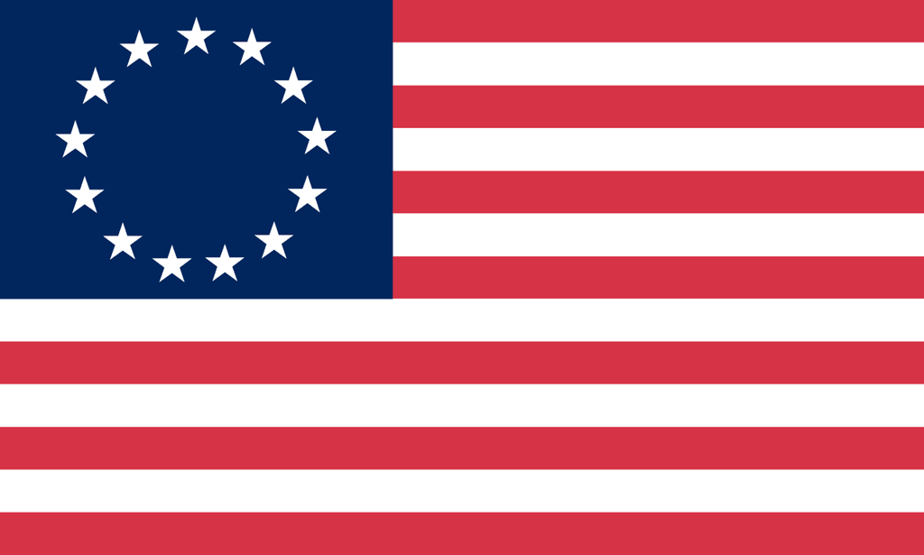U.S. History with Mr. Brown Name _______________________________ Period _____
European Exploration Web Quest

Directions: Visit the websites listed below and explore to find the answers for each of the following questions.

http://www.mrdowling.com/704-exploration.html Also if you Google search European Exploration it should come up near the top of the results
1) European Explorers began to travel outside the lands they knew in search of new trade routes with spice producing lands in _______________.
2) What are two reasons European wanted spices for their food?
1
2
3) Think about this one: You read that “The Turks defeated the Byzantine Empire in 1453, cutting the land link between Europe and Asia.” How would this defeat have cut off the land route between Europe and Asia?
4) What route did Vasco de Gama’s voyage have to take to reach India from Portugal?
5) When Columbus arrived in the New World where did he think that he had sailed to?
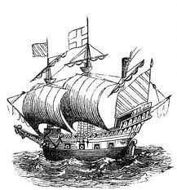
http://www.britannica.com/EBchecked/topic/196140/European-exploration
Also if you Google search European Exploration it should come up near the top of the results
Explore the Images provided

6) Name two explorers whose routes circumnavigated the globe (took them completely around the earth)?
7) Contarini’s world map in 1506 looks at the earth from a perspective that is centered on the __________ pole.
8) In what year did the Vikings first reach North America?
9) Jacques Cartier explored North America. What current country was exploring the land of?

http://library.thinkquest.org/J002678F/
Also if you Google search European Exploration it should come up near the top of the results
10) What type of valuable animal furs were the French seeking in North America?
11) Do further research: You read that “Although many people thought the world was flat, educated Europeans knew that it was round. The problem was they had no idea how large the world was.” Eratosthenes an Egyptian scholar estimated the circumference of the earth in the year ________________ which was WAY before European Explorers began to leave their home lands.
12) In what year did Prince Henry the Navigator open a school for sailors?
13) Who became the First Englishman to sail around the world in 1577?
14) Do some math: How many years earlier did Ferdinand Magellan’s crew finish their trip around the world?
15) What is the answer to the Double Puzzle Code in the Games section of this website?
