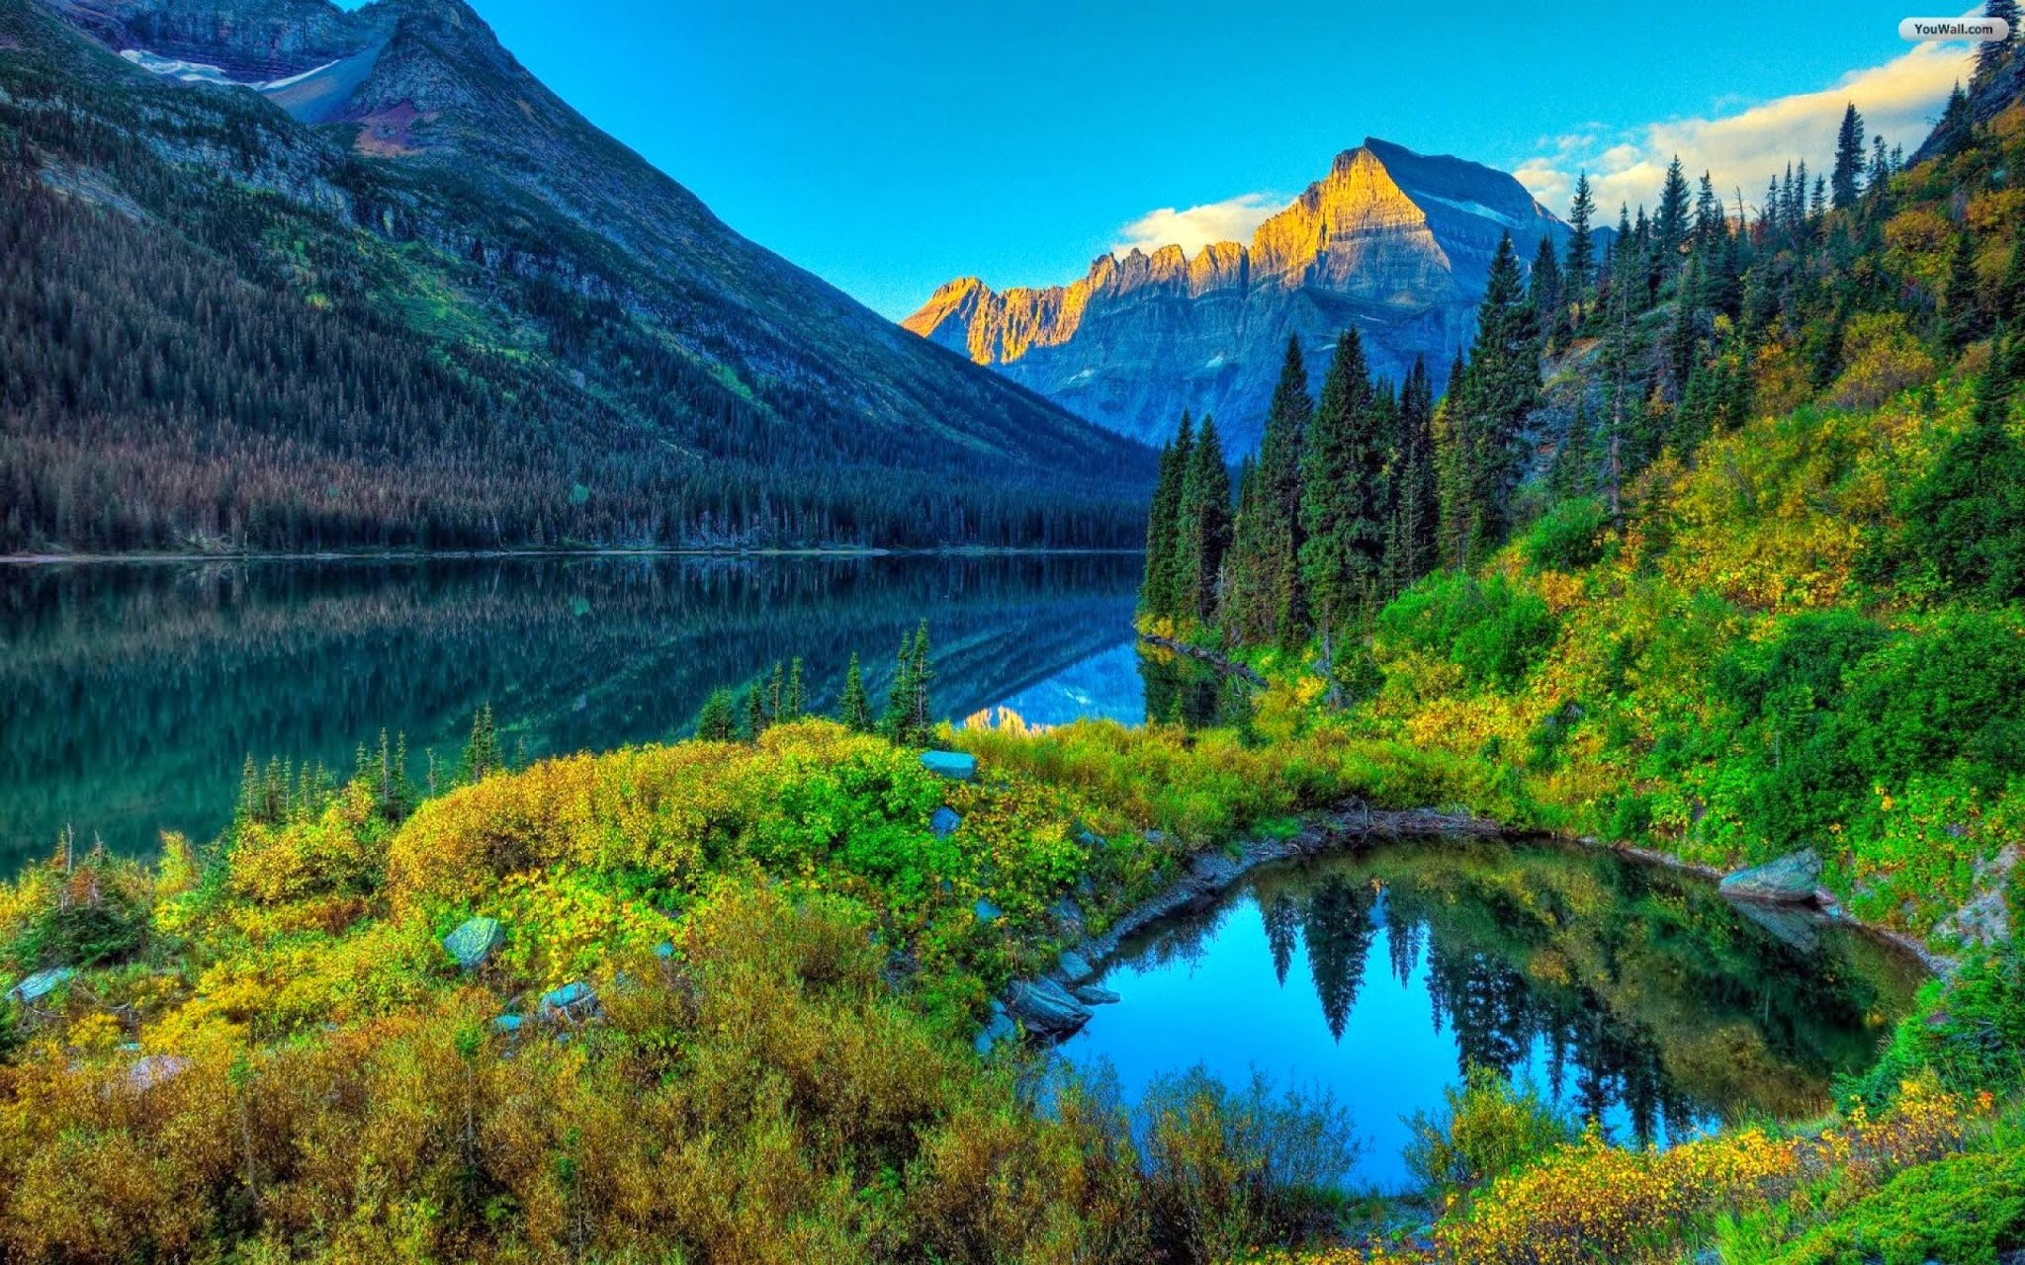-Nail Care-

Acrylic Set $28

Acrylic Fill $20

White Tip Set $30

Solar Pink & White Set $35

Solar Pink & White Fill $30

Dipping Powder Set $35

Dipping French Powder Set $40

Pink Fill $20

Glossy Gel $5

-Extra Service-

French / American $5

Nail Design $3

Nail Repair $3 & up

Nail Removal w / wo Service $5 / $10

Nail Polish Hands / Feet $8 / $10

Change Shellac Color $20

Change Shellac French $23

Cut Down $5

Extra Service $5

-Body Massage-

30 Minutes $35 60 Minutes $65

Hot Stone / Deep Massage $10 / each

Enjoy a relaxing, touching experience. Place your trust and your body in the loving hands of a trained professional massage therapist.

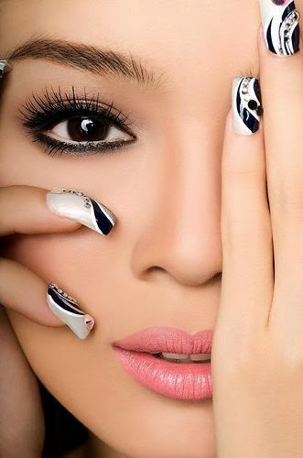Massage alleviates the effects of stress you often aren’t even aware of. Large Muscle knots create pockets of tension throughout your body, blocking vital energy, reducing circulation and glandular functions. Through massage, your body gets the healthy attention it deserves without pills or drugs.

-Waxing-

Eyebrow $8 Stomach $15 & up

Lip $6 Back $30 & up

Ears $20 & up Half Arms $25 & up

Chin $8 Full Arms $35 & up

Sideburns $15 Half Legs $40 & up

Full Face $25 Full Legs $50 & up

Under Arms $15 & up Bikini $30 & up

Chest $25 & up Brazilian $45 & up

Eyebrow Tinting $20

-Eyelash Extensions-

Individual Full Set $75

Individual Fill $35 & up

Cluster Full Set $35 & up

Cluster Fill $20 & up

Lashes $15 & up

Remove Eyelashes $15 & up

**Mini Service $45**

A revitalizing facial for people on the go, facial steamer cleansing, hot pamper wraps, exfoliation, facial Massage to refresh your skin. (40 min.)

**Europe Facial $65**

This facial includes facial steamer cleansing, hot pamper wrap, exfoliation, masque, facial, neck, shoulder massage and hot stone therapy. (60 min.)



[https://www.facebook.com/river.nails.and.spa.rowlett](https://www.facebook.com/river-nails-&-spa.rowlett)

Appointment or Walk-Ins are Welcome

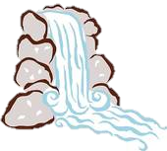River Nails & Spa

In Rowlett

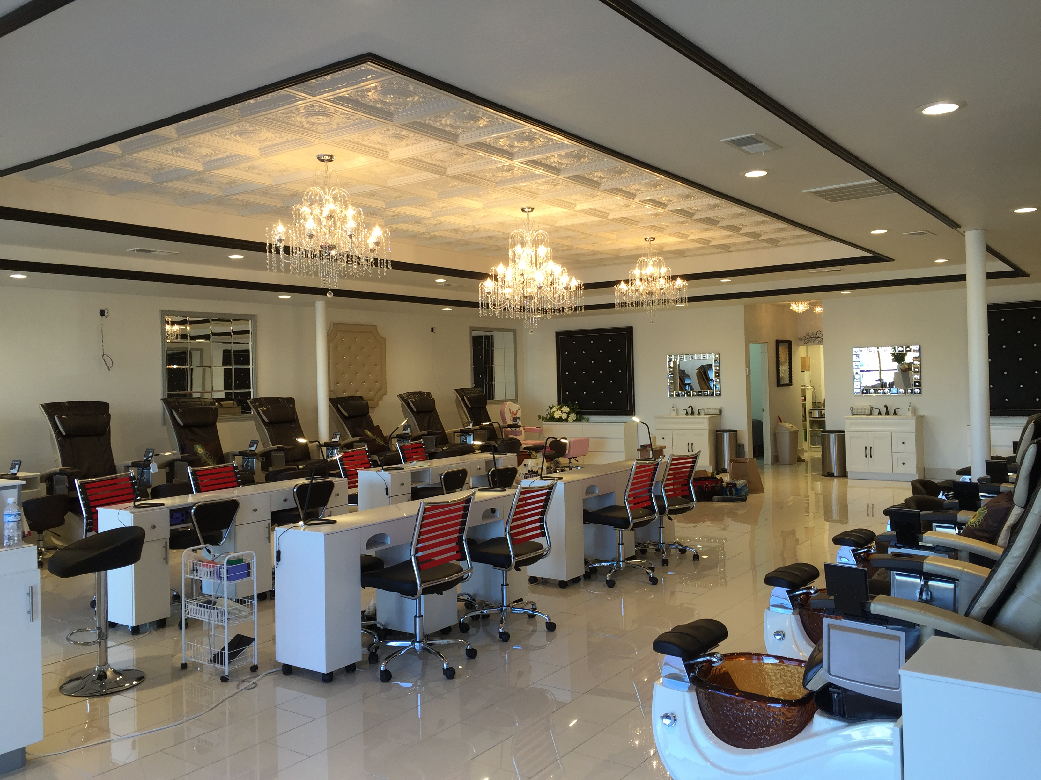---World Finest Nails & Designs---

(972)463-6440

500 Rowlett Road #108

Rowlett, TX 75088

Monday – Friday: 9:30 a.m. – 7:30 p.m.

Saturday: 9:00 a.m. – 7:00 p.m.

Sunday: 11:00 a.m. – 5:00 p.m.

Complimentary Water, Soft Drinks, Wine & Margarita

Gift Cards Available



http://www.rivernailsinrowlett.com/

-Pedicures-

**Classic Pedicure** **$24**

This service includes: Aromatic foot soak, natural nail care that includes reshaping nails, cuticle details, buffing, lotion massage, and your choice of nail polish. (30 min.)

**Essential Pedicure** **$27**

This service includes: Aromatic foot soak, natural nail care that includes reshaping nails, cuticle details, buffing, callus removal, sugar scrub, lotion massage, hot towel and your choice of nail polish.

(35 min.)

**Peppermint Pedicure** **$30**

This service includes: Aromatic foot soak, natural nail care that includes reshaping nails, cuticle details, buffing, callus removal, aromatic mask, hot towel wrap, hot stone massage, cooling gel, lotion massage, and your choice of nail polish. (40 min.)

**Signature Pedicure** **$35**

This service includes: Aromatic foot soak, natural nail care that includes reshaping nails, cuticle details, buffing, intensive callus, sugar scrub, aromatic mask, hot towel wrap and volcanic hot stone with candle oil massage, and your choice of nail polish. (45 min.)

**Ultimate Pedicure $45**

This service includes your choice of any aroma sensation, jelly foot soak and massage, natural nail care, intensive callus and heel treatment aromatic dry skin exfoliation scrub, aromatic mask, hot towel wrap, paraffin wax treatment, volcanic hot stone massage. Extended aromatic lotion massage, heel cream treatment, and your choice of nail polish. (55 min.)

**\*\*\*\*\*\*(Special: Choose any mask on the list)\*\*\*\*\*\***

**\*Add Hot Paraffin Wax - $5 *Add Shellac Gel - $15**

-Masks-

Masks has the most profound effects on the body’s five senses. Designed to turn your ordinary pedicures & manicures into an extraordinary spa experience.

**Aloe Vera (Fresh Aloe Vera) $5**

Aloe Vera gel is an excellent skin moisturizer. Its supplies oxygen to the skin cell which in turns increase the strength and the synthesis of skin tissue. It rejuvenates the skin hydrates and makes it flexible.

**Cucumber Indulgence (Fresh Cucumber) $5**

The natural qualities of cucumber essence to rejuvenate your skins healthy color and glow.

**Green Tea $5**

Formulated with nature’s most soothing and effected botanical, the green tea restores souls with treatment options that refresh and reenergized the body.

**Coconut Lime $5**

Coconut lime utilizes fruit acids designed to gently remove keratinized cells and callouses. The coconut lime removes the top layers of skin leaving a younger smoother skin with uniform pigmentation.

**Lavender $5**

Lavender mask moisturizes the skin, leaving it with a silky, smooth and nourished feeling. They will restore limberness of your skin by replenishing the water content. It helps in removing dead skin cells, bacteria and toxins from the skin.

**Milk & Honey (Milk Powder and Honey) $5**

Milk and honey provides a plethora of all natural beauty benefits with repeated use you can achieve soft, glowing and flawless skin.

**Sunkist (Fresh Orange & Lime) $5**

Exfoliating and moisturizing citrus scrub with fresh orange slices, firming mud mask wrap in hot towel and warm paraffin treatment will restore that healthy glow

-Manicures-

**Classic Manicure $14**

Incudes aromatic soak, natural nail care includes reshape nails, cuticles details, buffing, lotion massage and choice of nail polish. (25 min.)

**Shellac-Gel Manicure $29**

This service includes: Aromatic soak, natural nail care that includes reshaping nails, cuticles details, buffing, lotion massage, and your choice of gel nail polish. (30 min.)

**Shellac-Gel French/American Manicure $33**

This service includes: Aromatic soak, natural nail care that includes reshaping nails, cuticles details, buffing, lotion massage, and gel nail polish. (30 min.)

**Ultimate Manicure $35**

This service includes: Aromatic soak, natural nail care that includes reshaping nails, cuticle details, buffing, mask, sugar scrub, hot towel wrap, paraffin wax treatment, volcanic hot stone massage on arms, neck, and shoulders, extended aromatic lotion massage and your choice of nail polish. (40 min.)

-Angel Menu-

*For ages 12 and under*

Includes all the benefits of the spa manicure / pedicure

**\*Free nail designs\***

**Tween Manicure $12**

**Tween Pedicure $20**

**Combo Manicure & Pedicure $30**

