Preface
This is a Spiritual Book, NOT religious..
Everything in this book is true. Some names were changed in the book either to protect their privacy or their permissions were not given to use their names. Those that have been correctly identified gave their permission for name and likeness to be used.
The body of the book is an adventure and love story.
I dedicate this book to my children. My son Joey, my Daughter; Kwani Lois and my loving Mother Lois Anne who has passed on to a new life. This book would have not been possible without them and I would not be here today without them. I love my children more than life itself and although I know we fall short of perfection as a child or parent, We MUST forgive ourselves to go further and to keep trying.

Celebrate Eve
(without her taking that bite, we would not have had knowledge coupled with free will, which is really what gives this planet, the fun place to come to for spiritual growth)

Joe Hill
Associate of Arts, Associate of Science Criminal Justice,
Bachelors of Public Safety Administration
Page number
Table of Contents 3
Chapter 1: The Night of the Cobra 5
Chapter 2: How it Began 10
Chapter 3: The Adventure Begins 13
Chapter 4: Leta 24
Chapter 5: Atlantica 30
Chapter 6: The Conquering of Eagle Mountain 36
Chapter 7: Ochrid: Eastern Europe’s Riviera 41
Chapter 8: NBC Wound Treatment with Mass Casualties Training 47
Chapter 9: The River 56
Chapter 10: Home is Where Your Heart Is 59
Afterword The argument for the existence of Aliens 64
Epilogue 68
About the Author EXCITING True Life and Death stories 83
Bibliography 102

Chapter 1 The Night of the Cobra

The Little General, Him, the Evil One and other much whispered terms, were used to describe George Paul, the mastermind behind this adventure. I liked to think of him as, the Cobra, or Jeppetta, the puppet master. Steady and methodical; deadly when attacked… Svengali like... the Cobra, pulling the strings of fate to teach us how to stay alive.
His mindset is militaristic. The goal is ahead! Take the mountain! He is small in stature, but soon after you engage him in conversation you realize that he is a calculating thinking machine behind those, oh so carefully, chosen words and movements.
On Wednesday night of the first week of this adventure at about 10 pm, the men’s barracks was alerted to a possible attack on our base. We gathered for our evacuation at a predesignated point that had been agreed upon with our female counterparts the day before in preparation for such a scenario. We quickly discovered that even though we had settled on a gathering place we had not planned for a way to stay in communication with the women and no one had told them of an impending attack. The instructors ordered us, the men, into the evacuation vehicles where we had gathered. Protestations arose, but they were quickly squelched. No, no… We had fallen into the trap, so carefully laid by… The Cobra.
He had seen this failure to communicate before with other inexperienced trainees, and he was ready… ready to go forth and teach the lessons that had to be taught.
“Too late!” he barked, as I sensed a guttural sound of glee in his command to load up. He knew. He knew what lay ahead for the rest of the night and he could already feel the adrenalin begin to pump. Showtime! The Cobra knew that if he could just get into character enough, believe in himself enough, and become the Cobra, he just might make this group of trainees “feel the real” and that would mean that he had accomplished his goal and imbedded into the subconscious of another “nube,” a way to save lives. He rules with an iron fist and expects only as much as he gives. Who, but he, could really give that much? Through all of that tough, granite hard exterior, is a caring soul that believes in what he doing. It is what drives him. But for now, it was time for the lambs to be led to the slaughter. It was to be a night imbedded in our minds with all the sounds and smells and degradation that we could handle… or that the Cobra could dish out.
Our instructors were not happy. We were transported to a remote location in our military troop transport. As we traveled the desolate byways of the surrounding mountainous country we were jostled around on those wooden seats of the troop transport. We wondered what the women were going through right then. It would only be later that we would discover their horrible fate.
Suddenly, near a stream, explosions and gunfire ripped the quiet of the night. Our vehicle came to a jolting stop and gunfire exploded all around us. Some of the soldiers outside of the truck taunted us at the edge of the tarpaulin cover by banging on it and screaming. We were ordered out and lined up on our knees with our hands interlocked behind our head. We were dealing with masked men in uniforms of the government opposition forces. We found ourselves kneeling in an area that had been occupied by sheep some time earlier that had left a special present for whoever would venture behind them. The kind of present that a mother would be so proud of when their child was being potty trained.
The driver of our transport was brought before me blindfolded and screaming while being gripped by two of the dark forces of the night. The one in charge shouted at me, asking if I knew the driver. There was a momentary interlude of silence. The man before me had been observed around the military base where we had been housed, but I did not really “know” him, so I said that. They took him to the side of the river and blew his brains out. The ratta tat tat of the fully automatic machine guns were deafening in the cool mountain night air. A feeling of dismay came over me. What if I had said something different? Could his life have been saved in this scenario?
We could no longer hear the calm of the gently flowing mountain stream right next to us. Our ears were ringing from the weapon fire. Later, it was divulged that our driver had jumped out of our vehicle with an automatic weapon and shot and killed a couple of the troops that were now out for revenge and standing before us. By our negotiated agreement with the opposition forces, no one in our contingency should have had a weapon at all. The driver was dead no matter what would have been said. I may have been shot too if there had been an admission of any kind of real allegiance to him. I don’t know. The Cobra let me live that night and even allowed me to continue in this surrealistic event of a lifetime. No one could see which one of the armed masked men he was, but he was there, pulling the strings, watching every move, and changing the scene as needed. The berating by the opposition forces continued. They singled out some of us for ridicule and threats, seeing what we could take.
After the opposition forces, had finished with their fun it was time for a formal dress down by our Command Staff for our inability to think of our group as a unit. The difference now was that this admonishment was real. They insulted our manhood about to the extent that some of the men attempted to say something in defense. That was not the thing to do. More verbal punishment was dished out with a thick slice of degradation on the side. The commanders emphasized the need for us to understand that our teams were supposed to be like a well-oiled machine. Teamwork is supposed to mean that one part of the team is as important as the other. Every part is interdependent upon the other. Without a part of our machine we were not the same team and the loss of any part is like the loss of a limb. The loss of our women that night was more than the loss of several of our team members; it was the loss of the limbs of our body. That is what the instructors wanted us to learn that night.
As the “night of hell” continued, we were quick marched toward civilization (the barracks), down the unpaved dusty road in the moonlit, beautiful Macedonian night. We marched in silence and shame for our inexcusable mental lapse in evaluation. If the actions of that night had been real, it could have meant our female comrades’ lives. We would hear more about our debacle in the morning.
It seemed like more than the few short miles that it was. Silence and marching do not fit together. In basic military training marching was done with the sound and cadence of soldiers’ voices blending and acting as one, giving strength to one through the many. But that was not for tonight. Silence pervaded the atmosphere of that march. Introspection was the order for the evening for all of us. An internal question developed as we marched on in the night, “Do I have what it takes to help others and still survive?”
Upon arriving at the base we turned in for sleep. Discussion was for the next day in a classroom situation. We never forgot about the group functioning “as a whole entity” after that night.

Chapter 2 How it Began

This journey began as a college class for me in pursuit of a Bachelor’s degree in Public Safety Administration at Indian River Sate College (IRSC). It became something else for me. The course was described as a platform for preparing the participant for the life of a humanitarian aid worker in an, “on the job” training exercise. When the student leaves the course, they will not only have spent time in real life scenarios, they will have bonded with the other participants as a family. No one can go through the experiences this course puts a participant through, without establishing life bonds with the others around you. The internet allows us all to still have contact as if we were all still together. The incoming new student will feel a plethora of emotions as they and their comrades are pushed to extreme emotions, both good and not so good. There will be times when they will feel as if they can’t march a step further up that mountain, and then someone like Lucky, in the group will say, as in my case, “Come on old man, you can do it. There’s no turning back now.” It will be that little vote of confidence from one of their bonded comrades that will give someone the courage to say “Yes, I can”. It did for me.
The objective of this multi college, multinational, effort is to train international relief workers, humanitarian aid practitioners, and future emergency managers with a practical education through use of “hands on” training techniques. (Forage 2008)
This journey began for me even before leaving my home in Fort Pierce, Florida. For some reason, I felt compelled to go. My children were both teen agers who had crushed my spirit in recent years by being typical teen agers. Interacting with other adults they exhibited near perfect manners and displays of proper respect. Why could they not do that at home to me? Other parents of teens were experiencing the rebellion and disrespect that I was experiencing also. They had tried to quell my feelings of having failed as a parent by sharing their stories of rebellious teens with me. It helped me some, but the pain and doubt were still there.
Further reflection and prayer led me to consider that participating in this humanitarian aid training could possibly be life changing, maybe even world changing and it was something that I had to do for myself and God. Could it be that our journey as a group would assist in the total development of Macedonia in their quest for World and European Union participation? Was thinking that we could be a part of something that could influence a decision like the EU participation for Macedonia may seem a little grandiose, but what I have found in life is that sometimes the little man does have an influence in the grand scheme of things, you only must believe. Believe that you can’t and surely you won’t. Believe that you can and surely you might. Try hard enough and surely you will. I went to prayer on many occasions for God’s guidance in this matter.
In January of 2008 when I inquired about the mission to George Paul, the instructor that was organizing the class, he expressed his view that he did not think it would happen. I boasted to him that it would, now that I was involved. Sometimes people mistake my confidence in such matters, for an inflated ego. Not so. No one else really knows where another person has been in life, physically or spiritually, even if there are dossiers that say so. There are always places unseen and unknown of another person that only the individual walking that uncertain path of life in their own moccasins, will truly know where they have walked. Reflecting on one’s life path and where one has been often leads to new understandings. For me, the verse John 8:7 where Jesus advised the men of the community who were ready to stone a woman for adultery, that the man amongst them without sin should throw the first stone, speaks to my heart all the time now. I have learned to be more forgiving of others since my acceptance of Jesus Christ as my Savior and I have come into full realization that we as humans, continue to make mistakes and need forgiveness. To be forgiven, we must forgive others. Those two actions are as much connected as our heads are connected to our bodies. One cannot survive or exist without the other. Forgive others that we ourselves may be forgiven!
My personal experiences in life have taught me that generally when people do throw stones, by that I mean any sort of action, verbal or physical that is detrimental to do someone else’s harm, throw those stones as the result of their own self interests. When a stone throwing occurs, it should be scrutinized by all of us as to what is that person’s motivation is for throwing the stone. The answers that we may come to, will lead us to the truth. We first must have the courage to respectfully question others actions and to not be in fear.
Sometimes in life there is that one single choice which will determine the direction that one finds themselves in the rest of their lives, or as in some cases, the rest of the time of the time we have left. This is how I felt about whether to really push for my being able to go to Macedonia.
Buddy Holly, the “Big Bopper,” and Ritchie Valens, were waiting with their band for the next gig to fly on an airplane hired by Buddy Holly. The group’s bus was not providing enough heat in the Iowan winter cold. Valens flips a coin with the drummer of the band for the last seat. Valens wins the seat but does win? A future country star Waylon Jennings also gets bumped. The plane crashes in a snow blizzard killing all aboard. Now, who won? The world was then without the “Big Bopper,” Holly, and Valens, only to be replaced by the “King of Rock and Roll” Elvis Pressley, and others. Funny, how time and God work things out like that. Was it predestined in history to have the leaders in US teen music who were leading our youth to what many considered immoral and decadent social behavior to die suddenly? And if so, when the foremost up and coming rock and rollers are taken from the scene by a twist of fate, they are replaced by others… to fulfill destiny. How inexplicable the will of God is sometimes, or does fate itself decide who lives and who dies? My faith says that God would not let something happen were it not for the fulfillment of His supreme plan for our destiny. If we maintain the focus of our lives on love, we will know God’s purpose for each of us, more each day.
I made a choice to pursue a spot on the plane to Macedonia, but was almost too late. I had not asked Dr Paul about the trip again until the deadline was near at hand. I had waited until the last minute because of monetary restrictions, to attempt to be a part of something special, something that could be big, that had substance, and could be beneficial to others. Faith and prayer led up to the last day of the deadline for signup, but still no financing for my ticket. Two days later my brother tells me that he would have paid for it if he would have known. I went to my former professor for “Introduction to Public Administration” Lucky Louie, and told him that I could pay now. He did an inquiry for me but he said the answer was no. It was 36 hours too late.
In addition to my being President of the Philosophy club at IRSC during the previous 3 years, I had also been involved in student government. This had made people of significant power and influence within the system available to me if I chose to associate with them. During the Student Government Dinner at the end of the school year of 07, I met the backbone and leader of this fine institution on a very personal basis. He was as personable and warm as he is powerful. He is a man that commands respect because he deserves it. I decided to go to him for consultation on this Macedonia matter. He has an open-door policy for all his students and I decided to take advantage of it. He called a lady to him with which he consulted with for less than a minute. He said I would receive a call tomorrow whether I could go to Macedonia or not. I knew then that it was not settled one way or the other, and that George Paul would probably have the final word on the matter.
The next day as I performed my job duties as a Security Officer manning a guard house for an adult community on the 7am to 3pm shift, I could feel the presence of the Lord wanting me to go. I knew he was about to bring me to an epiphany showing me clearly how it was in His hands, and not my own. Even as the morning faded to the afternoon I stayed in faith and had no worry about it, with an unusual sense of peace. Around one thirty, I received the call on my cell phone from Lucky Louie, my former professor and friend, and he said to me, "I don’t know how you did it, but you are in. Go buy your plane ticket.” As Lucky’s call ended three vehicles arrived at my gate simultaneously. I recorded the information required for each vehicle taking the driver’s name, destination, verifying their access rights and recording their tag number. At the last car came my epiphany. A nurse who had a “vanity” plate that declared her faith and confidence in the choice of her life’s path. The third tag number recorded as it faded away from view had the letters IOU GOD. My skin tingled with excitement as it pinged with the “chill bumps” of life. Astonishment gripped my body. I felt God was speaking to me then and telling me that this was his will all along.
At that point, the feeling of destiny was upon me, but there was also the occurrence of the “three” cars at one time also meant something. For me it said: the Father, the Son, and the Holy Ghost. The third vehicle was the deliverer of the message and meant that the spirit of the living God was alive and speaking to me. Jesus said “Let those that have ears let him hear”. Mark 4vs9. (International Bible Society, 1990)
A feeling of ecstasy rippled through my body. Continued prayers for many days, thanking the Lord for this wonderful opportunity was the order of the day. Was it going to be real? Was it really going to happen? Could something this wonderful, really going to happen to me?! Prayers for worthiness and direction (of which unfortunately like most of us, are not always listened to) were to continue. Hopefully soon I would walk in some of the same areas as Paul; Jesus Christ’s Apostle for the Jews and the Gentiles.

Chapter 3 The Adventure Begins

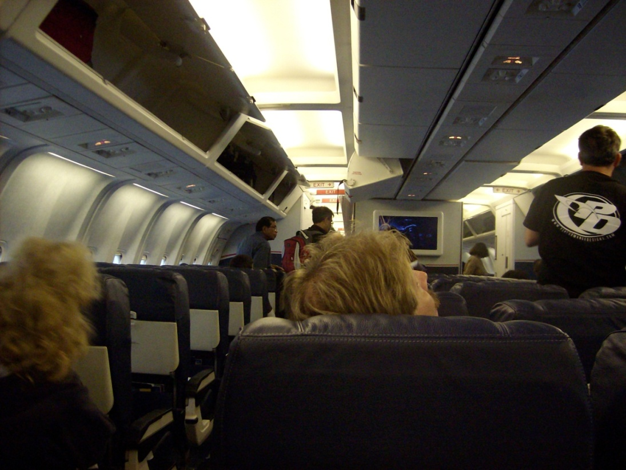
The flight over the big pond to Europe was interesting. It had been many years since my last jet flight, and that was from Florida to Texas. The two things different for me now were the intense security check points in the boarding and departing, and for some reason the airlines had decided to make the seats much smaller. I am sure it was not that I grown that much larger than when I was sixteen (is that possible?). After making a couple of friends on the way over and befriending the steward as well, he gave me one of the pouches reserved for the first-class people that included a sleep mask and some socks. The sleep mask came in real handy later when trying to sleep in a barracks full of other men that don’t always want to turn lights out when directed to.
It pays to be nice to others. It always seems to come back to you when you do an act of kindness, if you are not expecting anything in return. At least that is how it is for me. It is written in Romans 13vs8 that “… he who loves his fellow man has fulfilled the law.” “Love does no harm to its neighbor Therefore love is fulfillment of the law” (Romans 13:10). Do this and all the other commandments will follow forth. Christians are under the New Covenant, sanctified by the blood of Jesus Christ. “As a Christian I am no longer under the restrictive ‘Crime and Punishment’ of the Mosaic Law, including the Ten Commandments, rather I am under the two laws of Christ, which is only about love and Forgiveness of others, as we are ourselves forgiven for our sins. “Love God with all of your heart and… Love one another as you would your own self.” (Luke 10:27) Do these two commandments and all the other commandments will follow forth (Romans 13 8-12).
“This cup is the New Covenant in my blood which is poured out for you.” Luke 22:20 (International Bible Society, 1990) We, as Christians are no longer Jews and are not bound under Jewish law. “All who rely on The Law are under a curse.” (Gal 3:10) “So The Law was put in charge to lead us to Christ…Now that faith has come we are no longer under the supervision of “The Law” (Gal 3:24, 25). The covenant that God made with the Jews for prosperity and favor is now passed on to us, as Christians (the New Covenant, as decreed by Jesus at the Last Supper). We are now the chosen ones of God by direct lineage and establishment of the new covenant through the blood sacrifice of Jesus Christ. The main difference between Jews and Christians is the ability to forgive. We have Christ. Jesus who was a person who sacrificed himself for the sins of the world and because I believe, I am forgiven and I must forgive others. I can hardly write this without tears flowing down my face in love and admiration for my Savior. The Jewish Messiah has come, and he is mine.
Upon arrival at Skopje, the capital of Macedonia, we were about to be searched thoroughly at customs when Lucky mentioned that we were working with the Ministry of Defense and we had people waiting for us just the other side of the gate. After that, we sailed through customs. It showed to me that just as in my country the military carries a lot of weight, especially when the military is made up of the former Yugoslavian Army.
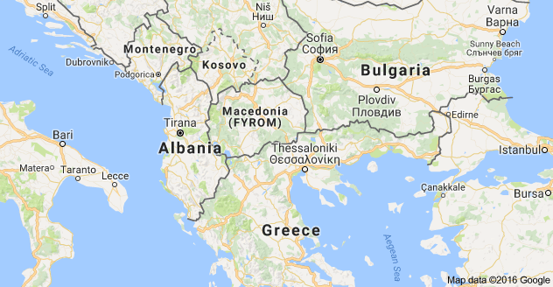

Macedonia is a country located in Europe just north of Greece. It attained its independence peacefully in 1991 from Greece. Greece is Macedonia’s major stumbling block for total international recognition. As part of their original dispute, Greece established a trade embargo against Macedonia. Greece lifted the embargo in the 1990’s and the two countries, in theory, have tried to normalize relations. My practical experience in interacting with the Macedonians tells me that everything still is not as well as it could get. When I commented on a local river looking dirty, one local Macedonian said it was because the river touched Greece. This was a river that flowed south from the scenic Macedonian mountain country into Greece. On the flip side of that attitude I can honestly say that the Macedonian people are some of the friendliest people, of foreign heritage, that I have ever met. The people of this country are very US friendly and hunger for the US to extend our wing and assist them to a better life.
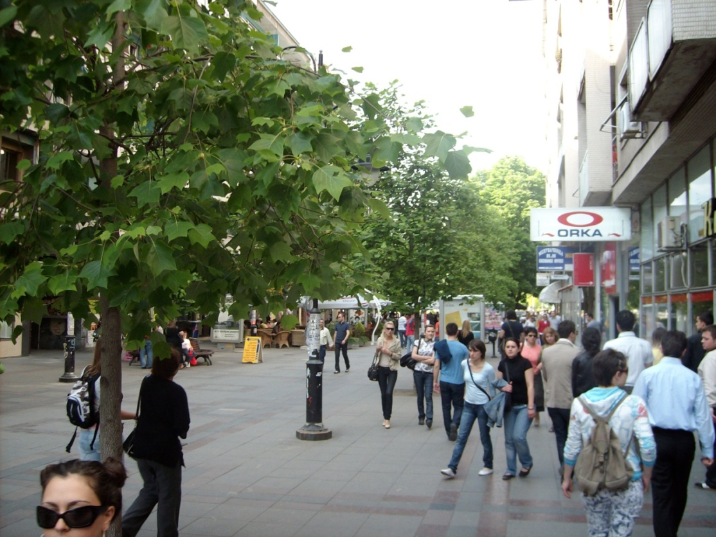
Dr Paul had designed our entry into this country to ease any culture shock before we made a military base our next home. He chose a Holiday Inn for us to stay in as he thought that would be a familiar sight. It was in the middle of their capitol, Skopje situated in a culturally rich area that exhibited some of the best that Skopje and Macedonia, had to offer. We could walk to a nearby pre-Medieval fort that was being excavated and revitalized. I managed to perturb Mr. Paul royally, when in my American attitude of ‘just ignore the sign and do what you want’ when I went past a rope barrier to stand next to a statue for a pic. This guy was truly anal retentive, did not like me, and was jealous of the rapport I had with virtually all my Macedonian contacts.
There was also a major commerce center right next to the hotel that I found fascinating. It was filled with open air cafes and street vendors. The outside of some buildings seemed to exhibit a sense of age from a time long ago, but step inside the doors and you discover the most modern businesses with finely marbled tiled floors and everything just sparkly clean.
In our wanderings, I discovered a statue of Mother Theresa, who was originally from Macedonia, and had my picture taken with her. This did NOT have a rope around it. 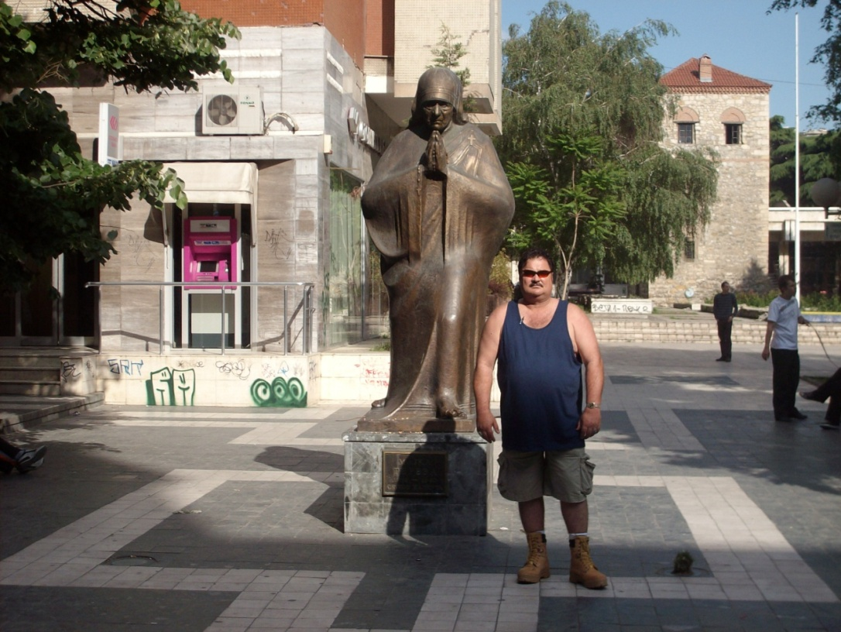

There was also a very vibrant youth culture. There were plenty of open squares with cafes lining the sides. Music seemed to be everywhere with a mixture of their traditional music and modern pop styles intermingling, creating a symphony of their own. There were also government organized programs, with elaborate stages and prizes acclimating the youth to the benefits of staying fit by running, healthy eating, and drinking milk. When I saw these events taking place with so much eager participation I knew then that the government of Macedonia was proceeding in the right direction. The youth of the world today, in any society, is the decision-making adult of tomorrow.
The US learned about nutrition of our young during WWII. The men coming into the US service during WWII had a lot of health concerns, mostly connected to inadequate early nutrition. A soldier cannot reach his or her full physical fighting potential if they have grown up malnourished through poverty or any other reason. It is the same for any youth. Our military’s analysis led to the development of the Women’s, Infants, and Children’s (WIC) program. WIC emphasizes the need for proper nutrition in the early stages of life and provides the means for all families to have that nutrition no matter what their income level is.
Before leaving the hotel, we were advised that once we entered the military base at Krivolac, some 3 to 4 hours away that we would be in the fictional country of Atlantica for training purposes. All laws and rules would be per this fictional foreign government and not the U.S. any longer. There is even a website with all the details of this fictional country that was developed specifically for this training.
As we traveled to Krivolac, which was located south of Skopje in about the middle of the country, we traveled through many other cities that were nestled into the cleavage of the Macedonian mountains. In those fertile valleys, rich in luscious green with the vibrant colors of spring after the winter’s thaw; were many houses sporting thick gardens alive with the vegetables of a new season, ready for the harvest and the art of canning them to begin. Many of the homes had small greenhouses built upon the front lawns facing south. I could picture the sturdy makeshift terrariums defying the cruel cold winters of this mountain laden country.
As we traveled onward, I noticed one unifying denominator to every city that we went through. Always, on the top of the nearest tallest mountain, to every city, was this huge Cross of Jesus. I rode on in anticipation of this wonderful Godly country that was slowly revealing its heart to me as I was traveling through it.

Chapter 4 LETA!

Awakening the next day to the rising sun after ‘the night of hell’, in those beautiful Macedonian mountains with the air crisp and clean; the sun had a particularly new gleam in its eye. Every morning there were always the friendly helpful faces of the Macedonian military that were there for us, but I found myself greeting this day a little extra special because no one killed me last night.
As usual, a bountiful healthy and balanced breakfast was served with respectful demeanor by our gracious Macedonian hosts before our ensemble proceeded to the classroom. In class, we were provided with copies of real news articles of incidents in foreign countries involving humanitarian aid workers where the women and men were kidnapped, raped and even killed. The training the night before was designed to instill upon us the reality of what we were being trained for. It especially became more real for the male participants, when we were ordered to compose a letter to the parents of the women in each of our teams and explain to their families of how their daughter died. My letter was about Leta. She was the lone female in my group of four. My letter reflected on everything I knew about her. In it was references to her infectious smile and joyous nature and of how all of us grieved, as well as them, because she was one of our family too (although I did not think of her just as a sister, if you know what I mean). It was easy to write the things I did about her because it was written from the heart. I thought at one time that a much closer relationship would form, but it did not.

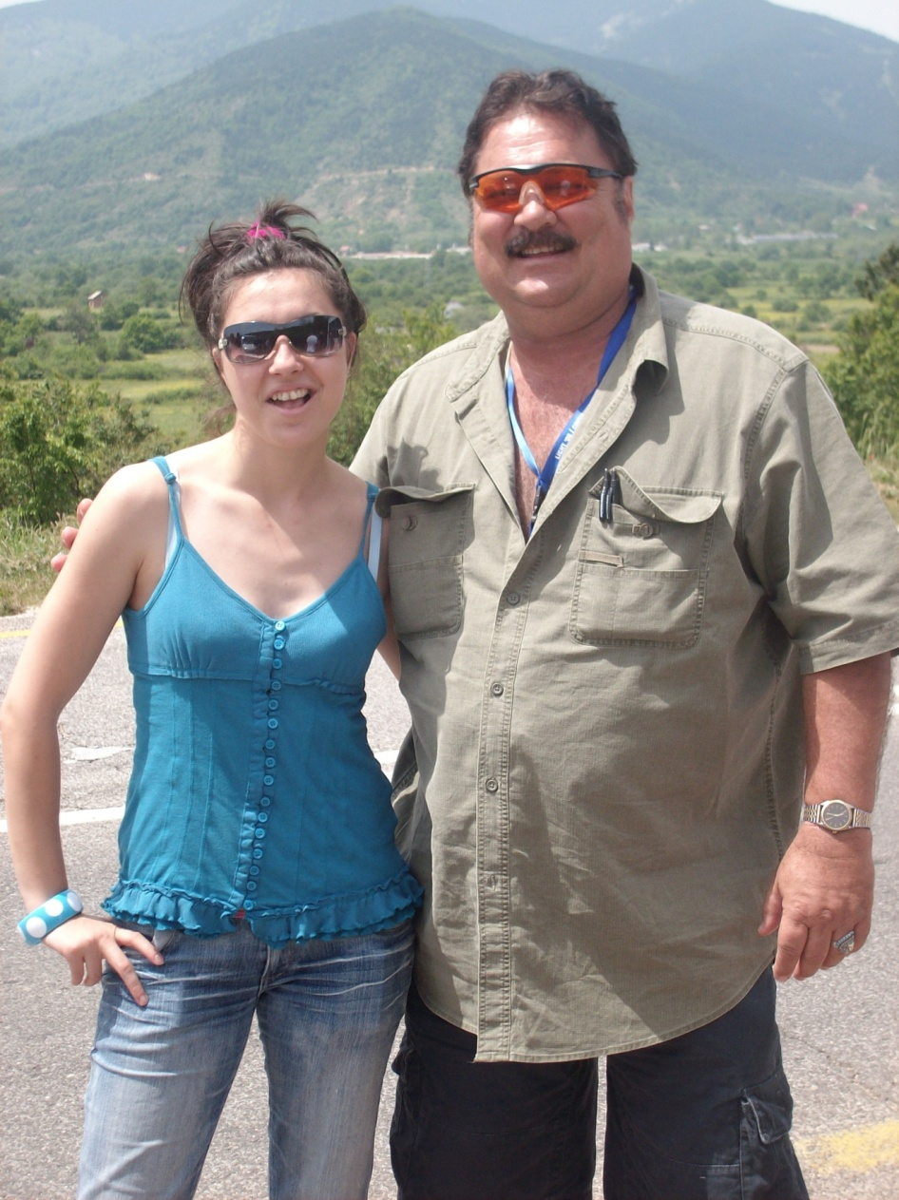
Leta and me. Her 23. How I wished I could turn back the hands of time and had asked her to come home with me and be my wife. She is now married with a child. I truly wanted to be the man that gave her a child. Prayerfully, God will send me another someday.
This training was foreign to my nature. All my life I had found myself in situations where defense of myself had become necessary, sometimes to the extreme. I give some examples in my “About the Author’ section of this book. There have been encounters in hand to hand combat situations as well as confrontations involving weapons, including guns, and I survived them all with only a couple of hospital stays. I lived a life of distractions during my younger years carousing and “sowing wild oats”. Generally speaking, though, it was my opponent(s) in the hospital. But that way of violence begets violence, was not the way of this training.
The training that we were going through now was going to teach us how to stay alive without the use of weapons. Any physical countermeasures were prohibited. It was a foreign way to think, only in the aspect that I was trained to take the other man’s weapon when I had to. Humanitarian aid workers are not allowed to have weapons. This was the lot each of us had drawn for our life in this time frame.
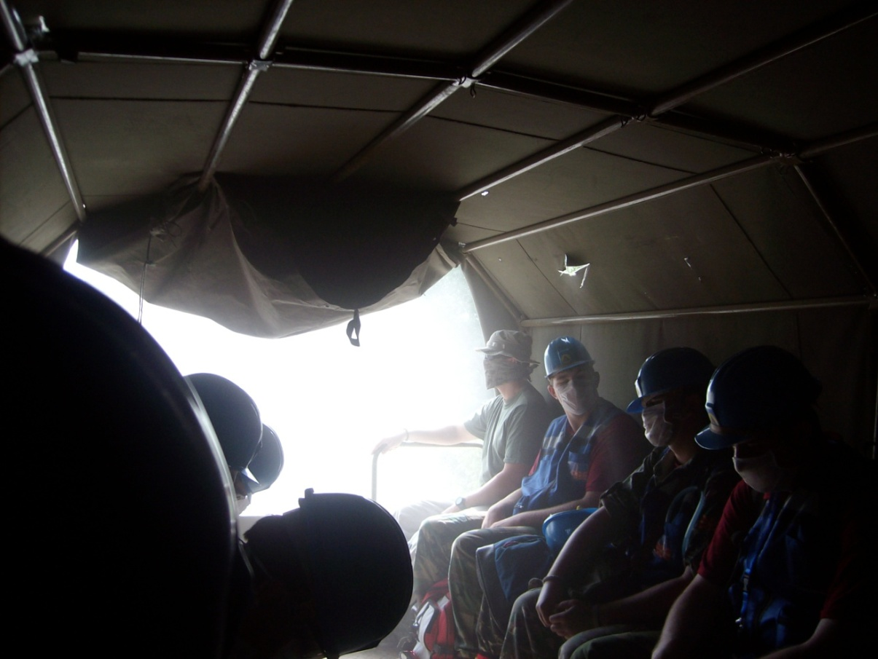
There were many night maneuvers. The training was as real as it gets just as if we would encounter in the field if we chose this road of endeavor for our lives. One night, the team that I was a part of, Team 5, was assigned to meet with a local opposition force leader and negotiate the right for us to serve an area under his auspice with humanitarian aid. We were transported by military troop transport truck to a secluded forested area next to a rolling muddy river. After exiting the vehicle, we were searched by armed and masked military personnel that were a part of “the opposition force.” Always we had to remember not to insult the “opposition force” by calling them any type of descriptive nouns like rebel, radical, insurgent, or word that would take away their honor. These men were honorable men that were fighting for what they felt was an honorable cause. Many peoples’ terrorist, is another’s hero. As a humanitarian aid worker, modeled after the Red Cross’s basic tenets; there are no sides to an issue, there is just suffering humanity in need of assistance to survive and we as humanitarian aid workers were there to help all those who need help. There are no terrorists. There are no governments.
After the security forces tasked to protect their leader from harm were satisfied that we carried no arms and no communication devices we were marched across the river over a steel bridge that echoed under our plodding steps as we progressed single file in the cool night. Luckily that night we had a brilliant moon in that pure Macedonian mountain air. The bobcat and the mountain stream trout are displayed proudly on their coins as a part of their heritage, holding close to nature, not forgetting the roots of this God loving, down home, folksy people. This kind of touch with nature, was well worth the danger we were headed for. We proceeded across the bridge and onward to what we had only imagined in our nightmares.
After marching some distance down the road, we stopped in front of a bombed-out house which was partially destroyed under the Clinton Administration’s ‘peace keeping’ UN initiatives in the 1990’s. As I stood with the rest of my comrades at military parade rest, I imagined this war torn two story house before us had once sheltered a family, now a part of a training scenario that would assist us to possibly save other homes from the same future by doing our part for World Peace. This country of Macedonia had not been immune to the many wars of Europe as recently as the 1990’s and this was one of the remnants of the past.
After once again being searched, we entered the house, guns all around us at ready. This was not just an exercise to these men in military garb that were intimidating us, and for good reason. These men were our chaperones, protectors, confidants, friends and now trainers. The Cobra was there somewhere but all wore ski masks to hide their identities. The men that were with the Cobra that night had real life war experience and knew that they too, had to act well to bring us into a reality that would prepare us to save lives, should we decide to become one of the most dangerous, the most thankless jobs in the world, a humanitarian aid worker.
By thankless, I mean that if a person expects that there will be loads of notoriety and lots of money for all them that do selfless acts to protect and save others is mistaken. Every day as a humanitarian aid worker, we would be saving lives just by giving others some of the necessities of life; food, shelter and medical aid. A person cannot take the time to be rewarded physically or monetarily for their individual achievements. It is humanitarian aid workers on a team, working together as a team, which achieves success that save many lives every day in this world and are as unheralded as the heroes that they are.
During negotiations that night Leta was the team leader and I should not speak unless spoken to or directed to by Leta. That is part of what being a team member is. It is knowing your part and doing your best when called upon. The machine of life accomplishes this task through use of all its parts, each doing their assigned task, each equally as important. Fortunately, I could contribute to its success more fully when the opposition force commander confronted me directly
It had been proposed by their leader that someone stay behind and give medical aid as necessary to his warriors. Leta had made him aware that we were all trained to give emergency medical treatment. He picked me to stay. He asked me what I thought about that idea. I knew that in a real-life situation, the possibility of being killed after my use would be high. I envisioned one of my heroes in life: Clint Eastwood as Josie Wales.
Josie has an Indian buddy that says to him “It is a good day to die” when preparing for battle. That was my mindset as we began to speak. I spoke of the honor of the warrior from my heart and meant what was said. I knew that I was speaking to true warriors that in real life had fought for their country in recent years. He knew what it was like to be on a side that might have to kill or be killed and I knew that he had already probably done so. A man that I perceived to know to fight with honor, is what truly matters. Only then can you take another’s life and live with it. Unfortunately, I also know of the person inside all of us all, that when we confront possible death, of what we are capable of doing in order to preserve the life of ourselves and others. I once tried to bite off a piece of someone’s foot that was kicking me in the face and body along with his buddy while I was on the ground. When it gets down to it you do whatever you got to do to preserve your own life and the peace that you are trying to bring upon society.
I successfully explained to him that trust and honor was essential to a successful partnership. We were asking for his trust to believe that we would not be betraying any information about his troops, their condition, numbers, or locations to the government. I emphasized that he also had to show us that we could trust him to always assure the protection and safety of our people that would meet him or any of the people that he had control of. If he took me for any reason it would be considered a hostage situation and that none of our other people would want to provide the help that his people needed. He listened to reason and in my mind as I saw the Indian Chief sitting across from Josie and saying that my words of death had honor, and therefore my words of life had honor. I watched Leta as she had relinquished control of my own destiny to me. Beautiful in the semi darkness as she was beautiful in the light. I yearned for her but I dare not tell her. An incredible woman at 23. So intelligent, well trained, and deadly. The kind of woman. I dreamed of siring warriors with.
The Commander would honor my words of life that night and I was not taken hostage, or killed. During the discussion with the leader, the soldier behind my head at the window kept pulling the hammer back on his 45 and dry firing it at times. In real life I have taken a gun from a man that was threatening me and beat him up with his own gun, but that was not for tonight. Nor would it be for my future in this kind of work. Others around the room would make their rifles inject a cartridge into their chambers, usually at times when the negotiations were getting hairy. We knew that at any moment, the Cobra could issue an order to have us all killed, just to teach us a lesson. Nothing like realism in life, except for this reality.

Chapter 5 Atlantica

Upon arrival at the military base our luggage was waiting to be evaluated and searched by the soldiers in charge of this fictional country of Atlantica (Forage 2008),` making sure we did not have any contraband. The entrance into this gated and armed military environment would be just as if we were in a real foreign country where there are other people, of another nation, in charge of telling us what we could have and could not have. Many foreign countries do not allow alcohol or other things we of the US consider as normal and acceptable; the penalties for possession of restricted items in foreign countries are usually severe for the violators. As part of the search we were also questioned extensively being asked about specific details from our passports. The purpose was to determine if anything we said would be different from what was written. It felt like one of those old black and white movies where the SS or the Gestapo is interrogating the peasant about strands of wheat (from an area where there is only corn), found in a suitcase. We proceeded to the barracks after that.
The rest room facilities were the most out of place from what we were used to in America. Just as our troops in the Mideast have encountered, there were squat holes instead of toilet seats, which I did not have a real problem with. There is a mantra of the US Marines, learn to adapt. When in Rome do as the Romans do. In a separate facility there were regular toilet facilities that we, as Americans were used to.
The bunks were similar to standard US military issue and comfortable enough with lockers next to them. I was able once again in my life to hear that my snoring is like the thunder of a summer storm echoing through valleys and canyons. Out of desperation one of my companions suggested that I sleep with a sock in my mouth. I passed on that suggestion, used my ear plugs, and took it with a grain of salt.
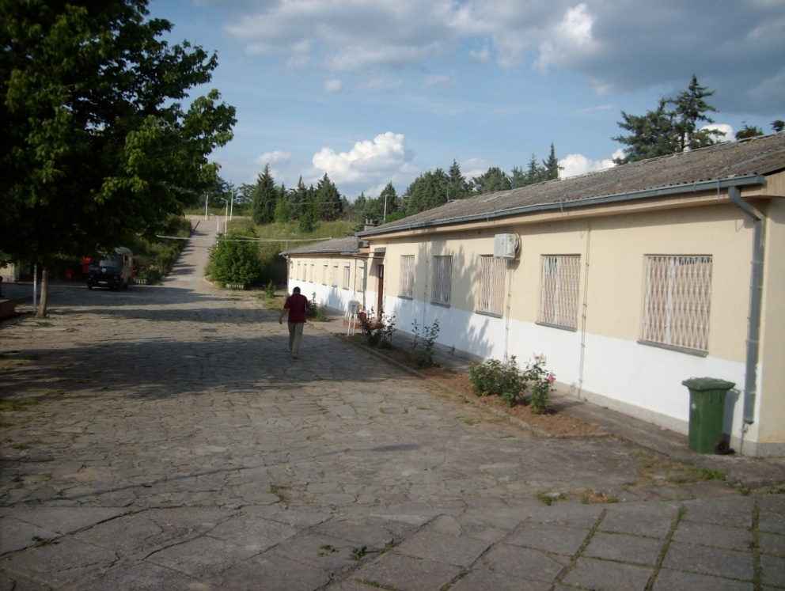
The first week was spent on the base and in the surrounding hills and valleys, engaged in intense real life training situations which were virtually non-stop. They included middle of the night exercises and early morning wake up calls. The meals were served in a standard military unit mess hall. Classroom teachings were as intense as any of the field exercises that were conducted. Generally people who undergo trainings in a class situation find them to be boring and not really productive toward situations that will be confronted in real life. This was not the case in these training classes. Everything we were being trained for may someday mean whether people would live or die, including ourselves if we continued in this line of work and chose to serve our fellow human being by being a humanitarian aid worker. We realized and grew to know that every bit of our training would be crucial.
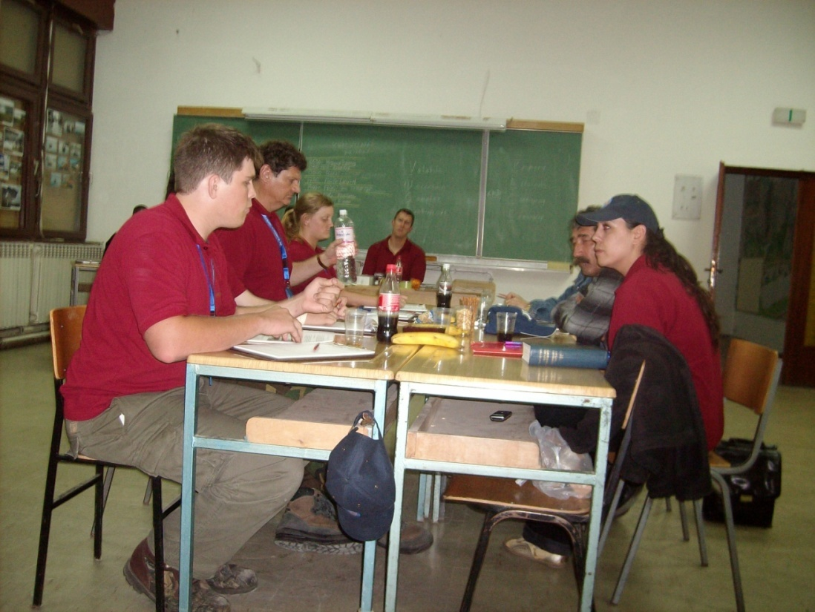
Classroom Training
Our second night in classroom training we were supposedly just learning the ropes of hostage negotiations should one of our people ever be taken hostage by a hostile entity while working in a foreign land. This training included the establishment of an Incident Command System (ICS), and acclimated us to the hierarchal structure by which we would establish chains of command for a coordinated response using multiple government agencies, to any incident. We regularly switched positions during the different trainings throughout the two weeks and took turns at being team leaders. ICS is a system used by many US government agencies today such as FEMA, the FBI, and most state and local law enforcement agencies.
As our evening class wore on, we were suddenly startled by gunfire outside of our classroom windows, followed by the cutting off all electricity to our building. In total darkness our classroom doors opened and a flash bomb exploded just inside them. In the mass confusion following, armed and masked intruders enter the darkened room their silhouettes standing out whenever a flash bomb exploded or a shot would be fired. They shouted orders and shot their weapons and creating total havoc in the room. One of our women ran from the room screaming in fear.
One big ape managed to step on my back yelling in their language, and forced me further down as I was not low enough to the floor for him. After what seemed like an eternity, they left. We waited until silence prevailed and in the darkness we called to each other in an orderly structured manner by team, in the way we had been trained. The team leaders established who was still present and who was not. The lights came back on and calm and structure prevailed. Our errant female returned to the room still somewhat distraught over the chain of events that had just occurred. During the roll call it was determined that one of our male comrades had been abducted, and we knew it wasn’t by aliens.
After a brief interlude and an after-action review, we continued on with training of the standard operating procedures for the ICS. Our team leaders established communications with the various fictional local Atlantican government and social agencies, such as churches, to obtain our kidnap victim back. The phone numbers given to the ICS team had live voices answering, and real negotiations as if lives depended on them were expected to take place.
In a foreign country, humanitarian aid workers must communicate with the established local agencies because those are the people that have been involved in the crisis from the beginning that will have established ties to many of the involved parties. Sometimes the situation that needs outside aid is one created by an act of God, such as earthquakes, hurricanes, tsunamis etc. Other times it is as the fictionalized situation that we were in, and that is the combat operations that results from civil unrest and social dissatisfaction. The standard operating procedures of the ICS system would continue throughout the training exercises in Macedonia.
Repetition in training is a standard technique for the military and most other paramilitary organizations. Repetition makes a person’s reactions become automatic, even when under conditions that are stressful. Examples of the organizations that use this technique would be is police, fire and rescue, full combat military or medical personnel in emergency situations in general.
In every situation that we were put in, “Risk Assessment” and being “Situationally Aware,” were emphasized at all points of any operation. (Forage 2008). The constant twists in our training, by the situations suddenly changing, hammered home those two points. Many times, we found ourselves suddenly in a situation that we did not expect. Was it because we had not evaluated it thoroughly or was it another “instructor’s twist” thrown in when it seemed that we had covered all the bases? Was it because we had become complacent and had not thought of all contingencies? That was something that the commanding officers could evaluate, and if for training purposes it would be deemed by them that there would be alterations in the master game plan, and go to plan B to further murk up the waters of illusion? Then that is what would be done. Either way, there would be twists that would train us to save other people’s lives, and again, most importantly, maybe our own.

Chapter 6 The Conquering of Eagle Mountain

Part of our training involved map reading and the use of a compass. On a Thursday, we went on a hike to make use of those skills in this beautiful rugged country filled with those majestic mountains. I grew up a “flatlander” in beautiful sunny Florida and the only mountains we have are the ones being formed by waste disposal companies. On the brighter side of that, the county I live in now has just signed an agreement with a Japanese company to provide the technology for waste disposal through plasma disintegration. Human refuse reduced into a fraction of its original mass and turned into brick like material for road building, all while generating enough heat for the production of electricity.
We started our hike in a field on the base, with an international map and compass. Two teams with two different routes were selected with the same goal; the top of Eagle Mountain. I was lucky enough to be on the team with our Macedonian handler named Roddy. Roddy led us in morning exercises and was rumored to have been part of an elite government Special Forces group.
Visual objects in the distance were located to give us a point of reference; degrees were calculated and onward in near straight lines we marched. Single file we marched, equipped with backpacks, water, extra clothes and snacks. Through farmers’ fields, crossing roads, and up goat paths we conquered the first hill. Hill was not the way I had described it when looking in the distance at it when first proceeding toward it. At the top of that “hill” we were shown our next objective and I realized then that it was a hill we were on. The top of the next hill was a mountain, thousands of feet high and more than two miles in the distance, was the top of Eagle Mountain. Those two miles plus were in a straight line and did not count the vertical part of our climb.
It was a beautiful, yet strenuous hike, filled with very scenic views of the surrounding countryside. Every so often along the trek, maps were consulted and compasses were used. This part of our training would be most useful to us when and if we were to be in a foreign land unfamiliar to us. Now we would have practical use of international maps and more familiarization with the metric system used by the rest of the world other than the US.
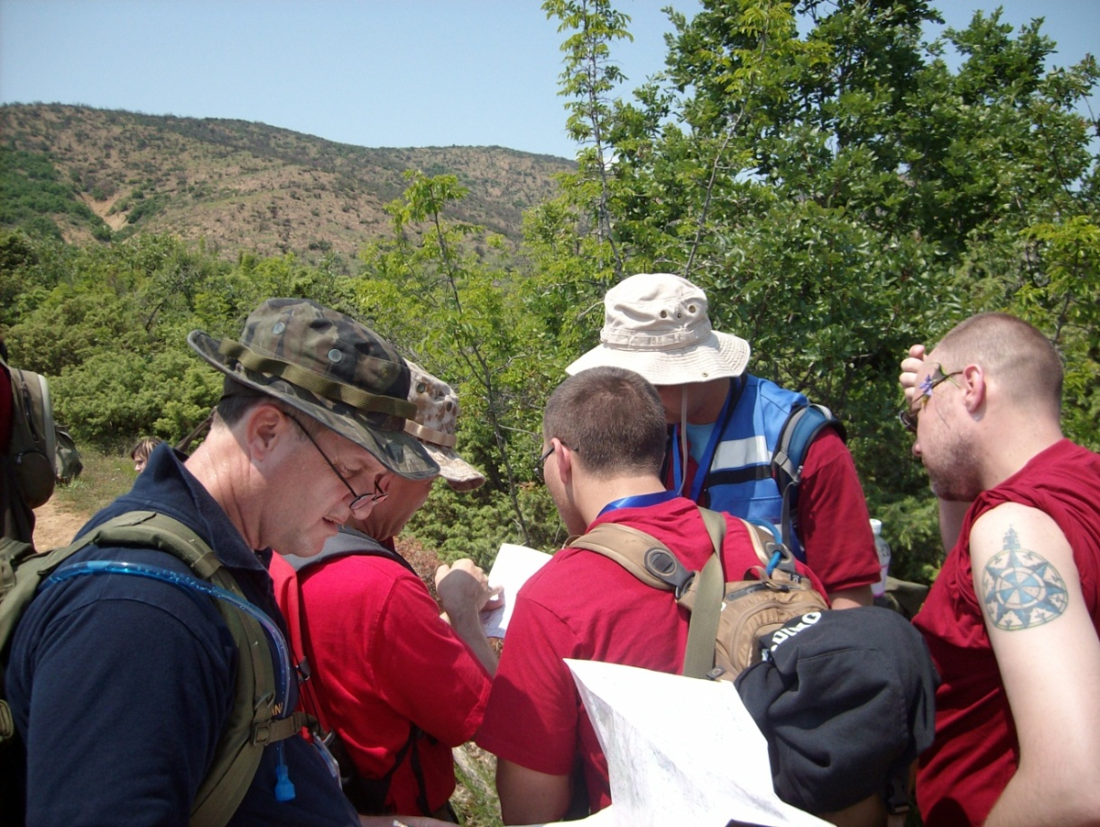
Which way did you say was up?

There were some of us that could not keep up with everyone else, but always the team approach kept being emphasized and it was ‘all for one’ and ‘one for all’. 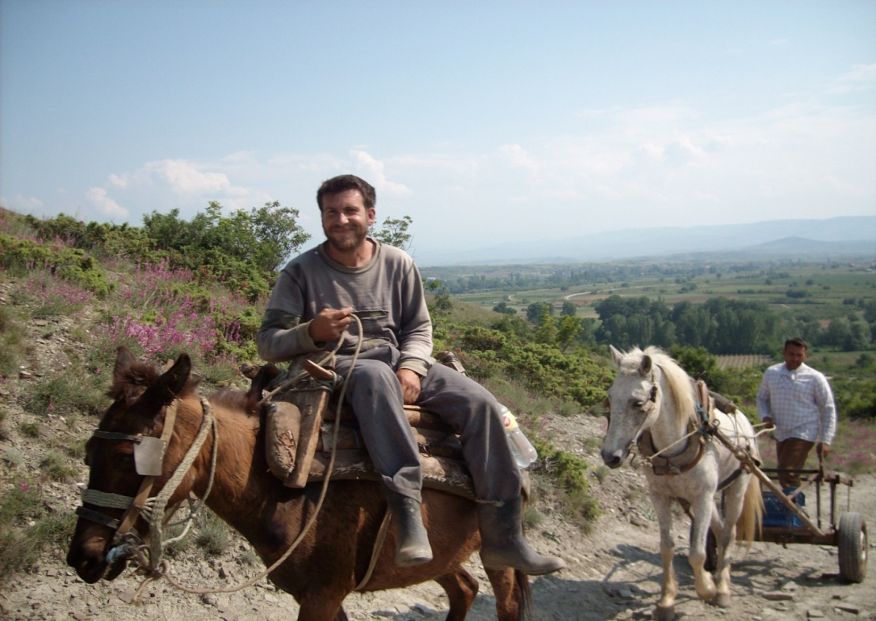 Best transportation for these goat paths.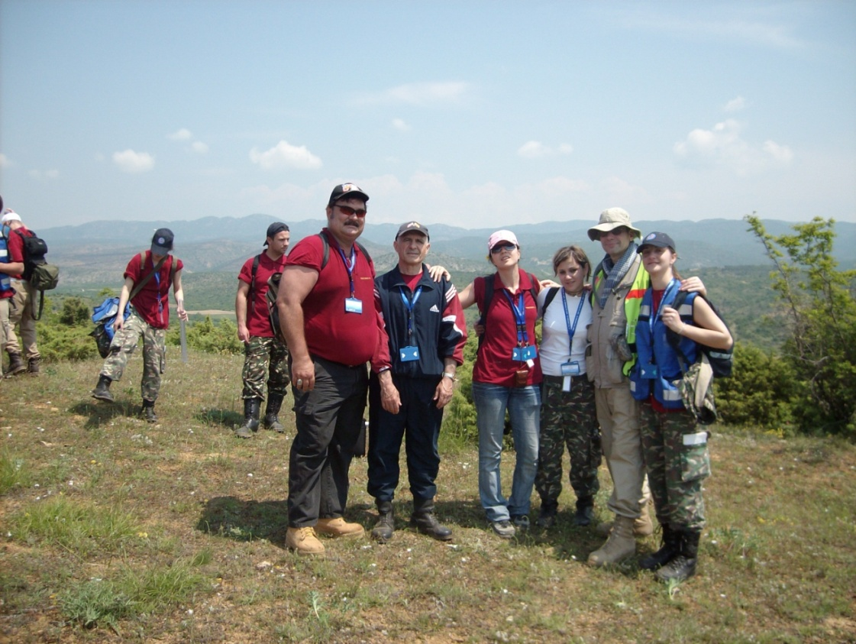
Left to Right previous page: Joe Hill, Rodddy, Leta, Ivana-Ici Krsteva, Stephana.
Standing on top of Eagle Mountain with my friends and instructors gave me a sense of peace and accomplishment. The pain in my feet became numb as we basked in the glory of our team making the top. My new friend, Roddy and my old friend Lucky, instrumental in providing some moral support that I needed to overcome the pain I could not suppress on the way up. Now it was time to reflect just a little as we stood at what seemed to us to be the top of the world. We had made it, and it felt good. The sharing of love was all around and the smiles reflected that feeling within us all at that moment.
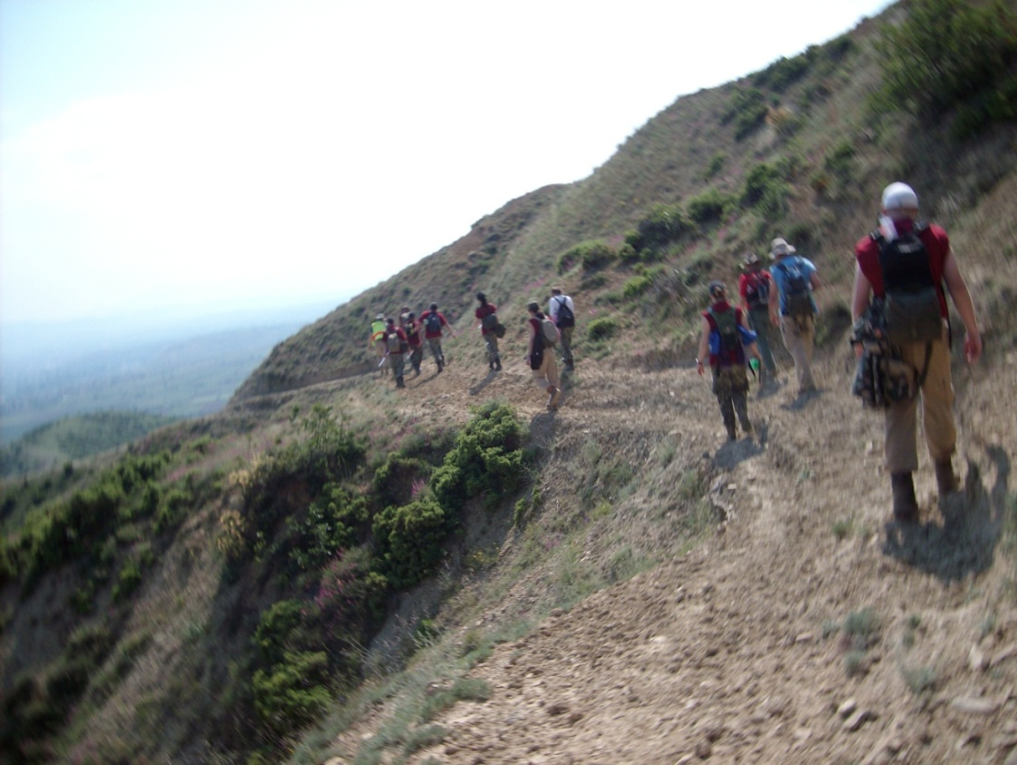
These were not tourist paths. The dangers were real every step of the way. The slope to the left ended about 500 feet down to the bottom.
Chapter 7 Ochrid: An Eastern European Riviera

The second weekend of our training, our enclave was transported to southern Macedonia to a place called Ochrid for some rest and relaxation after a grueling week of humanitarian aid preparedness training. At one time, it was considered the vacation spot of Eastern Europe and still today it is a tourist hot spot. The weekend had been billed to us as a time that we could be independent and participate in group recreational activities. My research of this town consisted of a computer search before I had left home. Ochrid was one of the primary birthplaces of Eastern Orthodox Christianity for Central Europe. At one time this relatively midsized city had 365 churches. It was bragged that a person could go to a different church every day of the year. We checked into a very nice hotel and prepared for our free time in the city.
Our stay there was excellent. During the first day, a group of us went out on the water of Lake Ochrid and observed the town from a boat. The water was crystal clear and extremely cold and deep. In my younger years, I would have had a beer or two and jumped in.
Back on land buying some religious souvenirs and browsing the local area observing the locals and their laid back, socially interactive lifestyle was the rule of the day. Just as I had seen in Skopje, there were many open-air cafes that were very conducive to social interaction both to the people in the cafes, and the people just walking by. Anyone could see that many knew each other. It was a community event, having lunch, not just an individual event, and just as in Skopje, there was a true sense of warmness and friendliness. Nowhere was this experienced this more that with us through our Macedonian instructors and handlers such as the bodyguards and drivers.
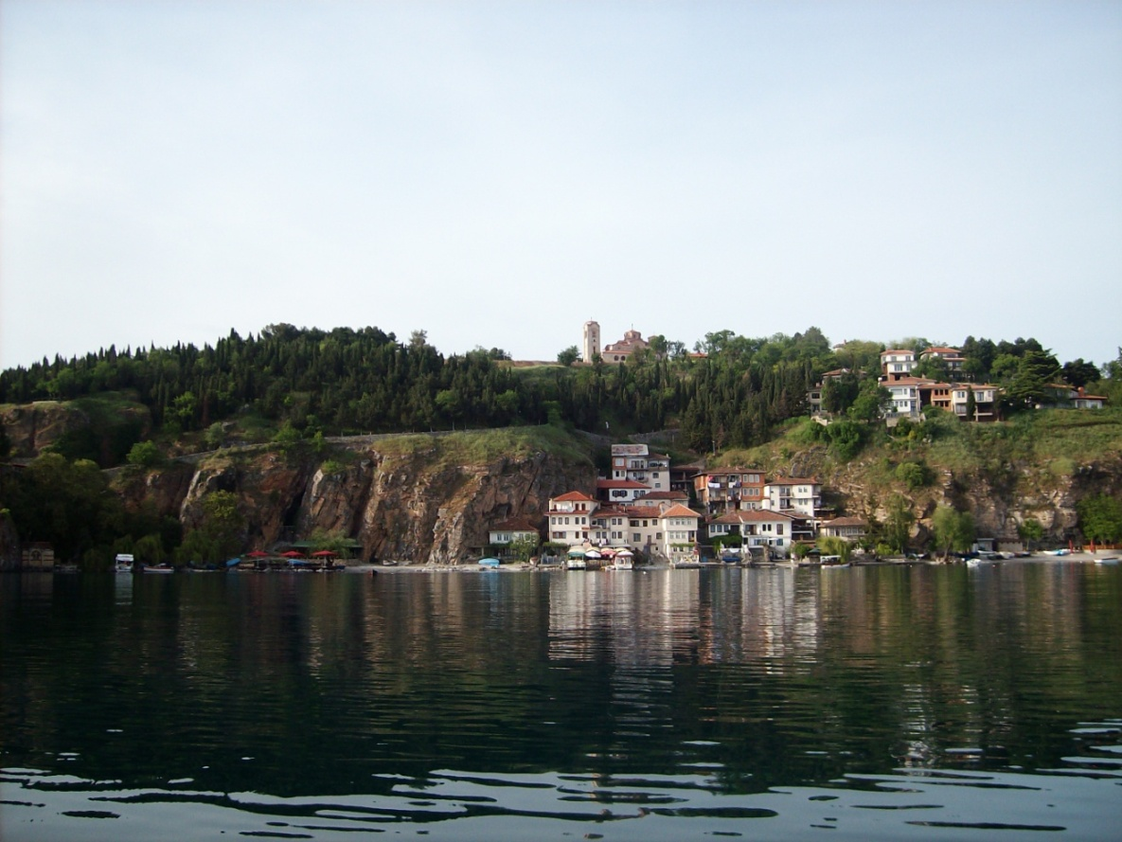
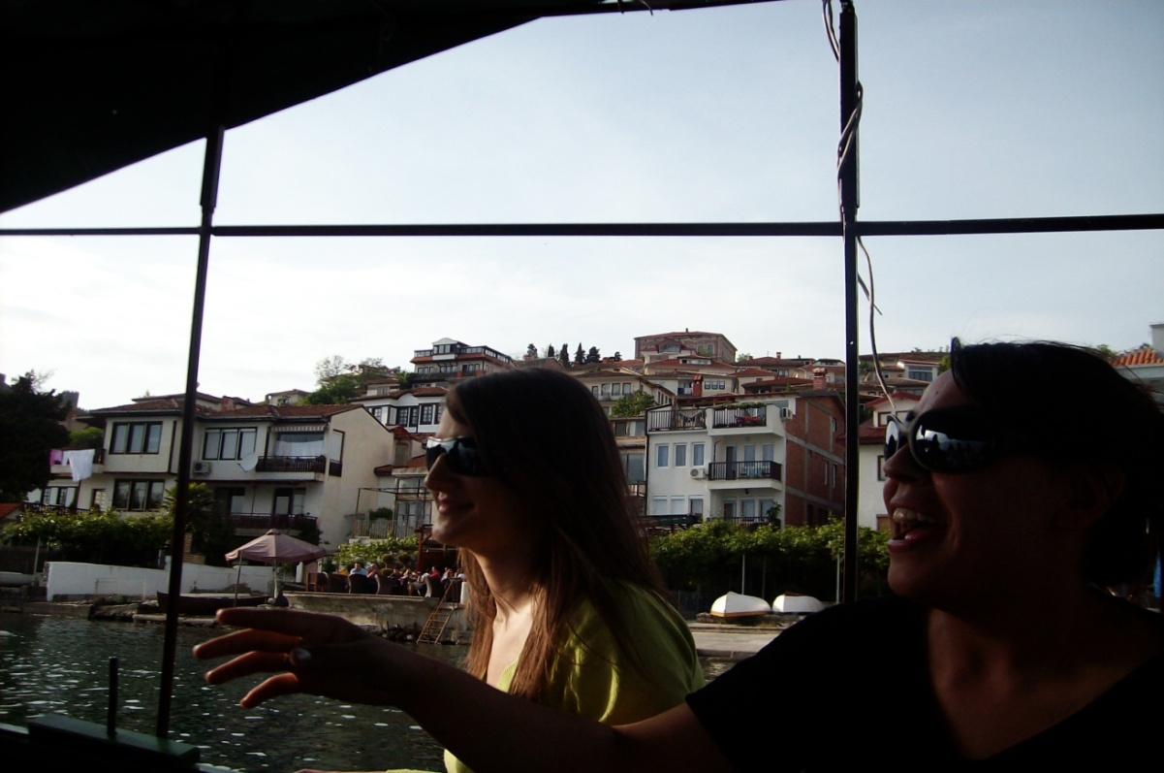
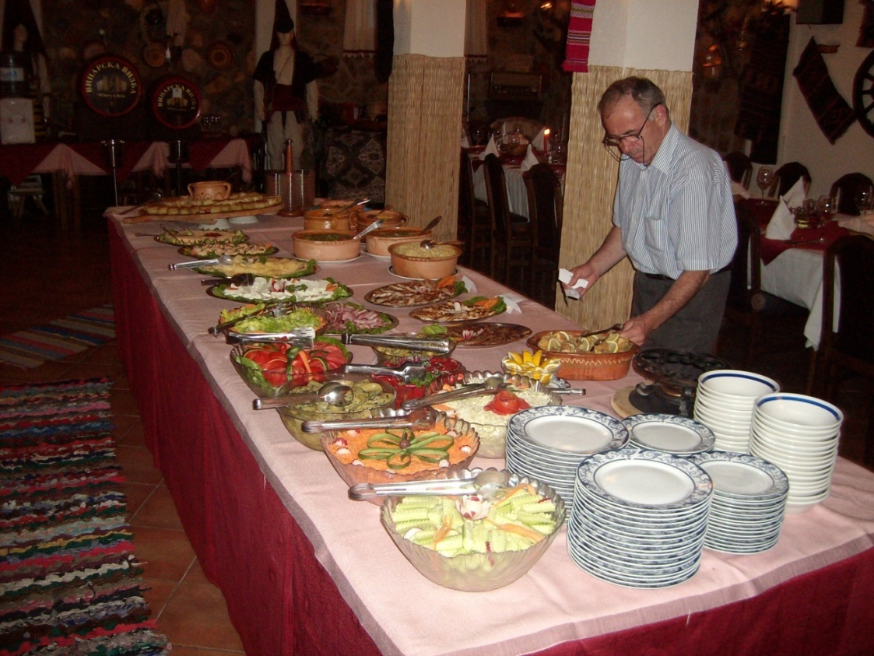
Upon returning to the hotel we were treated to a lavish dinner accompanied by live traditional music. It seemed that everywhere we went, Americans were treated like royalty. It did not matter that many of us dressed in shorts and sandals, Macedonian people truly liked Americans and see us as a way of life to be respected and pursued. As another example to this on that night, most everyone went to a local place to drink and dance. I stayed at the hotel, opting to rest and work on some homework assignments from an internet course that I was taking simultaneously with the humanitarian aid course. After everyone had left, I discovered that I had no computer with internet access at the hotel, so I called a taxi and went right back to the area that we had been during the afternoon. I had spotted a second story internet café near the place where I had purchased my Macedonian made cross earlier.
While at the internet café music wafted in on the gentle breezes through the open windows from the street below. The youth of the area, like our American youth, always want music to be playing while they interact in the evening hours. My time at the café encompassed about two and a half hours. During that time listening in the background of my mind, focusing on the most important objective was my homework. Every song played was in English. I knew almost every song and could sing along with most of them. Their youth are being influenced by the songs of our popular ‘rock’ songs from the 70’s and 80’s. It was very refreshing. The songs were upbeat and looking forward, not backward.
Practically every Macedonian that I met could speak some English or there was someone near that could. This country is ripe for American assistance that will produce friends that we need for our continued efforts to shape the world’s countries into free and democratic societies, and to combat global terrorists. This humanitarian aid course is a definite plus toward developing international ties that will become more instrumental soon for the establishment of Macedonia into the European Union and even beyond that.
I returned to the hotel before the others returned and turned in for the night. The next day was Sunday and we took a group tour of the local area and visited an old fort and several churches that date back to the establishment of the Christian Church in Eastern Europe. One instructor, Roddy, seemed to share my love of God. He was inspiring, full of energy, and eager to share his knowledge. I was lucky enough to share a room with him in Ochrid. He and Lucky and I had our picture taken in a mosaic filled church, one of my personal highlights of this grand adventure. I hope that someday I can do something significant for his country. Roddy’s mere presence in this exercise brought it to a new level for many of us.
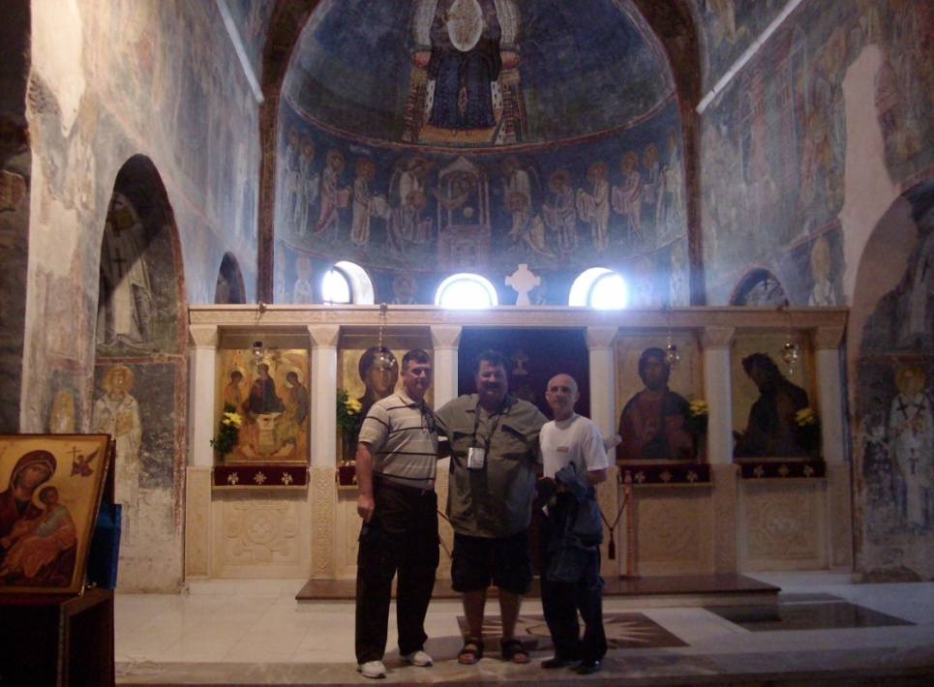 Lucky, me and Roddy.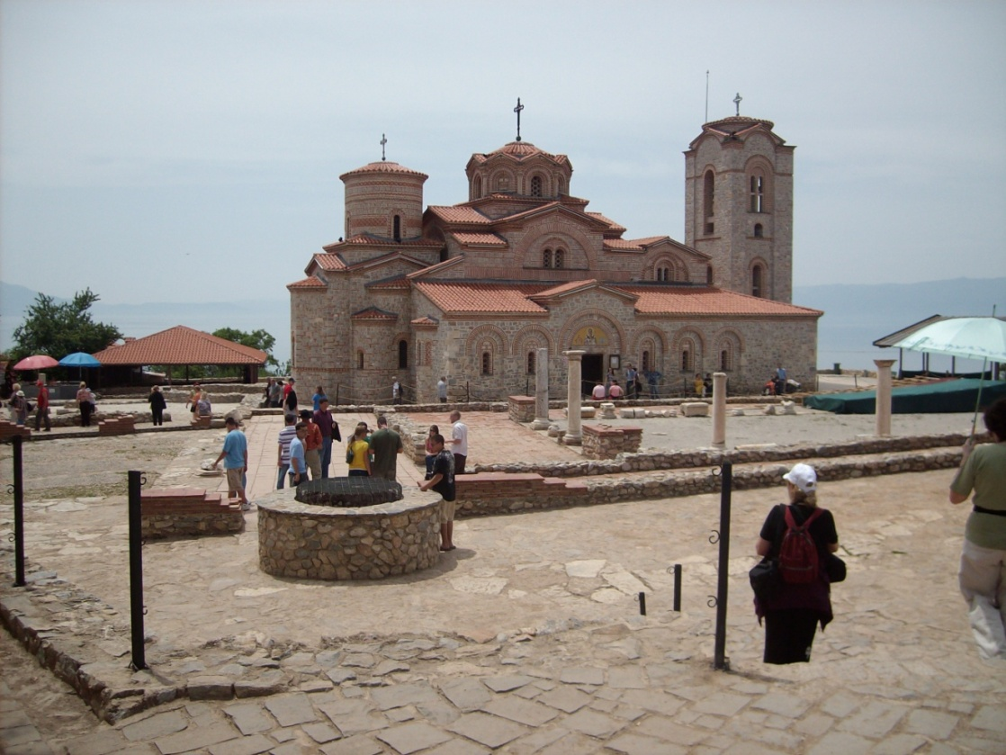 A pre-renaissance Church being renovated at the top of a cliff overlooking Lake Ochrid.
Chapter 8 Radiological, Biological and Chemical Wound Treatment
With Mass Casualties Training,

Upon returning to training we returned to a different world. We were no longer on a secure military base with hardened roofs over our head, latrines with flowing water, mess halls with complete kitchens, and clean concrete floors. We had returned to military tents, several of which we had to erect ourselves (for practical experience). Now we were truly in the field and it would be our training that would keep us and our fellow humanitarians alive and allow our mission to provide aid to others, to succeed.
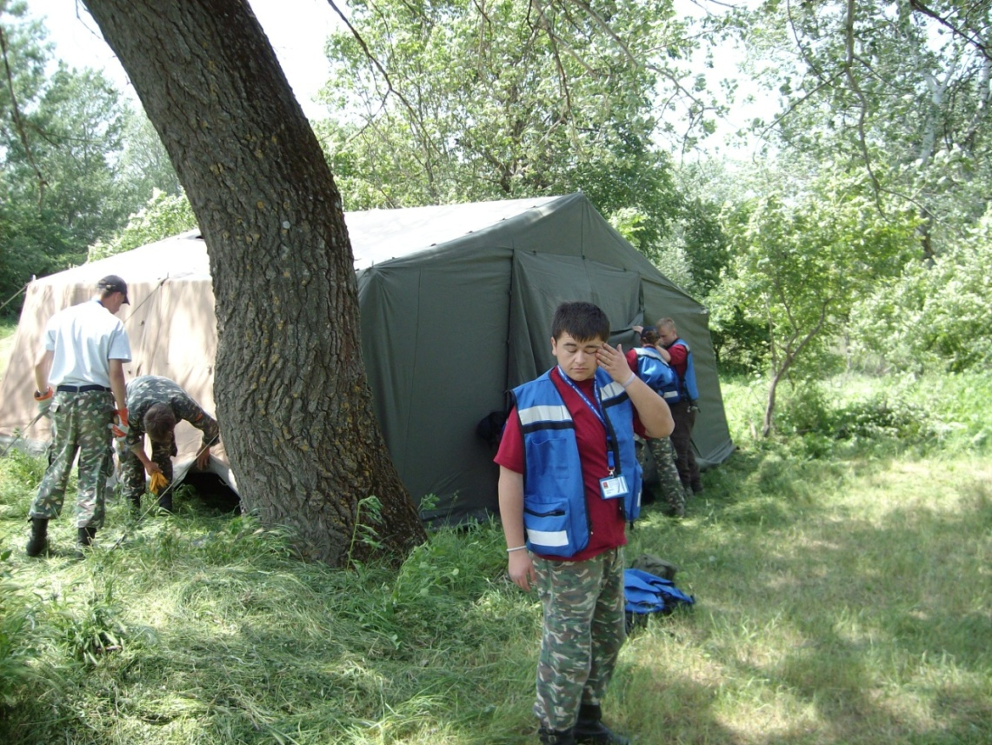
As part of the exercises in the field, a portion of the local population was employed to portray victims in multiple and varied situations. We even provided tents to house them temporarily that we erected ourselves both for experience in erecting tents and again, teamwork to accomplish goals. The victims were as varied as it would be in a real disaster situation. It did not take us long to realize that our “victims” had been schooled in the art of deception to add to our training. Some had been trained to become belligerent and combative at times to test our resolve to help them. This was another situation that an aid worker will encounter whether in China or Louisiana. There was a male tent, and a women and children’s tent. Military RTE (ready to eat) meals were provided. The military has made great strides in developing those meals and most were very tasty.
That evening started at 7 pm for my team and we were assigned to oversee our Macedonian brethren that were housed in these tents. As we got there for our shift it was already good and dark. Our team observed from an open-air tent some 60 feet away from their tents with a crackling fire between us to warm the night air. The Macedonian players had gotten a little rowdy earlier with the first team. It seems that one of our locals had snuck in a little booze to ease the pain of training. Team One did not know for sure if this was part of the training scenario but they were aware that the mustard bottle that one of our actors of our “Grand Play” was nipping at, did not contain mustard. Another local player openly brought bags of what looked like beer up to the camp along with the fresh catch of the day from the local river. Team one before us had already squelched that party early on while it was still being put together.
As the evening progressed, our team realized that someone had snuck the fish back in and the local chef began to prepare the fire for the fish. We did not interfere. There is no need to interfere when there is no problem. We had adults to watch, and the adults watched their own children.
Their dinner party progressed with friendly Macedonian camaraderie and plastic cups filled with some unknown liquid. I could not stand it. I had to be a part of it (minus drinking the unknown liquid for I was on duty). It was fun to be a part of that group sharing in love, happiness, and some good tasting fresh fish. The people involved were what made it one of my better times in life. I felt at home. The feeling was as one big family where everyone was welcome. After “sharing in the love” that surrealistic night I retreated to my work station until our relief team came around 1 am.
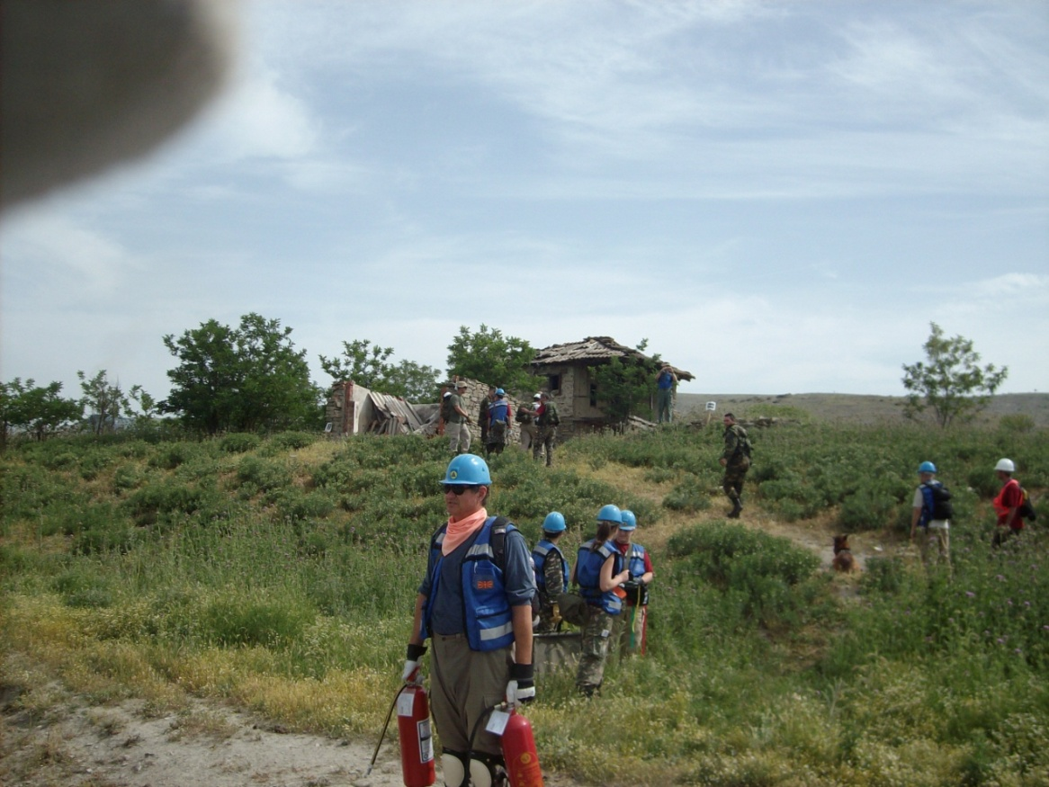
The next exercise occurred outside of our new base camp at a location several miles away. All teams participated. The exercise was accomplished at a site where a village used to stand on a small hill. The village had been bombed out in the very early 1900’s during WWII. Fire suppression and control would be just one of the skills that we would demonstrate. We had had extensive training in that category of aid when were still on the base.
The landscape provided our trainers with prime opportunity to place victims in bombed out houses and to locate the victims with rubble strewn on top of them, essentially burying them. We were not able to see them with the unaided eye. Body sniffing dogs were used to locate the victims we could not see that were safely buried in rubble. All victims were treated initially in the field just as it would be in real life. All wounds and fractures, etc., were made to look as real as it could get. If there were broken bones then the limb would be immobilized with special contoured wraps. Burns were taken care of with specially treated wraps and bleeding arteries were immediately taken care of per their needs. Some of our victims’ injuries spurted blood from ruptured vessels. Tourniquets were always used as a very last resort. When you are confronted with a primary artery spurting blood you must make a choice to tourniquet the limb and save a life knowing that the victim may possibly lose that limb because of the lack of blood flow to that limb. Compressing it and hoping for coagulation to take place is a call that is made in the field. All the teams were involved in all aspects of this scenario and performed admirably. For the victims that were buried, we carefully unearthed them and did initial medical assessment and treatment. We then gurneyed them to an awaiting Red Cross station staffed with real Red Cross Doctors.
The Red Cross team was the same one that had been on call for our exercises always. They were very mobile with their field hospital and could deploy anywhere at a moment’s notice and in less than an hour be fully functional. Among some of the things I brought with me to Macedonia were a few extra tubes of antibiotic ointment and a big box of cotton swabs along with other medical “goodies”. I left things like that, over there, with the medical team.
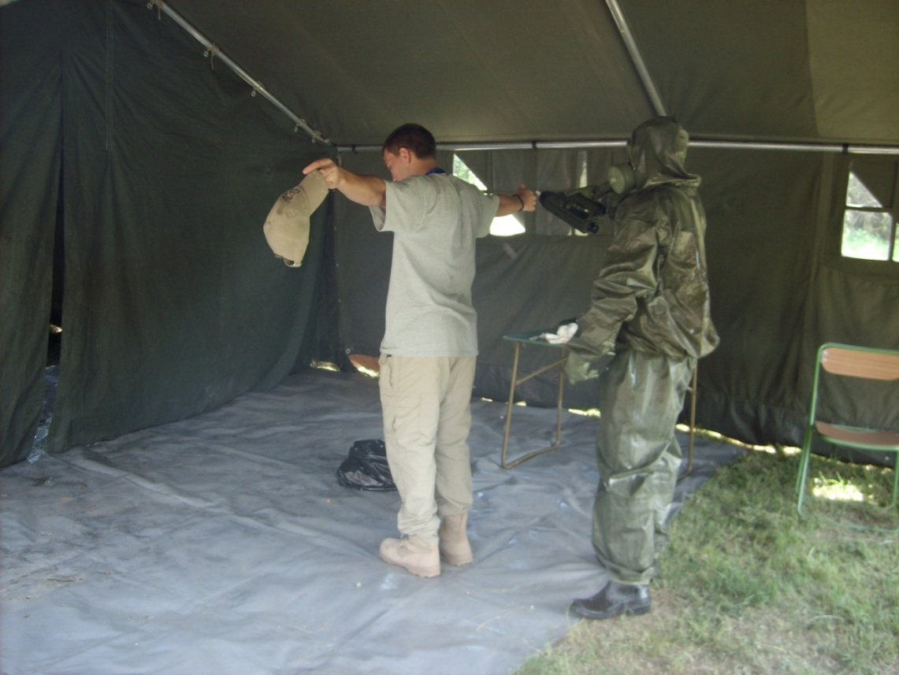
“Chaz”, (a dynamic youth) from North Western University Missouri.
The next training was very near our main camp and involved Bacteriological, Radiological, and Chemical contamination scenarios. (ICS Tabletop Exercise #3) Our teams were deployed to traverse a short distance down a road and retrieve people who could not make it to us on their own. Initially, the victims were treated by our mobile teams, and then, hand carried gurneys were used to transport them to the main processing point. The Macedonia Military had set up field decontamination tents complete with chemical wash downs to neutralize most all possible bio chemical hazards. The military handlers were dressed in the body encompassing gear used for the events should it really occur. The soldiers suffered in the heat, but tirelessly continued; knowing that the training they gave us could be used to assist their country someday should some of us become humanitarian aid workers. At the end of this exercise one of our team mates, (Chaz) went through the wash down to get the real feel of what the victims of such an attack would go through. Chaz was a cheerleader from North West University at Missouri. Cheerleading takes a lot of physical strength and stamina. The ladies in our entourage of Aid Trainees enjoyed this part of the exercise especially when Chaz had strip to down to his “skivvies” to be scrubbed down for decontamination (LOL). He was in top physical condition and ‘ripped’ as the ladies say. Chaz’s cheerleading team has since won top national honors at University level competition.
Our next exercise involved more of our locals acting as the victims in a mock disaster next to the river that was close by the camp. (ICS Tabletop Exercise #2) Our task was to, as always, do the initial medical assessment and treatment to victims. The victims, in this case, were on the other side of the river and had to be transported by boat to the safety of our side of the river and then to an awaiting Red Cross team. The first excursions with the 8 man boats were propelled by human power. Again, we have the real-life experience of possibly being in an area that has no fuel for engine power. After we had demonstrated that we were skilled in the control of a boat while using human power we could use the motors on the boats. Some areas may not have engines for motorized transportation. (Military, Overcoming Military Obstacles, 2008) This exercise went very well, no one drowned or fell in the water, and the mission was accomplished with no fatalities.
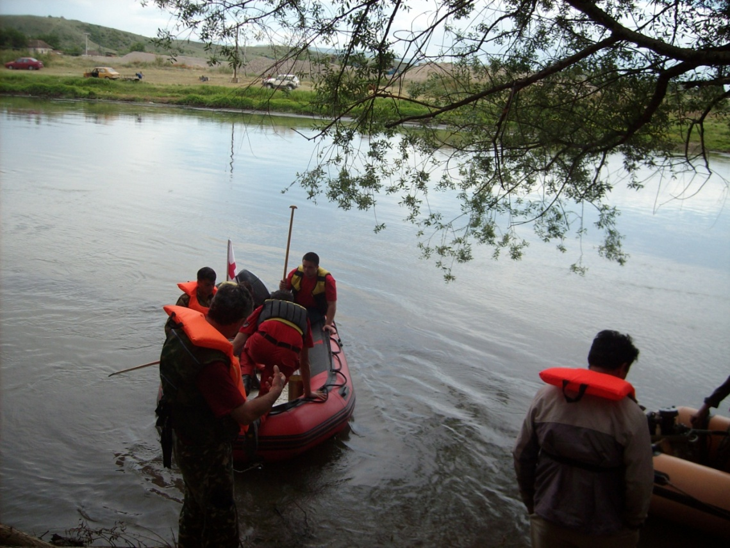
At one point, I became a little emotional thinking about my daughter back in the US and found myself tearing up. I stood at the back of the crowd along the banks of the river wanting no one to see my face. I fought back the flood of tears that wanted to come. I knew this was the last day that I could have ducked out of my commitment to finish this project and fly back early to the states and see my first born, graduate high school on Saturday morning. My ex wife left us when my daughter was 10 and my boy was 6. Had it not been for Kawani I do not think I could have kept it all together raising them alone and maintaining the bills by myself. She is a very special young lady and continues to impress many people with her drive, intelligence, and beauty.
It was not until my daughter was 15 before I learned that she could not cry. This shocked me. A 15-year-old girl that could not cry. I had been her example. She had looked to me to show her how to act and I had failed somewhere. I decided then, it was time to get in touch with the nurturing side of myself and start to show my children that I could cry too and still be strong and fearless “Daddy”.
Movie night for us started ending with a few tears. I wanted my children to be emotionally balanced and to know it is okay to show your emotions. I had to come more into contact with my emotions for their sake, and really for mine too. A person should not have to hide all emotions from others. Part of being in this world is to share life with one another and even the ones that seem negative have a place and time. It worked. Both my children developed into more balanced individuals that could express themselves.
Those of us that are Christians look to the words of Jesus Christ to guide us in our everyday struggles of trying to get along with others, even those that disagree with us. The Believer’s Freedom as interpreted by Paul in Corinthians 10 verses 23 and 24 “Everything is permissible, but not everything is beneficial…Nobody should seek their own good, but the good of others.” We are back to the two rules of Christ, “Love the Lord your God with all your heart soul and mind… Love your neighbor as yourself.” (Mt 22:37-39). Follow these two laws and the rest of other laws ever written will follow. The difference is that now we are about love and forgiveness, not crime and punishment.
Those minutes by the river were gut wrenching as I stood at the back of the crowd trying hard not to let anyone see me tear up. I finally came to grips with the fact that I was going to finish what I had started and not request to be sent home early. The day’s exercise was nearing its completion. Tears had fallen, but no one had seen.

Chapter 9: The Cobra’s Kiss Good Bye

We returned to base camp and began preparations for the evening’s negotiations for tomorrow’s prisoner exchange. One more negotiation and we would be in the final stretch of the Macedonian experience. I was appointed to be the chief negotiator for that night... American Indian, “Chief Negotiator” for the preparations and stipulations of the prisoner exchange scheduled for the next day. How fitting for the final negotiation. It should have forewarned me of the possible dire consequences that it implied. Once again in history would the treachery of the white man unfold, via the mind of The Cobra. For now, this Indian, far from his home, was ready to take his place at the table for the sacrifice.
We were told that there was a soccer championship on television that night and if the negotiations were successful there would be a planned party with all who chose to attend. Everyone in the camp was invited and encouraged to attend, except for the primary commanders of the incident command system. That should have indicated to us that all was not what it was purported to be.
We arrived at the Atlantican Military commander’s home and negotiations went very well. A neutral exchange spot for the prisoners from the government and from the Opposition Forces was established and the procedures of the exchange were agreed upon. The Red Cross and the media were to be allowed to attend this historic event. It had been presented to the Commander of the government forces that both sides would benefit from the notoriety. The government would be willing to be forgiving and receptive to others ideas, just as in a democratic form of government.
After successfully completing the negotiations, we were joined by most of our comrades from the camp. All but the ICS command had come. We joined the Commander in his personal office. We watched his favorite soccer team compete in a national final. With much cheering by all to the final second, we saw his team be defeated in overtime. Another omen prognosticating the change of mood about to occur; ignored once more.
As we left the hospitality of the Atlantican Military there was laughter and mutual cajoling occurring. Overall, we were a very happy group. As our truck left the compound area, the truck turned right. We had come into the compound from the left but I did not think it peculiar it being possibly just another way home, trusting soul that I am. We drove onward through the night on the dusty back roads of Atlantica, lit only by misty starlight, to a destiny that we had not expected.
Yes ... Atlantica. For a few short hours, we had forgotten that we were in Atlantica. The transportation of our souls by the television, the soccer game, and the camaraderie, to a better place, had made us forget that we were in hostile territory…but The Cobra had not. Once again, our transport truck was attacked in the night. At the initial point of attack, I had ordered the driver to continue on, just as we had planned in an emergency situation. That was quickly overruled by the instructor sitting next to me. He could not allow our group to escape his trap.
“The truck is disabled” he barked as I saw his steely eyes of sadistic glee begin to flow into glowing white vertical slits in the dark. The eyes of a snake, the Cobra, alive in the night, ready once again for that hypnotic dance with the devil.
We were subjected to gunfire, threats, accusations, and one of our own was made to run for miles as punishment for his mouthiness. I think he enjoyed it. Kyle is a paramedic back in the states and he likes to stay in shape. Another one of our team members was taken hostage during the melee. When finally, we returned to our camp, there were further negotiations by the ICS team commanders to regain one of the cogs of a wheel in our family. A Macedonian female, Kristine, received an exemplary achievement award for her actions involving the retrieval of our comrade in humanitarian aid. She selflessly went by herself to give the captors what they wanted (my American peanut butter which I had brought with me to share with all), to buy our fellow aid worker’s freedom. Another lesson that even the simplest things to us as Americans can have value to others.
The peanut butter later showed up near the dinner tables the next day available for all who still wanted to share in its deliciousness. I was raised on Jif peanut butter and had brought a couple of big jars with me to share with the people of another country who may have not had access to the best peanut butter in the world. A locally produced Fort Pierce Florida honey was also brought along for everyone to enjoy. Macedonia is a big producer of honey themselves. Macedonia supplied much of the honey for the Olympics held in Beijing China 2008.
During the evaluation, the next morning we were reminded we should never let our guard down when in a foreign country. Anything can happen at any time, and in Atlantica especially, trust no one. As we prepared for the prisoner exchange that morning and loaded the trucks, a sense of tiredness filled the camp. It had been long, grueling two weeks. Marches, night maneuvers, ambushes, and repetitive class trainings. This had been no ordinary class in survival and many, including myself, needed some rest. But onward we plowed.
At the prisoner exchange point we found ourselves in the middle of a large field at the base of a heavily brushed mountain. More than me searched the brushy hill for snipers. Security perimeters were established, tents were erected and guards chosen. My designation was to be part of the news media. This was fitting as I had a video cam that had already taped a good part of our journey so far.
The Red Cross tent was centered directly between the tents that housed the Atlantican Military personnel and the opposition forces that were responsible for providing the prisoners. Seeing that Red Cross flag, fearlessly flying there between those two warring factions, it brought to my mind of an island in a sea, surrounded by blusterous winds and thundering dark clouds of fury. The Red Cross tent, an island of refuge, for the weary and for the war worn. War mongers on both sides, now ready to do a thing that would possibly be the first steps of a lasting peace. That oversized Red Cross became a symbol of the catalyst to calm a storm that had gone on too long. Protection, healing, The Red Cross... Warriors, in their own right; but warriors for peace. Warring in the way of Martin Luther King, Peaceful, without violence, and caring for all equally.
After the setting up of the exchange area, the prisoners arrived from both sides and were directed to their separate areas. The prisoners to be exchanged were released one at a time from their vehicles and entered the neutral zone after checking in with our people at the gate. Identifications were verified meticulously. The Atlantican Government personnel gathered in the tent to the East, and the opposition forces gathered in the western tent. The Red Cross tent was set up perpendicularly between the two, to the North. The prisoners were exchanged one by one and examined by the Red Cross immediately. Papers were signed and the ceremony was concluded without another mini war breaking out. We weren’t totally sure that The Cobra would not throw us another curve ball and allow hostilities to escalate during this final process as another learning tool for a possible real life encounter. In real life, there have been full blown hostilities break out during the final negotiations for peace. It would not have surprised us if that had happened. Our training to this point had taught us to always be prepared for the unexpected. Luckily though that did not occur. As I have written, we were all, very tired.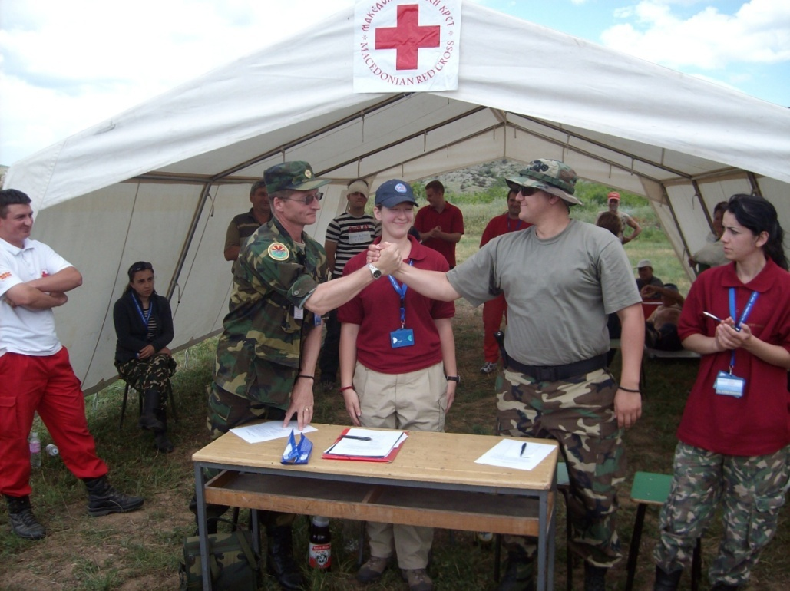
Again we folded up the tents and loaded the supplies, for our journey back to base camp. Jill Walker (center) and Sonya (right).

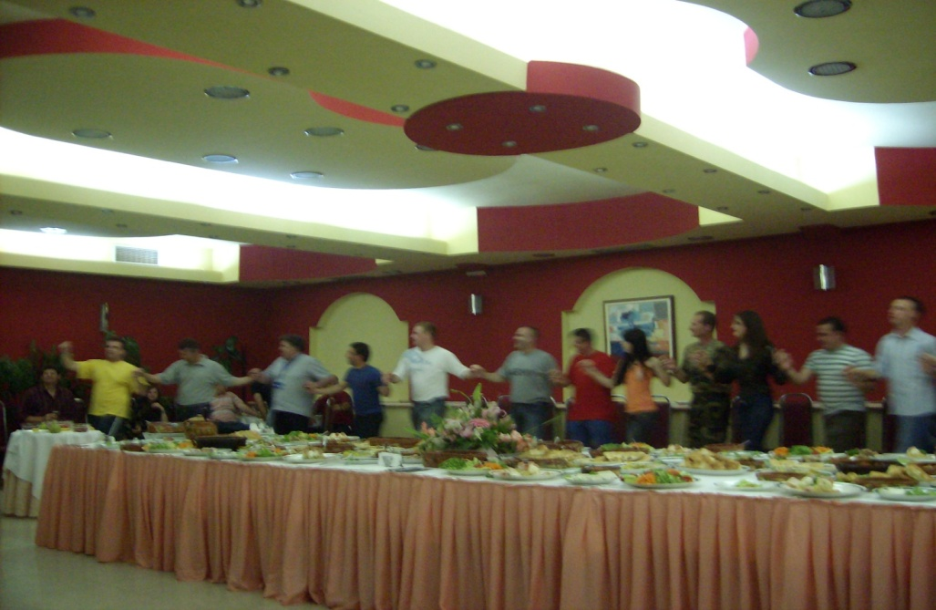
That night, our group journeyed into a local town where we were presented with our certificates of training. Afterwards we had a most lavish dinner with dancing. There was live music and plenty of government dignitaries; I even had my picture taken with a Macedonian General. The security forces that night loosened up and danced also. It was a spectacular ending to a most spectacular training exercise. Nowhere else could we have been so welcomed and trained so thoroughly without being enlisted in a military organization. We were somewhere where the US is respected and loved like country of Macedonia.
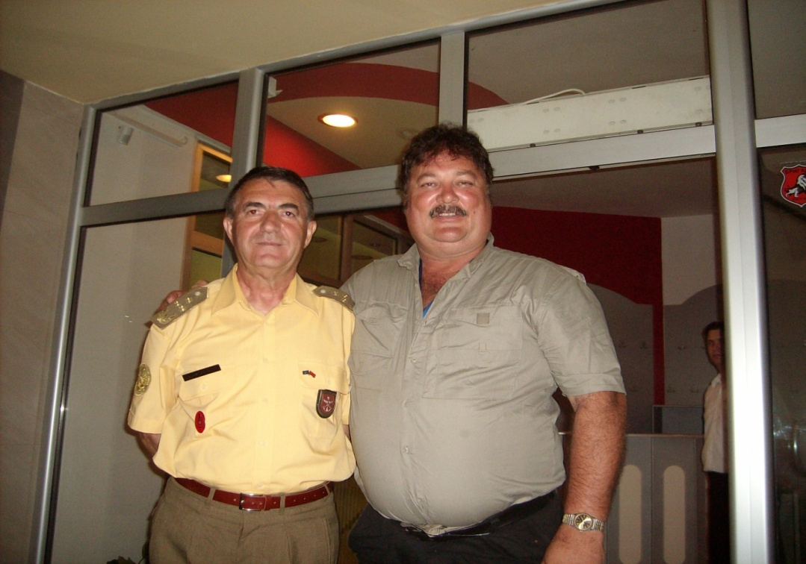
The people of Macedonia are overdue for recognition. They should be let into the European Union and the US should be the ones pushing for their recognition. Everywhere I traveled in Macedonia, I met absolute and genuine friendliness for Americans. Macedonia could be a strategic ally as America continues to push for Democratic governments controlled by their own people. Worldwide, communism appears like a good idea on paper because it seems to distribute the wealth evenly among all participants, in theory. The reality is that communism stifles creativity for all of the people (leaving some out), and it stagnates many that would push further if the right carrot was held on that proverbial stick that leads us all. Money, fame, and selfless acts, things that Democracy provides by allowing and promoting “free will”, leads the people to find their own level. People will choose the levels that they are happy with, because of freedom to do so. The only carrots that communism provide are graft and corruption to get ahead. The people of Macedonia are a proud and resourceful people, and ready for America.

Chapter 10 Home is Where Your Heart Is

The trip back to the good old USA was uneventful, although throughout the whole trip back there was a sense of anticipation and excitement to be returning home. People never really appreciate home until they go somewhere else, especially a foreign land. Reflecting on our troops overseas and thinking of how they must feel, I knew I could never come close to feeling their pain and separation of family for the lengths of time that they do. I am proud of our American service men and women, and usually shake their hands and thank them for their service to my country when observing one in uniform in my everyday walk of life, no matter if there is disagreement internally with a particular war or not.
Customs in Philadelphia was more stringent than our points of origin in Europe, Macedonia and Switzerland, which was kind of backwards; after all, we were now at our destination.
When arriving back at the police academy, the point of origin of our incredible journey, my hearts were there to greet me home, both of them. My son looked to be about 4 inches taller. Two long weeks, and I had missed a teenage growth spurt. My daughter was arrayed in her International Baccalaureate Degree colors with Honors cap and gown reminding what I had missed. I felt a little ‘kick in the groin’ from her but in a, ‘I still love you” kind of way. I had missed her high school graduation for this trip by one day. She said she thought I would like to see her in her splendor...and she was right. We had seen many difficult times together the previous 9 years. Kawani had tackled and achieved her International Baccalaureate Degree program in straight "A" fashion. She finished in the top ten percent of her class in a highly competitive environment of other overachievers from a high school that was rated as one of the top 20 best high schools in America by Newsweek magazine during one of her years there and rated in the top 50 other years. I do not intend to miss her graduation from the University of Florida. 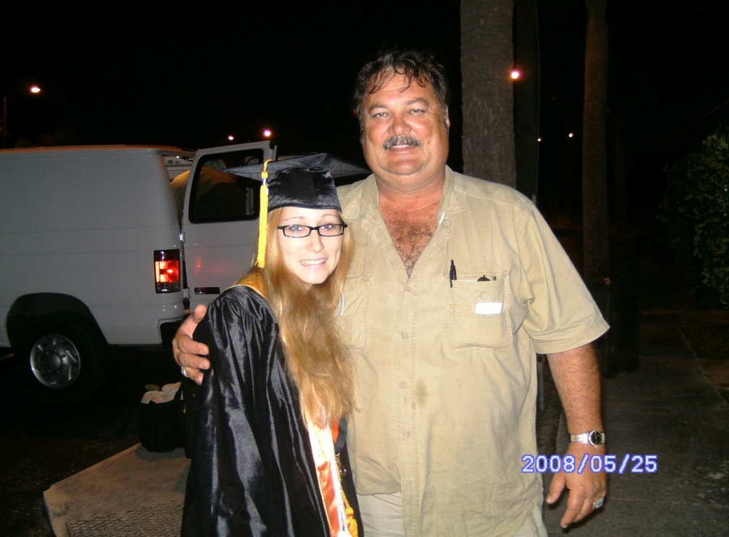 My daughter in her Baccalaureate Degree with Honors gown. 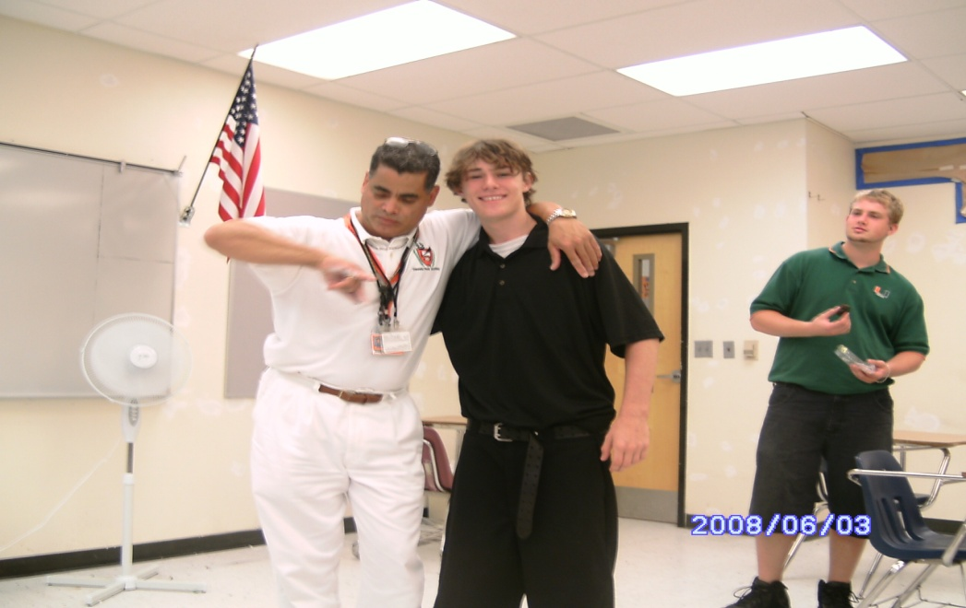
My son at school with his favorite teacher.
Update Nov 2013: Not only has my life been totally turned upside down since this trip, I was unable to attend her college graduation. I know God meant for me to take this trip. But when I look back at everything it has taken from me, it is disheartening at times, and then I say to myself ‘there is a reason’. There were too many signs showing me the way. There must be a reason I do not understand and that is where Faith comes in.
I felt led to this journey for spiritual reasons as well as for educational purposes. It has prepared me for a job with the federal government involving mass destruction with casualties and the analysis of such incidents, or to teach. At the writing of this book I now have my Bachelor’s Degree in Public Safety Administration. It is a “down” economy, but I know there is something out there for me.
My pursuit of this journey to Macedonia has resulted in a stronger faith in my Lord Jesus Christ. The obstacles in my personal life with my children have only shown me further, that my faith, like the Apostle Paul, has carried me through the valley of darkness once more.
Many people do not realize that Paul never met Jesus Christ before his crucifixion. Paul persecuted and killed Christians and was on his way to Damascus to round up more for the killing when he met our Risen Savior. “I am Jesus of Nazareth whom you are persecuting” (Acts 22:8). My faith was blind and accepting like Paul before recent years. Now, The Spirit is moving within me all the time if I allow myself to listen. This adventure truly began the day I saw that tag IOU GOD appear before my eyes after receiving the news that I could go on the “Grand Adventure”. That was not a coincidence. There are no coincidences (“V for Vendetta” the movie).
Another facet of being a Christian is that we are not bound by religious doctrine. Religious doctrine is an interpretation by man of scripture as an attempt to control the masses. In the past when man was less civilized and more primitive, the control of society through religion to produce a harmonious co existence of all types of people living together was a good thing. We are now in a time that man has progressed emotionally enough to take the next step in evolutionary progression. Being a Christian by faith is a part of that evolutionary step for those of us that believe in the word of God as told by Bible. Romans 7 vs. 6, “we have been released from the law so that we serve in the new way of the Spirit, and not in the old way of the written code,” and it is that way now when it comes to religious doctrine whether it be Catholic, Baptist, Methodist, or any other religion who claim to be Christ oriented. To not to dance, drink, smoke, attend church certain days, or to wear or not wear makeup, are all religious doctrines.
Under Christ, we are free for all things. Speaking of food, Cor 10 vs. 23 Paul says.”Everything is permissible, but not everything is beneficial.” Of sexual immorality, Cor 6 vs. 12 Paul says “Everything is permissible for me, but not everything is beneficial,” and so on. It is the constant seeking of God, reading his word, and learning to listen to His voice inside us that we find our bountiful path in the Lord. It is also the understanding that everything is open for us to do. It is up to our conscience as to what is permissible. Is what we are doing against other’s wills? Is what we are doing in the name of Love? Are others endangered by what we want or are doing? If the answers are no, yes, and no respectively, then what we are doing is relatively okay.
Something else, I am not apologizing for the way I live or what I do. I may take a drink…. One or two some times but let me tell you, Matthew 11:18 “John came neither eating or drinking and you say he has a Demon! The Son of Man has come eating and drinking and they say here is a glutton and drunkard, a friend of tax collectors and sinners. But wisdom is proved right by her actions.” (Luke 7:34 also).

What I have learned is, more than anything, is that my personal relationship with the Lord is all about what is between me and him. It is not about any established religion and their rules. It is about how we act toward all forms of life (do unto others as you would have them do unto you) and what is said and done in our prayer closets (seek God with all your heart), that define the relationship that we as Christians, develop with our Living Lord. Knock and the door shall be opened, speak and He will listen. Amen.
No matter what ‘Revelations’ are to come, Have Faith, continue believing, and know that Jesus Christ is real, powerful, and alive in us.

Afterword
When writing this book I felt compelled to do so. Not compelled in such a way that I was being made to do something, rather I was compelled by a will greater than my own to bring a message that will be needed in our near future.
There is another far deeper reason that this message must be heard and considered. For many years I have administered a brief oral test to many and any who would listen and agree to take the test. Most all fail it, but I premise the test with that information, advising the participant that even the most highly educated and degreed have failed it.
It has truly amazed me that many of the highest educated of our society do not know what they are looking at in our night time sky. I have never wanted anyone to feel that I was trying to make them look stupid. My purpose has only been to educate and inform the many to prepare them for the future and what it holds.
The first question is:
1) What do you see when you gaze into the sky at night? I have received many answers starting with angels. This is how some of our society is so disconnected from reality and bound by their religious beliefs. From there the answers have been more real and many answer the moon, stars, and planets. Many believe that the moon is a planet, it is not. It is an asteroid that circles the Earth. Many believe that the flickering dots of light in the sky are planets, they are not. There are only three sometimes four planets that are visible to the naked eye. A vast part of what we see flickering in the sky are stars. Most of the rest are whole galaxies that are so far away that they appear as one flickering dot even though they are collectively millions of stars clustered together.
2) The next question is: where is our nearest star? Many of the more educated will venture a guess as Alpha Centauri or the North Star. Both answers are wrong. Our nearest star is the sun. That is what a star is, A sun. Most all those twinkling lights in the sky are suns with most having planets revolving around them just as our sun does. Our sun (star) is part of the Milky Way Galaxy which has more than 600 million suns (stars) in it (most with planets around them). The possibility of life elsewhere starts becoming more of a reality as I watch their eyes and see the wonder pass over their faces when exposed to this new knowledge. Then comes the real “kicker”. There are over 100 million galaxies, each galaxy having hundreds of millions of stars (suns) in each of them, in the known universe. Once you really start thinking about the hundreds of millions of Galaxies and Planets running around out there, you will come to grasp the reality that other intelligent life beyond this planet exists. Now what?

There is a time coming soon when it will be revealed to us, the common people, of the reality that there are other intelligent beings out there and they have been visiting us for millennia. I will restate here that I have been an engineer at Kennedy Space Center Florida with a Top Secret Clearance. That is where I first learned of Roswell New Mexico 1947, the crash of a ‘flying saucer’ and Alien bodies recovered. It was the ‘Grays’, who piloted that particular saucer. Throughout history, cave drawings of rockets with flames under it, scriptures in the Bible of flying machines, and hieroglyphics with men in helmeted space suits have been documented by Archaeologists and explorers from many countries. The Mahabharata of India writes of floating cities and war between two kingdoms. What they describe is a nuclear war. Since recent archaeological excavations in Afghanistan the scientists have found a radioactive strata that indicates nuclear fallout in that area from 1000’s of years ago. There is nothing new. Where we are now, we have been there before. What truly matters is how we handle our affairs now. http://theextinctionprotocol.wordpress.com/2011/07/20/historys-lost-lesson-ancient-nuclear-war-among-indus-valley-civilizations-reexamined/ )
How does this affect us as Christians? For me there is no effect. I have had this knowledge since even before working at Kennedy Space Center and I have reconciled my belief in God and Jesus with it. God seeded the Heavens and the earth. The Beings beyond Earth are a part of God’s plan just as we are, and they are not Angels and Demons. Angels and Demons are Spiritual entities. The beings referred to here are corporeal like us, just different the way they appear. They too will answer to God in the end. This is part of what this book is preparing us for as Christians and what we can expect for the future.
Now, as for reasons that why some highly intelligent life that could travel the vast distances of space safely, would want to contact us and for what reasons, vary. Some life forms may want our bodies for nourishment (they will harvest us like we do cows and go for the fat ones first. Thank God for an intergalactic federation that puts protection upon us from them), others may just have a voyeuristic need for observation (they probably gamble on what we will do next each day), and then there are the scientists of the universe that observe us because it is fun to watch the development of a society and to see what will come forth (anthropologists). There may be other reasons not mentioned here dealing with certain species that manipulate genes to produce a superior race or gender (shades of the Nazi movement). Only few know why “they” are here and it is kept secret by the ones of our own society that have cooperated with them for their own earthly personal gain. I do not write these things to induce fear as our government does for control, this is for preparation.
The Grays are the most seen ‘Aliens’. Many wonder why do they kidnap people and reportedly do sexual type of experimentation on them? The Grays had lost the ability to reproduce while being ‘cloned’ by the Pleiadians (http://arcturi.com/PleiadianAliens.html ) for menial work. The Pleiadians had developed a ‘worker bee’ and then replicated it over and over through cloning. After many centuries of mindlessly doing the bidding of their ‘masters’ they had developed a ‘knowing’ that they existed. The problem was a lack of soul and spirit, so they have been trying to cross breed their DNA with ours to try and regain a spiritual essence. They have done it finally and there is a struggle for this world now between competing “Aliens”. http://locklip.com/the-6-alien-species-currently-fighting-for-control-over-earth/

Epilogue
Sept 2012- It has been just over four years since that fateful trip to Macedonia. Many adversities have befallen me. I have accepted them with Faith and stamina. Homeless back in Fort Pierce and jobless. I have spent many nights underneath the South Bridge next to the most beautiful Indian River Lagoon fed by the Fort Pierce Inlet to the ocean. The fishing has been so so, but the experience has been gratifying. Searching everyday (2012) for the most menial job just for gas money to be able to search for the next job. Cutting some of the money made, out for food. Going to the local food bank for assistance, seeking out the local agencies for help in anything, and receiving what I have with humility and respect for those that provided.
One occasion, St Mark’s church filled my gas tanks. Thank God for Mom and the money she has deposited in my account for whatever I deemed necessary. I thank the truck drivers at the truck stop that were generous when providing what work they could to me. I imagined that my brother and his wife had something to do with some of the work that was thrown to me out there. They are a cross county truck driving team with millions of safety miles between them. I remember the tow truck company owner that allowed me to weed eat his property and then trained me to be a tow truck operator only to be turned down by his insurance company.
Only one thing is common here, my continuing sharing and believing in the glory of Jesus Christ and his Love. The people I have met under the bridge and elsewhere, hearing of their predicaments, and victories in staying alive. Sharing the continued Love of Jesus Christ and the Hope he provides. Not only the hope he provides but the pure and awesome power that he wields against all obstacles. The power to heal the sick, when there seems to be no other hope. The power of pure and undying Love for all. This is written in Colossians 3:8 “But now you must rid yourselves of such things as these: anger, rage malice, slander, and filthy language from your lips” (because of being one in Christ in your transformation), 3:11 “Here there is no Greek or Jew, circumcised or uncircumcised, barbarian, Scythian, slave or free, but Christ is all and in all.” Christ is our definition for living. To live a Godly life means loving one another without prejudice or malice, as Jesus did. He sacrificed himself knowing it was for the greater good ‘down the line’ of history. Hope, when it seems there is no hope. A chance, when it seems all chance has exhausted itself. Christ is King.
This brings me to a point that I must relate to you the reader about a dream I had in the Spring of 1989, many years ago. I was asleep and I dreamed I died. I suffer from sleep apnea and very well could have died that night sleeping next to my pregnant wife. Anyway, my spirit ascended from my death spot exiting this earthly vessel and went towards the sky.
Above me was a heavily clouded ceiling with several holes that were each emitting a bright beam of light. I gravitated towards the ‘hole’ which I felt inwardly was ‘my light’. In front of my intense beam of light was the figure of Jesus Christ and how I perceive he looks. I entered the beam speaking to Christ “Thank you Lord, I am ready. I am so tired of the suffering, the violence, and most of all my personal physical pains in my body (I was experiencing incredible back pain at that time ever since 1977), I am ready.”
As I entered the beam I felt wrapped in an amazing feeling of pure unadulterated Love, is the only way I can describe it. My skin and pores tingled with excitement that I was finally loved for who I am. The power of it was amazing. It was like there was no other power greater on Earth. It could have squelched a thousand atomic bombs. Then it happened. A voice solid, yet compassionate said “No Joe, Your time is not now.” I awakened in my bed next to my pregnant wife.
As I lay half awake in bed reflecting on my dream, I could feel Jesus speak to me, “Joe. Those other holes in the clouds, those are other ways to heaven to God other than me.” For us as Christians to believe one small part of the world is going to heaven and the rest of the world is going to hell is wrong all because they have never heard about Him, is highly ego/ethno centric and vain, two vices that Jesus tells us himself to not have. Jesus is my personal Savior and is the best way of all the different religions that I have taken the time to study and develop understandings of. In my teen age years I studied many religions. Jesus is my way; the best way, but he is not the only way, and I will bring as many people or aliens to Him as I can. Oh well, the Truth is the Truth.
One of the messages that this story ultimately brings is one of controversy over the singular divinity of our Lord Jesus Christ. My opinion is not one that is meant to bring division among Christians, although it will; the ultimate goal of this message is to unite all with the love of Jesus Christ as it was meant to be.
The acceptance of other beliefs as having validity will show love to all who believe differently, that our Jesus Christ is the truly loving one, and the one to follow.
This is not to say that Jesus has not been in other forms and names other than the name Jesus. It is my belief that God’s spiritual son has come upon this earth in other names. I also believe that he has been among other civilizations on other planets in our galaxy, so in that aspect He is not the only way, as the name Jesus only, But Spiritually, He is always Jesus. (Please refer to my Afterword further along in this book about life beyond this planet and the scientific basis for it. Do the intelligent life forms out there go to hell because they do not know Jesus?)
I will do my best to spread His word and expose The Word, to the people of this world and other worlds for Him. It is for their sake and their salvation as well as the sake and salvation of the world itself. He is not the only way. He is the best way, and I will still love all others in their own beliefs. It is through our Christian Love and understanding that we will change others, not through war, violence and intimidation. Martin Luther King comes to my mind while I write this. He and his movement changed America and the world through peaceful means at first, then violent means took over after his death when our politically corrupt system shot him down in cold blood. It will be that way again soon I think. Someone will come along wanting to peacefully fulfill the will of the people and the powers that be, will do the unthinkable again, once more in our violent filthy history, and it will probably be by our own government’s hand again even if in an indirect way JFK, MLK, and RFK. Currently our President Obama is receiving heavy criticism for peacefully settling the Syrian problem of use of chemical weapons. Eventually Love will prevail. We have to have Faith. Amen.
What is coming when the governments of the world (2017) finally reveal the influence that Aliens have had on our planetary history including genetic manipulation of the common Ape type of species inhabiting this planet; we are going to find there is a Universal Jesus that is real, and powerful in our spiritual sustenance for Him. Our Faith has power in Jesus. Jesus has His power by our Faith. He is very real.
People who use alcohol occasionally tend to be free thinkers because of the insights they receive from the barriers of fear and inhibition that are lifted when imbibing a little. Most churches do not want this. Many want to maintain control through fear. It is their own fear that the coffers will dry up. The Catholic Church has the deepest pockets of any Christian religion so that fear can be put to rest. Their open use of wine for all occasions do not keep the parishioners from contributing.
The sin is not in drinking, it is being a drunk that is the sin. It is being incapacitated and not being able to fulfill one’s obligations to ourselves or society is the sin. Matthew 11: 18-19.: “For John came neither eating nor drinking and they say he has a demon. The Son of Man came eating and drinking and they say, Here is a glutton and a drunkard, a friend of tax collectors and sinners”. This is the age old saying of damned if you do, damned if you don’t. Jesus partied with the people that needed it most. He drank as they drank and it wasn’t alcohol free wine. Paul followed this tenant almost all the time in his preaching of the gospel. Cor 9 19-23” …I make myself a slave to everyone. To the Jews I became like a Jew, to win the Jews. ….To to those not having the law I became like one not having the law…. To the weak I became weak to win the weak. …. I do all this for the sake of the Gospel that I may share in its blessings.”
Jesus partied with them as they partied to be one with them to be able to teach the Good News of the new interpretation of the Jewish Torah. Matthew chapter 23 details how Christ felt about the Pharisees and their hypocrisy, preaching the law but not following the Law themselves. Many times, in that chapter he addresses them as hypocrites, not worthy of being listened to or followed. We all must guard ourselves that we do not look as hypocrites to our children when we lead them by our words instead of our actions.

Intimidation can start in the home. If Jesus’ teachings are taught in the home with a too strict a hand coupled with violent acts for disobedience; this will only lead to the student (child) rebelling as soon as they have a chance. Not bringing in solid science into the teaching of Jesus Christ will lose the child when they are taught in school about science. Children are trained in school that observation and conclusion based on known, verifiable, and seen facts as science. They will be taught historical origins of other civilizations that have had virgin births of their gods in the Mesopotamian and Egyptian Empires, and even crucifixions. The preparation for our children to go out into the world and confront these facts of other civilizations is up to us as the parents to prepare them properly with the truth. Preparing them with the truth and solid knowledge and not just Faith will armor them against those that want to tear us down. It will only be us, the parents; that can instill the concept of Faith properly that they will need to conquer life’s obstacles.
Jesus’s life and resurrection is chronicled in the one of the most accurate documents in history, the Dead Sea Scrolls, and the Bible. The Torah was the paving of the way for Jesus in preparing the Middle Eastern World for Him. Prophets of the Old Testament and Jewish Torah foretold of His coming. Jesus fulfilled the prophecies to a “T”. Jesus himself was very conscious of this. There were times he made sure that he was fulfilling them. For instance, during his entry into Jerusalem on Palm Sunday he made sure he had a donkey that had never been ridden, by paying for it when it was still veryu young. He sent two of his Disciples to fetch the donkey just before he rode into Jerusalem as prophesied by the Torah that their Messiah would ride through the gates of Jerusalem on a donkey never ridden before. This was just not a baby burro. This donkey was paid and cared for with the instructions that no one was to ride it. Luke 19:28- 44 . Matthew 21:1-11 .
Be careful of any literal interpretation in the King’s English of the King James Bible. The perversions by use of that English are many and I suspect that there is a direct correlation of the will of the king of that day to further control of the masses. This was not necessarily a bad thing with savage like, uneducated people. I personally lean always to a more detailed interpretive bible like the NIV.
Many times, when I encounter people that ‘Bible thump’ and say that the Bible is to believed word for word and there is no ‘wiggle’ room, I bring to their attention Cor 14:33, … “As in all the congregations of the Saints, women should remain silent in the churches. They are not to be allowed to speak, as the Law says. If they want to inquire about something they should ask their own husbands at home; for it is disgraceful for a woman to speak in the church.” I ask them when both spouses are present. There is usually a lot of backpedalling or ‘that is taken out of context.’ It says what it says and that is not the way Jesus wants us to live. Jesus wants women to be active and have a voice. Paul was writing this from a Jewish point of view wanting to keep women subjugated to man. Then and now, it is the same. When I attended Synagogue with a Jewish friend in 2004 it was the same. They separated the men and women and the women had no voice. It could be different in other temples than the ones I attended, but I do not believe so.
A theocracy is not right in a democracy. A true democratic government is inclusive of All People, All Religions. The Catholic Church was dealing with many savage and uneducated peoples during the formation of the united organized world and the use of Christianity doing what they thought was right to force the word upon others, even inflicting death by beheading and other means upon those who did not convert.
Just as the Muslim religion was the ‘religion of the sword’ (convert or die by getting beheaded), so it was with the Spanish conquistadors and others spreading the Christianity of the European world. Convert or Die. https://www.britannica.com/topic/Spanish-Inquisition As part of the control the Catholic Church insisted upon, no one was allowed to read the scriptures or interpret them except the priests themselves. This is highly reminiscent of the Jews and their form of teaching their flocks, even today. I have attended a Jewish service in recent years where the leader still spoke the scriptures in Hebrew. Why? Just as the Catholics, to keep the word from the people and to have only the rabbinical interpretation allowed or encouraged.
It was not until the Protestant Reformation under Martin Luther that things changed. Thank God! Finally, the word of God was read to many in their own language, and the people themselves could interpret for themselves what Jesus was teaching to them. Free will finally! Wikipedia says:
Keeping the scriptures within the church’s hierarchy and interpretation was about control. Total and absolute control. This led to the corruption of the church. During the 1400’s, the Catholic Church was The Law. It had gotten to where the church was selling absolution for murder, rape, robbery, and many other crimes in lieu of contributions to the church. While Luther did not deny the Pope’s right to grant pardons for penance imposed by the Church, he made it clear that preachers who claimed indulgences absolved those who obtained them from all punishments and granted them salvation were in error, in agreement with Catholic theology.^{[59]}
It is commonly believed that the Catholic Church was in the business of selling indulgences for money, though the Church itself says that all such transactions were officially classified as donations.^{[60]} Nonetheless, the Council of Trent took steps to put a stop to them.

Council of Trent[edit]
On 16 July 1562, the Council of Trent suppressed the office of quaestores and reserved the collection of alms to two canon members of the chapter, who were to receive no remuneration for their work; it also reserved the publication of indulgences to the bishop of the diocese.^{[61]} Then on 4 December 1563, in its final session, the Council addressed the question of indulgences directly, declaring them "most salutary for the Christian people", decreeing that "all evil gains for the obtaining of them be wholly abolished", and instructing bishops to be on the watch for any abuses concerning them.^{[62]}
A few years later, in 1567, Pope Pius V cancelled all grants of indulgences involving any fees or other financial transactions.[63][64]
This meant also that there would be forgiveness in the eyes of the law also. The Catholic Church had a list of what it cost to be absolved of any specific crime. Again the rich could buy their way out of anything, and this would be sanctioned by the Church itself. Martin Luther rose up and rebelled. He led us from darkness into light! No longer would sermons be restricted to a language that no one could understand; Martin Luther brought us the freedom to understand and choose. No matter what ‘Revelations’ are to come, Have Faith, continue believing, and know that Jesus Christ is real, powerful, and alive in us.
What I say to my fellow Christians now is, do not be swayed for the many that may say “Now that you know the truth, know that He is not, nor has He been”. Keep the Faith when all this arises. Jesus is a powerful Spiritual entity that is strong in us, his followers. Our faith is strong in his strength, and our strength. Together we will still exist as the powerful Spiritual force that We Are. Miracles will still be performed in His name.
Several years ago I prayed over a woman with inoperable liver cancer. I prayed in the name of Jesus, and His power. Three days later at a doctor visit, her doctor found no liver cancer whatsoever. I told her, do as we had prayed; be a testimony to the power of Jesus Christ and go in peace. The lame shall walk and the dead shall rise, all in His name. There have been others I have prayed Jesus’s power over and have had success there also, usually a cancer.
Although I do not take stock in many of the predictions by Man about Dec 21 2012 and other dates being bandied around, I do have a personal prediction. The year 2015 Nov 1 plus or minus six months will be the start of years of tribulation for earth and the hand of God will strike as in Revelations. The planet Nibiru is in its 3600 year old cycle to intersect with our solar system and will be the cause. What is described in Revelations as stars falling from the sky will be meteors with ground zero being the Mid East, Armageddon and Babylon. Rev 16:16 and 16:19. Rev 16:21 “…huge hailstones of about 100 pounds apiece each fell upon men.” It will be new a beginning rather than an end to the Earth. While we lose half of the world’s population due to nuclear, biological fallout, earthquakes, tsunamis, and air pollution filled with ash around the world globally, mostly in the North Hemisphere, as a result of the destruction and impact upon Israel’s nuclear and biological stores. The diseases and radiation will produce people that look like Zombies. Truly they are the living dead and sadly their destruction will be the only way the remaining healthy will survive. The Horses of the Apocalypse will act almost simultaneously at times, not long and drawn out as the reading of the Bible may suggest. Solar storms may even be a part of the destruction as our sun will be in a cycle that will be produce high activity for solar flares, another sign of God’s hand that cannot be controlled by man. This will occur over a period of years and not in one massive way.
But why does God do this? Why will he let bad things happen to good people? Many who will die will be His followers. It is as in oriental philosophies of Yin and Yang. You cannot know good without also knowing bad. One cannot survive without the other. God puts choices in front of us. He has given us free will. We select our own futures. This makes me think of Quantum Physics today and the prediction of multiple universes. The reason for multiple universes is that in one life we had we chose certain paths at ‘forks in the road’ of our lives. In one reality, we chose the left path, in another reality (universe), we chose the right path. In Quantum Physics, all universes exist simultaneously. If you the reader do not have a VERY strong higher math and science education, I am sure right now you are thinking this totally ‘junk science’. I only ask you to realize that the most educated leading physicists in the world put validity in these theories. You do not have to believe in them. The Bible saying that we have free will, I believe, puts validity in these theories. This also leaves open for fluidity in time and fates to be changed. The ‘Apocalypse’ described in the Bible may not come at all if we were to suddenly be thrown into Full Disclosure of Alien life forms existence and their ability to deflect asteroids from hitting Earth. The ‘Apocalypse’ can be avoided.
Our Spirit side of us has chosen to come here to live the life we are living. Having free will then makes us ask “what is right, what is wrong, or what is sinful?” Paul said it a little differently, Romans 3:20 “Therefore, no one will be declared righteous in His sight by observing The Law; rather, through The Law we become conscious of sin.”. Before Jesus we knew good and bad through The Law. Now through Jesus we know good, through pursuit of loving one another, and as a Christian, 1 Corinthians 6:12 “’Everything is permissible for me’ but not everything is beneficial and I will not be mastered by anything.”. He continues in Romans 7:23 “but I see another law at work in the members of my body waging war against the law of my mind and making me a prisoner of sin at work within my members.” Vs 25 “…So then I myself, am a slave to God’s law but in sinful nature a slave to the law of sin.” Romans 8:1 “Therefore there is now no condemnation for those who are in Jesus Christ 2 because through Jesus Christ the Law of the Spirit of Life set me free from the law of sin and death.”. It is said by some Biblical scholars that Paul had some sort of sexual addiction (I am sure that many of us can identify with that), but as Paul wrote about sex, therefore, there is now no condemnation for those that are in Christ Jesus, … I take this to mean that although homosexual sex is wrong in many religions in Christ, it is still permissible and as Paul elaborates “but not all is beneficial”. For the Christian, ALL is permissible. There is no condemnation, for those of us that live in Christ. We know that our way is heterosex for the continuation of our species through the sharing of Love (sex) with a member of the opposite sex. It is through our acceptance and loving of people of different thoughts on these others may change, not through the condemnation of their practices, but of Sharing Love with people of THEIR choice.
Mt 19 in verses 11 and 12, he says that “not everyone can accept this word, but only those to whom it has been given. For some are Eunuchs because they were born that way; others were made that way by men.” I interpret this to mean that some are born gay and others were made gay by men. People born without sex of that day (morphodites) could not have the complex operations to save their lives by relocating urethra etc. People born with defects were killed by the village or their own parents. That is why I think Jesus was not referring to just Eunuchs. Our Christian love should accept them. It is not a fault of their own. Born or made that way by men. If they were made that way by men who preyed upon them as children is not our Christian duty to Love them? It is not a sin of their own and per the previously mentioned scriptures ALL sex is good. It is not for others to judge.
The governments of the world are preparing now. Huge underground facilities have been built to preserve the elite and upper government administrators to preserve our organized society once the calamity has passed (Continuity of Government). Many years ago, just outside of Dallas, our government was going to build the world’s biggest collider, all deep underground. It was started but never finished. What happened to the existing facility? Was it finished making it another facility that will house many to survive the coming destruction? Or has the collider been finished and not publicized?
It seems to me the predictions of “Nibiru”, the rogue intersecting planet returning in its 3600 year cycle will be the culprit of the destruction. Egyptian and Sumerian Hieroglyphics tell of an ancient civilization, the Annunaki, returning in relatively the same cycle as what most is believed to be Nibiru. (Click on my Nibiru link on my site for further explanation.) The 3600 year old cycle of Nibiru also coincides with the time era of our past that is associated with the great world flood and destruction as recorded in many societies with Jewish lore and the story of Noah. Truly the Hand of God, an act of the Cosmos, totally uncontrollable by man. Many You Tube videos express the opinion that Nibiru is a Dwarf Star with trailing planets like our star, The Sun. Its orbit penetrates our orbital pattern at an obtuse angle. Luckily for us, because that assists in alleviating collateral damages of intersecting masses. I suggest YouTube for more information but beware of the government’s disinformation network. The truth is out there if you search for it diligently enough.
Finally, why would the government not tell us of the impending disaster? One reason is that there cannot be built enough protective facilities for the world-wide bio and nuclear waste fallout that will occur after impacts occur. Many FEMA facilities stand empty and ready to ‘take in’ the survivors and insurrectionists above ground.
The Bible says that a third of the world will die. Rev 9:15 “And the four angels who had been kept ready for this very hour and day and month and year were released to kill a third of mankind.” Another part says that one in the field will die, the other will live, and indicating half of the population will perish. Who decides who can occupy the underground safe facilities that have already been built? What happens to society when many hear of an impending disaster and feel doomed and there is only a partial chance for survival after tomorrow? Do they go ahead and rob a bank and live it up for one more day? Or do they commit even more horrific crimes that are unmentionable? These predictions I make are not to forewarn the abhorrent of society, but are to allow the good of society to prepare spiritually and physically the best we can prepare. Stores of food, digging into the side of a hill and going underground, even a little ways; developing ways to grow indoors or underground. Building wind powered electrical turbines for small groups of homes, acquiring machines that purify water and air (the air will virtually be unbreatheable for a period of time), and acquisition of medical supplies. It will be advantageous to have a separate room for surgical procedures and a body scrub room for those that want to enter your secure facility. Many who did not make it to your place of refuge on time will be diseased or infected with radiation. Many of the Zombie movies now are preparing the public mentally for what is coming. They will not really be Zombies rather they will be highly infected walking dead that have no chance and will only spread disease. It would also be advisable to have ways to protect yourself and family. There will be those that will kill you for what you have, even if it be a glass of clean water.
Part of the reason of the world catastrophes that are occurring now is to get the world’s mind set to be one of ‘being prepared’ for a disaster in order to save more. There are conspiracy theories out there about HAARP (Tesla technology, earthquake machine etc) and its destructive powers, is that the government is behind many earthquakes and tsunamis. (https://www.youtube.com/watch?v=2TdIkI1ory8 ). The only reason that I could fathom would be a “big picture” scenario by our Illuminati brothers where by killing thousands now and making the Earth prepare. It will save millions and maybe even billions later, just by preparation. There are plenty of you tube videos on HAARP about these theories. The Illumanati see a bigger picture than most all of us can see. It is my stance, their intentions are overall good and Father like.
I believe that if we can hold out for a year and half after world destruction starts, we will be past the critical point and be able to return to the sunshine. 2017 could be the Year. Don’t hold me to that prediction, it could be worse but I pray not. With the advancements of CERN reactor, the time travel they are doing to supposedly try and save humanity, there is a struggle. If you are reading this, the good guys are winning, LOL. I would love to be a part of that again. Save the day. It’s my nature. lol
The Earth has a lot of self healing powers just as we do and hopefully she heals herself soon for us the ones who have prepared and have survived. The strong in Spirit and Jesus will survive, and I know that we are them. Keep the Faith.

About the Author
(A little wordy. There is much more information to explore, especially about the Aliens, in the Afterword and the Epilogue after this short story of my most recent life. Thank You for reading)
After pursuing (2011) various job opportunities while working as a handyman trying to survive, I leaned back on what was learned in my construction years to provide something to do. Body is worn down of the tests of time, but still it trudges on. I have to. Achieving a general Associates in Arts, an Associates of Science in Criminal Justice and a Bachelor’s Degree in Public Safety Administration from 2004-2009 while attending school full time and taking care of my children the best I could without a steady counterpart beside me, I struggled on . Looking back I can see why a proper family has two complementing leaders. It was not good for me to deprive my children of two parents. Yin and Yang. Soft and hard. Good cop, bad cop. But it was not completely my fault. My kids especially my daughter would see someone I brought in as a person who might take the parent they had left away from them and I was blind to that emotional conflict, so therefore powerless to change it.
Kawani, my number one, my right hand, my top lieutenant, graduated the University of Florida with her Bachelor’s in Anthropology and a Minor in Human Sexuality. I guess all those years I took their mom to a closed door meeting in the bedroom a couple of times a day “for a talk” worked on her sub conscious. LOL. My son is concentrating his efforts on becoming a Chef at the restaurant where he works full time. Joey had a steady girl friend and discovered certain truths about her. He is in search again of a love to fill his pain and his loss of family he felt when I lost the house.
Joey has no idea how much it has weighed on me, his father, losing the family home of 15 years his kids grew up in. I raised the kids by himself when my ex wife left on a party Dec 5th 1999 and did not come back. The kids were Kawani 10 and Joey 6. I assist them as much as they will let me when I am able. He and Kawani are prayed for daily.
Although our family home has been lost to foreclosure (2010), Faith in the Lord is uncompromised. It is felt that it is the Lord’s plan for my future success in serving Him better and like Paul, Phi 4:11 “…for I have learned to be content whatever the circumstances. 12 I know what it is to be in need. And I know what it is to have plenty,,,, 13 I can do everything through Him who gives me strength,” and I am still thankful for all things.
One thing about being at the bottom and associating with all manner of people around you is that there is a lot less prejudice on everyone’s part. We are all trying to do the same thing and that is to survive. I will have to admit though I much prefer to have consistent association with “church people” more that the dredges of life. Many at the bottom have fallen because of addictions, mental illnesses, or breaking laws and then unable to get a job. I like to be able to set something down and it not grow legs and leave me. Not all are like that but unfortunately many are. One of the nights I was living under the bridge that went over the Indian River I met a young man that was troubled. We engaged in conversation. I had never been much of a believer in demons thinking that the religions that believed that way were just a bunch of uneducated ‘yahoo’s’, not anymore. I do not recall the exact conversation but there was a point I prayed for him casting out evil in the name of Jesus and something shadowy left him and disappeared into the ground. It kind of surprised me, I was not expecting anything like that and it was the first time I had ever experienced anything like that, that I can recall. His attitude seemed changed and he left. I never saw him again. Months later I was up late one night and went into the living room where my second ex wife housed herself. She was looking at me from her chair. Her eyes glowed bright green in the darkness. I had always said she had demons to conquer having had a very distraught childhood and teen years, then I knew one is in her still. I knew then that it was all too true. My belief in powerful evil spirits solidified at that point.
All the people at the bottom are not just drug addicts and thieves, although those categories do exist there, there are also people like myself, and who am I Lord? I only live by the two rules of Christ, Matthew 22: 37-40 “Jesus replied, Love the Lord your God with all your heart and with all your soul and with all your mind. This is the first and greatest command and the second is like it, Love your neighbor as yourself. All the Law and the Prophets hang on these two commandments.” (Romans 13 8-12) I love God and search His meaning as I have always done since childhood. By doing the latter I will also forgive others for their transgressions as I want my transgressions to be forgiven. Simple rules so easily done by the heart filled with Love. One other big point I get from those verses and others that are exactly them is that the Last Supper and the establishment of the New Covenant signifies the abolishment of the Old Testament rules including the Ten Commandments and we now have forgiveness. This is not to say that the Ten Commandments do not exist in different form. As Paul says in Rms 13:8-12, Love is fulfillment of The Law (Torah, Prophets, etc) , If you do Christ’s two laws you will not steal, covet, murder, dishonor your parents and all the rest of the Laws. It is done now in a completely different mind. It is no longer Crime and Punishment of the Old Testament complete with a beating down physically, emotionally, and mentally; instead it is a mindset of Love and Forgiveness. Understanding that each of us has fallen short of the glory of one who is humble and reaching to all others as helping hand and spirit. Forgive, because each of us at one or another in our lives needs to be forgiven. If you do not then your God in heaven will judge you as have judged others and there will be no forgiveness for you.
There had already made great strides in overcoming my inbred Southern prejudices during the last twenty years or so since moving to Fort Pierce in 1989. This has been my ‘coup de gras’ of overcoming personal prejudices for anyone, gay, people of color etc. I can remember my days in Jr High standing up for the Black man against the red necks of my community. Then years later there was a time in High school I stood and fought against a multitude of those that traveled in gangs (they were Black) that were harming individual people. Being righteous had no color for me.
The key is to just lose everything of physical value in your life, have nothing but friends and relatives left, and see who is still standing with you against the horde of humanity that still wants what you have; no matter how little it may be anymore. This is more than a coincidence, (there are no coincidences (movie V for Vendetta)), that black people have consistently played a factor in my life that has been phenomenal. A black man risked his life for me when I was in the army and he saved my life. He ended up in the Emergency room same as me but with serious head injuries requiring stitches.
A collection of mostly black people that I guarded at the state facility 1994 to 2004, and had risked my life for on several occasions banded together, when my daughter was in the eighth grade, and paid for her class trip to New York. The money I earned was not enough. My wage was just around 6 dollars an hour. There were some white people that contributed but it was mostly the Black people I worked with that contributed. A female Jewish lady started the effort. So, not all of my experiences with Jewish people have been bad. There was one lady that was Jewish there that did everything she could to cause trouble for me and then along comes one that organizes a fund raiser. Conversely, there was a male Jewish friend that I called Brother and had many boat trips, Bar B Q’s and in general, positive camaraderie with. My observances of the socially active Jewish people that I have experienced is most are very conscious of the poor and contribute their time and money to overcome social inequalities. I like that. I would like to be more like that again when financially able.
A Black manager of a store I worked at recently saw potential in me when others did not. His faith in me allowed me to keep working and prove others wrong. Another former manager reestablished ties with me (white guy), after the Christian thing was done and forgave him for a past transgression. Friendship was offered where he thought there was none, which resulted in adding to my bank account and allowed me to survive. Cool. The list goes on like that. Forgive so that we can be forgiven.
There were many Achievement Awards earned while employed by the state for 9.5 years, that were recommended by mostly fellow employees who were black and saw my enthusiasm and dedication to do a good job and appreciated it. My job then was protecting their property and life in a bad area of town. Or it was, before my tenure there. Dateline (NBC), had drove down Ave D on a Saturday night not long before my starting the post on Ave C. They declared it the “most dangerous street in America”. Not LA, Not Harlem, and Not Detroit. Fort Pierce at that time was the biggest port for Cocaine on the East United States. Massive amounts of packets of diversion kilos would wash up on our beaches regularly then.
Reporting to work at 745 am, the bad guys would still be shooting each other 300 feet away from me just over the next block. Several police officers came and shook my hand a year and a half later congratulating me on my work done in the area after the stats started coming in. They said it was like there was a ‘bubble’ of protection around my area. I believe the key was when I walked across the street and shook hands with the people that lived in the area. A group effort is always better that a single effort.
There are some high paced action stories from there. Once there was a man reported with a gun at the front desk. I was at my tree just to the north of the main building. What did I do? Run and wait for the police? It had already been proven calling the police back then was useless. The Fort police department has changed since then. They are now accredited and honorable and a great bunch of men. I miss that area having moved back to my birthplace since losing my home.
When in a situation like an intruder with a gun, it is imperative that taking command of it should take place as soon as possible, for many psychological and physical reasons. My style is not normally Type A aggressive, but am a little more sideways and passive, but I can get down ‘Just as Bad as U Wanna Be!’ when necessary. I entered the building looking for the intruder. The ladies pointed me the way where ever I traversed. They were expecting me to ‘take care of the situation’ and give my life if necessary. That is how they felt about me. They were not wrong. Every woman and child that entered that facility (Heath Department), in my mind, was my wife, my children, and I conducted my job exactly like that. Before I turned that last corner going toward a dead end hallway, I said to myself, “This is what I do” The intruder was walking quickly toward me from the ‘hole’ at the end. Control had to be taken immediately. I frisked him down and escorted him away from my pregnant women and babies. Out in the main lobby there were two men waiting for him. I kept them separated.
The real story was that the intruder had stolen something from the victims chasing him. They said it was VCR. He knew that if he made it to my building, he would be protected just like anybody else. When he started talking about a gun, he was referring to the men chasing him. My women at the front desk panicked. That is where I came in at. The final part to that story is what the intruder actually stole was a big bag of crack cocaine and the dealers were chasing him down. There was no doubt they had been chasing him with guns but had hidden them by the time they made it to me.
One other incident that happened early on in my tenure there I will relate now. During the first nine months street corner drug sales teams had stayed off of ‘my corner’ that was within my eyesight. One morning they started dealing within sight. Standing erect on the ‘deer stand’ I had built looking over the parking lot and building, staring directly at them while they performed drive by sales had no effect. At about 1142 am a buyer left them without paying for their crack. Shots were fired by the dealers. Tom (my co hort) and I were standing down by my tree then. Silent anger began to reach a boiling point. First, there was anger over them moving in ‘my corner’ within direct line of sight of my women and children, secondly, that shot could have mistakenly hit one of them. No, “I’m sorry, I wasn’t aiming at them” was going to work for me. I was angry to the max. Tom asked me what was I going to do? He already knew too, it was useless calling the police then. Silent anger gave way to a plan of action to be initiated at my lunch time. I observed the women safely to and from their vehicles during their prime lunch period. At 115 pm I told Tom I was officially on ‘my time’ for lunch and marched off leaving Tom looking quizzically.
For many weeks prior there was suspicious activity observed south of us. My experiences in life told me that the main drug supplier for many street corner sales was stationed down there. I walked past the dealers on ‘my corner’. They politely gave me greetings, “afternoon Sarge”, and so forth. I nodded with a terse look and proceeded on. They did not realize I was going to tell on them to someone I just knew was their boss. Inwardly I laughed.
After rounding the two story building further down, there was an old wooden Florida style house tucked off of the street. It had a chain linked fence and there were 4 very tall and big framed black males standing at the entrance gate. I walked up to them confidently and without flinching asked “who’s in charge here?” A tall man from within the darkened the house stepped on the porch and stated “I am”.
After telling him I would like to talk to him, he cordially invited me into his home. The lieutenants parted as I walked boldly through their ranks. Proceeding through the entrance, I entered a very dark small living room. Choosing the big chair with its back against the wall looking toward the lit open front door, I sat down. There was a couch immediately to my left with the end of it within my reach. There was another big high backed chair facing me to my right just out of reach the ‘boss’ sat in. Friendly formal introductions were made and we sat down. Two of the men sat on the couch to my left. The other two, one stood at the far end of the couch and the other stood immediately behind the ‘big man’. The ‘boss’ asked me what was going on and was this some new policy of Fort Pierce police he was not aware of? Most all bad guys on the street considered everyone wearing a badge and uniform, a cop. I have never stated that to anyone nor did I say that to him. I also was unarmed except for the PR24 club on one side and a set of Smith and Wesson handcuffs on the other.
Politely and casually, I started telling him that I had been a few places in life and had not always worn a uniform. I was the security guy from up the street guarding women and children and I knew what he was doing down here. He straightened up at that questioning me tersely, “whatch you mean, you know what I am doing?”
Smilingly I moved to the edge of my seat formulating a plan of defense as the man closest to me put his hand behind his back and started pulling something from there. There was no doubt it was a gun. I continued conversing with a calm smile on my face, the main man gave his Lieutenant a quick look that said No. His Lieutenant’s hand went back down and it came out clean. I firmly stated to the boss, “What you are doing down here is None of My Business. What you are doing on that corner up the street near my women and babies, Is My Business.” Main Man stood quickly and offered his hand in friendship stating “Joe, I know exactly what you are saying” and very authoritatively said, “I Will Take Care of This.” I walked out alive. By the time I got back up the street the dealers were gone and not to return until many years later, I assumed that was when someone else had become in charge.
They did not know what I was going to do that day sitting on the edge of the seat and positioning myself, formulating a plan of action; but the ‘big man’ had seen what was in my mind. I was going to kill them all. If that man near me had pulled his gun out, I was grasping the gun with his hand still on it, popping him in the head while his finger was on the trigger. Using his paralyzed body as a shield and pick the rest of them off starting with the ‘big man’ first. He knew it too. Men like him and myself have survived many past violent encounters with others. He knew. He saw. That’s why that day he wanted to live and he made the right decision for both of us to live in peace. I carried death into the house with me that day. He could choose peace or death. We both lived.
On a secondary note here for those that have not dealt with people in this kind of life style, I risked my life going in that house of someone so powerful in the drug industry. Very easily I could have been killed or severely hurt. I knew what I walked into. The drug lords of the area were killing armed police officers, and who was I? No weakness or fear could have been shown. No way could I have said when the gun came out on me, could I have said “oops, I made a mistake, I think I will just leave”. The only way I could leave would have been with holes in me or a swim in the ocean with concrete boots. This is real life among that level in society. Those are not just ‘stories’. Those things REALLY happen. The ONLY thing that saved my life that day was willingness to give it up to protect my people. And the only I was going down was with a fight taking as many of them with me as I could.
Days later I was conversing with a person I met in a parking lot of a discount food store. It was put to me by that man, an Odenist (a religion of the Nordic variety), what would I do to someone that brutally murdered my wife and children? My reply is I don’t know really, thanking God I have not been put in that position. The Odenist was a little more self assured and graphic in detailing the cutting off of the heads of the perpetrator’s relatives and putting them on the perp’s fence posts before finally killing the scumbag himself. Lord forgives me for my thoughts of my agreeing with him mostly but I would not have killed the innocent relatives. I know vengeance is His.
In the heated moment I can see myself protecting my life and others by killing the scum that might take my wife and children’s life. I do believe that letting justice take its path and incarcerate them if is the right thing to do. Prison is No Fun no matter what the conservative wanks say about food and shelter being provided for prisoners and ‘they have it so easy’ crap. Jail is a jungle full of wild animals, all looking to be King. Assaults of all types occur where the guards cannot see or will not look. It is predatory and does not rehabilitate.
What I was able to salvage from the home of 15 years I had is in storage and will be lost after my Mother is gone also, as she is the one keeping the payments on the storage building. My Faith continues. Even now I update my book knowing the time is getting close for the last test of The Faithful. I wrote this book as a directive from God. It is to prepare the aware Christian for what is coming. It has caused me a lot of ridicule from others, even my family, that do not believe in the Bible as I do and accept the Bible as the Word of God.
Appendum to the Epilogue
It has come to my attention that I should address reincarnation. The early church and early followers of Jesus taught reincarnation until again the early Catholic church felt that the belief in reincarnation had a negative effect on control of the masses. By Papal decree the beliefs of the Church changed. Taken from the reluctant-messenger.com/reincarnation there is a great resource of information for the Bible backing the belief up. Here are some:
Job 1:20-21
Then Job arose and tore his robe and shaved his head and he fell to the ground and worshipped. And he said, "Naked I came from my mother’s womb, and naked I shall return there. The Lord gave and the Lord has taken away. Blessed be the name of the Lord." Job says here that he will return to be born again in a womb indicating that he expects to reincarnate.
"For all the prophets and the law have prophesied until John. And if you are willing to receive it, he is Elijah who was to come." (Matthew 11:13-14)
"And the disciples asked him, saying, 'Why then do the scribes say that Elijah must come first?' But he answered them and said, 'Elijah indeed is to come and will restore all things. But I say to you that Elijah has come already, and they did not know him, but did to him whatever they wished. So also shall the Son of Man suffer at their hand.' Then the disciples understood that he had spoken of John the Baptist." (Matthew 17:10-13)
As for the John the Baptist-Elijah episode, there can be little question as to its purpose. By identifying the Baptist as Elijah, Jesus is identifying himself as the Messiah. Throughout the gospel narrative there are explicit references to the signs that will precede the Messiah. "Behold I will send you Elijah the prophet, before the coming of the great and dreadful day of the Lord." (Malachi 4:5)
But Jesus knew better, and said so in the plainest words possible:
"This is the one ... there has not risen anyone greater than John the Baptist.... And if you are willing to accept it, he is the Elijah who was to come. He who has ears, let him hear." (Matthew 11:11-15).
It comes down to this: Jesus said John was Elijah, and John said he wasn't. Which of the two is to be believed - Jesus or John?
History records that the early Christine church believed in Reincarnation and of the souls journey back to oneness with God. This all changed by Emperial decree some 500 plus years after the death of Christ.
Emperor Justinian in 545 A.D. was able to apply the full power of Rome and his authority to stop the belief in reincarnation. He forced the ruling cardinals to draft a papal decree stating that anyone who believes that souls come from God and return to God will be punished by death. The actual decree stated:
“If anyone asserts the fabulous preexistence of souls, and shall assert the monstrous restoration which follows from it: let him be anathema. (The Anathemas against Origen), attached to the decrees of the Fifth Ecumenical Council, A.D. 545, in Nicene and Post-Nicene Fathers, 2d ser., 14: 318).”
A prominent theologian named Origen wrote around 250 AD about the pre-existence of the soul. He taught that the soul’s very source was God and that the soul was traveling back to oneness with God via the lessons learned in multiple lives. He taught that Christ came to show us what we can become. For centuries this was the mainstream view of Christianity but 300 years later it became a huge issue and the belief was made illegal because Emperor Constantine believed it was dangerous to the Empire to believe in reincarnation.
In the sixth century A.D., Emperor Justinian and Pope Vigilius disagreed on whether or not the teachings of Origen should be condemned as heresy. The Pope supported the teaching as being consistent with the teachings of Jesus the Messiah. The Emperor was determined to eradicate the belief even though the Pope and the church believed in reincarnation. The fact that the doctrine of reincarnation had been a part of Christian theology for over 500 years did not sway the Emperor.
Origen's writings were considered heresy by important cardinals in the sixth century. Origen's teachings had been considered as profound spiritual wisdom for three centuries. Origen lived around 250 AD and wrote about the pre-existence of the soul and in reincarnation. He taught that the soul’s very source was God and that the soul’s was traveling back to oneness with God via Reincarnation.
Emperor Justinian wanted Origen’s writings and teachings to be condemned and destroyed but Pope Vigilius refused to sign a papal decree condemning Origen's teachings on reincarnation. As a result of his disobedience, the Emperor had the Pope arrested and put into jail. In 543, Justinian convoked the Fifth General Council of the Church and told the Pope he would sign whatever into doctrine whatever the council decided. On the way there, under guard, the Pope escaped to avoid being forced to condemn Origen’s writings. The Emperor commanded the council to continue despite the Pope’s refusal to attend.
The council, as instructed by the Emperor, produced fourteen new anathemas and the very first one condemned reincarnation and the concept that souls pre-existed with God.
"If anyone asserts the fabulous preexistence of souls, and shall assert the monstrous restoration which follows from it: let him be anathema."
Even though these events are in the history books, modern Christianity treats the doctrine of reincarnation today as if Jesus never taught it or that the early church ever believed it.

THERE IS ONE MORE THING TO REVIEW.
Here is a video to watch even if it angers you at first. It does that first to try and get you not to watch it. Watch with caution. It does not deter my Faith.
https://www.youtube.com/watch?v=XiuqheVn72A
Jesus is real. I have some theories about how both the video and the truth in Jesus is valid. History is real also. The last part of my book is the key to our answer to those who have the eyes to see. To combat those against you, you must know them or sometimes learn from them. Here is a friend’s view which I endorse.
When Jesus said “I am the way, the truth, and the life. No one reaches the Father but by me,” or when he gave the parable of the treasure buried in a field, I think he was referring to the fact that no one can know the Father without first knowing the Self, Son, Christ or Atman.
One sees the Self or Christ in a moment of illumination (when the kundalini reaches the fourth chakra), sells all his or her worldly desires, sits down and meditates upon the Self that was seen, until it gradually becomes the vision of the Father (sahaja) and the seeker “buys the field” or achieves mukti (when the kundalini passes the seventh chrakra and reaches the hridayam or spiritual heart).
In my view, when one “buys the field,” one has Christ consciousness.
Namaste,
Steve

May we bathe in the Light of Truth. Peace to all, and Love is the Final answer.

Suggested sites
https://www.youtube.com/watch?v=mtBz1roiQR8 Biblical backed ET origins A video by Trey Smith.
http://www.youtube.com/watch?v=fgg2tpUVbXQ How big is the universe?
This next site is the one of the most important that answers why the government does not reveal why they do not reveal our interaction with aliens.
https://www.youtube.com/watch?v=ifq0BHivado
The narrator of this next video is a man after my own heart, Trey Smith. He addresses the story of Noah https://www.youtube.com/watch?v=lktmmd7YnD8

Something dear to my Heart is next:
Justice
The next sites are about reinvestigations of incarcerated people and the amount released due to DNA science as well as other new sciences searching for truth. Up to 311 last I looked (They now are thousands. Thousands have been declared innocent after sitting on Death Row, many for decades.). Many came off of death row. I was raised by a man that said to me many times, “Joey. The state has to jump through so many hoops to convict a man and give him the death penalty. Everyone one of them should be put to death a week after conviction.” I see this as cruel and unfair now. Having an OJT education now as well as an institutional education I am strongly against the death penalty. I pray after anyone else studies this, their consensus will be the same.
Just saw on the news this morning (11/11/13) about how a man who spent 25 years in jail for the murder of his wife that new DNA testing proved he did not commit. There was misconduct on the prosecutor’s part withholding evidence from the defense just because he believed that they ‘just had the right man’ and was afraid the jury would not convict the husband. DNA also proved who the actual killer was from a man incarcerated for something else. They finally had collected his DNA and showed a match in this other case. I have seen this in all too many other cases in law enforcement. The officer’s intentions that perpetrates these types of things, like withholding evidence or to even go as far as manufacturing evidence seems in theory to be admirable. Getting a criminal off of the street when the officials ‘just know they have the right guy’ but are afraid that he will get away on a technicality. In the 1990’s the FBI infiltrated the Austin Texas PD and the New Orleans PD. They discovered ‘Star Chambers’ where the police were the judge, jury, AND EXECUTIONER. It had progressed to political hits being done in the name of the law. Since the advent of new sciences (DNA etc), and new investigative techniques, 100’s and 100’s of men have come off of death row in the past 15 years. That is just the death row stats. The man mentioned above had a life sentence. I leave you with that final thought from a security officer, ‘cop want to be’, about subjects that are close to my heart. Truth and Justice. Our law officers must follow the ‘Rule of Law’ to eliminate personal preferences and ‘ideas’ that someone is dirty. That is up to the system to conclude.

http://www.innocenceproject.org/know/
http://www.truthinjustice.org/ips.htm
http://www.law.northwestern.edu/wrongfulconvictions/

References
Google Earth 2009
(2008). In P. Forage, Summer Institution Disaster Relief and Humanitarian Assistance 2008.
Google. (n.d.). Google. Retrieved August 2008, from Google World: http://www.google/world
Learning for Life. (2008). Retrieved August 2008, from Exploring Law Enforcement: http://www.learning-for-life.org/exploring/lawenforcement/study/hostage.pdf
Military, U.S. (2008). ICS Tabletop Exercises . Krivolac.
Military, U.S. (2008). Overcoming Military Obstacles. Unknown.
International Bible Society. (1990). Holy Bible. NIV Grand Rapids, Michigan: Zondervan.
http://reluctant-messenger.com/reincarnation

